REGULAR MEETING
AUGUST 19, 2021

The Regular Meeting of the Town Board of the Town of Hampton, County of Washington and the State of New York was held at the Town Hall, 2629 State Route 22A, Hampton, New York, also via Zoom and live streaming on the You Tube Channel for “Town of Hampton New York” on the 19th day of August 2021.

Due to the Corona Virus, occupancy inside the Town Hall is limited at this time. Supervisor O’Brien did provide a link to join the meeting via Zoom.

PRESENT: David K. O’Brien----------- Supervisor
Donald Sady-----------------Councilman
Tamme Taran----------------Councilwoman - absent
Andrea Sweeney------------Councilwoman
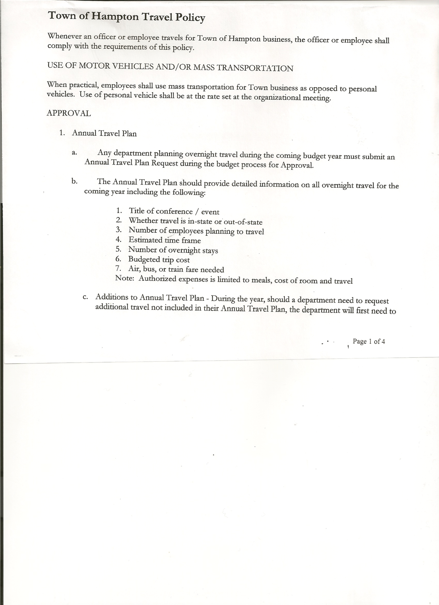
Michael Pietryka------------Councilman
Rebecca Jones---------------Town Clerk
Camilla Shaw----------------Tax Collector/Deputy Town Clerk
Herbert Sady, Jr.-------------Highway Superintendent

Planning Board Member(s):… Bonnie Hawley, Chair; and Matthew Pratt
Others present at the Town Hall: See attached list

The Regular Meeting was called to order by Supervisor O’Brien at 7:30pm, followed by the Pledge of Allegiance. Location of Fire Exits were given. Quorum of board members present.

Supervisor O’Brien asked for a moment of silence in memory of Charlotte Burney, Jeremy Spaulding, Gerald Loeber, Celestine Ann LaRose, Ethel Garrick (Councilwoman Tamme Taran’s mother) and Hazel Mestyan

RESOLUTION NO. 65-2021
APPROVAL OF THE MINUTES
On a motion of Councilman Sady, seconded by Councilman Pietryka, the following resolution was ADOPTED: AYES 4 O’Brien, Sady, Sweeney, Pietryka
NAYS 0
ABSENT 1 Taran
RESOLVED, that the Special Town Board Meeting Minutes for July 12th, 2021 and the Regular Town Board Meeting Minutes for July 15th, 2021, are approved.

PERMITS/SUBDIVISIONS

Bonnie Hawley came before the board with a Boundary Line Adjustment.

RESOLUTION NO. 66-2021
SHORT ENVIRONMENTAL ASSESSMENT FORM/NEGATIVE DECLARATION
On a motion of Councilman Sady, seconded by Councilwoman Sweeney, the following resolution was ADOPTED: AYES 4 O’Brien, Sady, Sweeney, Pietryka
NAYS 0
ABSENT 1 Taran
RESOLVED, that the Short Environmental Assessment Form is complete and to adopt a negative declaration and finding that there will be no adverse environmental impacts and to consider it a minor subdivision, therefore waving the public hearing.

TOWN BOARD MEETING
AUGUST 19, 2021 PAGE 2

RESOLUTION NO. 67-2021
APPROVAL OF BOUNDARY LINE ADJUSTMENT
On a motion of Councilman Sady, seconded by Councilwoman Sweeney, the following resolution was ADOPTED: AYES 4 O’Brien, Sady, Sweeney, Pietryka
NAYS 0
ABSENT 1 Taran
RESOLVED, to approve the Boundary Line Adjustment for Bonnie Hawley.

RESOLUTION NO. 68-2021
SUBDIVISION FEE – WAIVED
On a motion of Councilwoman Sweeney, seconded by Councilman Sady, the following resolution was ADOPTED: AYES 4 O’Brien, Sady, Sweeney, Pietryka
NAYS 0
ABSENT 1 Taran
RESOLVED, to waive the $50.00 application fee.

Larry Carman, Dog Control Officer submitted his report, which was read by Supervisor O’Brien, copy of report is attached.

Camilla Shaw, Tax Collector….had a request for a payment receipt, other than that, no other activity. Submitted Bank Statement to the Board for review and signatures.

Bonnie Hawley, Chair gave Planning Board Report……Copy of Planning Board Minutes of August 18th,2021 meeting is attached. Attached is a copy of the letter received from NYS Ag and Markets informing that the Town of Hampton has been awarded $25,000.00 to develop an Agricultural and Farmland Protection Plan. Also attached is a copy of the letter that the Planning Board sent to Mr. Ken Ray of Ray Terminals regarding the addition of the truck parking stations.

Herbert Sady, Jr., Highway Superintendent submitted his report, copy of which, is attached.
Paving for this year will be done after Labor Day. Supervisor O’Brien suggested the board consider doing a bond for the paving. Following a discussion regarding the paving, the following resolution was introduced.
RESOLUTION NO. 69-2021
BOND FOR PAVING
On a motion of Councilman Sady, seconded by Councilwoman Sweeney, the following resolution was ADOPTED: AYES 4 O’Brien, Sady, Sweeney, Pietryka
NAYS 0
ABSENT 1 Taran
RESOLVED, to authorize Supervisor O’Brien to start the process for a Bond for $100,000 for the paving.

TOWN BOARD MEETING
AUGUST 19, 2021 PAGE 3

SUPERVISOR’S REPORT/ COUNTY UPDATES/ COMMUNICATIONS

RESOLUTION NO. 70-2021
APPROVAL OF SUPERVISOR’S MONTHLY REPORT
On a motion of Councilman Sady, seconded by Councilman Pietryka, the following resolution was ADOPTED: AYES 4 O’Brien, Sady, Sweeney, Pietryka
NAYS 0
ABSENT 1 Taran
RESOLVED that, the Supervisor’s Monthly report be accepted as submitted for JULY
6/30/21 7/31/21
ACCOUNT BALANCE RECEIPTS DISBURSEMENTS BALANCE
General Fund $ 48,865.28 $ 46,789.51 $ 12,411.41 $ 83,243.38
Highway Fund $186,956.68 $ 4.57 $ 59,610.71 $ 127,350.54
Equipment Reserve $ 79,909.39 $ 1.97 $ 0.00 $ 79,911.36
Fire #1 $ 21,648.50 $ 0.00 $ 0.00 $ 21,648.50
Fire #2 $ 5,100.00 $ 0.00 $ 0.00 $ 5,100.00
Cemetery $ 1,751.05 $ .73 $ 0.00 $ 1,751.78
Totals $344,230.90 $ 46,796.78 $ 72,022.12 $319,005.56
All Board Members present signed Supervisor’s Report.

Sales Tax to increase in 2022. We received $22001.00 in 2021. We will be receiving $26124.00 in 2022.

Census numbers have gone down, Population in 2000 was 871;
in 2010 it was 938
and for 2020 it is 857
The Town loses 10% of our state aid because of this reduction.

OLD BUSINESS
Noise Control Ordinance

RESOLUTION NO. 71-2021

MOTION BY: Councilman Michael Pietryka
SECONDED BY: Councilman Donald Sady

RESOLUTION INTRODUCING THE PROPOPSED
NOISE CONTROL ORDINANCE FOR THE TOWN OF HAMPTON
WHEREAS, it is the intention of the Town of the Hampton (the “Town”) to promote the health, safety, and general welfare of the residents; and
WHEREAS, pursuant to Section 10 of Municipal Home Rule Law and Section 130 of the Town Law, the Town has the authority to adopt local law and ordinances in order to preserve, protect and promote the public health, safety, and welfare of the community; and

TOWN BOARD MEETING
AUGUST 19, 2021 PAGE 4
WHEREAS, it is the intention of the Town maintain an ambient noise level in the Town, so as to preserve, protect and promote the public health, safety and welfare, and the peace and quiet of the inhabitants of the Town, prevent injury to human, plant and animal life and property, foster the convenience and comfort of its inhabitants, and facilitate the enjoyment of the natural attractions of the Town; and
WHEREAS, the proposed Ordinance is intended to regulate the making, creation, or maintenance of excessive or unreasonable noises within the Town, which are a menace to public health, comfort, convenience, safety, welfare, and the prosperity of the people of the Town; and
WHEREAS, the proposed Ordinance has been prepared in furtherance of these intentions.
NOW, THEREFORE BE IT RESOLVED THAT, the proposed ordinance titled the “Town of Hampton Noise Control Ordinance” is hereby introduced; and be it further
RESOLVED, that a public hearing shall be noticed and held by the Town Board on September 16, 2021 at 7:15 p.m. to consider the proposed ordinance, and be it further
RESOLVED, that this resolution shall take effect immediately
Supervisor O’Brien handed out and went over “Stimulus Funds Proposed Usage”. After reviewing, the following resolution was introduced.
RESOLUTION NO. 72-2021
STIMULUS FUNDS PROPOSED USAGE
On a motion of Councilman Sady, seconded by Councilwoman Sweeney, the following resolution was ADOPTED:
By Roll Call Vote: Supervisor O’Brien AYE
Councilman Sady AYE
Councilwoman Sweeney AYE
Councilman Pietryka AYE
Councilwoman Taran ABSENT
RESOLVED, to accept the Stimulus Funds Proposed Usage as presented.

Cannabis Opt Out/In …..Still discussing about Opting In or Out. Councilwoman Sweeney stated that she would not be at the September meeting. Her vote on the matter would be to OPT IN for sales, to permit the establishment of a Cannabis Retail Dispensary Licenses, but to OPT OUT of On-Site Consumption.

NEW BUSINESS

Budget Forms were handed out and need to be returned by September 1st, 2021.

Briefly discussed Disability Insurance and Paid Family Leave Insurance. Will obtain more information on both and discuss further at a future meeting.

TOWN BOARD MEETING
AUGUST 19, 2021 PAGE 5

RESOLUTION NO. 73 -2021
AUDIT OF CLAIMS
On a motion of Councilman Sady, seconded by Councilman Pietryka the following resolution was ADOPTED: AYES 4 O’Brien, Sady, Sweeney, Pietryka
NAYS 0
ABSENT 1 Taran
RESOLVED that the bills have been reviewed by the Town Board and are authorized for payment in the following amounts.
General Fund No. 104 through No. 113 $ 4,504.95
Highway Fund No. 87 through No. 101 $ 6,902.55
Total both funds $ 11,407.50

The Town Clerk’s report for July 2021 was submitted to the Board. The Town Clerk had Board Members review and sign bank reconciliation statements for the Town Clerk Account and Special Clerk Account dated July 31, 2021.

RESOLUTION NO. 74-2021
MEETING ADJOURNED
On a motion of Councilman Sady, seconded by Councilwoman Sweeney, the following resolution was ADOPTED: AYES 4 O’Brien, Sady, Sweeney, Pietryka
NAYS 0
ABSENT 1 Taran
RESOLVED that the meeting adjourned at 9:05pm.

Respectfully submitted,

Rebecca S. Jones, RMC
Town Clerk

