Mad for Emojis
Recital Gift Order Forms
PRE-ORDERS DUE BY: JUNE 1^{ST,} 2019
AMOUNT:
Tumbler alone: $13.00
Emoji Goodie bag alone: $5.00
Buy Both Together for $15.00
Please return Complete order form with payment in an envelope at front desk.
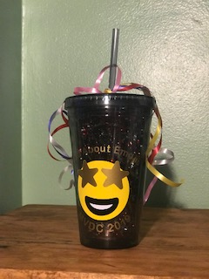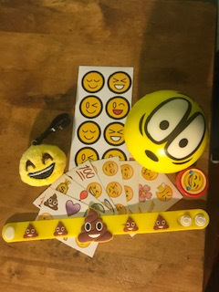
Tumbler picture on the left. Goodie Bag on the right.

Phone number where you can be reached in the event we have any questions.
Name: _______________________________________________________
Number: _________________________________________________
ALL PRE-ORDERS MUST BE PRE-PAYED.
PLEASE MAKE CHECKS PAYABLE TO: MVDC
THANK YOU!
Orders will be ready for pick up at recital in the main lobby!
Limited stock! Get your orders in!!!!

