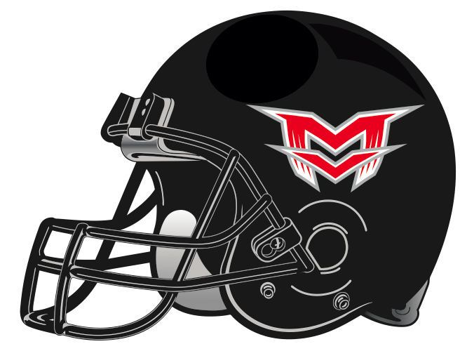
Linfield Scholarship Contract

As part of the scholarship/monetary help you are receiving for the Linfield team camp, players are required to fill out this contract. All requests must be made by May 15th, 2019.

Player Name: ______________________________________________________________

Amount of Player Scholarship Paid by MV Football: $125
Amount Player Owes (Check to Linfield College): $128

As part of this agreement, both player and parent understand that during the summer and season, that athletes who were given Linfield Scholarships will be required to perform the following:
-Any player who uses scholarship money for Linfield but does not come out for football in the fall will be required to pay back their scholarship in full.
-A thank you card will be written to anonymous donors who help make this scholarship possible.
-Take part in at least one stadium/field/weight room clean-up day
-Agree to sell a minimum of 10 Gold Cards in our August fundraiser
-Parents agree to help in Concession Stand during the season several times

I agree to the conditions of this contract:

_____________________________________________________________ _____________________
Player Name (Print) Date

_____________________________________________________________
Player Signature

_____________________________________________________________
Parent Signature

