Joseph J. Jacques Jr. Post 7945
THE POST OBSERVER
2015, Issue 2 10217 Quivas Street, Thornton, CO 80260 303-438-6700 MARCH-APRIL News

FROM YOUR COMMANDER
Greetings Comrades and Auxiliary!
First, I would like to thank all the Post and Auxiliary members, as well as their family members, who volunteered to make the State Voice of Democracy banquet a great success! From the setup, to the serve up, to the cleanup this was another high quality event that once again set Post 7945 apart as one of the finest in the State of Colorado! We can all be very proud of this accomplishment!
I am pleased to announce that we have hired our new canteen manager! Bleu Perry began working with us in January and we are very excited to have him join our Post family. If you have not yet had an opportunity to meet Bleu I encourage you to come to the Post and welcome him.
Once again it is that time of year to begin thinking about electing our Post officers for the next year. Nominations for elected officers will be made at our March post meeting. Any member who is interested in running for an officer position and would like to know more about the responsibilities please feel free to contact me or an officer who is currently serving. This is a great way to be involved in our Post activities as well as an opportunity to meet more of your fellow members.
Attention!! Comrades with annual memberships! We have a large number of annual memberships which have expired or their renewal dates are quickly approaching. If you have questions regarding your membership status, or if you are interested in becoming a VFW Life member, contact me or Post Quartermaster Ron Schlieman.
May God continue to bless and watch over our great Nation. Especially over those who serve in our defense.
Leroy Chavez
Post Commander

FROM YOUR PRESIDENT
I hope all are enjoying the beautiful weather we have been having, spring will be upon us in no time.
I would like to remind everyone to pay their dues and cancer dues. If you would like to pay your dues or have someone join please contact Lennie Dolan. Please remember that without members we would not be able to do all we do for our Veterans.
As it is important to teach our children the many things they need to know, Brandi Dolan, Americanism Chairman has been working hard at giving out things to help teach our children the meaning of Americanism. Brandi would also like to remind everyone who has someone in their neighborhood or a business that flies their flag to let her know.
Last but not least, please remember to report, report, report to Barbara Petschauer. Let her know if you sent a card, drove a Veteran to an appointment, bought a Veteran lunch, just to name a few things. Let's continue to show that our hard work does support our Veterans.
May God continue to watch over and bless each and every one of us, especially those serving to protect us.
Brigitte M. Dolan, President
Ladies Auxiliary to the Veterans of Foreign Wars, Post 7945

VOICE OF DEMOCRACY BANQUET SALLY ADAMS, CHAIRMAN
Post 7945 was honored to host the 2014-2015 Voice of Democracy Department Banquet on January 24, 2015. Five finalists were chosen from the 12 entries submitted by the Districts in Colorado. It was with great pleasure that our District 10 winner, Adam Densmore, was selected as the first place winner. He received a check for $1,000 and an all expense paid trip to Washington, D.C. from February 28 to March 4. His essay will be competing against the winners from the other state departments for the national first place prize of $30,000 in college scholarship monies. Besides the first place prize there are an additional 53 prizes that can be awarded. This year all of the department winners from across the United States will be attending the “Freedoms Foundation” workshop in Valley Forge, Pennsylvania for a week beginning June 18. At the banquet we were privileged to listen to the finalists deliver their essays. These students did a tremendous job. If you know of a student in high school please encourage them to check out the vfw.org website for information on this competition.The National Commander will be releasing the theme for this year soon.

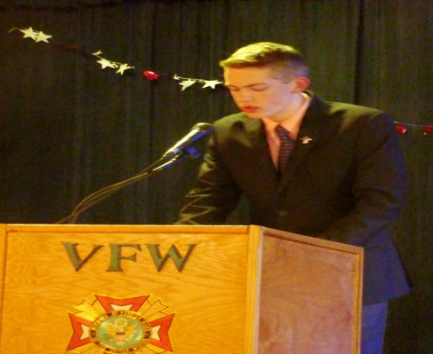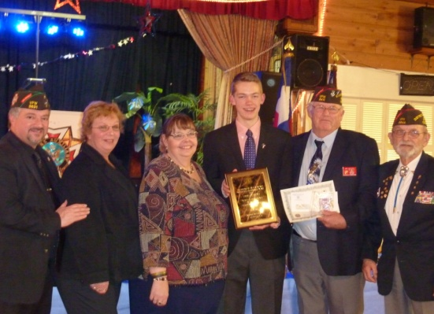
***********************************************************************************
CHAPLAIN’S CORNER Micheal Ayers 303-594-8898 Debbie Semmen 303-438-9893
Please call our Chaplains, Mike or Debbie with any card requests due to illness, hospitalization or deaths. Funeral luncheons will only be provided for deceased members of our Post or Auxiliary, upon request of the family. If the deceased was not a member of our Post or Auxiliary, the family may contact the Canteen Manager about use of the Post for a luncheon.
TAPS WALTER LEAS, DORIS DADE

CANCER GRANT CHAIRMAN Shirley Colvin, Patriotic Instructor
The National and our Auxiliary Cancer Grant applications are available at the Post. Please contact me at 303-427-2982 if you need any information. The Auxiliary Grant can be mailed to me at 8381 Delaware, Denver CO 80221.

MEMBERSHIP CHAIRMAN Lennie Dolan, Treasurer
Ladies, remember that after December 31, 2014 you are no longer considered a member in good standing if you haven’t paid your dues. Please get 2015 dues sent to continue to be eligible for Cancer Grants. Also Life Members need to send $6.40 to keep your Cancer Grant current. Send to me at 1170 Fulton Street, Aurora CO 80010. Thanks!

POST QUARTERMASTER – Please send your Post dues to 10217 Quivas Street, Thornton, CO 80260.
***********************************************************************************
DATES OR MARCH AND APRIL
MARCH 1, The proceeds from Chuck’s breakfast will be matched and sent to The Wounded Warrior’s so please support this.
MARCH 11TH , Post and Auxiliary Meeting 7:00, nomination for Post Officers.
MARCH 13TH, Come and celebrate ST. Patrick’s Day with Corned Beef and Cabbage dinner, 6-8 $7.00
APRIL 8TH Post Auxiliary Meeting, 7:00, election of Officers for 2015-16.
APRIL 24TH We host the Department Salute to Service Banquet.
DINNER SERVED EVERY FRIDAY NIGHT 6-8 AND BREAKFAST SERVED EVERY SUNDAY MORNING 8:30-11.KARAOKE EVERY FRIDAY NIGHT WITH COYOTE BILL STARTING AT 7:00, BRING YOUR FRIENDS !!!!
POST DIRECTORY PHONE 303-438-6700
Commander Leroy Chavez chavezl.@msudenver.edu 720-724-6773 Sr Vice Commander Micheal Hudson 303-429-0599 Jr. Vice Commander Quartermaster Ron Schlieman sshelbell@aol.com 303-349-5615 Chaplin Michael Ayers 303-594-8898 Judge Advocate/Adj. Dave Garcia 303-979-0977 Surgeon George Sandoval 303-948-4920 3 Yr Trustee Terry Timberlake 720-379-5474 2 Yr Trustee Chuck Archeletta 720-621-3002 1 Yr Trustee Darwin (Ole) Haydeen 303-451-1296 Service Officer Scott Evans 303-457-1999 5 Yr Home Board Bruce Dolan 303-421-1630 4 Yr Home Board Scott Evans 303-457-1999 3 Yr Home Board George Apodaca 303-906-8661 2 Yr Home Board Bill Bingham 303-880-8620 1 Yr Home Board Mike Bergman 720-276-0870
AUXILIARY DIRECTORY
President Brigitte Dolan 720-394-5474 Sr. Vice President Brandi Dolan 303-353-9629 J r Vice President Sally Adam 303-452-0474 Secretary Shelley Schlieman sshelbell@aol.com 303-550-7689 Treasurer Lennie Dolan linebrd@aol.com 303-341-7488 Chaplin Deb Semmen djsemmen@comcast.net 303-438-9893 Conductress Cat Apodaca 303-906-8671 Guard Joyce Alverado 3 Yr Trustee Brandi Dolan 303-353-9629 2 Yr Trustee Sally Adam 303-452-0474 1 Yr Trustee Maggie Munoz 303-637-7394 Patriotic Instructor Shirley Colvin 303-427-2982 Newsletter Shelley Schlieman 303-550-7689
POST HOURS CANTEEN MANAGER Bleu Perry
Monday Thru Thursday 12:00 – 8:00 Friday & Sat. 12:00 – 2:00 Sunday 8:00 – 9:00
Sunday Drink Special 8:30 – 11:30 is Bloody Mary’s and Screw Drivers for $2.00
Joseph J Jacques Jr. VFW 7945
10217 Quivas Street
Thornton , CO 80260

