Application
Times for Camps 9:30 – 12:00 (4 days)
(Younger Campers up to age 12)
Times for Workshops 12:30 – 3:30 (3 days)
(Older Youth ages 12 through 17)
Cost for Each Session: $100 for KIFA Members & $115 for Non-Members (includes Youth KIFA) $10 off each additonal camper
Camper #1__________________________________________
tudents
Camp Session(s) ____________________________________

Camper #2__________________________________________

Camp Session(s)_____________________________________

Camper #3__________________________________________

Camp Session(s)________________________________________

Any allergies?_____________Students are to bring snack & drink

Parent Contact Info:________________________________

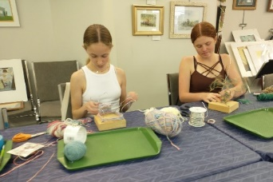
Kent Island Federation of Arts
405 Main Street, Stevensville
arthousekifa@gmail.com
410-643-7424
~Ask about Scholarships~
The Kent Island Federation of Arts, a 501c3 non-profit,
is partially funded by- Maryland State Arts Council, The United Way of QAC , Mid-Shore Community Foundation, Elks Lodge 2576, VFW 7464,
Queen Anne's County Government, Queen Anne's County Centre for the Arts, American Legion Post 278, Local businesses, Individual Donors,
& KIFA Members
2024 Summer Fun
Camps & Workshops
Begins June 17th
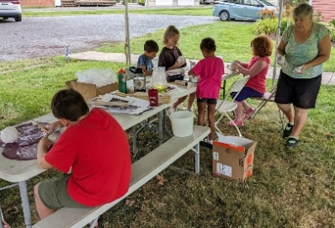

Ceramics, Painting, Drawing, Animation
Sculpture, Creative Writing & Illustration
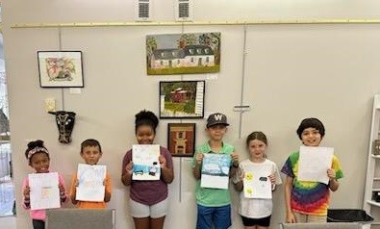

Fiber Arts, Space Art, Mixed Media, 3D
Upcycled & Recycled, Plein Air Painting
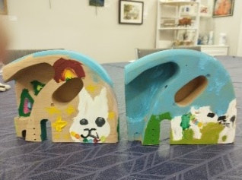
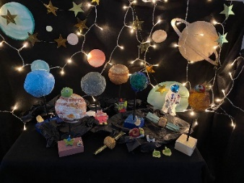

Come Join Us ….

