FAQs

What? A plastic bag ban proposal. Let's phase out single-use shopping bags in Wellfleet

Where? At the point of sale at Wellfleet retailers, markets, restaurants

Who? Sponsored by Wellfleet Recycling Committee with support from members of the Board of Health and conservation community

When? Please vote at Town Meeting, Monday, April 27, 2015 at 7PM! If approved, the bylaw would go into effect on January 1, 2016
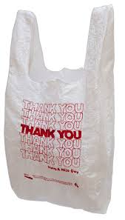

Why in Wellfleet?
Because. . .

There is a growing trend on the Cape & Islands -- Provincetown, Falmouth, and Nantucket have plastic bag bans in place. Harwich will vote on May 4 and Brewster is working on a ban.

Protecting our harbor and coastline is essential to the local economy.

In the US 60,000 bags are handed out every 6 seconds. The EPA reports that only about 15% of plastic bags are recycled; the remainder are incinerated, buried in landfills, or end up as litter.

Plastic bags pollute the environment and endanger wildlife.

Plastic bags choke, strangle, and entangle turtles, marine mammals, birds, fish, and transport harmful microbes and toxins up the food chain.

It is easy to use alternatives to plastic bags (reusable bags, paper bags, cardboard boxes and box tops).

Alternative “compostable” or “biodegradable” plastic bags require very specific and controlled environments in order to biodegrade.
When you "Remember Your Reusable Bag" it does not cost the market retailer/restaurant/business anything. Zero.

When you remember your reusable bag it saves fossil fuel resources and money.

