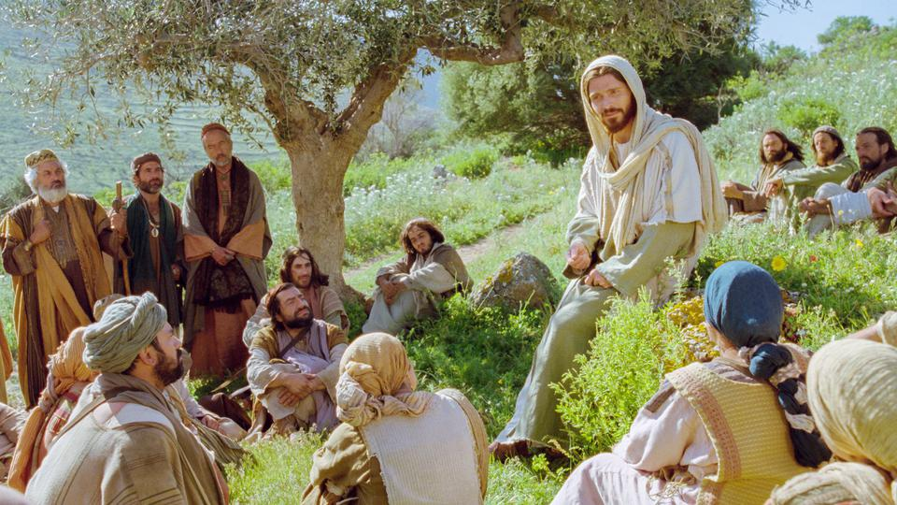

August 1, 2021

10th Sunday after Pentecost

Carson City United Methodist Church

10:00 am
Prelude/Greeting
*Indicates stand as you are able

Call to Worship
From Psalm 86

L: Teach us your ways, Lord,
P: So that we will remember your unending faithfulness.
L: Give us an undivided heart, so that we may honor your name.
P: We will praise you, Lord our God, with all our heart soul and mind.
L: To love the Lord is the beginning of wisdom,
everyone who follow his instructions will never be put to shame.
P: He provides for the needs of those who love him, the Lord remembers his promises forever.
L: For great is the Lord’s love toward us.
P: You have delivered us from the depths, from the realm of the dead.

*Hymn:

Opening Prayer: (unison)
Heavenly Father, graciously you accept us as living members of the body of Jesus Christ, you nourish us with spiritual food in the Sacrament of Christs Body and Blood. As we continue our journey into a world filled with so much anger, pain and selfishness, through your Holy Spirit remind us again Lord that, you are always with us. Remind us again of your unending mercy and love for all your people. Remind us again that you have called us to be a light shining in this darkness and voices of peace and reconciliation to you through Christ our Lord. AMEN.
*Hymn: Let the Worshipers Arise (Phillips, Craig &Dean)

Gospel Reading: JOHN 6:35-40
Old Testament: PSALM 78:22-28
Epistle Lesson: ROMANS 8:11

THE MESSAGE
Communion

*Hymn: Less Like Me (Zach Williams)

Sharing of our joys and concerns

Call to Prayer: Turn Your Eyes Upon Jesus
UMH 349

Pastoral Prayer/Offertory Prayer

Doxology UMH 94

*Hymn: The Church’s One Foundation UMH 545

BENEDICTION

CCUMC – Announcements

========================================
UMW Meeting: August 5th @ 10:00 am.
========================================
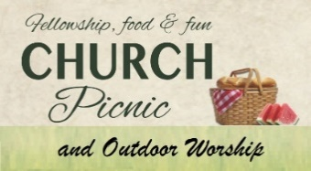
Annual Church Picnic
& Sunday Service 8/8/21

Please plan to come to our Service to be held at Red Pines Campground on August 8th at 11:00 am followed by the Annual Church Picnic. Hot dogs, buns and condiments will be provided. There will be valet parking available. Bounce house. There is a pavilion and a small lake. Please bring chairs and fishing poles. Camping is also available. To reserve go to www.redpinescampground.com
========================================
Ad Board, Finance & Town Hall meeting will be held on August 25th @ 6:00 pm.
========================================

Serving and Supporting Sunday Worship
Audio/Video: Pat Monroe

Joys, Concerns & Prayer Request
For those battling cancers: Wendy Crawfis,
Beth Grienke, Kale Litwiller, Jim Dunlap,
Carolyn Nykerk, & Ray Seaman

For everyone who needs support,
guidance or has health concerns.

Monthly Giving
7/4 $1499.73 7/11 $3182.57
7/18 $2322.99 7/25 $1814.45

Upcoming
8/3 Jaquette Funeral & Lunch 11:00 am
8/5 UMW meeting 10:00 am
8/14 On the Hunt for Romance 3:00-7:30 pm
8/25 Ad Board, Finance & Town mtg 6:00 pm

Our Church in Ministry This Week

Mon 6:30 pm | Personal Transformation Class

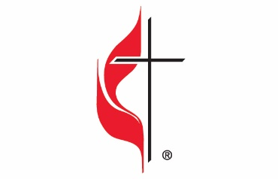

Carson City United Methodist Church
Location: 119 East Elm St., Carson City, MI
Mail: PO Box 298, Carson City, MI 48811
Phone: 989-584-3797 Email: carsoncityumc@gmail.com
Website: carsoncityumc.com
Office Hours: Monday-Thursday, 9:00 am-12:00 pm
After hours by appointment
Pastor: Ian McDonald 906-322-5318
Secretary: Bonnie Seaman 989-763-1674

Weekly Sunday Bulletin now available on our website
@ www.carsoncityumc.com

“Father, thank You for being my ever-present help in good times and bad. Give me the grace to be still and know that You’re God”

