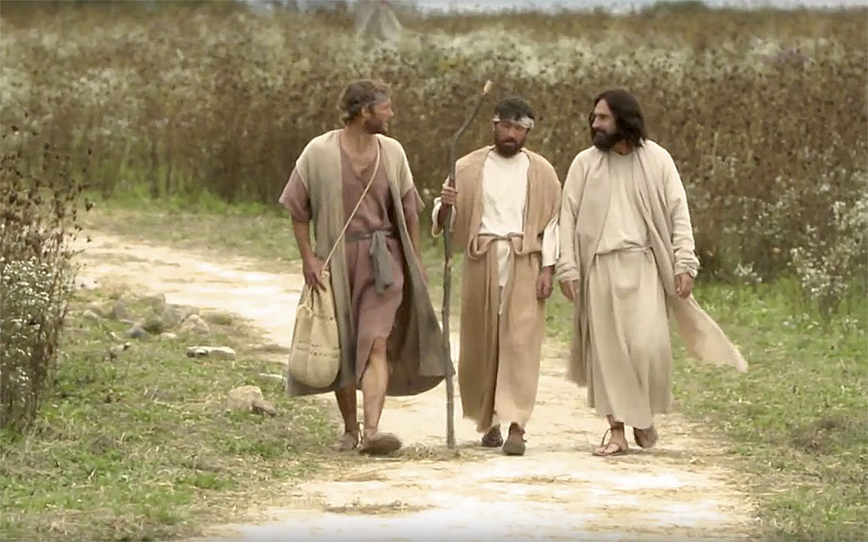

October 10, 2021

20th Sunday after Pentecost

Carson City United Methodist Church

10:30 am
Prelude/Greeting
*Indicates stand as you are able

Call to Worship

L: Teach us, your ways Lord, the way of true discipleship.

P: Give us understanding, so that we may keep your ways
and obey your ways with all our heart.
L: Direct us in the path of your commands, for there we find delight.
P: Turn our heart toward your statutes and not toward selfish gain.
L: Turn our eyes away from worthless things, preserve our lives according to your word.
P: How we long for your precepts! L: Never take your word of truth from our mouths. P: For we have put all our hope in your words.
*Hymn: Come Thou Fount of every Blessing UMH 400

Opening Prayer: (unison)

Gracious Heavenly Father, it is our desire to be in your presence today gathered here together, as disciples of your son, our lord, and Savior Jesus Christ. Father we come seeking to feel your presence, to hear a word from you, to feel your touch on our souls. We come to strengthen our faith and to be reminded of the joy that fills our hearts when we hear your very words spoken to us in your presence here in your house. AMEN

Contemporary Song: The Great I am (Phillips, Craig & Dean)

Offering

Doxology UMH 95

Offertory Prayer

Gospel Reading: LUKE 1:1-4
Old Testament: ISAIAH 7:9B
Epistle Lesson: 2 PETER 1:16-21
Worship War Zone Song: Power Shuffle (VBS)
Children’s Church

THE MESSAGE

Contemporary Song: Praise You in This Storm
(Casting Crowns)

Sharing of our Joys and Concerns

Call to Prayer: See Ye First UMH 405

Pastoral Prayer

*Hymn: He Lives UMH 310

Benediction

CCUMC – Announcements & Upcoming Events

=========================================
Beginning Oct 14th through Oct 21st, Pastor Ian will
be on vacation and Pastor Larry will be overseeing
in his place.
=========================================
Euchre: Oct 9th 5-7:30 pm @ CCUMC. Potluck at 5,
cards to follow. Bring a dish to pass.
=========================================
SPRC/Church Charge Conference: Oct 11th. SPRC
meets at 6:00 pm with the rest of Church congregation
meeting at 7:00 pm. Meetings are via Zoom, so please
bring your laptop.
========================================
Join us for our next Soup Lunch
Fri, Oct 15th, 11 am - 1 pm
Soup Luncheons email
umwluncheon@gmail.com
========================================
Finance meeting: Oct 19th @ 6:00 pm.
========================================
CCUMC presents its
12th Annual Trunk-Or-Treat
on Halloween Night 5:30-7:30 pm
A Safe, Fun Way for Children to Trick-or-Treat

Halloween Candy Donations: There is a box located
in the Church Foyer labeled for Halloween candy
donations. There is also a sign-up sheet located on
the Welcome Desk for those who would like to provide
a vehicle and/or decorated during this event.
========================================
OCC Shoebox: Deadline for collection is Sun, 11/14.
More information to come.

Serving and Supporting Sunday Worship
Audio/Video: Pat Monroe
Children’s Ministry Audio/Video: Colin Fitzpatrick

Joys, Concerns & Prayer Request
For those battling cancers:
Beth Grienke, Jim Dunlap,
Carolyn Nykerk, Ray Seaman

For everyone who needs support,
guidance or has health concerns.

Monthly Giving
9/26 $3308.57 10/03 $3596.99

Nursery Schedule
10/10 Molly Fitzpatrick 10/17 Jenna Benjamin

Lighting of Candles

Passing of Collections Plate

Our Church in Ministry This Week

Sun 6:30-8:00 pm | Women’s Group
Wed 6:30-8:00 pm | A.R.K.

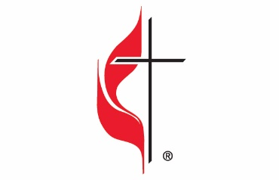

Carson City United Methodist Church
Location: 119 East Elm St., Carson City, MI
Mail: PO Box 298, Carson City, MI 48811
Phone: 989-584-3797 Email: carsoncityumc@gmail.com
Website: carsoncityumc.com
Office Hours: Monday-Thursday, 9:00 am-12:00 pm
After hours by appointment
Pastor: Ian McDonald 906-322-5318
Secretary: Bonnie Seaman 989-763-1674

Weekly Sunday Bulletin now available on our website
@ www.carsoncityumc.com

“Father, thank You for Your constant
presence no matter where I am”

