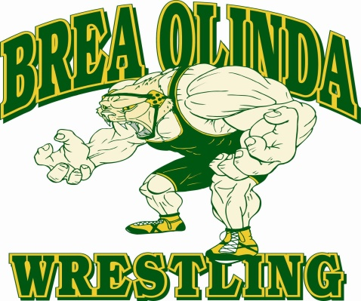
HALLOWEEN BASH

*All wrestlers must have a valid USA Wrestling Card to compete*
SUNDAY OCTOBER 28th, 2018
Weigh-Ins: 7:00-8:30am Wrestling Begins: 9:00AM
Brea Olinda High School Main Gymnasium
789 Wildcat Way, Brea CA 92821

Styles: Folkstyle Wrestling
Levels: Bantam, Intermediate, Schoolboy/girl, Middle School, Cadet, Junior

Costs: Spectators $5 ea. ages 10+

Entry: Wrestlers $10 first weight, $5 additional weight class

BWC Brea Wrestling Club & the ACWA American Catch Wrestling Association
The Brea Wrestling Club and the ACWA present the Brea Halloween Bash Sunday morning October 28th. Come out and get some matches at our USA Wrestling sanctioned event, and watch senior level grapplers compete in catch submission wrestling with the American Catch Wrestling Association sister event.

Sign-ups for the ACWA event can be found at:
ww.eventbrite.com/e/acwa-catch-wrestling-tournamenttickets-49926242736

For more information please look at www.BreaWrestling.com

