Texas History with Mr. Brown Name ____________________ Period _____
Chapter 2 Texas’s Place on Earth
Picture Search p. 26 - 40
Directions: Use the pictures, maps, graphs, Info boxes, and their captions to find the following information.

1) What took the photograph of Texas on p.26?
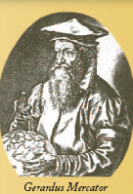
2) “I’m sittin’ here looking at a map . . . and I’m trying to figure out how to get back home again. I wish I was sitting right under the “x” in Texas.”
Texas ____________ Johnny Gimble
3) In what year did Gerardus Mercator invent cylindrical map projection?
4) What Mexican city is closest to Brownsville, TX?
5) What is the Mexican State capital of Coahuila?
6) What was used in 1840 to survey the Texas boundary along the Sabine River?
7) How many continents are there on our planet?
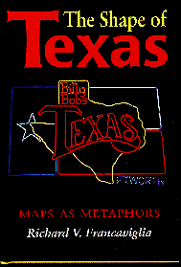
8) Which two continents are in both the Northern and Southern hemispheres?
9) Which cities are located at 30°18 N, 97°42 W and 32°51 N, 96°51 W?
10) Where does Dr. Francaviglia teach?
11) What was discovered at Paint Rock?
12) Which special parallel is the furthest North?
13) Which special parallel is closest to Texas?
14) Who is the cartographer pictured on p.33?

15) What Interstate Highway is Castle Hills located near?
16) Where is the Institute of Texan Cultures located?
17) Name the three types of map scale:
18) Name three shapes used to develop map projections:
19) Cartography dates back as far as:
20) The first maps were drawn on:
21) In the distorted projection map on p.36, how is the map distorted?
22) How are modern maps made?
23) What city gets less than 8 inches of rain per year?
24) What city has the same average precipitation as Dallas?
25) What does GPS stand for?

