2017
August
TRUE LIES
The Stuart Rod & Reel Club Newsletter
The Stuart Rod and Reel Club is dedicated to improving local fishing through by increasing angler knowledge, encouraging conservation and maximizing the fun involved in light tackle fishing in the Stuart Florida area. We hold monthly meetings on the second Thursday of each month, year-round. Please join us or contact any board member for more information on how you can become a member of the Stuart Rod and Reel Club.
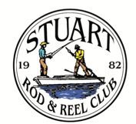

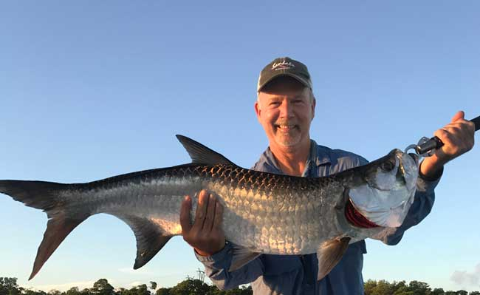
It’s Tarpon Time on the Treasure Coast! Philip Quick caught and released this beauty near the mouth of Big Mud Creek. Philip won the July tarpon tournament event with this fine fish. See action photo on page 9. Photo taken by Jim Bohrer on his boat.
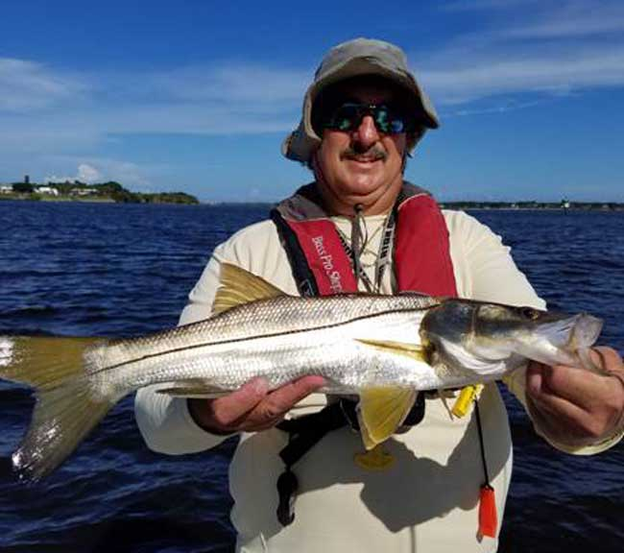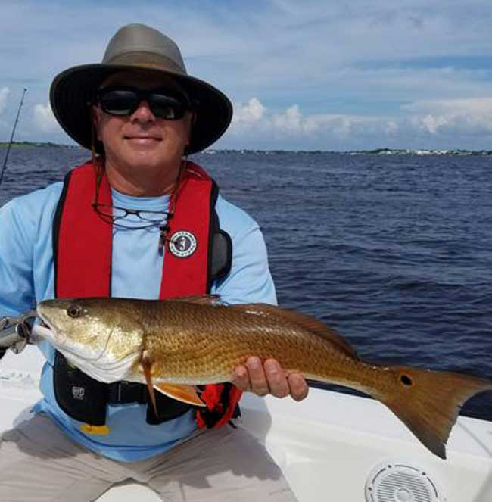
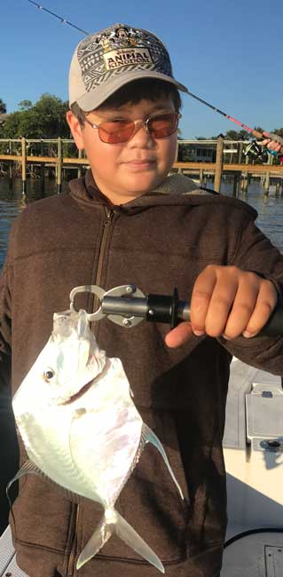

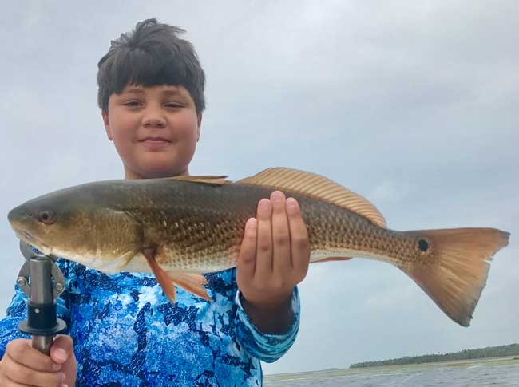
Top Left: Keith Palant with a nice snook that he caught and released.
Top Right: Jorge Perez with a pretty redfish.
Bottom Left: Toby Rooney with a lookdown. The moonfish is similar, but has shorter anal and dorsal fins.
Bottom Right: Toby Rooney with a fine redfish caught near Steinhatchee with his uncle, Jim Bohrer.

 |  |  | Club Officers
President | Jim Bohrer |  | halieutics@gmail.com | 301-648-2052
Vice President | Jim Bowdish |  | jlsb@crarybuchanan.com | 772-475-5068
Treasurer | Pete Noll |  | mpnoll@aol.com | 772-223-2136
Secretary and Newsletter Editor | Fred Bartlett |  | fredbart@aol.com | 913-909-9326
 |  |  | Board of Governors
Director |  | Roy Buckley | rlbuckley007@aol.com | 772-871-7008
House Committee |  | Jerry Hoge | jhoge@hogeengineering.com | 772-485-7267
Angling Committee |  | Frank Miller | frmiami2@gmail.com | 305-469-4654
Membership Comm. |  | Eric Rosenberg | erosen1031@aol.com | 772-210-5563
Meeting Speakers |  | Jim Bohrer | halieutics@gmail.com | 301-648-2052
Raffle Chairman |  | Jim Harter | pjharter@comcast.net | 772-223-0648
Conservation Coordinator |  | Jim Harter | pjharter@comcast.net | 772-223-0648
Events Coordinator |  | Bob Ruggeri | bob.ruggeri@yahoo.com | 772-285-4264
E-mail all newsletter copy and photos to Jim Bohrer at halieutics@gmail.com or to Fred Bartlett at fredbart@aol.com. Closing date for photos and copy is the 25th of the month preceding publication.

Angling Director’s Report by Frank Miller

Hi SRRC members: Here is a rundown for our outing covering the dates of July 14th,15th & 16th while targeting the wily tarpon.

For a while it looked like we might not have any winners because as of mid-day Saturday, we didn't have any entries. We had several anglers in pursuit and multiple sightings but no fish on the line. Finally, Sunday afternoon I received a text that Philip Quick had subdued a fish weighing approximately 50 pounds aboard Jim Bohrer’s boat. The catch was witnessed by club president Jim Bohrer. An accompanying photo appears on the cover of this month’s issue.

Congratulations Phil on your new shirt. Bohrer reported that he had a pretty good tarpon hookup that beat him up pretty badly but the fish released himself just prior to boating.

Our lunch at Shrimpers’ was a great event with 44 members attending. I believe that is our largest turnout ever for a Shrimpers’ lunch. We capped off the event with a birthday celebration for Roy Buckley. Congrats, Chef Roy; many more to you.

Our Fish of the Month for the period of May 12th thru June 18th was won by Todd Puig who bested 15 snook. Way to go, Todd! Here's to a new cap for the Fish of the Month award.
FWC Spotted Seatrout workshops scheduled in Fort Pierce for August 09, 2017 at 6 PM.
The FWC is hosting spotted seatrout public workshops throughout the state in late July and early August. Learn more about the current status of spotted seatrout and share your input on management of this fishery by attending one of these workshops.
Our local Workshop will be from 6 to 8 p.m. on August 9th in Fort Pierce, St. Lucie Commission Chambers, Third Floor Meeting Room 303, 2300 Virginia Ave.
If you cannot attend an in-person meeting, submit comments online by visiting MyFWC.com/SaltwaterComments. Additional details and updates for these meetings will be posted at MyFWC.com/Fishing (click on “Saltwater Fishing,” “Rulemaking” and “Workshops.”)
Please let Jim Bohrer know if you would like to attend and we may be able to put a carpool together. This is the only meeting to be held on the Treasure Coast and it would be helpful for our members to attend. We would like to have Seatrout protected as a gamefish in Florida.

Date | Outing/Event | Details | Host/Food Service | Rules
August  11, 12, 13 | Local Trout and Redfish Outing | Largest Trout & Redfish, total inch length | Sandsprit Park 1:00 PM Stuart, August 12th. | Longest total trout and redfish combined.
September  15, 16, 17 | Longest Snook | Longest Snook –Bait Restriction: Any snook caught on bait is worth ½ a fish caught on an artificial lure. 24” snook minimum length | Sandsprit Park 1:00  PM Stuart, Sept 16th. | Longest snook, minimum 24”
October  13, 14, 15 | Pine Island | Total Length in Inches: 1 Trout, 1 Redfish, 1 Snook (24” minimum on snook) | Pine Island Away  No Local Luncheon | Longest total length
November  10,11,12 | Local Redfish | Longest Overall Redfish | Sandsprit Park 1:00 PM, Nov 11th. | Longest total length
December 9 | Christmas Party | No Outing | Dolphin Bar & Fish House Jensen Beach | No Outing.

All Stuart Rod and Reel Club Outings are based purely on the Honor System. All scheduled Club Outings will be “Daylight Outings”. You can fish any of the dates listed above. Event will begin at the first safe light in the morning with lines out of the water by 1PM. Scores must be turned into the Angling Director or other board member by email, phone or verbally by 2 PM local time on the day after the event.  Natural Bait (alive or dead) is allowed except for March, May and July. Bait restriction is in effect for September.  Guests and spouses are invited to attend the food services on Saturday at Sandsprit Park. For food at restaurants, guest and spouses will be charged for their meal and beverage costs. | Family members under the age of 18 must be accompanied by a parent or legal guardian to participate in an outing. While guests are always welcome to join members during our outings, you must be a paid member of the Stuart Rod and Reel Club to be eligible to win an outing. Outing scores shall be published in the Club’s Newsletter following the Outing. Outings cancelled due to weather shall be rescheduled for the following weekend. Outing result disputes shall be settled by the Angling Director.  OUTING SCHEDULES AND RULES MAY CHANGE DURING THE YEAR.  FISHING BOUNDARIES  Boundaries will extend from the south shore of the Jupiter Inlet to the North Vero Beach Bridge.

2017 TOURNAMENT OUTING SCHEDULE
Support our Advertising Sponsors
We are very fortunate to have many local businesses that advertise on our web site and provide additional sponsorship support to the Club. These businesses provide a wide range of products and services for the entire community. Whether you are looking for lodging, restaurants, fishing supplies, boat repair and restoration, guide services, legal services, or roof repair our sponsors deserve your consideration. You can learn more about these businesses by visiting our website at www.stuartrodandreel.com. Click on the advertiser’s tab and you will find a brief description of our sponsors with contact information and links to their websites. Make our advertising sponsors your priority when shopping. Please let them know that you learned about them through the Stuart Rod and Reel Club and that you appreciate their support.

Bait & Tackle  - Crowder Rods  - D.O.A. Lures  - Fish Heads of Stuart  - Snook Nook  - Treasure Coast Rod and Reel  - White's Tackle  - T & A Jigs, Inc. | Area Lodging  - Marriott - Hutchison Island Resort
Area Dining  - Big Apple Pizza  - Crawdaddy’s  - Dixie Grill  - Manatee Island Bar & Grill  - Manero’s Restaurant  - Polka European Deli  - Rancho Chico  - Shrimper’s | Guide & Charter Services  - Cajun Fishing Adventures Louisiana  - Catch 22 Charters Florida  - The Fish Intimidator Louisiana
Marine Products & Services  - C&H Trailer  - Manatee Marina  - Marine Customs Unlimited  - Marine Parts Outlet  - Master Repair  - Metco Marine Electronics  - Outboards Only  - Sailfish Marina  - Stuart Propeller  - Treasure Coast Battery & Alternator | General Business  - Capps Roofing  - Inn of the Dog  - Plaza 95 Marathon, Dairy Queen and Highway Café  Professional  - Crary Buchanan Attorneys

MEMBER’S INFORMATION
MONTHLY MEMBERSHIP MEETINGS WITH SPEAKERS: The monthly membership meeting is the second Thursday of the month. Our home port is The Quality Inn/Flanigan’s Bar & Grill located at 950 SE Federal Hwy. (US 1) Stuart, FL. We have the privilege of listening to many fishing industry and conservation leaders in the Southeastern Florida region. These experts include tackle manufacturers, tournament winning Captains and guides, television and print journalists, and academic researchers. We have a guest speaker from this pool at each monthly meeting. Speakers will address topics of interests such as how to fish for the upcoming outing’s targeted species and our diverse estuary system. This is a great way to gain additional local knowledge of this fishery. Dinner begins at 6PM with Meeting at 7 PM.

MONTHLY OUTINGS: The Club sponsors a fishing outing each month. All outings are based on an Honor System. You don’t have to keep your catch or take a picture of it either. Outings are scheduled for the weekend following the general membership meeting. Outings are usually three day events where anglers select to fish Friday, Saturday or Sunday. Most outings are scheduled from first safe light till 1PM. The targeted fish and scoring change from month to month with interesting twists such as more points for one species than another. The intent is to have fun! The winner of each monthly outing receives a Club logo embroidered fishing shirt. As part of the outing we have several lunches at restaurants along with club and family cook-outs. Additionally, the Board is encouraging members to partake of the lunch regardless of the day fished. These are no-cost events. With two away outings and the remainder based at Sandsprit Park, there is opportunity to participate without travelling around the state. Frank Miller as the Angling Committee Chairman will also consider your ideas about other outings in other parts of the state. This year’s outing schedule was developed to increase participation, emphasizing the fun of fishing. You are able to view the schedule in every edition of True Lies.

NEWSLETTER: We publish a newsletter, True Lies, each month. It is circulated by e-mail. We are constantly looking for your fishing reports, pictures, recipes, and any other Club related information for inclusion. Submitting information is easy. You can send an e-mail to Jim Bohrer (halieutics@gmail.com).

WEB SITE: The Club’s web site (www.stuartrodandreel.com) is a wealth of information. You can find the latest weather and tides, fishing tips and information on our advertisers/sponsors.

RAFFLE: An activity at our membership meetings that generates a great amount of interest is the “Raffle”. Tickets are $1 each or 6 for $5. Raffle prizes vary monthly but usually include a fishing rod, reel or combination. Other prizes have been tackle bags, boxes, pliers, lures and boating accessories. Your purchase of raffle tickets gives you a good chance of winning and helps support the activities of your club.

MEMBER DISCOUNTS: Your Club membership can help you to save some money. White’s Tackle offers a 10% store discount on all purchases. Be sure to mention that you are a current member of the Stuart Rod and Reel Club and that you appreciate the support that they give the club.

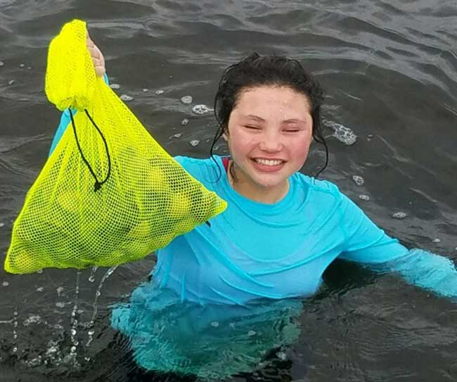
Jim Bohrer had a productive trip with his wife, niece and nephew to Steinhatchee at the end of June for both scallops and redfish. There are very large grassy flats that contain these tasty treats.
Top Left: Rose Rooney with a bag of scallops.
Bottom Left: Hilarie Bohrer brings up a bag of fresh scallops.
Below: Rose shows off a cooler full of the treats. Jim Bohrer had a mess of scallops to clean. Jim stayed in the boat as a safety spotter while deploying a red and white dive flag.
Jim reports that scallop season opened two weeks earlier than normal this year (on June 16th) to allow the area some economic relief from the devastating hurricane last year. Hilarie and the kids enjoyed it so much that they didn’t want to leave. They are planning to go back next year for both the scallops and the fishing.
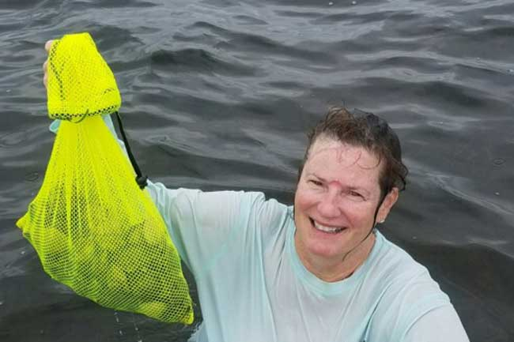
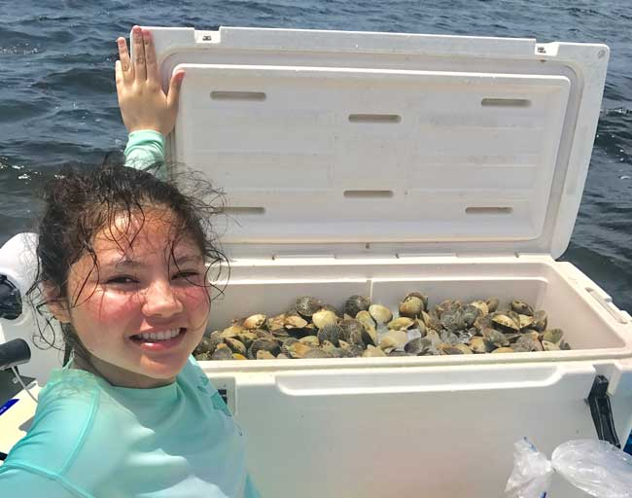
The Sea Hag Marina in Steinhatchee offers appropriate small boats to rent or you can hire a guide for a half day of fishing and a half day of scallop hunting. This area has some tricky areas, so a newcomer may want a guide for some help and navigational advice. Although it is primarily a soft marsh shore, there are rocks as big as a car in some areas.

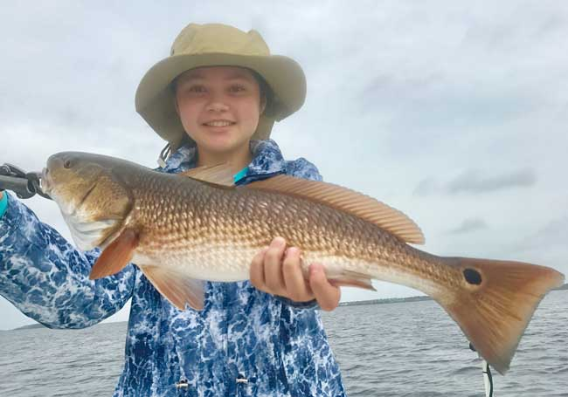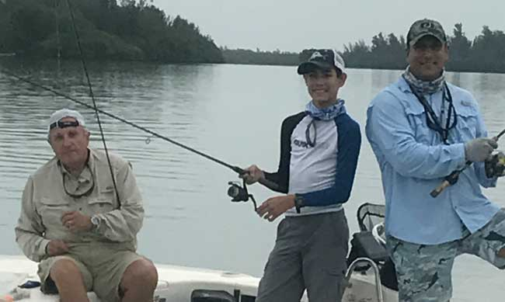
Three generations of the Giachino Family, all out for a nice day. The family that fishes together has a fine relationship. Grandfather Juan Sr., grandson Michael and son Juan Jr.
On the same Steinhatchee Trip, Rose Rooney caught this fine redfish.

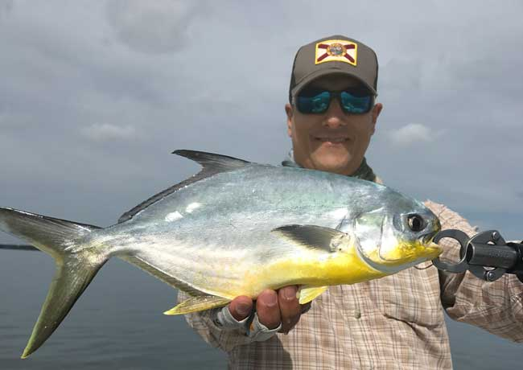
Juan Giachino Jr with a very nice Summer Time Pompano. It is rare to find this size in July, but Juan did it. A beautiful example of a fine tasting fish.

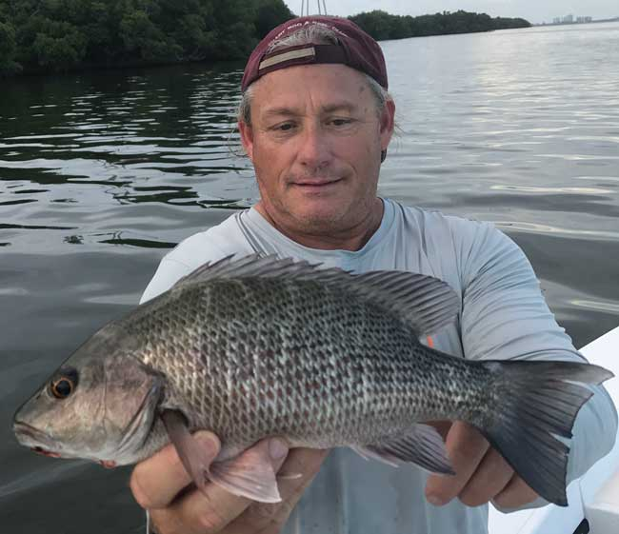
Jay Honan with a chunky mangrove (gray) snapper caught north of the power lines. Smaller fish are common in this area, but this is a big one for our inside waters.

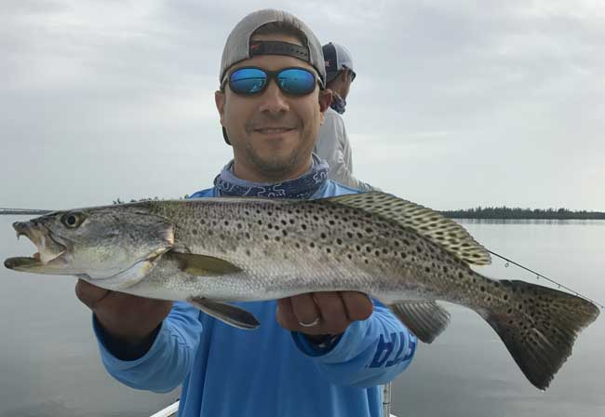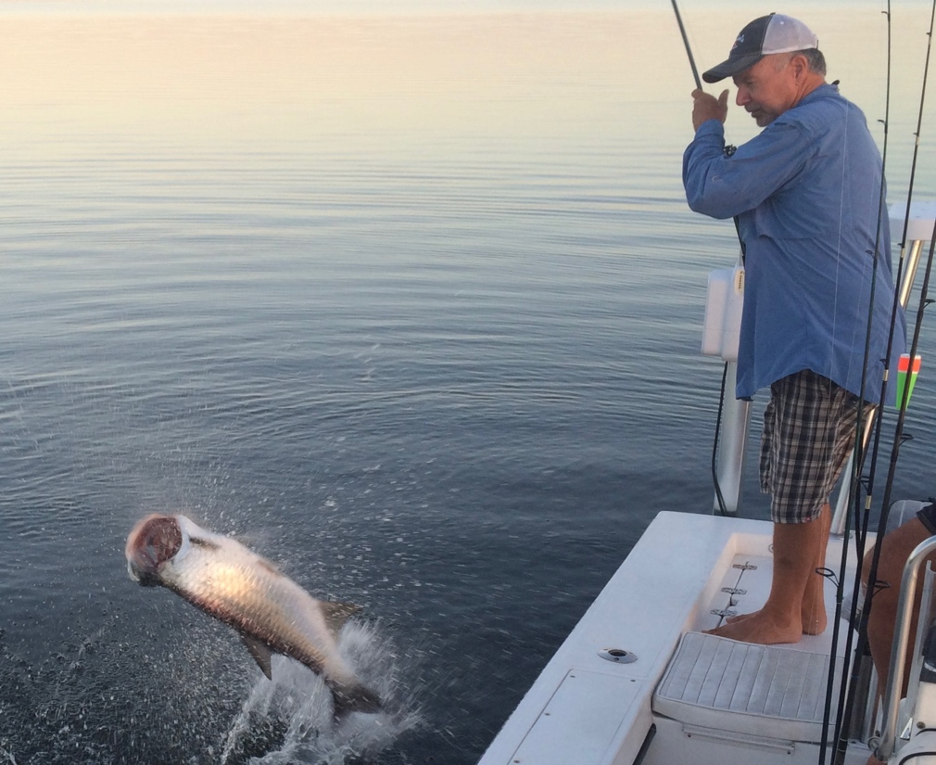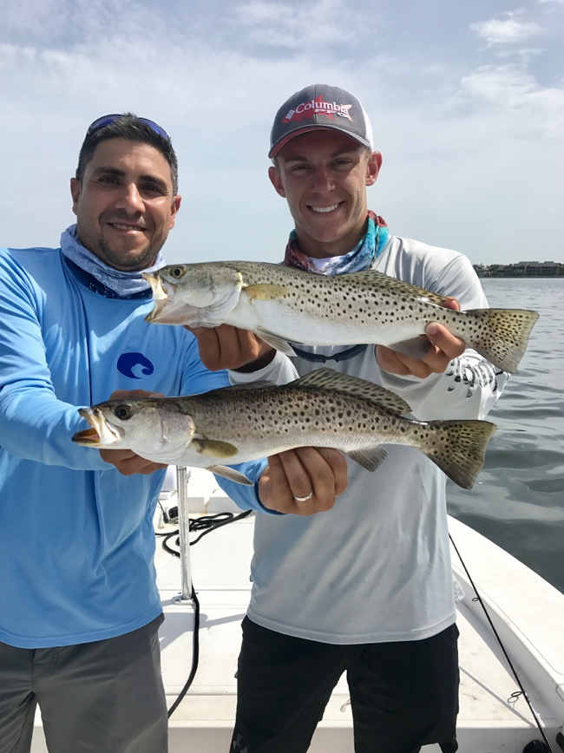
Welcome New Members:
Justin and Amanda Steckley
Randy and Linda Siciliano
Dan and Lisa Doherty
Edward and Elizabeth Ginocchio
Michael Weissing
Todd Weissing
Their names will be added to our roster so you can fish with them. Please welcome them when you see them.

Nando Giachino with a beautiful summer time trout caught in the Round Island area of the Indian River Lagoon.
Here’s the hard part: Getting the tarpon at the boat. This fish gives a spectacular last-minute jump with little time to react. Usually, you want to bow to the Silver King, but Philip Quick gets the job done here by eliminating slack and keeping tension. Photo by Brian Burrage.
Nando Giachino and his nephew Drew (visiting from Texas) with a nice doubleheader of seatrout.

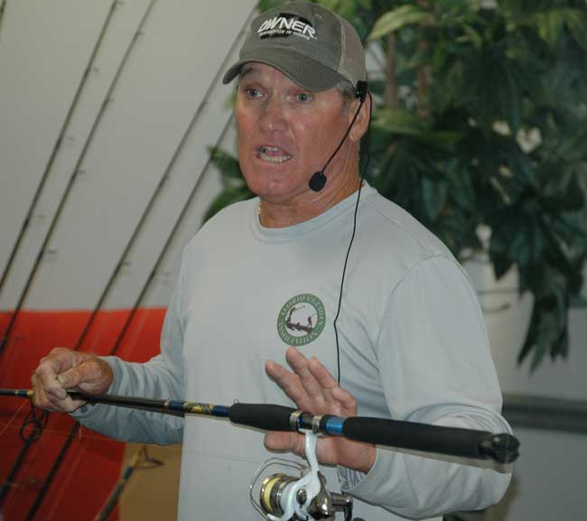

GUEST SPEAKER CAPTAIN DANNY BARROW-July 2017 General Membership Meeting

Captain Barrow shared a lifetime of fishing experience with our members at the July meeting. Danny has been fishing is south Florida his entire life. He is a premier Captain, specializing in snook fishing. His normal area of operations includes Palm Beach County, especially off of Palm Beach Island, Boynton Beach and Ocean Ridge. But, he also has a wealth of experience in the Stuart area.

Capt. Barrow discussed his choice of custom rods and Shimano tackle with Owner hooks. He likes to use live bait with new or less experienced clients and then goes to lures if the angler so chooses. He has a specific rigging technique with live bait, using a cone shaped popping “cork” float appropriate to the bait size. He adapts the size of the Owner circle hook to the bait and float. He can fish mullet up to 12 inches long or greenies and sardines that are much smaller, all by varying the hook, leader and float sizes. He allows the float to ride free on the leader, using a red bead along the line to stop against the leader knot. This gives the bait, leader and float the most aerodynamic casting action for long and accurate casts.

In inlet fishing, he likes black or gray jig heads while in spillway areas, he prefers blaze orange heads both with DOA or similar bodies. He has a specific technique to suspend the lure into a current for a natural presentation. If a fish is hungry, he can get it to eat.

Danny is on the Shimano fishing program, so he endorses this brand of reel. He sizes the rod and reel combination for the area and line required like most fishermen. However, his experience tells him to use moderate sized 2500-3500 series reels with appropriate braided line and fluorocarbon leaders.

The speakers that we feature are one of the primary benefits of membership in the Stuart Rod and Reel Club. The featured captains fish more in a week that many members fish in a year. Please join us for these meetings. The July meeting was very well attended and it is nice to see members and guests come out in the summer. There is always something new to learn at our membership meetings.

to
GUEST SPEAKER FOR AUGUST
Our speaker for the August General Membership Meeting will be Terry Gibson. Mr. Gibson has been very active in the local “clean waters” movement. Terry lives in Jensen Beach and has been fishing in the southeast since the 1970’s. He has served as an editor for Saltwater Fly Fishing Magazine and Florida Sportsman among others. He is a recreational fishing consultant for the Pew Charitable Trust’s Environmental Group. Please join us on August 10th for his presentation.
2017 Annual Dues
Fully paid memberships begin the first day of January, and end on the thirty first day of December of each calendar year. An individual membership is one adult 18 years of age or older. Family memberships consist of the member, their spouse or significant other and their children under the age of 18.

Individual membership for a HALF YEAR (June 1 through December) is $45

Family membership for a HALF YEAR is $55
(June 1 thru December)

Send your checks payable to:
Stuart Rod and Reel Club, Inc.
c/o Pete Noll, Treasurer
1888 S. W. Mooring Dr.
Palm City, FL 34990
Membership entitles a single person (or family as applicable) to participate in all outings and to enjoy a meal at every local outing. Members also receive an included meal (with soft drinks) at Shrimper’s and Manatee Island Grill on the appropriate dates. We hold monthly meetings with interesting speakers and share information on where and when to fish in our area.

2017 SRRC Fish
of the Month Contests
The Fish of the Month Contest will run from the day after the monthly membership meeting and end at 12 Noon the day of the following meeting. All fish need to be legal size except for Snook that must be 24-inch minimum. Natural bait (live or dead), artificial lures and flies are allowed. The member catching the most fish will be the monthly winner. The monthly winner will receive a monogrammed club hat.
Date | Species
Jan 13 thru  Feb 09 | Snapper, Bluefish
Feb. 10 thru Mar. 09 | Most Pompano
Mar. 10 thru April 13 | Most Snook
April 14 thru May 21 | Largest Trout
May 12 thru June 18 | Most Snook
June 19 thru July 13 | Most Redfish
July 14 thru Aug 10 | Most Trout
Aug. 11 thru Sept 14 | Most Tarpon Caught and Released
Sept. 15 thru Oct 12 | Largest Snapper
Oct. 13 thru Nov 9 | Largest Redfish
Nov 10 thru Dec 13 | Most Black Drum

The Winner of the Year Overall will be the person catching the most total species during the calendar year. The overall prize is a $50 gift certificate to White’s Tackle in Stuart.

