Who We Are
The C.E. and S. Foundation, Inc., located in Louisville, KY, was formed in 1984 as a private, non-operating family foundation. The history of the Foundation is rooted in the interest in supporting projects and initiatives that improve identifiable people’s lives. In 2021, the Foundation continued with grantmaking strategies to identify, fund, and nurture projects and organizations in the fields of Education, the Urban Environment, Global Competency, and Disaster/Humanitarian Relief. The Foundation is also dedicated to fostering philanthropic spirit and organization effectiveness through service to the field. The Foundation has assets in the range of $70 million and since inception, it has distributed more than $100 million in grants.
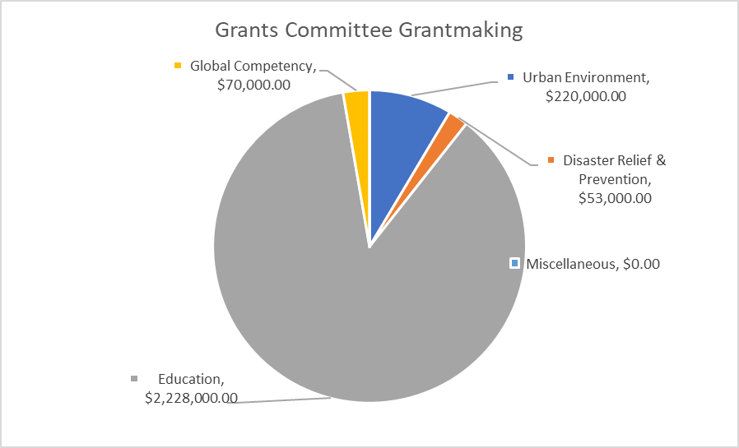
2021 Grantmaking Areas
In 2021, the C.E. and S. Foundation’s Grants Committee approved 28 grants totaling approximately $2.57MM to non-profit organizations. Just as in the previous year, all but one of the grants were made to organizations in the Louisville area and were in alignment with the Foundation’s primary areas of focus.

While the Foundation distributed grants to a variety of organizations, the majority of the grants approved by the Grants Committee supported the Foundation’s strategic goal of catalyzing measurable improvements in educational outcomes within the cradle-to-career ecosystem. Over the course of 2021, the Foundation’s seventh year of implementing its education strategy, the Grants Committee approved nearly $2.2MM (87 percent of its distribution) for education-related investments.

Examples of funding granted in 2021:

Education
Evolve502 – Scholarship Fund - $1,000,000
Lincoln Foundation – College Transitional Enrichment Program - $100,000
National Center for Families Learning – Say and Play with Words Expansion - $50,000

Disaster/Humanitarian Relief
La Casita Center – Investment in Safe Reopening - $38,000
WaterStep – Haiti Earthquake Relief - $15,000

Urban Environment
Louisville Public Media – 89.3 WFPL Newsroom Expansion - $100,000
New Directions Housing Corporation – Family Self-Sufficiency Program - $45,000

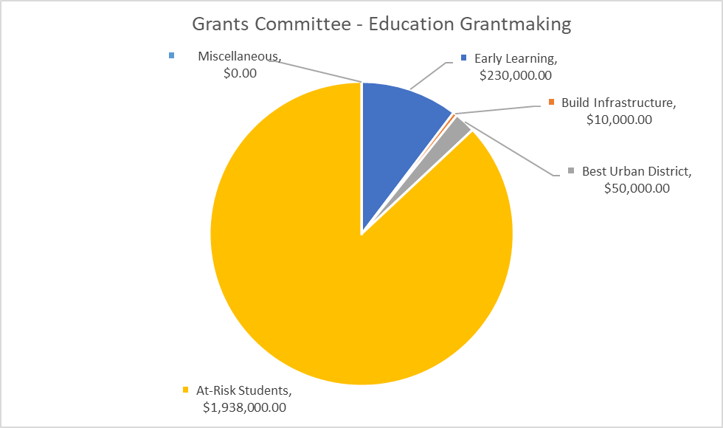
2021 Education Grantmaking
Seven years ago, the C.E. and S. Foundation defined an education grantmaking strategy with four focus areas:
- Build infrastructure to galvanize stakeholders, spur action, and measure progress.
- Prepare students for success from the start.
- Create conditions for schools to be effective and for JCPS to be the best urban district.
- Support at-risk students to college/career readiness and completion.

In 2021, the Grants Committee approved 22 grants in support of the Foundation’s education grantmaking strategy, totaling $2,228,000. Of these, 17 were newly originated grants and five were payments on multi-year grants. In the seven years since launching the education strategy, the Foundation has approved 157 education grants totaling approximately $14.5MM.

Examples of education funding granted in 2021:
The following grants are aligned with each of the Foundation’s education grantmaking strategy focus areas.
Build Infrastructure
Kentucky Youth Advocates – ACEs Campaign - $10,000
Best Urban District
Teach Kentucky – Recruitment and Retention of Teachers - $50,000

Early Learning
Play Cousins Collective – Centering the Black Child - $50,000
Community Coordinated Child Care (4-C) – Developing Sustainability - $80,000
At-Risk Students
YMCA of Greater Louisville – Black Achievers - $100,000
Sowing Seeds with Faith – Summer Enrichment Program - $25,000

Within the focus area supporting at-risk students to college/career readiness and completion, many of the grants were to intended address pandemic-relatedchallenges faced by students by funding additional support through the community’s out-of-school time providers. Also notable as a grant in this focus area is the Foundation’s second payment of $1MM toward a $5MM commitment to the Evolve502 Scholarship Fund.

