SECOND SUNDAY OF LENT
MARCH 16 & 17, 2019
STAND FIRM IN THE LORD

It is not hard to imagine, in this age of wars, evil groups bent on the destruction of humanity, and political follies, that the words of Saint Paul were no accurate, even for his time. It seems that the world never changes. Paul says, “Many…conduct themselves as enemies of the Cross of Christ. Their end is their destruction… Their minds are occupied with earthly things” (Philippians 3: 18, 19). The result is the destruction of innocent people of the Earth itself. But Paul says to the Philippians, “our citizenship is in heaven, and from it we also await a Savior, the Lord Jesus Christ” (3: 20). He will “change our lowly body to conform with his glorified body” (3: 21). Note that he says “body” rather than “bodies.” He is talking about the whole community of believers, who, following the example of Jesus and Paul, will come into the glory of God. So “stand firm in the Lord” (4: 1).

INVISIBLE GOD
By Dennis Tavares
In 63 BC, the Roman General Pompey captured Jerusalem. He had heard of the famous Jewish God, Yahweh, who had inspired fierce loyalty over centuries from the Jewish people. So he went straight-away to the temple to see for himself what Yahweh looked like. Pulling back the curtain before the Holy of Holies, he expected to see a gold statue, or a flame, or a picture. But there was nothing; and he began to laugh loudly. Being educated only in material things, he thought that the Jews had no God; they were fooling everyone around them. Today, it is not much different as many worship visible Gods. But the real true God is not visible except through the prism of human believers who reflect Him in their actions. The God of Abraham and his Catholic descendants have always been in the hearts and souls of believers.
THE CLOUDS OF GLORY

Loving Father, when our eyes are dim,
may our ears be open and our hearts be ready,
so that we may know your Son.

When my father was teaching me how to drive, he said I should never put the high beams in a heavy fog. “The fog will just reflect the light right back to you,” he said. “Be patient, and keep your eyes on the center line.”
“God is light,” says Saint John, but it isn’t just darkness that blinds our eyes. The overwhelming Glory of God does so too: He is dark from His very brightness. So when Peter, James, and John are with Jesus on the mountain, and He is transfigured before their eyes, a cloud came and cast a shadow over them, and they became frightened when they entered the cloud. That will happen to us sometimes, and not just when we feel that God has drawn away from us. We cannot bear too much of the weight of Glory. In those times it will not do to force things, to turn up the little lights of our intellect, and then see less than ever.
Keep your eyes on the center line, and remember that Jesus is with you. It is better to be shadowed by that cloud of Glory than to be lit up by all the bright lights of the world.

Today’s suggested penance:
Listen to someone you would otherwise
pass by.

A HEARTFELT MESSAGE

A big part of our yearly Lenten almsgiving penitential observance and discipline is that of individually and communally contributing to our Diocesan Annual Ministry Appeal (AMA). This year our Parish has been tasked with providing assistance to the various spiritual, developmental and charitable programs/projects of Bishop Vasa and his team. Our 2019 goal is $15,931.00 100% in excess of the total amount will be given back of us. If we have a shortfall under 90% of goal, we will be billed for the AMA collection shortage. I, therefore, plead with you to help our Parish raise 100% of our AMA goal.
May God bless you, your families and loved ones for your generous support and participation in this worthy cause.
Father Andre
WE WILL HAVE STATIONS OF THE CROSS
EVERY FRIDAY, DURING LENT AT 5:30PM IN THE CHURCH.

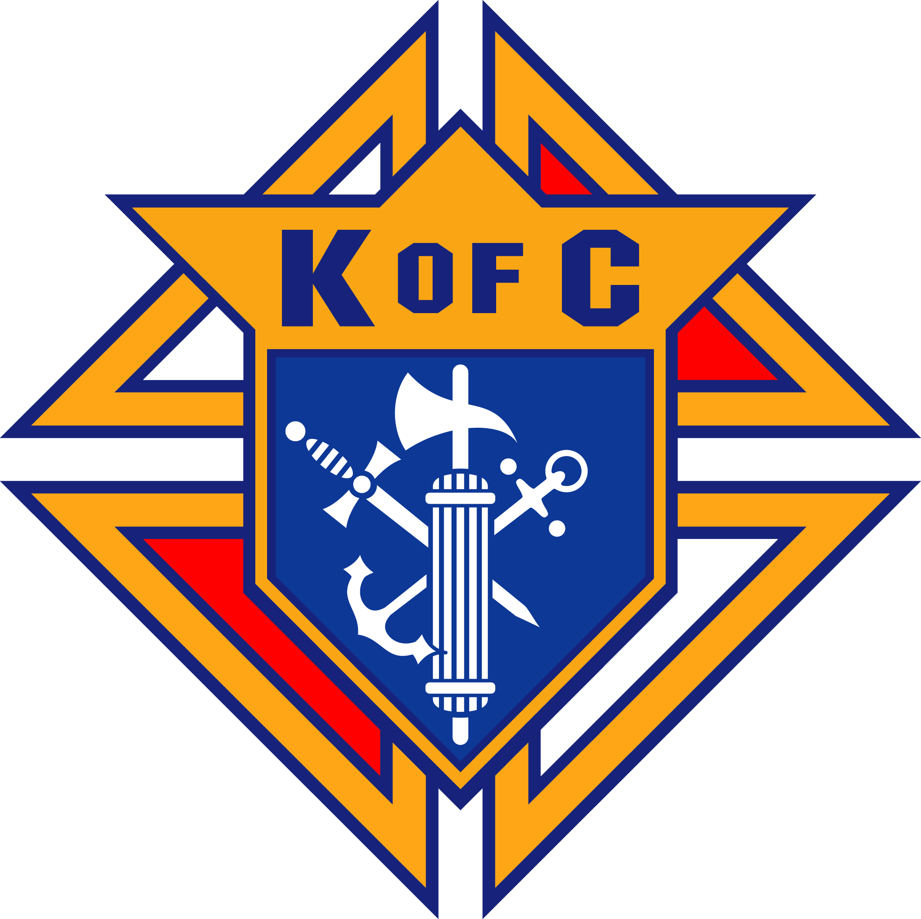
THE KNIGHTS OF COLUMBUS, COUNCIL 4025
WILL BE CONDUCTING A MERCHANDISE RAFFLE.
THERE ARE FIVE WONDERFUL PRIZES:
FIRE HD 10” TABLET
4 FEET BENCH WITH BACK
½ CORD OF OAK FIREWOOD
½ CORD OF MADRONE FIREWOOD
$75 GIFT CERTIFICATE TO OVERTIME BREWERY

PROCEEDS FROM THE RAFFLE ARE TO BE USED TO SUPPORT OUR ONGOING EDUCATIONAL GRANT PROGRAM AND MANY COMMUNITY ACTIVITIES.
TICKETS ARE $10 EACH
AND WILL BE AVAILABLE AFTER MASSES.
DRAWING WILL BE HELD ON APRIL 7TH.
ALL FORT BRAGG HIGH SCHOOL CLASS OF 2019 GRADUATING SENIORS.
Knights of Columbus Educational Grant application forms are available in the Parish Office.
Application’s deadline is: April 5th, 2019.
For additional information, please call 964-0229
or stop by the office
Monday – Friday from 10am -2pm.

WE MAKE A LIVING BY WHAT WE GET, BUT
WE MAKE A LIFE BY WHAT WE GIVE.
Do you have the desire to adorn God’s altar or help in the Sacristy with various chores? God, and the rest of us, will appreciate you for it.
For more information, please call the office at 964-0229.

PLEASE PRAY FOR OUR SICK PARISHIONERS
Richard Braga, Lisa Wright, Ricardo Contreras, Florencia Chávez, Refugio Yáñez, Tarcicio García, Sofía García, María de Jesús Mendoza, Antonio Cazares, Ana García, Ryan Moore, Jane Vartanian, Eileen Seeman, Marianne Brannan, Lilia Parrish, Nancy Smith, Julián Palomar, Luisa Martínez, Jennifer Vera, John Braet, Kim Koskinen, Margaret Valencia, Matthew Marcoulier, Dennis Tavares, Jose Freitas, Alfredo Sousa, Juana Arreguín, Aron Yasskin, Victoria Walzer, Fidela Yáñez Jara, Erika Ramos, Bill Gibson, Carla Tomas, Erasmo Yáñez, Memo Soria, Patricia Vargas, Fidela Yáñez, Elvia Flores, Yonel Ruíz, Angie Freitas, Russel Bryant, Derrick Heater, Luis Angel, Juan Barrera-Terán, Gabriel Hurtado, Gerald Butler, Helen Reynolds, Toni Clark, Ann Gallagher, Brianna Lopez, Margaret Milliken, Gina Pivirotto, Nick Quin, Mary Servis, Denis Sousa, Victor Venegas, Matty Walker, Charles Lorenz, Rebecca Lorenz, Ofelia Ibarra, Leonardo Naal, Gina Leal.

UNITED CHRISTIAN WOMEN’S POTLUCK SALAD LUNCHEON

DATE & TIME:
THURSDAY, MARCH 28, 2019 @ 12 NOON.

PLACE:
FIRST BAPTIST CHURCH
E. PINE & FRANKLIN STREETS, FORT BRAGG, CA

PLEASE BRING A SALAD AND FRIENDS TO SHARE IN THE DAY. THE BAPTISM WOMEN WILL PROVIDE DRINKS AND DESSERTS FOR THIS AFTERNOON OF SHARED CHRISTIAN FELLOWSHIP.
PLEASE CALL KAREN LYNN AT 961-0376 WITH YOUR RESERVATION COUNT.

THE THEME IS “ONCE UPON AN APRON”
PLEASE BRING OR WEAR YOUR APRON.
WE ARE HAVING CATEGORIES FOR THE OLDEST, APRONS WITH ATTITUDE, FRIENDLY APRONS, CUTE APRONS, SEXY APRONS???, LEGACY OF AN APRON, STARCHED APRONS, AND APRONS WITH STORIES FROM THE PAST OR PRESENT.
WE HAVE PRIZES FOR THE WINNER OF DIFFERENT CATEGORIES.

WEEKLY COLLECTION
MARCH 9 & 10, 2019….$2,400.00
MAINTENANCE FUND….$1,663.00

THIS WEEKEND’S SECOND COLLECTION:
CATHOLIC RELIEF SERVICES & CCHD
NEXT WEEKEND’S SECOND COLLECTION:
YOUTH MINISTRY AND RETREATS

THANK YOU
FOR YOUR SUPPORT & CHRISTIAN GENEROSITY

MASS INTENTIONS
MARCH 20 - 24, 2019
Wednesday (20)  Thursday (21)  Friday (22)  Saturday (23)  Sunday (24) | 12:05pm  12:05pm  12:05pm  5:00pm  6:30pm  8:00am  10:00am | Basilio Tan †  Héctor Magaña †  José Miranda Alvarez †  Prachak Sripramong  (b-day)  Fred & Clara White †  Joaquín Sánchez Rodarte †  Galo Sánchez Avila †  Josefa Rodarte †  José Manuel Salazar †  Josefat Padilla †  Ray Lotten †  James Braga Melo †  Maria Alda Melo †  José, Ubaldo & Rogelia Muñoz †

PRAY FOR OUR FAMILY AND FRIENDS THAT ARE IN THE MILITARY SERVICE
José Araiza Jr., Edgar Toscano, Marina González, Alondra Jara, Sonia Jara, Jason Lorenz, Matt Mill & Jared Schroeder

“MARK YOUR CALENDAR”
FIRST COMMUNION MASS
WILL BE MAY 11TH AT 12:00PM
CONFIRMATION MASS
WILL BE MAY 12TH AT 10:00AM

OLGC’S MEMORIAL TREE
In the vestibule of the Church, on the southern wall, is a beautiful Memorial Tree.
Its bright leaves represent permanent memorials to the departed of our Parish.
For the sum of $200.00, you can give to the Parish Secretary, the correct spelling and dates of the departed and in due time the leaf is printed and attached to the tree: a permanent reminder of a loved one who is gone.
For more information, call the Parish Office at
964-0229.

