Pictures for the Henry Clay Niles Article

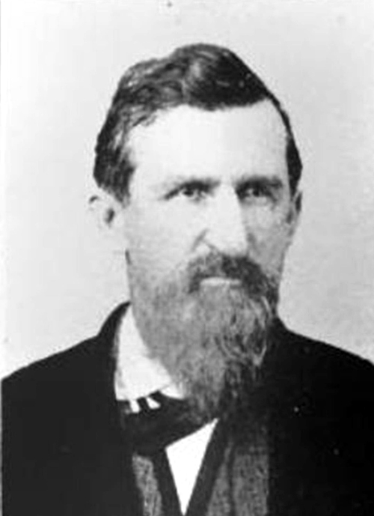

Photograph can be located at

Gresham, John, *Historical and Biographical Record of Douglas County, IL* Logansport, IN: Wilson, Humphreys and Company, 1900, p. 174-175.

And also at

Brewer, Linda, Senior Editor, “Tuscola’s Best Historian,” *Tuscola: Strolling Through the Past 1857-2007: A Pictorial History*, Sponsored by City of Tuscola: Ann Arbor, MI: Malloy, Incorporated, 2007, p. 2.

<http://tuscola.org/content/tuscola-history-book/>

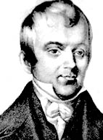

Kovarik, Bill. *Encyclopedia of American Journalism History*, New York: Routledge, 2006. <http://www.environmentalhistory.org/billkovarik/about-bk/research/editor-who-tried-to-stop-civil-war/niles-weekly-register-1811-1849/>

Painting of Hezekiah Niles.

Ancestry.com. U.S., Indexed County Land Ownership Maps, 1860-1918 [database on-line]. Provo, UT, USA: Ancestry.com Operations, Inc., 2010.

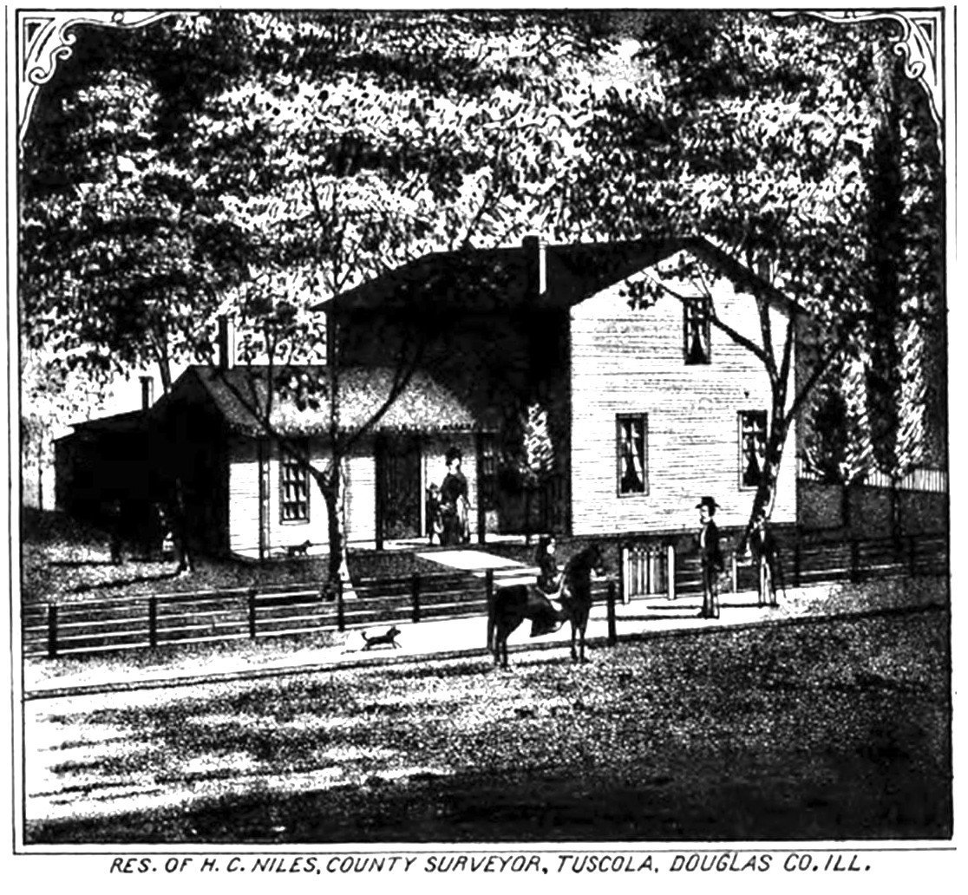<http://interactive.ancestry.com/1127/31617_072107-00405/534615?backurl=http%3a%2f%2fsearch.ancestry.com%2f%2fcgi-bin%2fsse.dll%3fnew%3d1%26gsfn%3dH.%2bC.%26gsln%3dNiles%26rank%3d1%26gss%3dangs-g%26mswpn__ftp%3dDouglas%2bCounty%252c%2bIllinois%252c%2bUSA%26msbdy%3d1830%26pcat%3dROOT_CATEGORY%26h%3d534615%26recoff%3d6%2b7%2b8%26db%3dLandownershipAtlas%26indiv%3d1%26ml_rpos%3d19&ssrc=&backlabel=ReturnRecord>

“The ‘Cottage Hotel’, which was on South Central Avenue and Parke Street was a popular place for transients beginning in 1867. It was operated by Mrs. Henry Niles who home-cooked Sunday dinnrs to many Tuscola people who knew her skill in cooking. The ‘Cottage Hotel’ was built when the business section of the town fronted on the railroad park, and the hotel was included in the ‘Square’ of that day. But time brought the inevitable changes, and with them, the switching of the business block around the corner to Sale Street, leaving the hotel in a somewhat quiet, secluded corner.”

“Lida Jane Hunt papers, July 20, 1917,” Brewer, Linda, Senior Editor, *Tuscola: Strolling Through the Past 1857-2007: A Pictorial History,* Sponsored by the City of Tuscola, Ann Arbor, MI: Malloy, Incorporated, p. 31. <http://tuscola.org/content/tuscola-history-book/>

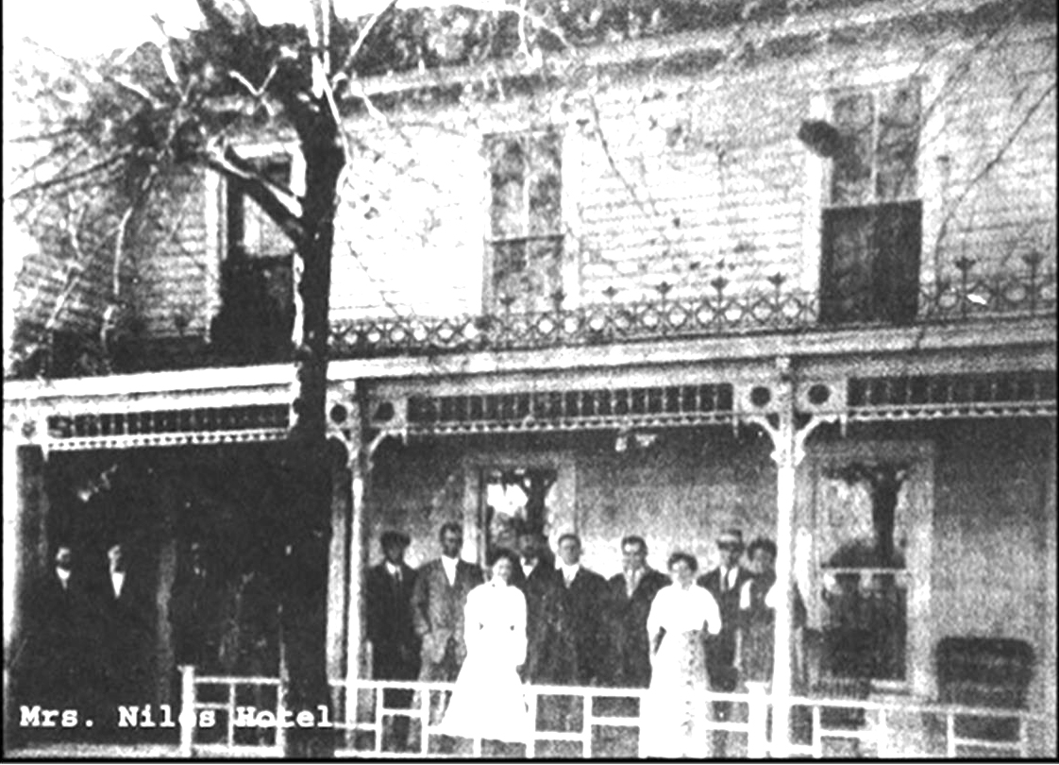

Mrs. Rebecca Niles is the woman on the right. Mrs. Sadie Niles, her daughter-in-law is on the left. Sadie continued with the hotel after Rebecca died in 1922.

Tombstone of Henry Clay Niles

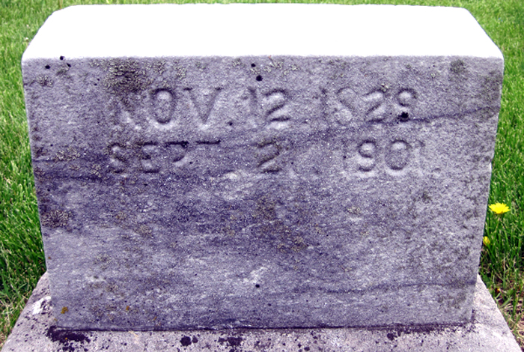

Photograph by William Harshbarger, Tuscola Township Cemetery,

May 5, 2015.

“City of Tuscola, Douglas County, Illinois, W. R. Brink & Co, 1875.

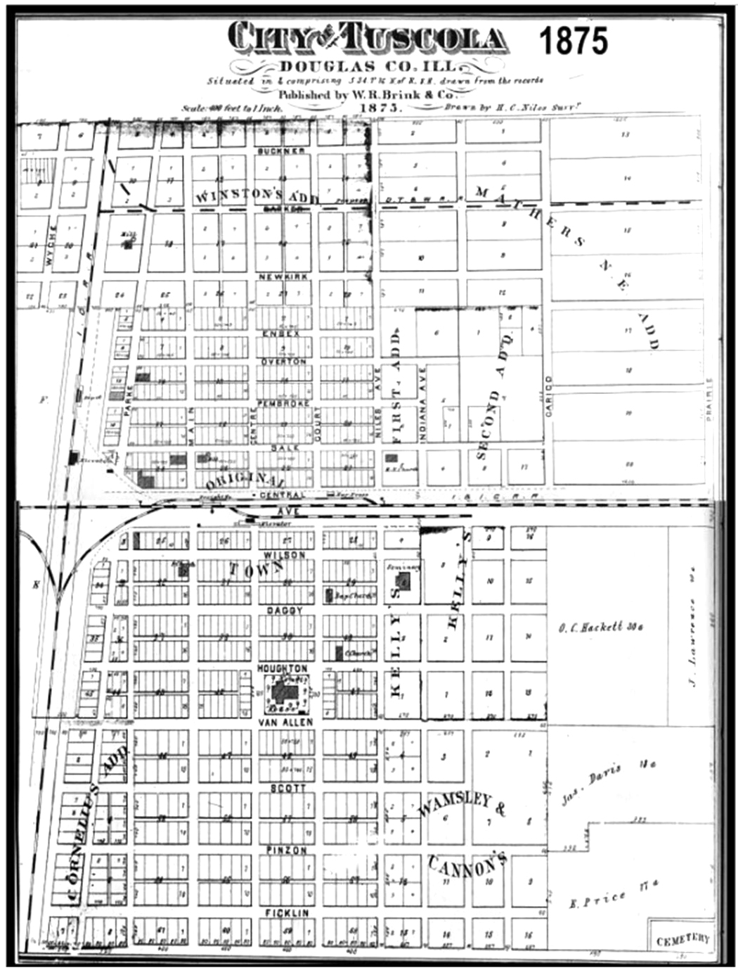

“Review of Tuscola’s Past,” *The Tuscola Journal,* [Sesquicentennial Edition June 26, 2007](http://thetuscolareview.com/category/sesquicentennial-edition-june-26-2007/)

<http://thetuscolareview.com/wp-content/uploads/2013/03/courthouse.gif>

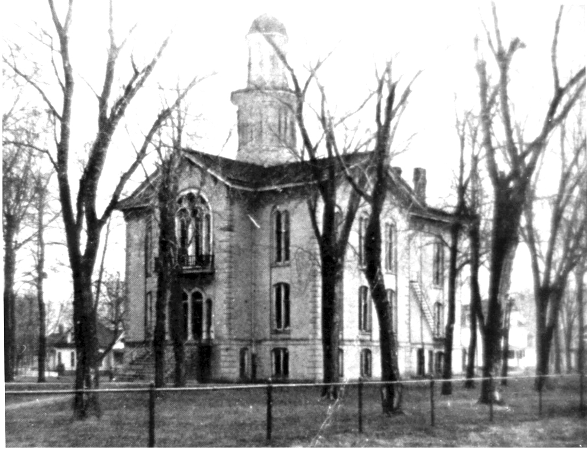

Old Douglas County Court House.