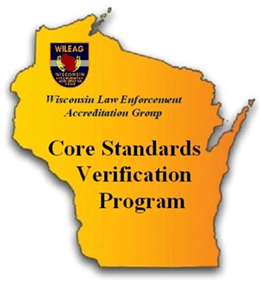
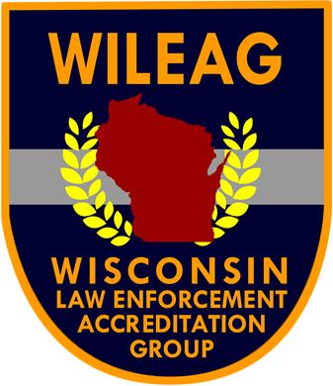
Core Standards Verification Program
2020 Fee Schedule

Item | Cost | Notes
Start Up - Application Fee | $100  one-time fee | The initial application fee covers staff time for processing, program installation and guidance.
Annual Membership | $350  Annually  Includes WIPAC membership | Annual membership is invoiced in December; payment is due in January.  Member benefits include FREE attendance at all CVMIC - WILEAG Sponsored training courses, FREE access to CVMIC legally reviewed model policies and access to the CVMIC newsletter.
File Assessment  (re-verification is required every 3-years) | -0- | In an attempt to maintain minimal program costs, Core Standard Verification agencies are required to provide an assessor to conduct at minimum one Core assessment in a 3-year period. Assessors are required to attend WILEAG assessor training.

