
Copyright © 2010 Integreat! Thematic Units
www.thematicteacher.com
Copyright © 2010 Integreat! Thematic Units
www.thematicteacher.com

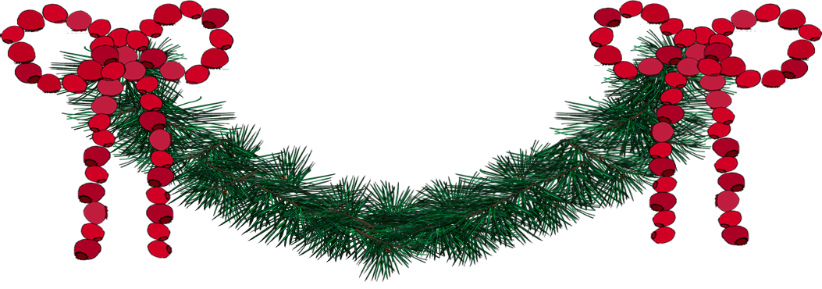
Joy to the woods,
To everything that’s good!
Joy to the chipmunk,
to the deer, and bear.
Joy everywhere!

Christmas 2010

Dear Student,

Have a wonderful vacation. I hope you will have lots of time to enjoy the beauty of the season. You are a hard worker and a good friend to other people. I’m so glad I get to work with you. See you next year!

Love,
Your Teacher

Joy to the woods,
To everything that’s good!
Joy to the chipmunk,
to the deer, and bear.
Joy everywhere!

Christmas 2010

Dear Student,

Thank you so much for all that you have done for our class. You are so helpful—I don’t know what I’d do without you. I especially appreciate the way you invite people who are “left out” to join you. Thank you so much. See you next year!

Love,
Your Teacher

Use these note cards to send a holiday message to the children in your class, to invite parents to special events, or send them out as thank you notes. They can also be package tags for your Christmas gifts. Each card will fit in Invitation Envelopes which you can purchase at WalMart ($2-$3 for a box of 60 white envelopes: 4 3/8 inches x 5 ¾ inches).
You could even use them as name cards for a holiday workshop—take the logo off the back and type the names of the people attending. When they set their name card up, they’ll see the image and you’ll see the participants’ names!
Run them off on cover stock. Turn them over and run the second side on the back. You might want to run a test paper through first to make sure you are feeding them correctly on the second side.
You can type your own message, or take the message off altogether and write the notes by hand.

