Center Ice Skating Club
Pepperoni Roll Fundraiser

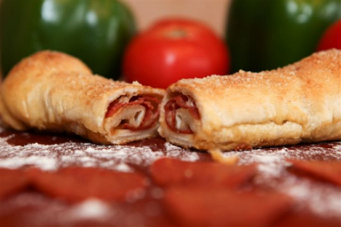
Pepperoni Rolls
$2.00 Each Roll
1 pack of 6 rolls Prepackaged Pack for $12.00 or 2 packs of 12 rolls for $24
Money due when ordering - CISC
$1.00 of each roll goes towards your skater’s fundraising and supports the Center Ice Skating Club.

7 Inches Long
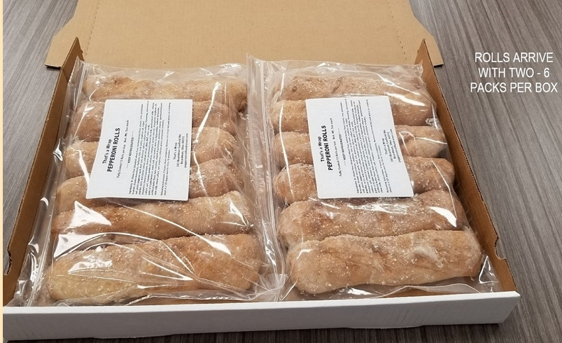
Delivered Fresh
Freezes Well
Contains No Peanut Oil
Reheat in Microwave or Oven

Sale Information
Sale Date Now through 2/4
(Turn in totals and one payment to Center Ice Skating Club, by 2/4)
Pick Up Date February 15, 2021 Location for Pick UP Center Ice Sports Complex (Time TBA)
**Remember Pick Up & Deliver Promptly due to freshness!!
DELICIOUS WAY TO FINISH UP THOSE FUNDRAISING REQUIREMENTS!

