
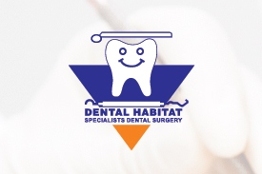 &

Proudly announces

2 Years Extensive Training in Dental Implantology

Salient Features

Part time to fit the busy schedule of the practitioners
Completion Certificates will be issued by U'R Smile England.
Each delegate will place minimum 10 implants each

Graced by the presence of International Speakers and Mentors

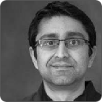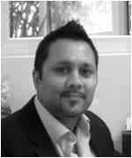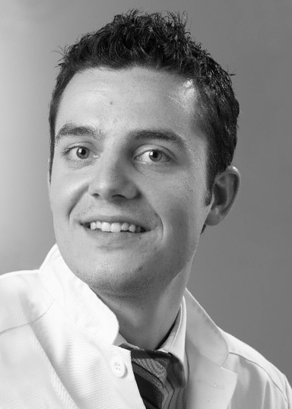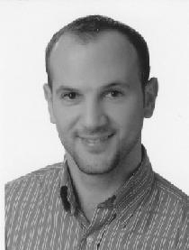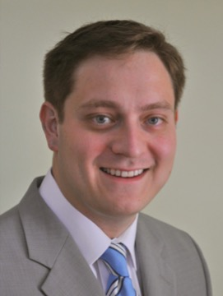
Kashif Hafeez, UK Sumair Khan, UK Colin Neil, UK Fadi Jarab, Jordan Rodrigo Kaiser, Chile
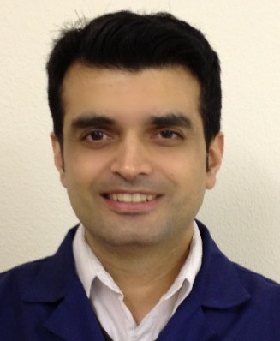

Ubaid R Khattak. UK.

Venue & Contact
Dr Gulraiz Khan
Dental Habitat
3 Babar Block
Garden Town, Lahore
Tel: +924235864467, 04235833414

