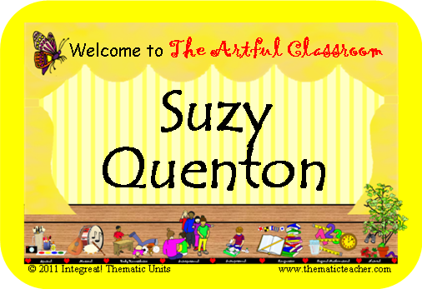
The Artful Classroom, Name Badges

Use these name badges on the first day of school to help you learn everyone’s name. You can also use them on field trips, or other situations where adults may be working with rotating groups of children. Keep a set for substitutes to use. You can change the font size, style, and color, type in your student’s names, and change the background color, if you wish.

Preparation Directions:
- Highlight “Student Name” and type in the names of your students.
- You can change the “Welcome” message, too, if you want. Just select it and retype.
- To change the background color (currently yellow), click on the page to select it, go to Format-Group-Ungroup. Deselect the items on the page, and then click on the yellow background block. Go back to Format and choose a new Fill Color, and then regroup the image (Format-Group-Regroup).
- Print on Name Badge labels. Avery 25395 is inexpensive (80 badges for between $6 and $7, and readily available at many discount stores, but other 8-badge-per-page paper will work. You may also print them on regular paper and place them in plastic pin-on badges, or print them on cover stock or tag, laminate them, and pin them on. You could also attach roving to make a “necklace”. They are easy to reuse in that format.
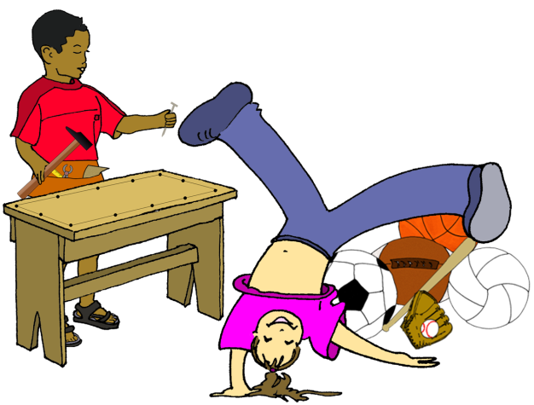
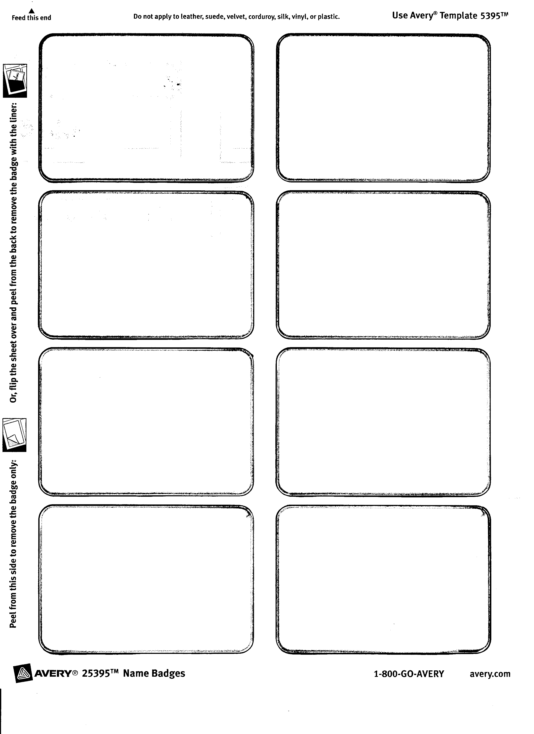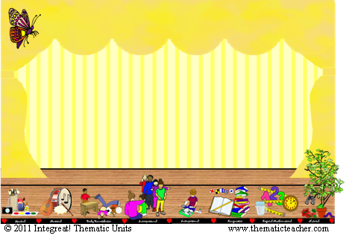
Welcome to The Artful Classroom
Student
Name

Welcome to The Artful Classroom
Student
Name

Welcome to The Artful Classroom
Student
Name

Welcome to The Artful Classroom
Student
Name

Welcome to The Artful Classroom
Student
Name

Welcome to The Artful Classroom
Student
Name

Welcome to The Artful Classroom
Student
Name

Welcome to The Artful Classroom
Student
Name

Welcome to The Artful Classroom
Student
Name

Welcome to The Artful Classroom
Student
Name

Welcome to The Artful Classroom
Student
Name

Welcome to The Artful Classroom
Student
Name

Welcome to The Artful Classroom
Student
Name

Welcome to The Artful Classroom
Student
Name

Welcome to The Artful Classroom
Student
Name

Welcome to The Artful Classroom
Student
Name

Welcome to The Artful Classroom
Student
Name

Welcome to The Artful Classroom
Student
Name

Welcome to The Artful Classroom
Student
Name

Welcome to The Artful Classroom
Student
Name

Welcome to The Artful Classroom
Student
Name

Welcome to The Artful Classroom
Student
Name

Welcome to The Artful Classroom
Student
Name

Welcome to The Artful Classroom
Student
Name

Welcome to The Artful Classroom
Student
Name

Welcome to The Artful Classroom
Student
Name

Welcome to The Artful Classroom
Student
Name

Welcome to The Artful Classroom
Student
Name

Welcome to The Artful Classroom
Student
Name

Welcome to The Artful Classroom
Student
Name

Welcome to The Artful Classroom
Student
Name

Welcome to The Artful Classroom
Student
Name

