THIS IS AN OPTIONAL ENRICHMENT ASSIGNMENT. PRINT AND COMPLETE IN INK.

Name:________________________________________ Class Period:_____
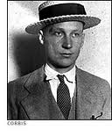
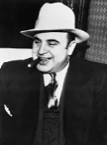
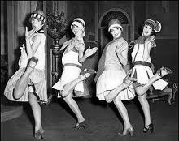
The Modern Era of the
“Roaring Twenties,”

Reading Assignment:
Chapter 23 in AMSCO or other resource covering the 1920s. Mastery of the course and AP exam await all who choose to process the information as they read/receive. This is an optional assignment. So… young Jedi… what is your choice? Do? Or do not? There is no try.

Pictured at left: Al Capone, Louis Armstrong, Flappers, John Scopes, Babe Ruth, public domain photos, WikiCommons)

Directions:
- Pre-Read: Read the prompts/questions within this guide before you read the chapter.
- Skim: Flip through the chapter and note titles and subtitles. Look at images and read captions. Get a feel for the content you are about to read.
- Read/Analyze: Read the chapter. If you have your own copy of AMSCO, Highlight key events and people as you read. Remember, the goal is not to “fish” for a
specific answer(s) to reading guide questions, but to consider questions in order to critically understand what you read!
- Write: Write (do not type) your notes and analysis in the spaces provided. Complete it in INK!

Learning Goals:
Defend or refute the following statement: The American economy and way of life dramatically changed during the 1920s as consumerism became the new American ideal.
Identify and evaluate specific ways the culture of modernism in science, the arts, and entertainment conflicted with religious fundamentalism, nativism, and Prohibition.
To what extent did the 1920s witness economic, social, and political gains for African Americans and women? To what extent did these years “roar?”
To what extent was American foreign policy in the 1920s isolationist?

Key Concepts FOR PERIOD 7:
Key Concept 7.1: Growth expanded opportunity, while economic instability led to new efforts to reform U.S. society and its economic system.
Key Concept 7.2: Innovations in communications and technology contributed to the growth of mass culture, while significant changes occurred in internal and international migration patterns.
Key Concept 7.3: Participation in a series of global conflicts propelled the United States into a position of international power while renewing domestic debates over the nation’s proper role in the world.

Guided Reading: The Modern Era of the 1920s, pp 475- 489
Answer the following questions by reviewing main events, defining terms, and analyzing significance in the spaces provided.
- Republican Control, pp 475-477
Prompt: Analyze the significance of Warren Harding’s landslide victory in the election of 1920 and explain the political and economic changes under his leadership.

Main Events/Ideas | Definitions/Explanations | Analysis
Answer: Harding was the first of three Republican presidents in the 1920s. Republican dominance during the 1920s illustrated American desire to “return to normalcy” following the Great War.  - Old Guard  - Harding’s Cabinet  - William Howard Taft’s appointment to Supreme Court  …continued on next page…  …continued from previous page…  Prompt: Analyze the significance of Warren Harding’s landslide victory in the election of 1920 and explain the political and economic changes under his leadership.  Answer Continued:  Harding was the first of three Republican presidents in the 1920s. Republican dominance during the 1920s illustrated American desire to “return to normalcy” following the Great War.  - Republican Domestic Policy  - Pardoning Eugene Debs  - Teapot Dome  - Esch-Cummins Transportation Act of 1920  - Merchant Marine Act of 1920  - Fordney-McCumber Tariff Act of 1922  - Bureau of the Budget | Old Guard…  Harding’s Cabinet…  Republican Control…  Business Doctrine…  The Presidency of Warren Harding…  A Few Good Choices…  Harding’s Domestic Policy…  1)  2)  3)  Eugene Debs…  Scandals and Death… | Compare the “Return to Normalcy” business doctrine to the “laissez-faire” of the Gilded Age.  Compare the 1920s Republican view on taxes and tariffs to the Progressive views of Teddy, Taft, and Wilson. What is the key to understanding these differences?  Compare the leadership of Warren G. Harding to the leadership of Ulysses S. Grant. What is the significance of this comparison?

Prompt: Analyze the impact Calvin Coolidge and Herbert Hoover’s leadership had on the nation.

Main Events/Ideas | Definitions/Explanations | Analysis
Answer: Calvin Coolidge became President following the death of President Harding. He was then elected in 1924. He continued Old Guard leadership.  - “The business of America is business”  - Election of 1924  - New Progressive Party  & Robert La Follette  - American Legion, 1919 and the Adjusted Compensation Act, 1924  - Agricultural Credits Act of 1923  - McNary-Haugen Bill of 1928  - Boulder Canyon Project Act, 1928  Herbert Hoover was elected in 1928, the final of the three Republican presidents in the “Roaring” decade.  - Alfred E. Smith and the Election of 1928  - “Coolidge Prosperity” | The Presidency of Calvin Coolidge…  Election of 1924 & a new Progressive Party…  Vetoes and inaction…  Hoover, Smith, and the Election of 1928… | Explain the significance of the Progressive Party in the election of 1924, and compare this to the election of 1892 with the Populist Party.  Why did Coolidge veto so many new programs?  Explain the short and long term significance of the McNary-Haugen Bill and the Boulder Canyon Project.  Support or refute the following characterization: the U.S. government during the 1920s was more “progressive” than “laissez-faire.”
- Mixed Economic Development, pp 477-479

Prompt: Explain how the American economy developed and changed during the 1920s.

Main Events/Ideas | Definitions/Explanations | Analysis
Answer: The “Roaring Twenties” was overall an era of economic expansion with standard of living and income increasing as well as low unemployment. However, some parts of the population remained in poverty, and economic woes in agriculture foreshadowed the coming bust in 1929.  New technologies contributed to improved standards of living, greater personal mobility, and better communications systems.  - Business Boom, 1919-1929  -Scientific Management  -Mass Production  -Assembly Line  -oil and gas  -electric motors  -tax cuts  -Federal Reserve policies  -consumerism  -Buying on credit  -advertising  - Agricultural Doom, 1919-1929  -end of WWI  -heavy debt  -new technologies  - surplus  c. Decreased Labor Activity  -Labor strikes, 1919  (Boston Police strike, Seattle general strike, just to name a few)  -open shop  -welfare capitalism  -aggressive resistance  -United Mine Workers; John L. Lewis | Causes of Business Prosperity…  Increased Productivity…  Frederick W. Taylor…  Henry Ford…  Energy Technologies…  Government Policy…  Consumer Economy…  Impact of the Automobile…  Farm Problems…  Labor Problems… | What caused the post WWI recession? (see page 466)  In analyzing economic development in the 1920s, to what extent was the decade “Roaring?” Defend your answer with specific evidence.  Explain why agriculture suffered during the Roaring Twenties.  Explain why 1919 saw so many labor strikes. (see page 467)  Explain how business policies reduced labor union activity. Cite at least four methods in your answer.

- A New Culture, pp 479-483

Prompt: Explain how and why American culture changed in the 1920s.

Main Events/Ideas | Definitions/Explanations | Analysis
Answer: The United States, in the 1920s, became an urban nation with changing morals and beliefs which increasingly conflict with traditional, rural culture.  - Culture of cities  -“bordello on wheels”  -mass consumption  -modern culture  -jazz  -radio  -Hollywood  -heroes  The rise of an urban, industrial society encouraged the development of a variety of cultural expressions for migrant, regional, and African American artists (expressed most notably in the Harlem Renaissance movement); it also contributed to national culture by making shared experiences more possible through art, cinema, and the mass media.  Women earned the right to vote in 1920 with the 19th Amendment, however little changed for women politically or economically. Socially, however, women continued to challenge gender related limitations.  - Adkins v. Children’s Hospital  - Women in the 20s  -19th Amendment  -Homemakers  -Working Women  -influence of Sigmund Freud  -Margaret Sanger  -Flappers  -Increased divorce  c. Secondary education  d. Lost Generation  -disillusionment  -Gertrude Stein  -F. Scott Fitzgerald  -Ernest Hemingway  -T.S. Eliot  -Eugen O’Neill  …continued on next page…  …continued from previous page…  Prompt: Explain how and why American culture changed in the 1920s.  Answer Continued: The rise of an urban, industrial society encouraged the development of a variety of cultural expressions for migrant, regional, and African American artists (expressed most notably in the Harlem Renaissance movement); it also contributed to national culture by making shared experiences more possible through art, cinema, and the mass media.  e. Art and Architecture  -Art Deco  -Edward Hopper  -Rhapsody in Blue  and Porgy and Bess  f. Harlem Renaissance  -Great Migration  -Harlem, New York  -Langston Hughes  and other poets  -Duke Ellington and  Louis Armstrong  -Jazz Age  -Bessie Smith  -Paul Robeson  g. Marcus Garvey, Black  Star Line | A New Culture…  Jazz Age…  Entertainment…  Popular Heroes…  Gender Roles, Family, and Education…  Women at Home…  Women in the Labor Force…  Revolution in Morals…  Divorce…  Education…  The Literature of Alienation…  Art and Architecture…  Harlem Renaissance…  Poets and Musicians…  Marcus Garvey… | In what ways was modern culture in the 1920s similar to modern day culture? Cite at least two specific examples in your answer.  Google Adkins v. Children’s Hospital. Explain the significance of this ruling for feminism.  To what extent did the 19th Amendment improve gender equality? Defend your answer.  Explain why Sigmund Freud had such a profound influence on American culture.  List three causes of post WWI disillusionment.  a.  b.  c.  What is your prior knowledge of the Lost Generation?  Google Frank Lloyd Wright and Georgia O’Keeffe. How can you use these two individuals to illustrate modernism in the 1920s?  How did Harlem entertainment and audiences differ from other cities?  Compare the beliefs of W.E.B. DuBois with Marcus Garvey.  What did Marcus Garvey have in common with the American Colonization Society? (see page 215)

- Values in Conflict, pp 483-486

Prompt: How did changing urban society due to industrialization, urbanization, and modern culture lead to cultural conflicts during the Roaring Twenties?

Main Events/Ideas | Definitions/Explanations | Analysis
Answer: Technological change, modernization, and changing demographics led to increased political and cultural conflict on several fronts:  - tradition versus innovation,  - urban versus rural,  - fundamentalist Christianity versus scientific modernism,  - management versus labor,  - native-born versus new immigrants,  - white versus black,  - idealism versus disillusionment.  …continued on next page… | Values in Conflict…  Religion…  Modernism…  Fundamentalism…  Revivalists on the Radio… | Explain how Darwinism impacted culture conflict.  Google Billy Sunday and Aimee Semple McPherson. How can you use these two individuals to illustrate culture conflict in the 1920s?
…continued from previous page…  Prompt: How did changing urban society due to industrialization, urbanization, and modern culture lead to cultural conflicts during the Roaring Twenties?  Answer Continued: The “noble experiment” illustrated a cultural conflict regarding the morality of alcohol consumption (or alcohol’s impact on morality).  - 18th Amendment and the Volstead Act, 1919  - Speakeasies  - Al Capone & organized crime in the 1920s  - J. Edgar Hoover becomes head of the FBI, 1924  - 1933, 21st Amendment  The global ramifications of World War I and wartime patriotism and xenophobia, combined with social tensions created by increased international migration, resulted in legislation restricting immigration from Asia and from southern and eastern Europe.  As labor strikes and racial strife disrupted society, the immediate postwar period witnessed the first “Red Scare,” which legitimized attacks on radicals and immigrants.  Several acts of Congress established highly restrictive immigration quotas, while national policies continued to permit unrestricted immigration from nations in the Western Hemisphere, especially Mexico, in order to guarantee an inexpensive supply of labor.  - First Red Scare  -Palmer Raids, 1919  b. race riots (see page 467)  c. Nativism  -Emergency Quota Act of 1921  -Immigration Act of 1924  - Ku Klux Klan renewed, 1915  - ACLU  - Sacco & Vanzetti, 1921 | Fundamentalism and the Scopes Trial…  The Trial…  Aftermath…  Prohibition…  Defying the Law  Political Discord and Repeal…  Nativism…  Quota Laws…  Case of Sacco and Vanzetti…  Ku Klux Klan…  Tactics…  Decline… | Compare the viewpoints of William Jennings Bryan and Clarence Darrow as illustrated in the Scopes “Monkey” Trial.  To what extent did Prohibition have a positive impact on the nation from 1919-1933? Defend your viewpoint AND your opposing viewpoint with one piece of evidence.  Explain the causes and effects of the First Red Scare. (see page 467)  How did fear of communism impact nativism?  How did nativism and fear of anarchy impact the Sacco and Vanzetti trial?  The ACLU was founded in 1920 in response to Wilson’s WWI limitations on civil liberties, the Red Scare, racial discrimination, and nativism. What does ACLU stand for?
- Foreign Policy: The Fiction of Isolation, pp 486-488

Prompt: To what extent were the foreign policies of Harding, Coolidge, and Hoover isolationist?

Main Events/Ideas | Definitions/Explanations | Analysis
Answer: In the years following World War I, the United States pursued a unilateral foreign policy that used international investment, peace treaties, and select military intervention to promote a vision of international order, even while maintaining U.S. isolationism, which continued to the late 1930s.  American foreign policy in the 1920’s was largely isolationist; however this characterization is a bit misleading because the U.S. did participate in diplomatic efforts to maintain peace.  - U.S. occupation of Haiti and Nicaragua  - U.S. withdrawal from Dominican Republic  - Increased economic investments in Latin America  - Oil drilling rights in the Middle East  - League of Nations  - Washington Naval Conference, 1922-3  -Four Power Treaty,  -Five-power Naval Treaty,  -Nine Power Treaty  - Tariffs and retaliatory tariffs (Fordney-McCumber)  - The Dawes Plan, 1924  - Economic negotiations in Mexico, 1927  - Geneva Conference, 1927  - Kellogg-Briand Pact, 1928  - Clark Memorandum, 1930 | Foreign Policy: The Fiction of Isolation…  Disarmament and Peace…  Washington Naval Conference, 1921…  - Five-Power Treaty…  - Four-Power Treaty…  - Nine-Power Treaty…  Kellogg-Briand Pact…  Business and Diplomacy…  Latin America…  Clark Memorandum (Google it)…  Middle East…  Tariffs…  War Debts and Reparations…  Dawes Plan…  Legacy… | To what extent were the foreign policies of Harding, Coolidge, and Hoover similar to Gilded Age foreign policy?  What role did the League of Nations play in the Washington Naval Conference?  To what extent was the United States politically isolated from world events during the 1920s? Defend your answer with at least two specific pieces of evidence.  Compare the Underwood Tariff (see page 422) to the Fordney-McCumber Tariff of 1922. Is it fair to say the later undermined the progressivism of the first?  Explain the significance of the United States as a creditor nation in regards to foreign policy during the 1920s.  Explain the difference between the Roosevelt Corollary (see page 418) and the Clark Memorandum. Which one was a more “progressive” policy?
- Historical Perspectives: How Conservative Were the 1920s? page 489
Prompt: Compare and contrast historical viewpoints of the Roaring Twenties.
The 1920s was a conservative era dominated by narrow-minded, materialistic abandonment of Progressivism… | The 1920s were a continuation of the Progressive Era… | Traditionalists of the 1920s were trying to preserve federalism…
Only Yesterday, 1931…  Arthur Schlesinger Jr…  Modern day return to this view… | Revisionists…  The Perils of Prosperity, 1958… | Alan Brinkley, 1980s…
- Food For Thought… Did Progressivism really end with WWI? Highlight Main Ideas and compare to your historical perspectives notes above.
At first glance, it might appear that the three Republican administrations of the 1920s sandwiched between the Democratic administrations of President Woodrow Wilson (1913-21) and President Franklin D. Roosevelt (1933-45) would have brought with them a period of conservatism, in much the same way that Ronald Reagan's election in 1980 might be viewed as a reaction against government growth and activism in the 1960s and 1970s. However, before FDR's administration, the Republicans were the party of government activism and the Democrats the party of conservatism. Furthermore, except for President Wilson's election that was the result of a temporary fracture of the Republican party into Republicans and Progressives, the Republicans, along with Republican ideas, dominated the White House. After Abraham Lincoln's presidency, Grover Cleveland was the only Democrat to hold the office until FDR. The ideas of Progressivism, found mostly in the Republican party, provided the intellectual foundation for the substantial growth of 20th century government.
Another factor relevant to the political environment in the 1920s was the relative balance of power between the president and Congress. During World War I, the balance of power tipped considerably toward the presidency, but the 1920s brought a reduced amount of power to the presidency, and increased the power of the Republican-dominated Congress. After the 1920 elections, Republicans held a majority of 303 to 131 in the House and 60 to 36 in the Senate and, particularly when compared with the previous two decades, the political agenda during the 1920s was more controlled by Congress than by the executive branch.
The theme of the Harding administration was a "return to normalcy," which must have sounded especially desirable after World War I. This theme was immediately adopted by Coolidge after Harding's death in 1923. One feature of this return, and an indicator of the conservatism of the Harding and Coolidge administrations, was the slashing of income tax rates, which involved considerable congressional debate. But when the income tax was established in 1913, the highest marginal tax rate was 7 percent; it was increased to 77 percent in 1916 to help finance the war. The top rate was reduced to as low as 25 percent in 1925, but that is substantially higher than the 7 percent rate prior to the war, and the income levels that defined the brackets had also been lowered substantially from their prewar levels. The "normalcy" of the 1920s actually incorporated considerably higher levels of federal spending and taxes than the Progressive era before World War I.
The Progressive movement, and the Progressive party, remained vital through the 1920s, the difference being that the Republicans had been able to regain the support of Progressives. In 1924, the Progressive party ran Robert LaFollette, a Republican Senator from Wisconsin, as their presidential candidate. LaFollette gained a respectable 13 percent of the popular vote. Despite the three-way race, Coolidge still won a 54 percent majority, which contrasts sharply with the 1912 election in which the Progressive party split the Republican vote and led to the loss of the Republican incumbent. Normalcy, in the Harding-Coolidge sense, meant peace and prosperity, but it also meant a continuation of the principles of Progressivism, which enabled the Republican Party to retain the support of its Progressive element. Despite the popular view of the 1920s as a retreat from Progressivism, by any measure government was more firmly entrenched as a part of the American economy in 1925 than in 1915, and was continuing to grow. Harding and Coolidge were viewed as pro-business, and there may be a tendency to equate this pro-business sentiment as anti-Progressivism. The advance of Progressivism may have been slower than before the war or during the New Deal, but a slower advance is not a retreat.
The Hoover administration, from 1929 to 1933, must be analyzed differently because of the onset of the Great Depression, but compared with his immediate predecessors, it is much easier to make the case that Hoover was an active supporter of increased government involvement in the economy. Hoover served in the Wilson administration as head of the United States Food Administration beginning in 1917 and, as Secretary of Commerce throughout the Harding-Coolidge administrations, was the most active Cabinet member in pursuing increased government involvement in the economy. From 1929 to 1933, under President Hoover's administration, real per capita federal expenditures increased by 88 percent. Under President Roosevelt's administration from 1933 to 1940, just before World War II, they increased by only 74 percent. Although Hoover started from a lower base, in percentage terms expenditures under Hoover increased more in four years than during the next seven New Deal years. If a case can be made that federal policies under the Harding and Coolidge administrations were a solidification and extension of Progressive principles, the case is much more easily made for President Hoover's administration.
The government did not treat farmers as generously as they wanted to be treated in the 1920s but, despite the "industry versus agriculture" impression that some historians have of the period, the 1920s saw no reversals of government policy to aid agriculture, and a substantial growth in new agricultural policies. Benjamin Anderson has argued that the original introduction of the McNary-Haugen bill in 1924 marks the true beginning of the New Deal. From 1924 on, legislation was increasingly designed to help control the economy and to support the economic interests of well-defined interest groups, and farmers were major beneficiaries. In 1920, federal expenditures on agriculture were $17 million (in 1930 prices), and had increased by 193 % to $49 million by 1930. Whether evaluated financially or with regard to programs, the 1920s saw considerable government growth in the agricultural industry, and laid the foundation for more federal involvement that was to follow in the New Deal.
(Food For Thought excerpt from essay, “THE GROWTH OF THE FEDERAL GOVERNMENT IN THE 1920s,” by Randall G. Holcombe)

- Analyze the message and significance of the following images. Connect your context to a specific event in the 1920s, and identify the theme.
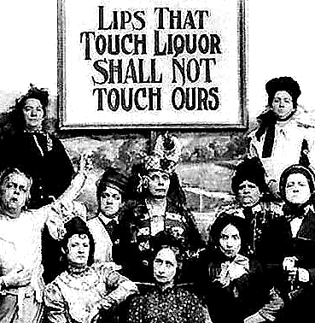
Historical Context:

Purpose:

Theme:

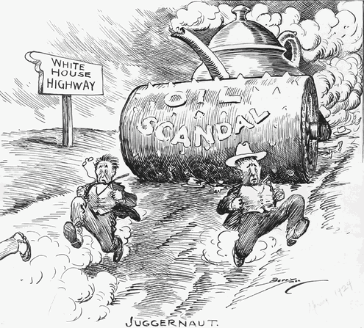

Historical Context:

Purpose:

Theme:

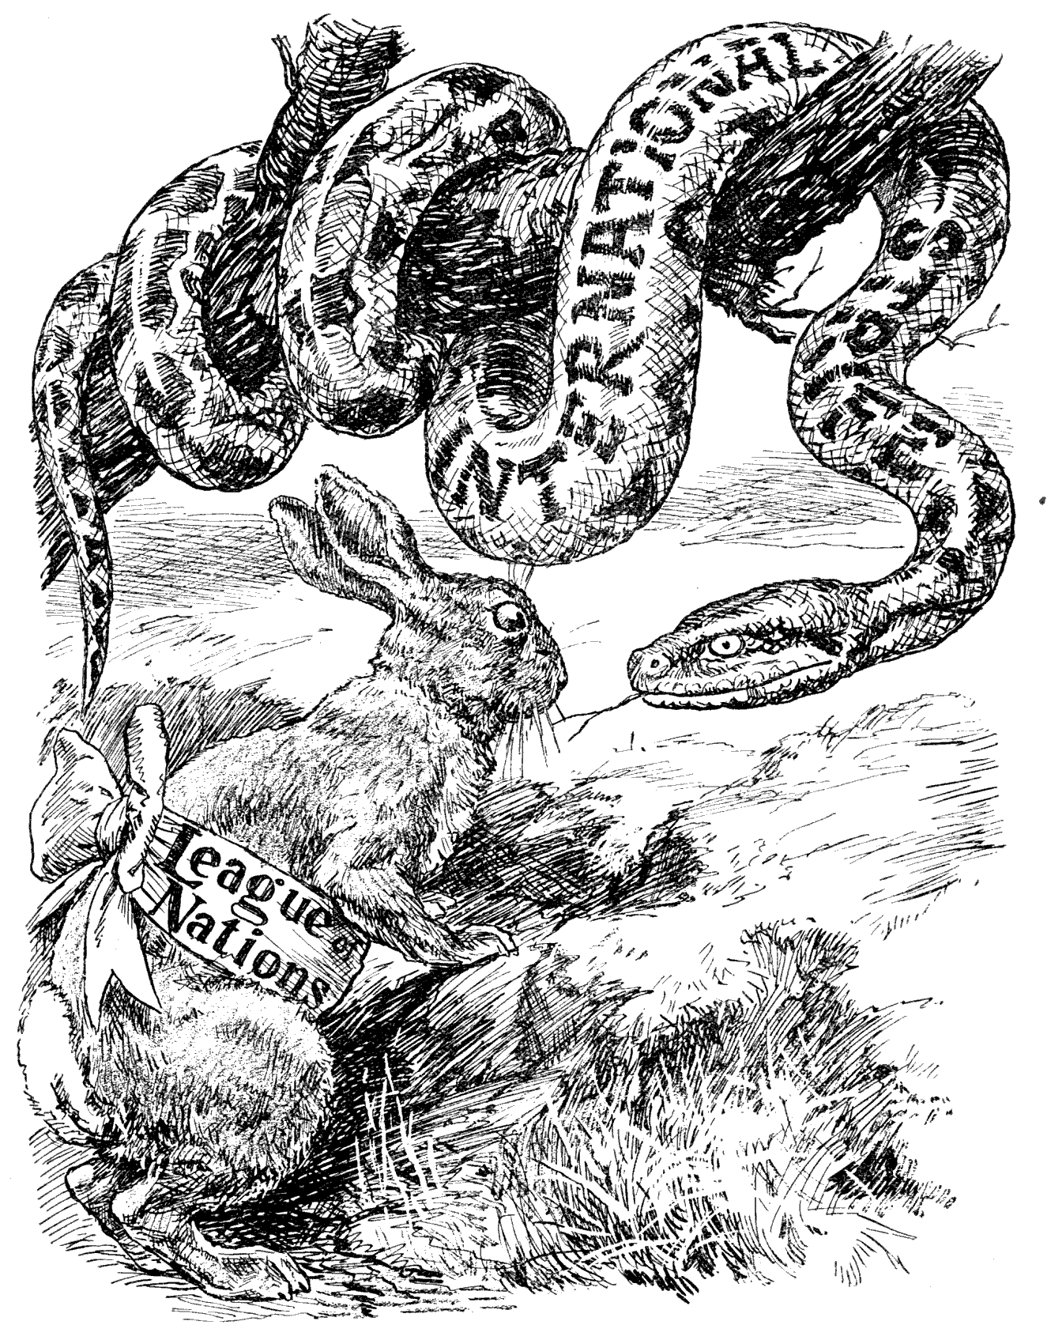

Historical Context:

Purpose:

Theme:

- Food For Thought: Made In America… the Art of Cool
Read the excerpt, highlight main ideas, and then answer the questions in the spaces provided.

Born in New Orleans around 1900, jazz was the first genre of music to inspire a worldwide mania for all things American (which often meant all things African American), especially in Western Europe. Drawing from blues and ragtime, the genre also folded the jaunty-yet-soulful marching music of traditional New Orleans’ funeral processions into its ingredient list. Before long, jazz spread north, following the wave of African-Americans migrating from the rural South to big Northern cities, and soon it took hold in places like Chicago and New York City, with pioneers like Louis Armstrong, Ferdinand Joseph LaMothe (better known as Jelly Roll Morton), and Duke Ellington.

Jazz was more than just a new kind of music: it was a part of a broader style, “American Cool,” which quickly became America’s top export. And while there’s nothing less cool than trying to explain “cool,” we’ll give it a shot in the interest of the historical record.

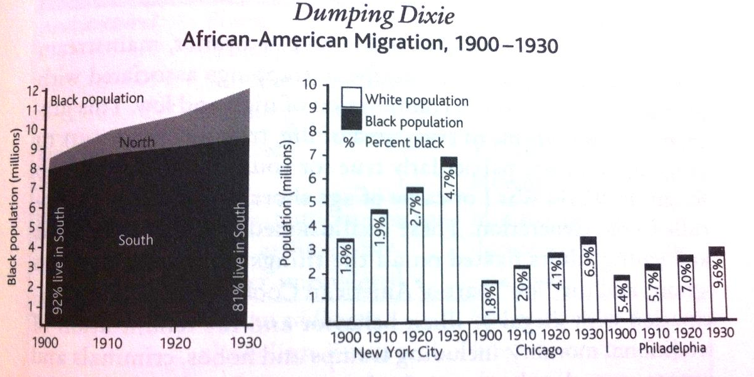
What caused the Great Migration?

What effect did the Great Migration have on America?

An emotional style focused-paradoxically- on minimizing emotion, “being cool” likely began in African-American culture as a way for individuals to passively deflect the psychological hurt inflicted by white racism. In American Cool, effortless mastery of both oneself and one’s context became expressed through verbal and body language, or lack thereof: the cool American is calm, unfazed, even slightly jaded or blasé. This new emotional minimalism was part of a long-term shift in what society modeled as “proper” emotional behavior. In the nineteenth century Victorian period, individuals were expected to control the extreme feelings raging just beneath the surface; by the twentieth century, they were supposed to be truly, inwardly detached from those feelings, skeptical of any passion except for “natural” urges like hunger and sexual desire.

Along with this general attitude and demeanor, mainstream America also picked up the aesthetic trappings associated with African-American cool: a combination of high and low. This juxtaposition was visible in every area of life, from fashion to art to language, and was particularly true for younger Americans who fought in WWI or came of age shortly afterward—the so called Lost Generation. These disillusioned and dissolute teens and young adults fixated on all the things their elders tried to ignore, and the “low” part of American Cool manifested in a fascination with illegal or illicit behavior and the renunciation of traditional morality, including tramps and hobos, criminals and private eyes, dive bars and flophouses, drugs and alcohol. (At least, in cities. Rural American remained a bit square, holding fast to traditional values.) One example of this renunciation was the risqué “flapper” fashion embraced by young women of the day.

…the idea of “cool” quickly spread through mainstream culture, giving rise to scores of expressions: you can “be cool,” “stay cool,” “play it cool,” “keep it cool,” “lose your cool,” “cool it,” “cool your heels,” or “cool your jets.” We all want to make a “cool million,” and someone can be a “cool customer,” “cool cat,” “cool as a cucumber,” “coolheaded,” or just “really cool.” Before long (surprise!( the concept was co-opted by corporate America and soon anything could be cool. By the 1950s you could eat “Cool Whip,” wear “Cool-Ray” sunglasses, paint your nails will cool Cutex polish, drink cool 7-Up, grill with cool A-1 sauce, or “jazz up” your salad with cool French dressing. For some reason it was extra-cool to spell the word with a “K” in brand names – e.g., Kool cigarettes, Kool-Aid, Dura-Kool fabrics… the list goes on.

Of course, cool wasn’t the only new slang being slung in America. “Hip” and “hipster,” coined by jazz musicians, referred to the typical position of a supine opium smoker, lying sideways on his or her hip, leading to the coded inquiry: “Are you hip?” (Erik Sass, The Mental Floss History of the United States)

What evidence can you pull from this excerpt to help you explain the influence of African American culture on the changing, modern American culture of the Roaring Twenties?

Reading Guide written by Rebecca Richardson, Allen High School
Sources include but are not limited to: 2015 edition of AMSCO’s United States History Preparing for the Advanced Placement Examination,
2012 and 2015 Revised College Board Advanced Placement United States History Framework, images from WikiCommons, and other sources as cited in document and collected/adapted over 20 years of teaching and collaborating

