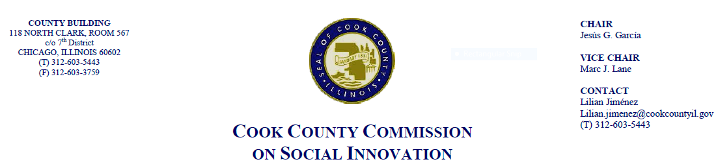
November 16, 2017, 4 P.M.
118 N. Clark, Rm. 569
MINUTES

- Call to Order

The Cook County Commission on Social Innovation convened via an in-person meeting to discuss new appointments, policy initiatives, and hear from a guest speaker. The meeting was chaired by Chairman Jesus G. Garcia and Vice Chair Marc J. Lane. The meeting was open to the public and took place from 4:10 p.m. to 5:30 p.m.

Commission Members Present:
1. Jesus “Chuy” Garcia
2. Marc Lane
3. Emile Cambry
4. Victor Dickson
5. John Yonan
6. Valerie Leonard
7. Marc Loveless
8. Reggie Greenwood
9. Matthew Erickson
10. Christyn S. Henson
11. Morgan Malone
12. Harold Rice
13. Howard Males
14. Wendy Raymer
15. Mike Hobbs

Commission Staff Present:
2. Lilian Jimenez
3. Victoria Moreno

Meeting Notes and Decisions Made:

- Approval of Minutes

Comm. Howard Males moved to approve the Commission’s minutes from October 19, 2017. Comm. Harold Rice seconded the motion and the motion passed unanimously by a voice vote.

- New Appointments to the Commission

Chairman Garcia welcomed new members to the Commission on Social Innovation:
- Matthew Erickson – Originally from South Cook County, he is a technology expert with focus on justice and privacy rights, role of technology.
- Christin S. Henson – Consultant and advocate with experience on community development in Chicago’s South and West Sides with a focus on helping neighborhood businesses thrive through unstable economies.
- Morgan Malone - Director of Englewood Quality of Life Plan with experience as an organizer and has been a member of Intellectual Capacity Committee. She brings a focus on disinvested communities and seeks to broker private-public partnerships while prioritizing diversity and inclusion.
- Xochitl Espinosa (absent) – Consultant with community development experience

- Proposal for Bringing a Resolution to the Commission

Comm. Loveless moved to bring the Good Food Policy Resolution to the Commission. Comm. Raymer seconded the motion. The motion passed unanimously by a voice vote.

- Good Food Purchasing Policy Resolution
- Vice Chair Marc Lane acknowledges Social Capital Committee for their work on this resolution and observed that City of Chicago just enacted their own good food policy.
- Rodger Cooley from the Chicago Food Policy Action Council who has been working through the Mayor’s Office to explore this effort with various agencies. At the city level, each department will have a year to develop an action plan for implementation and review their current procedures.
- The city is getting current vendors familiar with policy. This is a mandate moving forward. Schools have included it in their wellness policy. The County should take time to teach departments carefully and all contracts that could be influenced.
- Vice Chair Lane suggested the Commission move ahead to Agenda Item #7 and hear from the Guest Speaker.

- Guest Speaker

- Jeff Korzenik, Chief Investment Strategist at Fifth Third Bank spoke about the County’s role in assisting the formerly incarcerated (“Second-chancers”).
- He has investigated challenges to U.S. Labor force and the needs of “second-chancers,” who are defined as people who have been convicted and have been incarcerated.
- Mr. Korzenik said this population needs non-profit support and government can reduce barriers to employment for them and help educate the business community on this population, including perceived risks, and the importance of treating them as valued members of workforce and normalizing them.
- Mr. Korzenik pointed out that there is no common database of employers of “second-chancers” or non-profits that support them
- Mr. Korzenik also stated that the arts and civic organizations have an important role to play. Removing barriers is a statewide issue and there are concerns for employer liability.
- Mr. Korzenik explained that 650,000-700,000 people come out of jail per year and there is a 76.6% recidivism rate. If this rate went down, it would have impact on workforce rates
- Comm. Leonard asked why these efforts are in Mr. Korzenik’s best interest as a banker and which sectors are likely to employ them. Mr. Korzenik explained that Fifth Third Bank has a history of being committed to building better communities. At the national level, there is much opportunity within manufacturing. Employers might be hesitant of jobs that require direct service. All of these jobs require drug testing.
- Comm. Loveless stated the importance of wraparound services, challenges with access to IDs, and the variety of needs “second-chancers” have from health, transportation, and other quality of life needs. He suggested providing incentives to employers. Mr. Korzenik acknowledged importance of partnering with non-profits to serve this population and that it is important to consider the employers’ needs. He stated that we need to do a better job of collecting data on benefits to employers.
- Comm. Males highlighted the work of Clean Slate, Cara, and QCDC in this area. He said that government can address these issues but need to include mental health also.
- Comm. Greenwood explained that Worklab Innovation just received a grant from Workforce Funders Alliance to send navigators to different parts of the country to address challenges faced by the formerly incarcerated and assist with support services and have established ventures in Denver, Detroit, and other cities.
- Vice Chair Lane remarked that is useful to borrow ideas from other jurisdictions. He provided the example of Franklin County, OH (1.4m population) where a Reentry Coalition that includes government, non-profit, and private interests has been formed with the goal that entities adopt, rent to, or hire a justice-involved resident. They offer awards to participating organizations and pledge to assist person within a given timeframe. The coalition monitors this to make sure it takes place.
- Vice Chair Lane invited the Social Capital and Intellectual Committees to collaborate on testimony given today. He proposed that the Chair of Financial Capital Committee explore how the Coalition is staffed.
- Comm. Loveless suggested reaching out to grassroots group already doing this work. Marc Lane confirmed this effort is open to various stakeholders.
- Comm. Leonard confirms that the Social Capital Committee can be involved.
- Comm. Dickson provided the example of Washington D.C. where a Mayor’s Office for Reentry was started and to perhaps consider something like this here.

- Committee Updates

- Comm. Dickson proposed conducting an impact analysis on new businesses and their impact on underrepresented populations. There is not a lot of thought given to this and could be an area for the Commission to consider.
- Comm. Raymer of the Financial Capital Committee said they are looking at their plans for 2018 and are talking to Tom Day for collaboration.
- Comm. Greenwood mentioned that the Dept. of Highways has hired Mr. Bennett to evaluate transit issues. This could include a Metra analysis. Dept. will also hire consultant to do mobility study.

- Other Business

- Comm. Loveless asked whether it is possible to address GMOs within the Good Food Policy and the Chair and Vice Chair confirmed that it can.
- Chair Garcia proposed that the next meeting be held on the third Thursday in January 2018

- Public Comment

No public comment was received.

- Adjourn

Comm. Greenwood moved to adjourn. The motion was seconded by Comm. Loveless. Meeting adjourned at 5:30 p.m.

