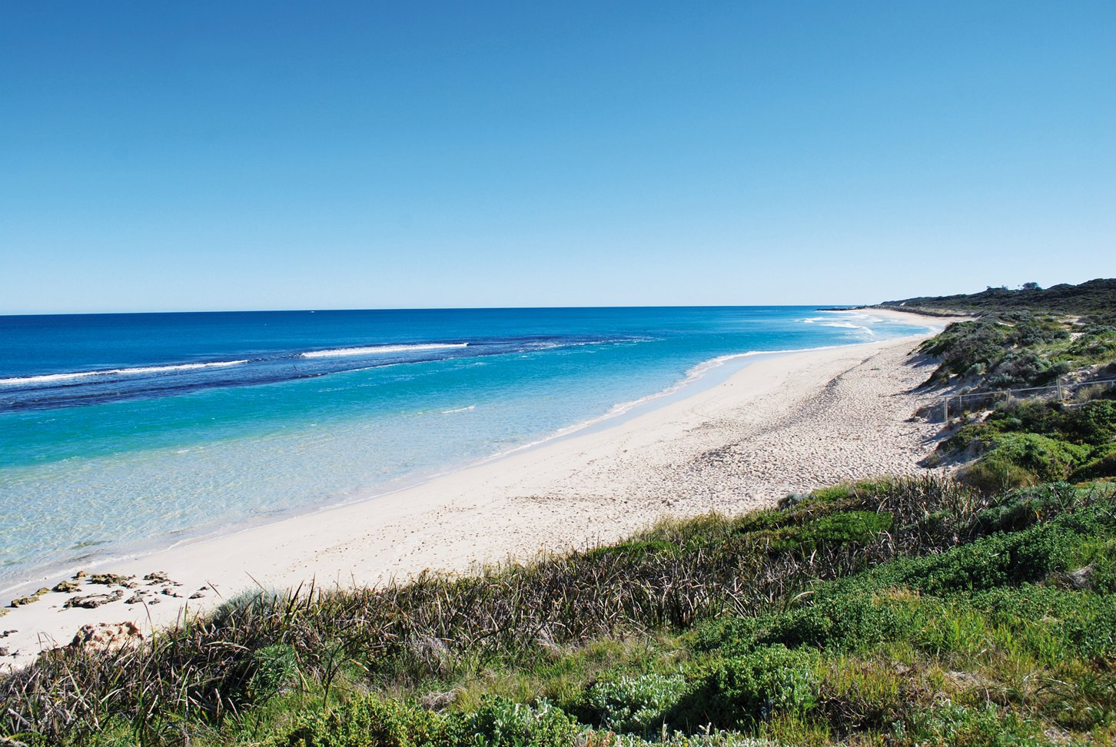
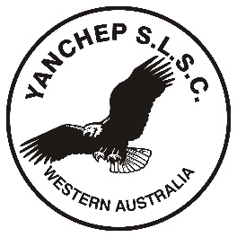
Yanchep Surf Lifesaving Club

Competition Squad

Information Guide 2018/2019

Yanchep SLSC support and encourage Nippers U8+ and Youth who wish to participate at competition level. Competitions events are fantastic for social and physical development.
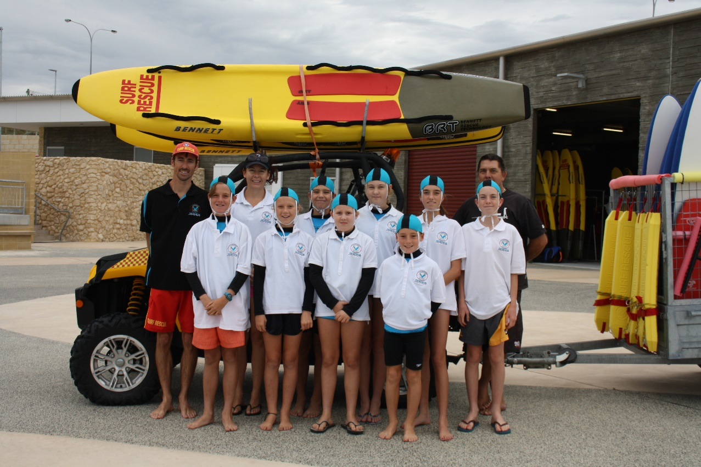

Your Competition Coach
Conan Millar has been an active member of the Yanchep Surf
Lifesaving Club, for 6 years. His 3 children have enjoyed 6 years
as Nippers within the club. His older 2 have attained their
Surf Rescue Certificate.

Should you have any enquiries regarding the Competition Squad please email Conan or Bec (Competition Director) at yanchepsurfsports@gmail.com

What is the Minimum age?
Competitors are to be Age 7 by 30 September 2018. As required by Surf Lifesaving WA

Which age group will my child be in?
Nippers and Cadets are divided into the following age groups:
Age | Date of Birth | SLSWA Age Group | Carnivals | Competition proficiency swim
7 | 01/10/2010-30/09/2011 | U8 | Little Nippers Carnival | Not applicable
8 | 01/10/2009-30/09/2010 | U9 | Little Nippers Carnival | Not applicable
9 | 01/10/2008-30/09/2009 | U10 | Nippers Carnival | Minimum 100m open water swim in 9 minutes
10 | 01/10/2007-30/09/2008 | U11 | Nippers Carnival | Minimum 100m open water swim in 8 minutes
11 | 01/10/2006-30/09/2007 | U12 | Nippers Carnival | Minimum 288m open water swim in less than 9 minutes.
12 | 01/10/2005-30/09/2006 | U13 | Nippers Carnival | Minimum 288m open water swim in less than 9 minutes.
13 | 01/10/2004-30/09/2005 | U14 | Senior Carnival | Minimum 288m open water swim in less than 9 minutes.
14 | 01/10/2003-30/09/2004 | U15 | Senior Carnival | Minimum 288m open water swim in less than 9 minutes.
15 | 01/10/2002-30/09/2003 | U16 | Senior Carnival | Minimum 288m open water swim in less than 9 minutes.
16 | 01/10/2001-30/09/2002 | U17 | Senior Carnival | Minimum 288m open water swim in less than 9 minutes.
.
Competition Proficiency Swim
This will be conducted at the first Water Competition Training Session.

What to bring
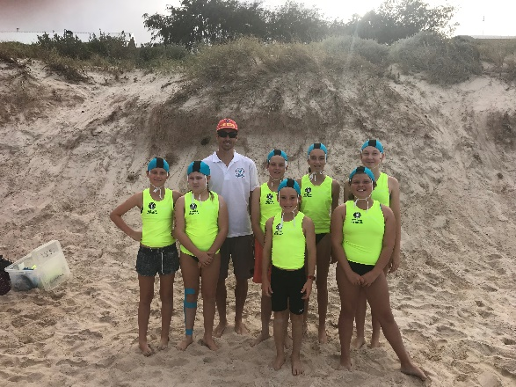
Squad Members should bring the following items to all training
activities:
- Rash Vest
- Age Group Cap
- Broad brimmed hat or peaked cap
- Sun Screen
- Bathers
- Water Bottle
- Towel
- Warm clothing (dependant on weather)
- Swimming goggles (not compulsory)

The following items must also be brought to competition events:
- Long sleeve Competition Squad Shirt
REMEMBER –No sunscreen, No Drink, No Rash Vest – NO PARTICIPATION

- Fleuro vest
- Competition Club colour Cap

Parent Responsibilities
It is essential that Nippers arrive on time and report to the Competition Coach to be marked in attendance.
Nippers MUST NOT leave their group without being marked off by the Competition Coach. This is to be done at the Club, with Parents/Guardians present.

Do I need to stay with my child?
YES. One parent or guardian responsible for that child needs to remain on the beach with their child
AT ALL TIMES.

When is Training?
There will be 2 training sessions a week; participants can choose either beach competition or water competition or both is also encouraged.
Beach Competition training.  This will be one afternoon during the week, and will focus on:  Beach Sprints  Relays  Beach Flags  General Fitness | Water Competition Training:  This will be Sunday morning 7:45 for 8:00am sharp start (TBC) , we will focus on:  Board technique  Board Race  Board Rescue  Surf Race  Iron Man/Woman Race
Please refer to the webpage for day and times.

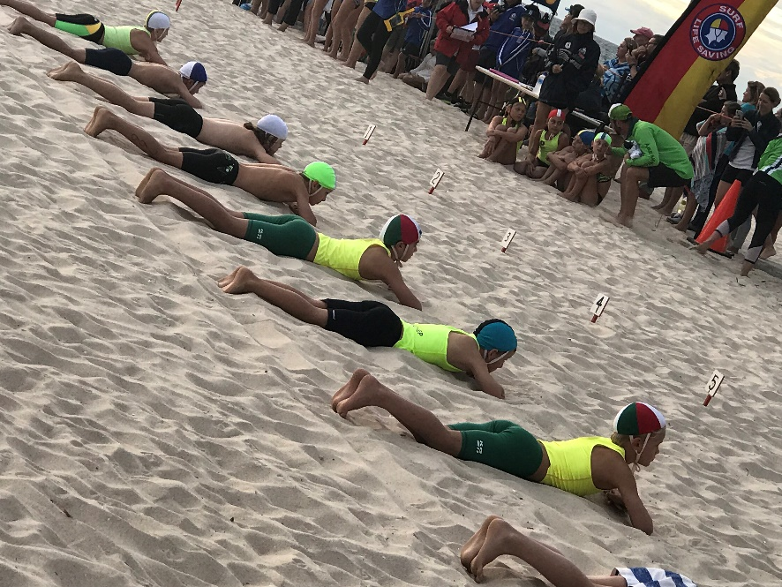
SLSA Carnivals
Competition Squad Age groups have the
opportunity to compete against children
from other clubs at junior and senior
interclub carnivals.

Carnivals are scheduled by SLSWA.

In addition to in season carnivals, there
will be State Qualifiers and State
Championships.

Please contact your Competition Squad
Manager for further details.

SLSWA include both individual and a
number of team events.

Please refer to the Little Nippers & Nippers Competition Guide available from Surf Lifesaving WA:

www.mybeach.com.au/members/surf-sports/competitions/competitions-2-2/

Calendar of Events
2018/19  Carnivals | U8 & U9 Little Nippers | U10-U13 Nipper | U14+ Senior
Development | - | 18 November 2018  Alkimos Beach | -
Round 1 | 13 January 2019 Swanbourne Beach | 2 December 2018  Coogee Beach | 11 November 2018  Leighton Beach
Round 2 | 10 February 2019 Cottesloe Beach | 20 January 2019  Mullaloo Beach | 16 December 2018  Trigg Beach
Round 3 | - | - | 17 February 2019  Secret Harbour
Qualifier | - | 23 & 24 February 2019  Trigg Beach | -
Championships | 3 March 2019  Sorrento Beach | 15,16 & 17 March 2019  Scarborough Beach | 9 & 10 March 2019  Scarborough Beach
All age groups – Country Carnival Denmark
26, 27 & 28 January 2019

Fees for Competition
There is a fee per Nipper, per competition. This will be confirmed on registration for the event.

As a parent how can I help?
Clubs are expected to provide water safety at carnivals, water safety personal must have SRC or Bronze as stipulated by SLSWA. Each age group will provide water safety for their own age group at carnivals.

To participate in SLSWA Carnivals, each Age Group is required to provide one competition official for every ten juniors competing. Club officials are critical to running of SLSWA carnivals. Training courses are run by SLSWA.

Working with Children Check

For further information visit www.mybeach.com.au/members/member-protection/ and head to the Working with Children Check information.

What type of Board is required?
The club has purchased a small number of Soft Boards and fibreglass nipper boards for the Competition Squad members to use. It will be a requirement for future squad members to purchase their own, however whilst we are still in the development phase of our squad, the clubs boards may be used. In keeping with the use and care of the equipment as outlined below.

- Soft boards will be allocated to the younger age groups – U8, U9 & U10
- Fibreglass boards are to be used by the U11 to U13 age groups only
- Larger fibreglass board for U14+

Should you wish to purchase you own board please ensure that the board complies with the SLSA Surf Craft and Surf Boat Specifications. A link can be found on the Competition page of our website. Please refer to your Competition Coach if unsure.

All damages and losses must be reported immediately to the Competition Coach.

Use of boards at Carnivals – preference will be given to Nippers that have attended regular training sessions.

Use and Care of Equipment for Competition
As you can appreciate, training and competition equipment is expensive both to purchase and to repair. Therefore, it is important that these items and all other gear and equipment is handled and cared for correctly.

Competition Boards:
- should be carried, not dragged, and should be laid fin up on the sand;
- are only to be used on Sundays during nippers (by competition squad members only) or during sanctioned training sessions;
- are not to be stood or sat on whilst on the beach
- must not be stood on whilst riding them
- are to travel in covers, when available.

The Competition Squad will be responsible for the set-up and return of gear after each training session.

Please remember…..We are all volunteers!!

Our Competition Coach, water safety and Nipper’s Committee are volunteers – parents, just like you - who have given up their time for your children. Please respect them, help them where you can and say thanks! We really like that!!

Stay in touch
Throughout the season and after we would like to keep in touch with you to bring you news about upcoming events, opportunities to help and next year’s program. Join the Club Facebook page or follow us on Instagram.
www.facebook.com/yanchepsurflifesaving/
www.instagram.com/yanchepsurflifesavingclub/

and remember to regularly check in on our website too yanchepsurflifesavingclub.com.au
If your contact details change, please email yanchepnippers@gmail.com

