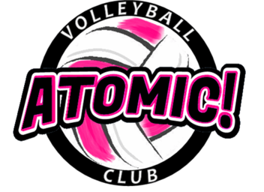
Atomic! Volleyball Boot Camp
For girls entering 7th THRU 12th grades in 2019-20 School Year
August 5th – August 6th from 9-11am
____________________________________________________

Location of Camp: Brownstown Sports Center
Address: 21902 Telegraph Rd, Brownstown, MI 48183

“We are the ONLY VB Club that originated Downriver”
Camp Details: This camp is designed to get your ready for MS/HS tryouts. High intensity camp geared high repetitions and drills that will be just like the drills you will be scored on during your tryouts. This camp will help you get ahead of your competition.

Think about it…..You will have 4 more hours of touching the volleyball instead of that other girl who hasn’t touched a volleyball in months. This makes a big difference at tryouts.

Please bring: Court shoes, knee pads and workout clothes, water bottle, good attitude, willingness to work.

Cost: $45 (payable to Atomic! VBC)

Coach: Coach Yack, Atomic! Volleyball Director. I am the former head Varsity VB coach at Woodhaven HS. I have 22 years of coaching experience at the High School/AAU volleyball and playing competitive volleyball for 27 years.

Mail Registration form and funds to : Atomic! VBC, PO Box 1381, Southgate, MI 48195

Questions: atomicvbc@gmail.com or 734-934-4064 (call or text)
Like us on facebook

Note: Brownstown Sports Center is our winter and spring program home. We are an AAU Club the focuses on player development. Sign-ups for the winter season will be in November 2019.
----------------------------------------------------------------------------------------(keep to portion for your records)------------
Registration Form Atomic! VBC Volleyball Camp, August 5 – August 6, 2019

Athlete’s Name: ______________________________Phone ______________________

Address:_____________________________________ City, Zip: ____________________

Phone: ____________________ Email (print clear) : _______________________________

Grade Level (Entering Fall of 2019) ______School Name: ______________________________

Emergency Contact Phone______________________
I hereby authorize the staff of the Atomic! VBC to act on my behalf according to their best judgment in any emergency requiring medical attention if I cannot be reached. I, further, waive and release the Atomic! VBC and its staff from any and all liability for the injuries or illnesses incurred while involved in this camp. I have no knowledge of any physical impairment that would keep the above named athlete from full participation in this camp.
Parent or guardian signature ___________________________________Date __________________
Parent Name (Printed) ___________________________
WE HAVE WINTER & SPRING PROGRAMS – CHECK OUT our webpage (atomicvbc.com) or our facebook page.

