The effect of temperature on cross-ventilation: Laboratory experiments from the MAGIC project

Urban areas produce 70% of the anthropogenic carbon emissions that drive global climate change. Simultaneously, climate change, deteriorating air quality and increased expectations for the quality of indoor environments result in an increasing energy demand in buildings because of mechanical cooling and ventilation. The Managing Air for Greener Inner Cities (MAGIC) project aims to break this vicious cycle by replacing mechanical ventilation and air conditioning with natural ventilation – using the free energy of the wind and temperature differences between indoors and outdoors. Our vision is to develop cities with no air pollution and no heat island effect by 2050.

Using a combination of field studies, laboratory experiments and CFD modelling, we examine how factors such as building form, traffic emissions and green and blue space impact pollution flows, indoor-outdoor exchange and, ultimately, the potential for natural ventilation in buildings. Our objective is to develop a suite of models underlying a decision support tool that will enable urban planners to understand the behaviour of pollution in cities and make decisions about how and when to integrate natural ventilation into new developments and building retrofits. MAGIC is an EPSRC Grand Challenge project.

As a part of MAGIC, a field study was performed in an office room in London over the summer of 2017. Tests were performed that cross-ventilated the office room, with the aim of comparing the results to simple mathematical models. However, it was not known what effect temperature differences between the outside and inside of a room might have on cross-ventilation. We therefore performed laboratory experiments using a reduced-scale model room in a water flume to understand the effect of a temperature difference.

We first examined the two extreme cases: purely wind-driven and buoyancy-driven ventilation through two windows in opposite walls, at equal heights in the room. Wind driven ventilation was well-mixed and the concentration of dye in the model room decreased exponentially with time, as expected. Figure 1 shows the decay of dye in the model room.

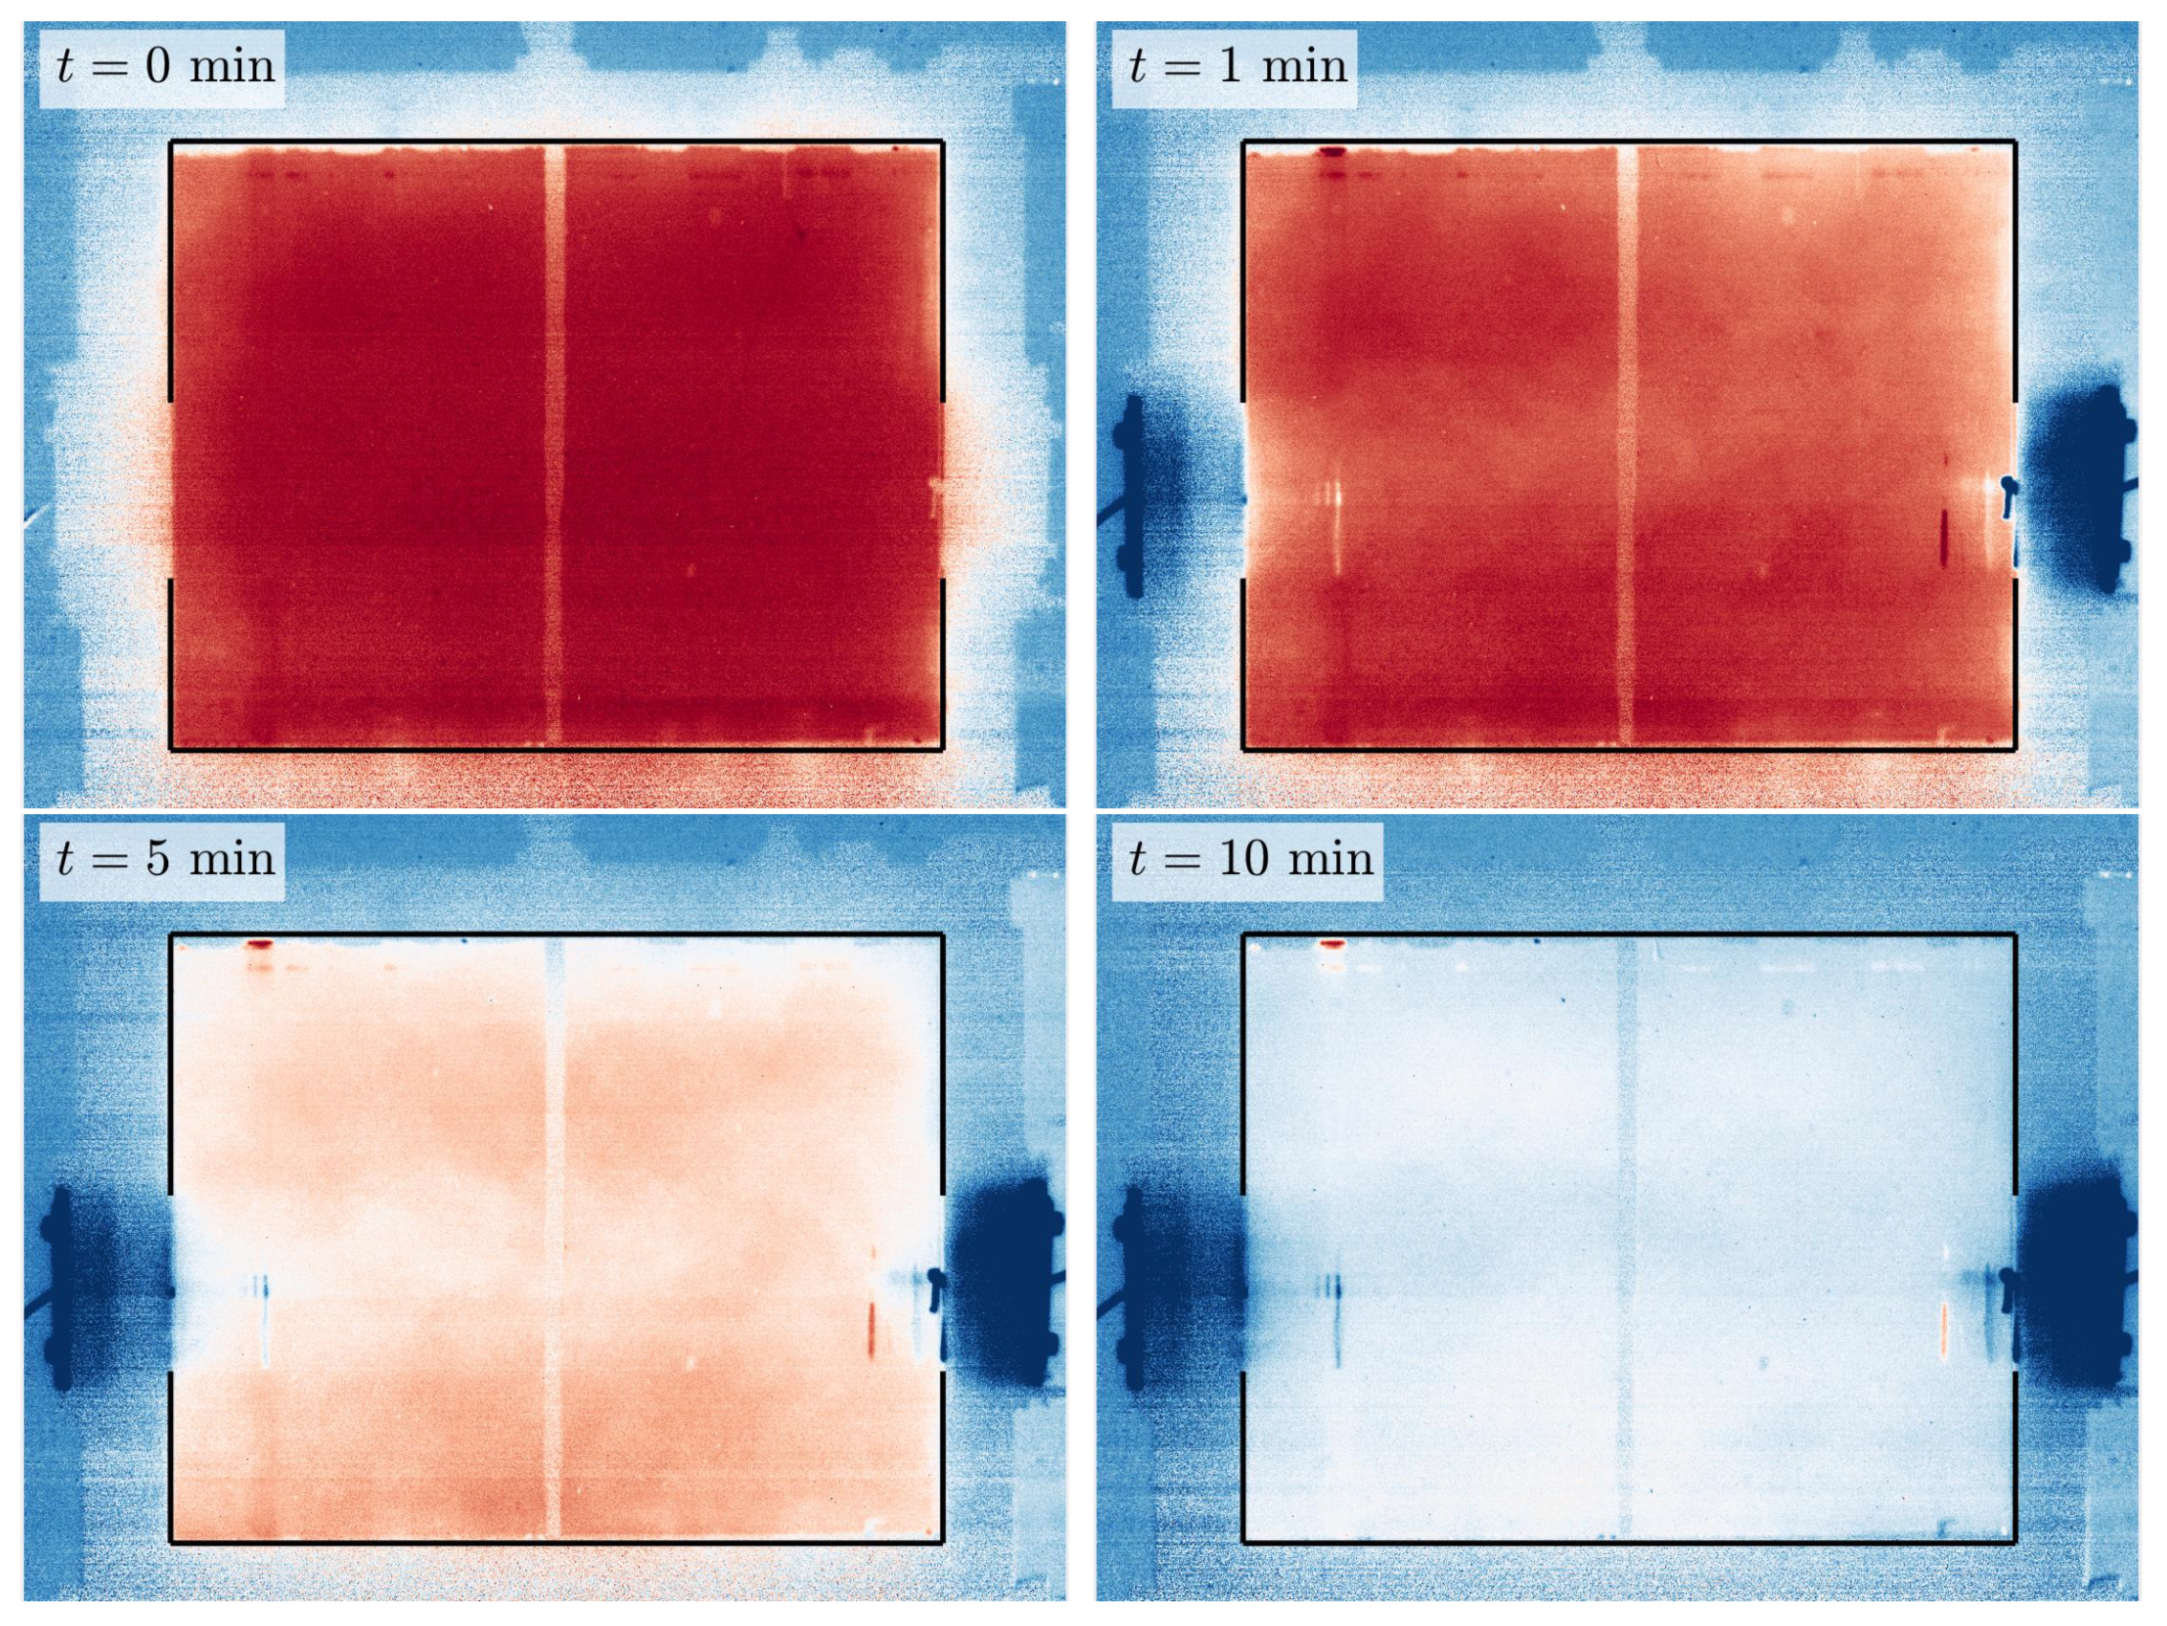
Figure 1: Wind-driven cross-ventilation.

The next case to be examined was purely buoyancy-driven ventilation (i.e. driven by temperature differences). The model room was filled with warm, dyed fluid, then the windows were opened. Exchange flow at the windows ventilated the room, until the volume below the top of the windows was replaced by ambient fluid, at which point all ventilation ceased. Figure 2 shows the different stages of ventilation of the room.

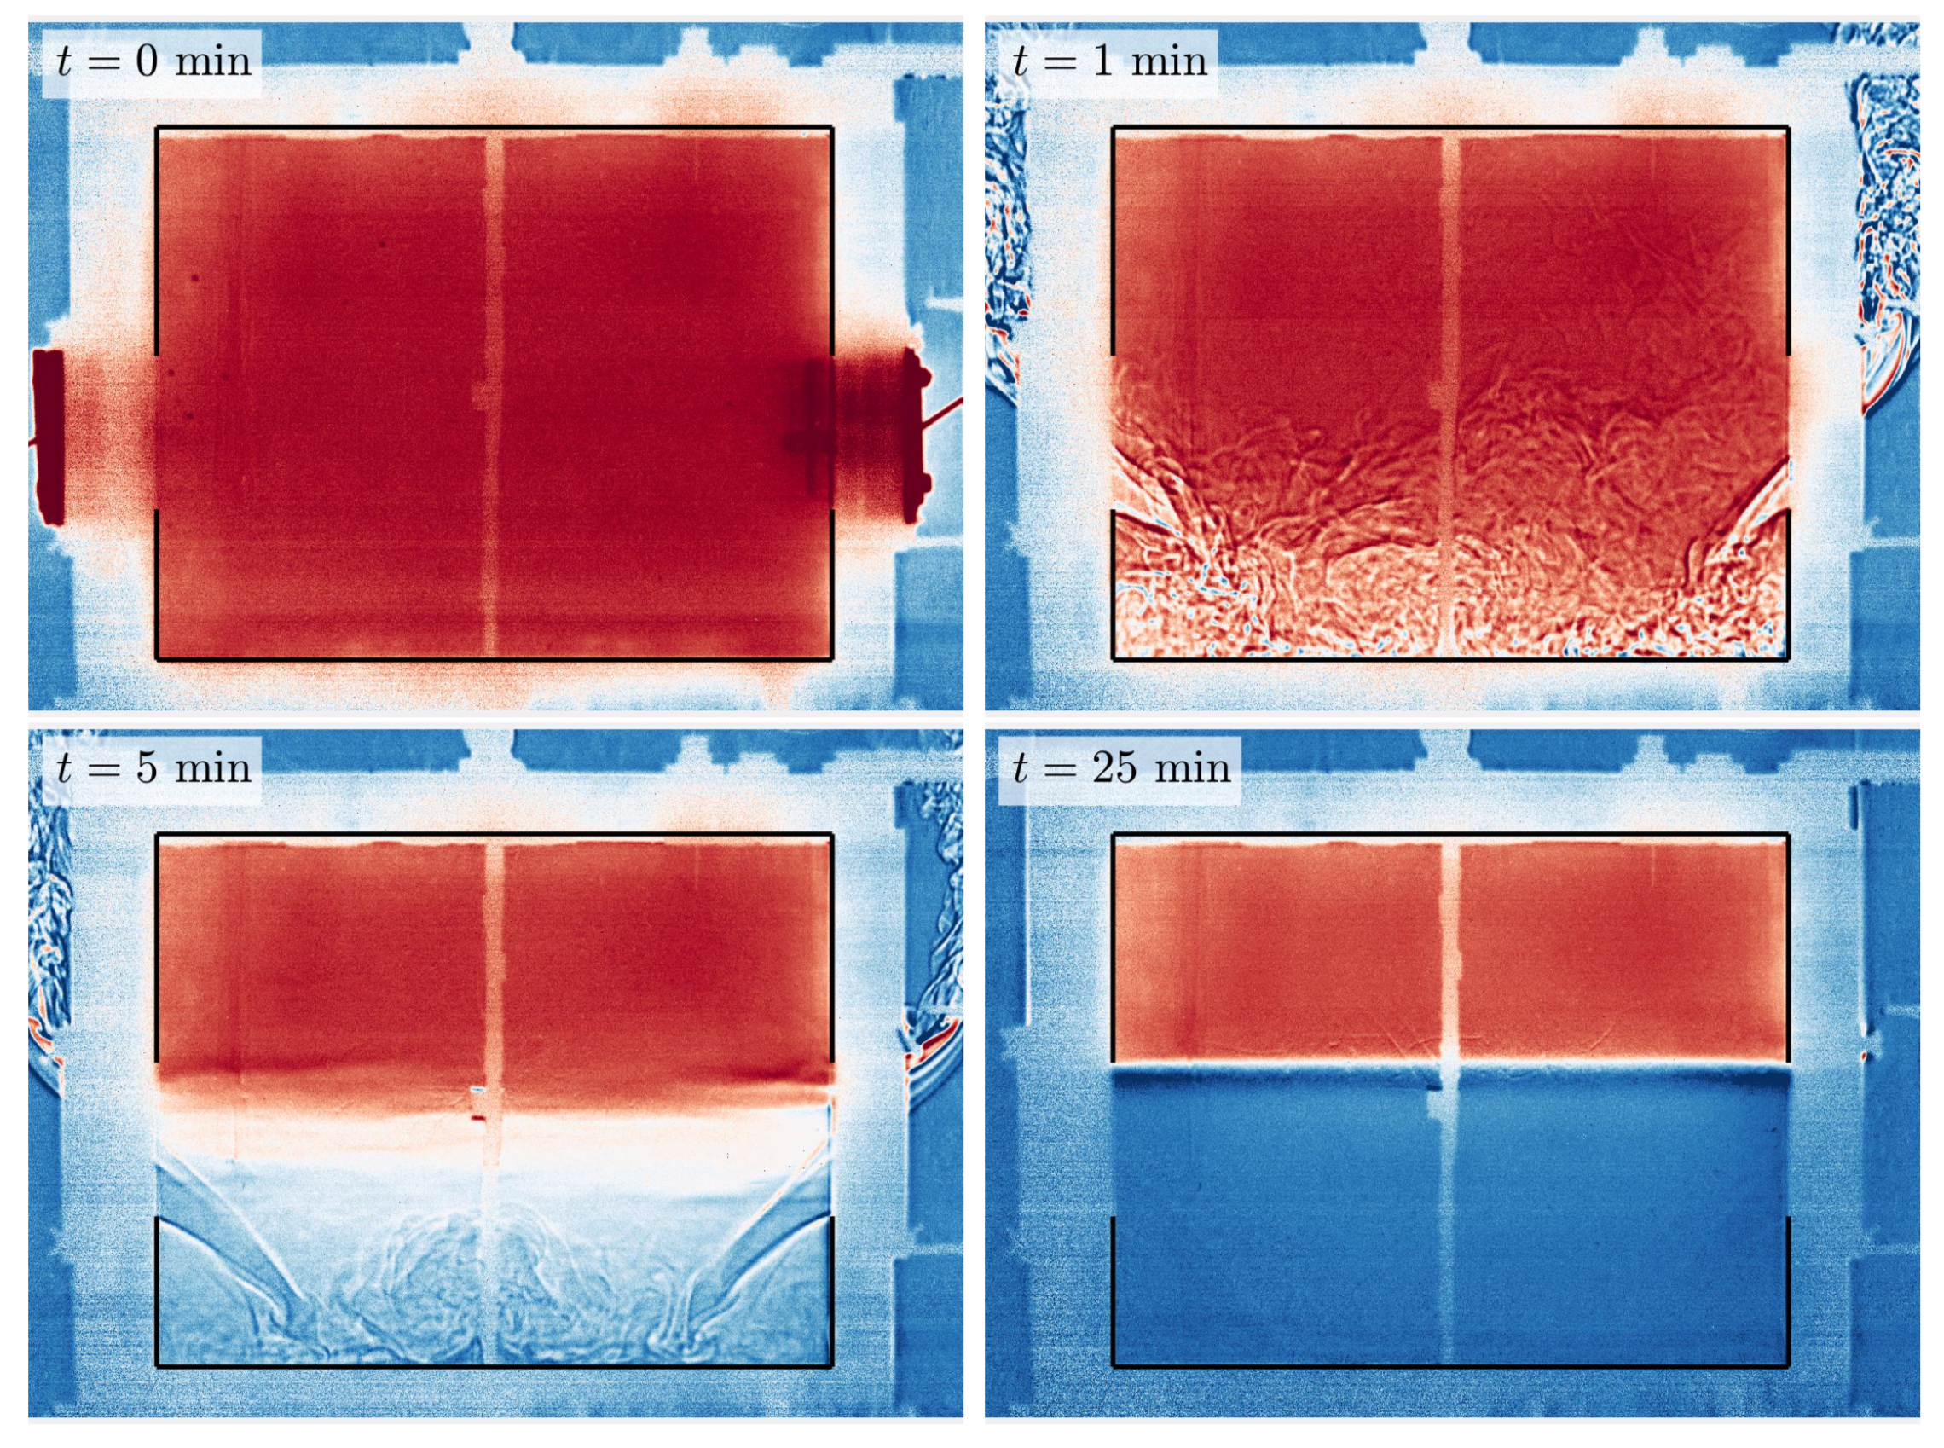
Figure 2: Buoyancy-driven exchange ventilation.

We then examined ventilation driven by a combination of wind and buoyancy. The relative importance of these two effects can be described by a Froude number
$$Fr=\frac{U}{\sqrt{bh}}$$

where $U$ is the wind speed, $h$ is the window height and $b=g γΔT$, where $g$ = acceleration due to gravity, $ΔT$ is the temperature difference between the inside and outside of the room, and $γ$ is the thermal expansion coefficient ($γ=1/T$for air, where temperature is measured in Kelvin).

If $Fr>1$, then the flow is wind dominated and if $Fr<1$ the flow is buoyancy dominated. We found that if $Fr>1$, the temperature in the room had very little effect on the ventilation rate through the window, but changed the ventilation rate of the room as a whole, as the room became stratified. Ventilation proceeded in two steps – first the volume below the windows was removed, leaving a war layer near the top of the room, then this upper layer was slowly eroded away by the cross-ventilation flow through the room.

We found that for $Fr<1$, when the flow is primarily buoyancy dominated, the ventilation through the window was affected by the wind, which increased the ventilation rate. Again, the temperature profile in the room was stratified, with ventilation proceeding in two stages – removal of the lower layer, then erosion of an upper layer. Figure 3 shows the different stages of ventilation driven by both wind and buoyancy.

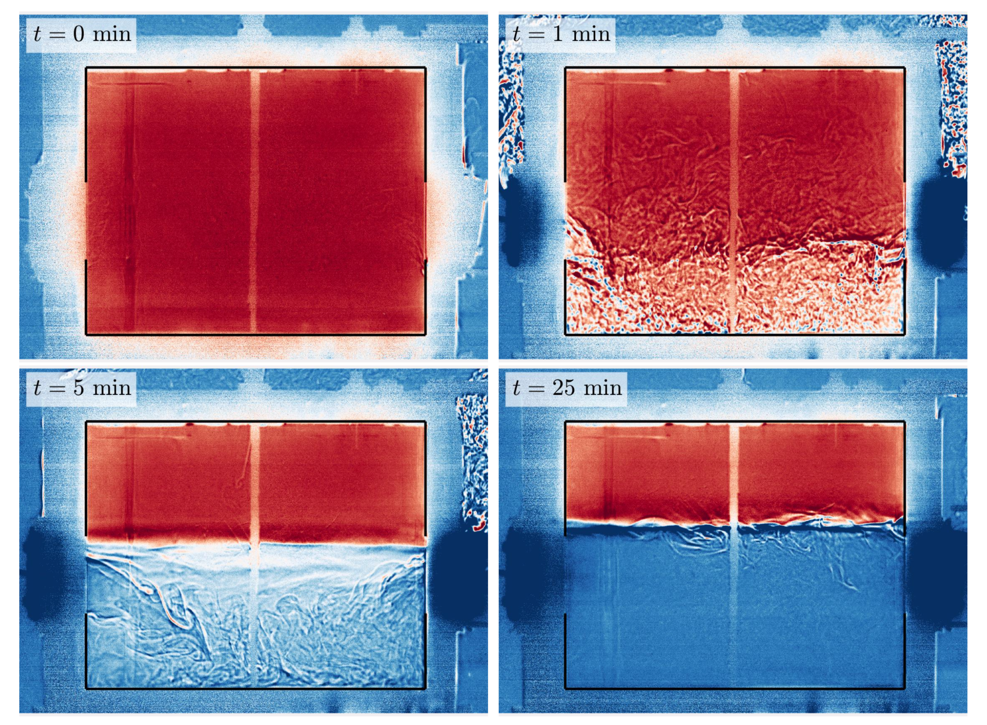
Figure 3: Ventilation due to both wind and buoyancy.

These new experiments show the significance of vertical stratification. From them we can build new models that indicate when vertical stratification in a room is likely to be important, so that it can be included in our calculations.

For further information about MAGIC follow us on Twitter (@MAGICities) or go to our website: www.magic-air.uk

