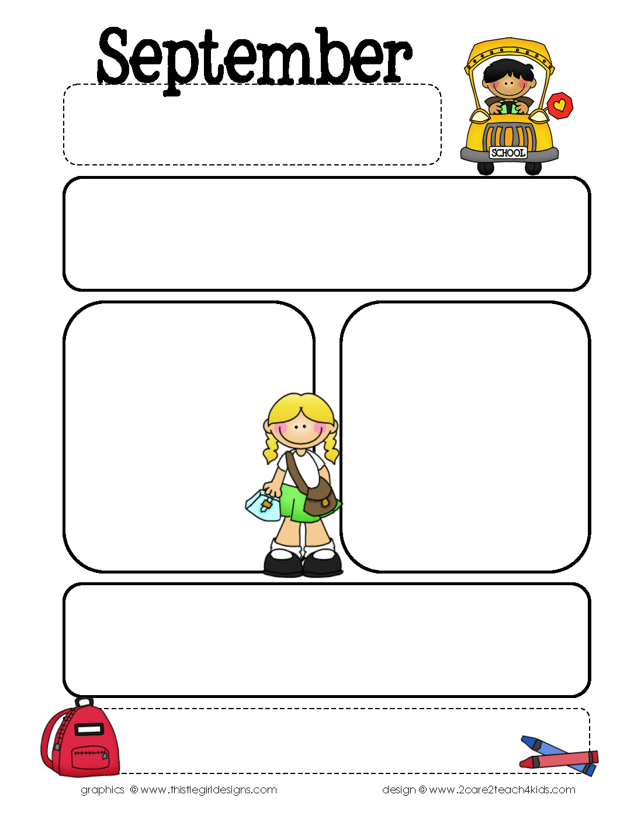

Providence Baptist Church welcomes you to Preschool! If you don’t have a church home,

please consider joining us on Sundays mornings and Wednesday nights for supper and

activities. Check out our church website, [www.providencecharleston.org](http://www.providencecharleston.org), to learn more.

Providence Baptist Church Preschool

294 Seven Farms Drive, Daniel Island, SC 29492

843-971-5275 fax 843-971-6862

[preschool@providencecharleston.org](mailto:preschool@providencecharleston.org) www.pbcpreschool.com

Welcome to Providence Baptist Church Preschool! We are so excited to start off our year. We enjoyed seeing everyone at our Meet the Teacher event. The teachers are so excited and have worked so hard to get their rooms and lessons ready. In addition to all of their planning, the teachers have gone through CPR and First Aid training. We are so delighted to learn and play with your children this year at PBCP. Thank you for giving us the opportunity!

Themes and Bible Stories for September

Aug. 29-Sept. 2 Back to School Fun/

Matthew 19:14

Sept. 6-9 Friendship/

Joseph and his Brothers

Sept. 12-16 All About Me/ My

Favorite Things/

Joseph in Egypt

Sept. 19-23 Families/ Pets/

Joseph Saves the Day

Sept. 26-30 Zoo Animals/ Joseph

and his Brothers Reunited

Focus Skills for September

Color: White

Shape: Circle

Opposites: Up/Down and In/Out

Letters: A and B

Numbers: 0, 1 (for 1’s and 2’s)

0, 1, 2 (for 3’s and 4’s)

Bible Verse: “The Lord was with Joseph.”

Genesis 39:2

Reminders…

*There is no school on Monday, Sept. 5 for Labor Day.

*Immunization Records are due by 9/30. They can be faxed to 843-971-6862.

*Children should bring their lunch, a, a change of clothes, and/or any diapering items.

*Please read our Parent Handbook and *sign and return the last page*.

*School Supply List: Lysol wipes and spray, tissues, 8 oz. hand sanitizer

*