Overview:
It is the purpose of this policy to set forth clear guidance on personal protective and patient care standards for the response and treatment of persons suspected to be infected with the COVID-19 virus.
BCEAA, through direction of WVOEMS, is following recommendations and guidance set for forth by the Centers for Disease Control and Prevention (CDC). Reference information for this guidance can be found and reviewed at:
https://www.cdc.gov/coronavirus/2019-ncov/hcp/guidance-for-ems.html
https://www.cdc.gov/coronavirus/2019-nCoV/clinical-criteria.html
https://www.cdc.gov/coronavirus/2019-ncov/hcp/guidance-risk-assesment-hcp.html
In some scenarios, BCEAA may exceed the recommended minimum PPE guidance set forth by the CDC.
Additional SOG Reference: 9.5 Dress and Appearance (Re: BCEAA Grooming Standards)

Background:
Emergency medical services (EMS) play a vital role in responding to requests for assistance, triaging patients, and providing Emergency medical treatment and transport for ill persons. However, unlike patient care in the controlled environment of a healthcare facility, care and transports by EMS present unique challenges because of the nature of the setting, enclosed space during transport, frequent need for rapid medical decision-making, interventions with limited information, and a varying range of patient acuity and jurisdictional healthcare resources.
When preparing for and responding to patients with confirmed or possible coronavirus disease 2019 (COVID-19), close coordination and effective communications are important among 911 Public Safety Answering Points (PSAPs), the EMS system, healthcare facilities, and the public health system. For the purposes of this guidance, “EMS clinician” means prehospital EMS and medical first responders. When COVID-19 is suspected in a patient needing emergency transport, prehospital care providers and healthcare facilities should be notified in advance that they may be caring for, transporting, or receiving a patient who may have COVID-19 infection.
High Risk populations such as those living in high rise apartments, nursing home facilities, long-term care facilities, etc, should be handled with extreme care as many of the residents of these facilities are among the highest risk for severe impact from the virus.

Public Safety Answering Points (PSAPs)
Berkeley County Central Dispatch has implemented the suggested PSAPs set forth by the National Academy of Emergency Dispatch and is questioning callers to determine the possibility that this call concerns a person who may have signs or symptoms and risk factors for COVID-19. The query process does not supersede the provision of pre-arrival instructions to the caller when immediate lifesaving interventions (e.g., CPR or the Heimlich maneuver) are indicated. This information will be provided on the Mobile Data Computers (MDC’s) in each ambulance before arrival on scene in order to allow use of appropriate personal protective equipment (PPE).

Personal Protective Equipment (PPE) and Disinfectant Cleaning Supply
Due to the nationwide shortage of PPE, BCEAA has pulled all PPE that was being stored at each station and created a strategic cache. We are stocking each front line with the following PPE:
- 20 Non-rigid N95 particulate masks for EMS clinicians
- 20 surgical masks for patient application
- 2 pair of safety glasses (to be issued directly to individual employees)
- 2 contact isolation infection control kits
- 1-quart spray bottle of Sanizide cleaning solution
- 1 container of purple top germicidal wipes
Restocking on these items should be requested when supply drops below 50% and should be requested through the Captain on duty.
Due to the decreased availability of PPE, multiple full isolation kits have been placed on Mobile 95 and a supervisor response will be required in all cases in which PSAPs confirm a positive screening for COVID-19. If providers enter a scene where they believe there is a need for full isolation that cannot be attained by the supplies on the ambulance, the supervisor should be requested to scene.

Patient Assessment and Treatment
If, through the use of their PSAPs, Berkeley County Central Dispatch finds that a patient EMS is responding to is suspected of having COVID-19 EMS clinicians should don all appropriate PPE prior to entering the scene and establishing contact with the patient. Whenever possible, patient assessment should begin with at least 6 feet of distance between clinicians and the patient. A standard surgical mask should be placed on the patient to control respiratory particulate exposure. Source control is one of the most important steps clinicians can take to reduce the risk of exposure. Clinicians should prioritize placing a mask on patients prior to beginning any type of assessment that requires them to be within 6 feet of the patient.
Appropriate PPE for patients who screen positive for COVID-19 will be referred to as “full isolation precautions” and include:
- N95 protective mask for the EMS clinicians
- Surgical mask for the patient
- Contact isolation gown
- Boot covers
- Head/Hair cover
- Safety glasses / goggles that protect the font and sides of the eyes. Standard eyeglasses are not considered adequate protection
- Disposable Examination gloves

For patients who screen negative through the PSAPs but present with signs and symptoms of respiratory illness, fever (at or above 100.5) or who have recently returned from travel to a high-risk area, the following PPE, referred to as “standard precautions”, will be required:
- N95 protective mask for the EMS clinician
- Surgical mask for the patient
- Safety glasses / goggles that protect the front and sides of the eyes. Standard eyeglasses are not considered adequate protection.
- Disposable exam gloves

Special consideration for additional PPE should be taken when patient treatment would increase the likelihood of aerosolizing respiratory droplets. These treatments and procedures include, Oxygen administration greater than 6LPM, Bag-Mask ventilations, CPAP, nebulized medication administration, advanced airway placement and CPR. Treatments that prompt aerosolization of respiratory droplets in the presence of suspicion of COVID-19 should prompt the clinicians to don gowns in addition to standard PPE precautions upgrade to full isolation precautions if there is any suspicion of COVID-19.

BCEAA COVID-19 Screening
Through the ImageTrend charting system, BCEAA has developed a COVID-19 screening survey and reporting tool. This screening has been developed in coordination with infectious disease experts from WVU Healthcare on our local Health Department. The screening tool is required to be completed on all patient contact regardless of the transport outcome. Any person or patient that has a positive answer for any of the 4 screening criteria questions should be considered high risk of infection of COVID-19 until proven otherwise.

Hospital Notification and Arrival
For any patient that screens as a high risk for COVID-19 and is requesting transport to the ER, clinicians must give direct report to the ER with as much notice as possible so that the receiving facility has ample time to make arrangements for the patients arrival. Clinicians should ensure they have received clear arrival instructions to include entry into the ER or potential secondary triage area. Clinicians should not enter the ER unless they have been instructed to do so.

Post Call and Decontamination
Following the transport of any patient with a high suspicion of COVID-19, ambulances will remain out of service for full decontamination following standard procedures for infection control decontamination. If, through the treatment of the patient, respiratory droplets were aerosolized, the Duty Officer will contact the VA Medical Center Fire Department or Martinsburg Fire Department and arrangements will be made for use of the mass disinfection machine on site at the VAFD or MFD.

Clinician Exposure
All clinicians that transport a patient with a high suspicion of COVID-19 should fill out an infectious disease occupational exposure form if an aerosolizing procedure was completed or if there was break in PPE any time including during decon. All forms should be turned into the Chief in person or by email ASAP followed by a phone call to confirm receipt. Post exposure protocols will be decided in conjunction with the departments Medical Director.
The CDC has released guidance on exposure risk levels for healthcare providers (HCP) as follows:
High-Risk - refers to HCP who have had prolonged close contact with patients with COVID-19 who were not wearing a facemask while HCP nose and mouth were exposed to material potentially infectious with the virus causing COVID-19. Being present in the room for procedures that generate aerosols or during which respiratory secretions are likely to be poorly controlled (e.g., cardiopulmonary resuscitation, intubation, extubation, bronchoscopy, nebulizer therapy, sputum induction) on patients with COVID-19 when the healthcare providers’ eyes, nose, or mouth were not protected, is also considered high-risk.

Medium-Risk - exposures generally include HCP who had prolonged close contact with patients with COVID-19 who were wearing a facemask while HCP nose and mouth were exposed to material potentially infectious with the virus causing COVID-19. Some low-risk exposures are considered medium-risk depending on the type of care activity performed. For example, HCP who were wearing a gown, gloves, eye protection and a facemask (instead of a respirator) during an aerosol-generating procedure would be considered to have a medium-risk exposure. If an aerosol-generating procedure had not been performed, they would have been considered low-risk.

Low-Risk - exposures generally refer to brief interactions with patients with COVID-19 or prolonged close contact with patients who were wearing a facemask for source control while HCP were wearing a facemask or respirator. Use of eye protection, in addition to a facemask or respirator would further lower the risk of exposure.

Currently, this guidance applies to HCP with potential exposure in a healthcare setting to patients with confirmed COVID-19. However, HCP exposures could involve a PUI who is awaiting testing. Implementation of monitoring and work restrictions described in this guidance could be applied to HCP exposed to a PUI if test results for the PUI are not expected to return within 48 to 72 hours. A record of HCP exposed to a PUI should be maintained and HCP should be encouraged to perform self-monitoring while awaiting test results. If the results will be delayed more than 72 hours or the patient is positive for COVID-19, then the monitoring and work restrictions described in this document should be followed.

The following page contains the most recent exposure classification data from the CDC. It was last updated March 7, 2020. BCEAA will follow guidelines for exposure from the CDC. Clinicians who report exposure will be required to consult with the BCEAA Chief and Medical Director to determine which post exposure plan will be enacted.

Updates and Amendments to SOG # 9.22
It is suspected that this SOG will be updated and amended regularly. Employees should always ensure that they are reading the most up to date copy of this policy. BCEAA leadership will notify all employees via email whenever this policy has been amended and republished.

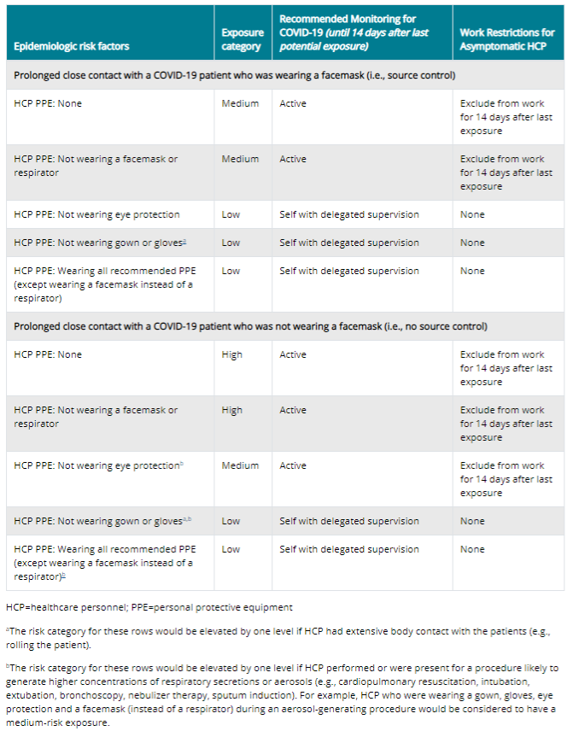

Amendment 1
Non-Patient Passengers
- Non-patient passengers are prohibited from riding in BCEAA ambulances or utility vehicles for the duration of the declared state of emergency in response to the COVID-19 pandemic.
- The only exceptions BCEAA will make is for a single guardian of minor patients or a MPOA who needs to accompany a patient who is unable to make decisions for themselves. No non-patient passenger showing any signs or symptoms of illness will be allowed to ride in BCEAA ambulances or utility vehicles and special considerations should be taken for persons who are classified as high-risk for complications secondary to COVID-19 infection.

Amendment 2

Visitor Policy for BCEAA facilities

- Effective 20:00 hours on 3/24/2020 BCEAA facilities will be closed to all visitors and may only be accessed by employees during their scheduled work hours.

Amendment 3

Self-Monitoring with Delegated Supervision

- If clinician exposure is classified “low-risk” they will be placed into self-monitoring with delegated supervision and provided a monitoring form.
- Clinicians will be expected to take an oral temperature twice daily and record any symptoms or lack of.
- The duration of this monitoring is 14 days.
- If clinicians develop any symptoms listed on the form or record a temperature at or above 100.5, they are to report to the Chief immediately.
- Clinicians will be responsible to turn the completed form in to the Chief upon completion of the 14 day period for discharge from the self-monitoring program.

Amendment 3

Transport of COVID-19 positive patients

When BCEAA is dispatched to transport a patient who has been confirmed to have COVID-19 through testing clinicians will need uphold the highest levels of PPE precautions. The following precautions and steps will be taken to ensure the highest level of provider safety.

- Full PPE precautions will be taken. N95, mask on Pt, glasses, gloves, gown.
- The recirculating fan should be turned on and in the high setting for the entire transport.
- The receiving ER is to be notified as soon as possible.
- Upon arrival to the ER, care is to be handed off based on their instructions. The rear doors of the unit should be left open.
- Crew needs to immediately move to decon the unit and wipe down all hard surfaces with disinfectant. Be sure to include the cab during disinfecting. Crews should maintain PPE during the decon process. Pt care report charting will be delayed until crew and unit decon is completed.
- As long as there was no break in PPE during the call or decon, the exposure potential is classified as low risk.
- MFD should be notified by the Duty Officer to make arrangements for crew to utilize the Clorox Total 360 disinfecting machine at MFD. If MFD is unable to assist, the Duty Officer shall contact the VAMC Fire Department.
- Upon completion of disinfecting, crews are to return to quarters, place their uniforms in the washing machine with hot water, shower and don clean uniforms.
- The ambulance cab should be disinfected once more.
- At this time the unit can be placed back in service.
- Crews will be placed into 14-day self-monitoring.

