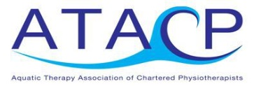
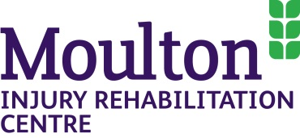

ATACP/CSP Accredited Foundation Programme in Aquatic Therapy

This foundation programme is based around the requirements of “Guidance on Good Practice in Hydrotherapy” (ATACP / CSP 2015) and is aimed largely at Band 5/6/7 physiotherapists who have had little or no undergraduate or post graduate experience in aquatic therapy and provides the minimum competency required to work unsupervised in the pool.

Aimed primarily but not exclusively at physiotherapists – only HCPC registered physiotherapists can continue on to the assessment process and gain accreditation.

The course is recommended by the Aquatic Therapy Association of Chartered Physiotherapists (ATACP).

Venue:
The Chris Moody Centre, Moulton College, Gate 4, Pitsford Road, Moulton, Northants, NN3 7QL

Dates:
Saturday 20th & Sunday 21st October 2018

Time:
09:00-17:00

Cost:
£260 per delegate

Contact Charlotte Brown at charlotte.brown@moulton.ac.uk or on 01604 492222 for more information on how to apply for the course.

