Forensic Entomology: Crime Fighting Insects
Crime scenes involving dead bodies can be pretty gruesome places. Add to that the analysis of maggots and the ick factor increases. Forensic entomology is the study of the insects, both mature and in larval/egg stages, found on or near a corpse in an effort to determine time since death and /or if the corpse has been moved from another location.
When a crime scene is more than a few days old, insect evidence, which insects/maggots are present, is more reliable than other methods, like body temperature, in determining time of death. When a body dies and is left exposed to the elements, it becomes its own ecosystem. It may take only weeks or several months for the body to decompose down to dry bones depending on the location. During decomposition, there are different phases that attract different insects. The first insects to arrive within 24 hours of death are blowflies and other flesh flies. Other species are attracted to the corpse only after decay has progressed. Other insects arrive at the scene ready to devour the insects on the body. Within hours to several weeks post death, maggots offer a wealth of reliable information. Maggots are the larvae of flies. Blowflies are attracted to a corpse very soon after death. They lay their eggs on the corpse, either in a flesh wound or an orifice. Since the development of a maggot is predictable, the time between the first instar/larval stage, the second, and the third instar larva, works like a clock. The third instar feeds for a few days and then moves away from the corpse to pupate. The pupal shell which is eventually shed, protects the developing insect as it metamorphoses into an adult fly. When reading the clock, external factors must be factored in such as temperature. Since insects are cold blooded, their development varies as temperatures vary. Warm temps bring a faster rate of development and cold temps slow the process. By analyzing the temperature and stages of insect development found on and near the corpse, it can be determined when the eggs were first laid by the blowflies, and since blowflies arrive soon after death, time of death can be calculated.
Using maggots to determine time of death is reliable up to when the adults emerge from their pupal covering. After that, you can’t determine if it is still the first generation you are seeing. After one generational cycle is completed, forensic specialists shift to analyzing insect populations, a technique called insect succession.
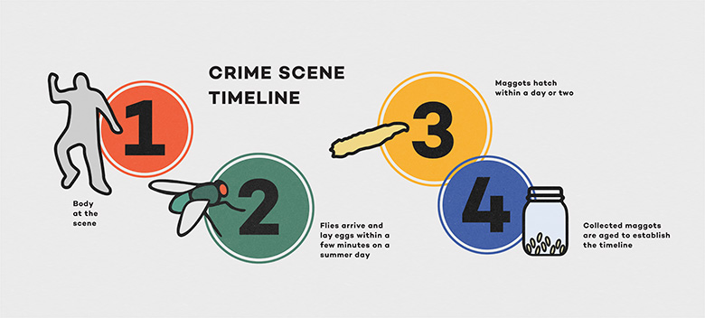
Where do forensic entomologists get the regional info that allows them to analyze crime scenes?
Body Farms
Body farms, each with specific geographic variations in temperature, rainfall, insect populations etc., provide the “ecosystem” that permits forensic scientists to study how a corpse decomposes and which insects participate in that decomposition. There are several such research facilities in the US. They are found in relatively remote areas
so that the bodies being analyzed are not disturbed.
During our lab today, you will mimic the scenes found at a body farm, attracting insects to a piece of meat to simulate corpses. Over the next week, you’ll observe/record the number and types of insects that feed on your “corpses”. The data you collect will be used to determine how the conditions of the crime scene affected the decomposition of your corpse and by extension, time of “death”.
This lab is a modified version of a lab designed by Jennifer O’Brien. The orogonal can be found at:
https://www.sciencefriday.com/educational-resources/forensic-entomology-body-farm/

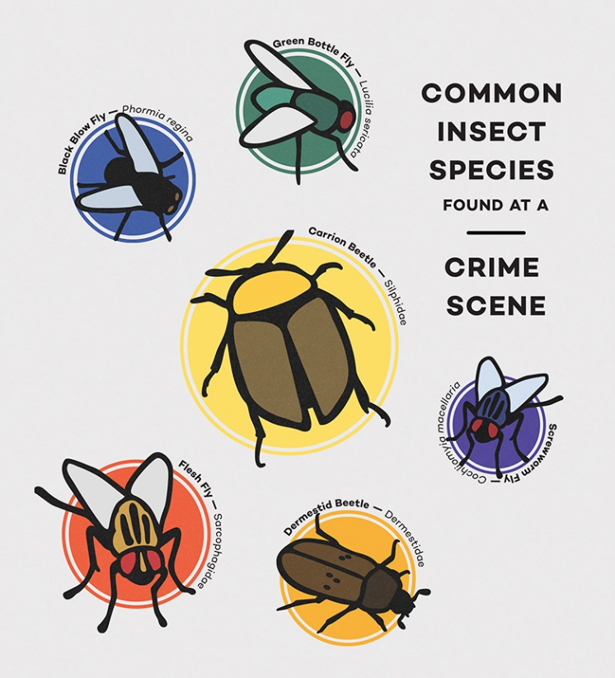
Flies and other insects are attracted to decomposing flesh by the odor the flesh releases. Blow flies and flesh flies are the first to arrive at the scene but there may also be beetles and other insects. The most common blow fly is the green bottle fly. This fly
has an iridescent green hue and can be found near any decomposing matter.
How do environmental conditions affect decomposition and insect development?
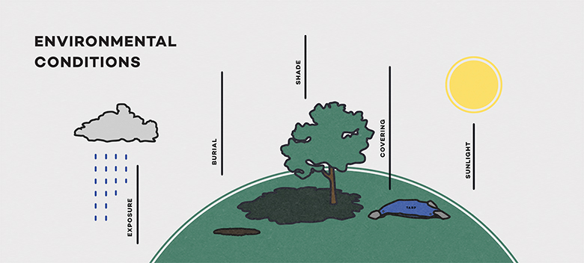
Analyzing the data you collect from your body farm will allow you to determine the insects that are attracted to the corpses at your simulated crime scenes. Pieces of meat or liver will serve as stand-ins for corpses. Since the microclimate of a crime scene affects the insect populations found, the environmental conditions of your body farm will offer data to show how this ecosystem affects insect development.  Material List:  four to five small pieces (2-inch square) of raw steak or liver  ** Raw meat can pose a health risk. Be sure to wash your hands before and after the experiment, and wear latex or nitrile gloves when assembling the body farm and inspecting the cups.  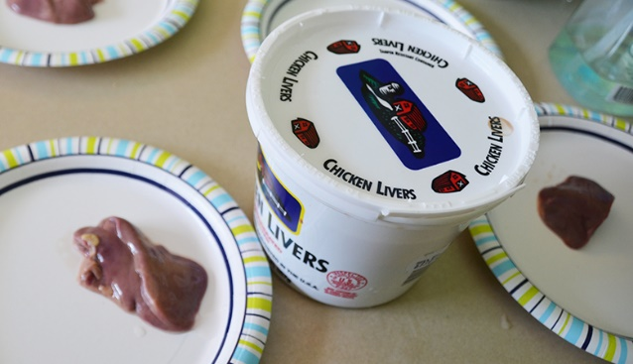  4-5 clear plastic cups (6 oz. or 8 oz.)  Forceps or plastic utensils, Permanent marker, Plastic wrap, Fabric scraps  One or two plastic laundry baskets (with a solid bottom, in case it rains)  Hand lens or magnifying glass, Latex or nitrile gloves  Soil, Crushed, dried leaves, small, broken sticks, or wood chips  Procedure:  1. Decide where your body farm will be located. You will need both sunny and shady areas.  2. Set up your control corpse:  Label the outside of a plastic cup as Control.  Place one piece of meat/liver in the cup  3. Select which three crime scenes you would like to study (listed on the following pages) and follow the directions for setting up those areas of your body farm.  For each crime scene, label the plastic cup with the crime scene case number.  Record the crime scene conditions: sunny/shady etc.  For each crime scene you create, predict what differences you night see when compared to the control cup. Make sure there is a control cup near your corpses…there should be one in the shady area and the sunny area if those are the crime scenes you choose.  Place the “sunny” cups together under an upside-down laundry basket to protect the cups from scavengers. If needed, place heavy rocks on top.  Repeat with the “shady” cups.  Leave your cups outside for the next 7 days, returning each day to make observations.  **Observation Sheet:  Record on an observation sheet data for both the controls and your corpses.  Include:  presence and # of visible eggs, maggots, adult flies, ants, beetles, other insects.  Record the environmental conditions each day.  **Take a photo of each cup in its body farm location at the start and at the finish of this experiment. Take a close up photo of each cup at the start and at the finish of this experiment.  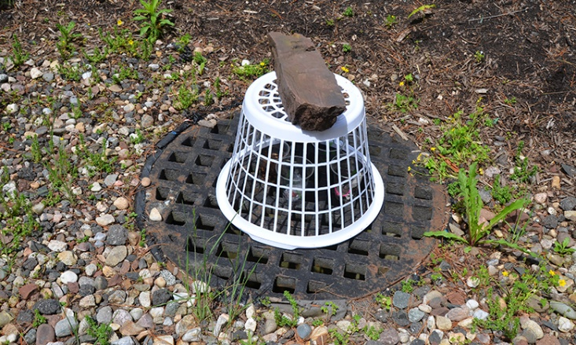 | - Plastic wrap*  - gloves
- 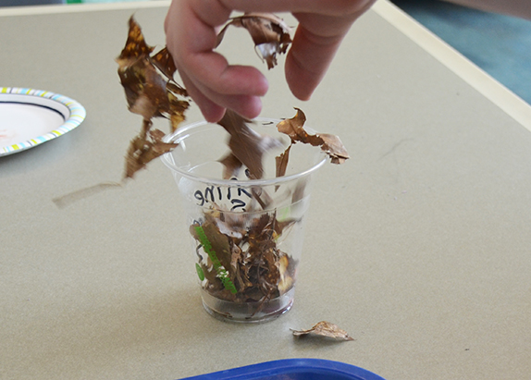
Crime Scene Case #1001
Description: Victim found in the woods, covered with a layer of leaves to hide the body.
The area is shady, and the body is not exposed to the sun.
Recreate the crime scene:
  - — Place a piece of meat in a cup.
  - — Cover with a thin layer (approximately 1 cm) of crushed leaves.
  - — Place your cup in a shady area.
- 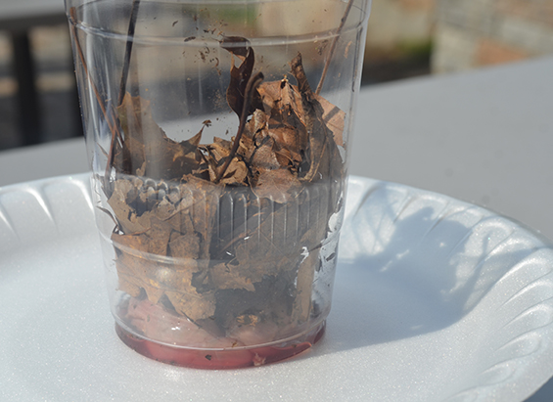
Crime Scene Case #1002
Description: Victim found in a field, covered with a layer of leaves to hide the body.
The area is sunny with no trees to provide shade.
Recreate the crime scene:
  - — Place a piece of meat in a cup.
  - — Cover with a thin layer (approximately 1 cm) of crushed leaves.
  - — Place your cup in a sunny area.
- 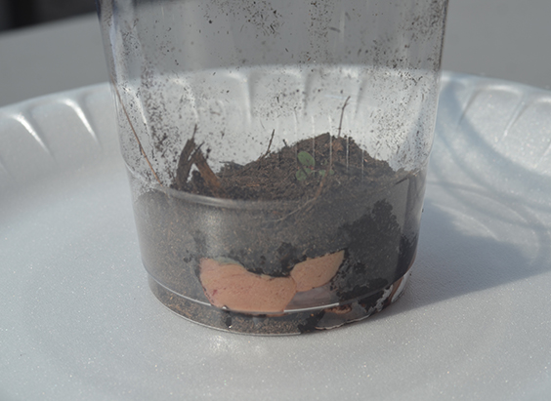
Crime Scene Case #1003
Description: Victim found in the woods, covered with a layer of soil to hide the body.
The area is shady, and the body is not exposed to the sun.
Recreate the crime scene:
  - — Place a piece of meat in a cup.
  - — Cover with a thin layer (approximately 1 cm) of soil.
  - — Place your cup in a shady area.
- 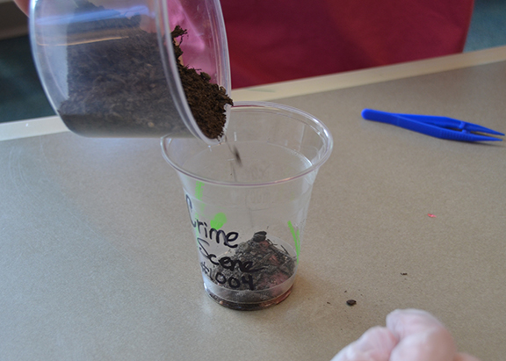
Crime Scene Case #1004
Description: Victim found in a field, covered with a layer of soil to hide the body.
The area is sunny, with no trees to provide shade.
Recreate the crime scene:
  - — Place a piece of meat in a cup.
  - — Cover with a thin layer (approximately 1 cm) of soil.
  - — Place your cup in a sunny area.
- 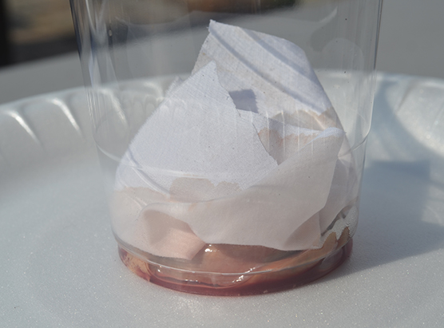
Crime Scene Case #1005
Description: Victim found in the woods, covered with a blanket to hide the body.
The area is shady, and the body is not exposed to the sun.
Recreate the crime scene:
  - — Place a piece of meat in a cup.
  - — Cover the meat with a small piece of fabric. Do not wrap the fabric around the meat.
  - — Place your cup in a shady area.
- 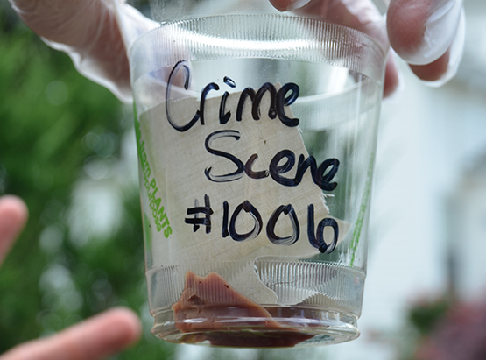
Crime Scene Case #1006
Description: Victim found in a field, covered with a blanket to hide the body.
The area is sunny, with no trees to provide shade.
Recreate the crime scene:
  - — Place a piece of meat in a cup.
  - — Cover the meat with a small piece of fabric. Do not wrap the fabric around the meat.
  - — Place your cup in a sunny area.
- 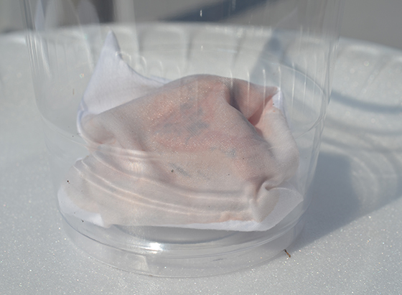
Crime Scene Case #1007
Description: Victim found in the woods, wrapped tightly in a blanket to hide the body.
The area is shady, and the body is not exposed to the sun.
Recreate the crime scene:
  - — Wrap the meat with a small piece of fabric. Be sure that the meat is completely covered.
  - — Place the wrapped meat in a cup.
  - — Place your cup in a shady area.
- 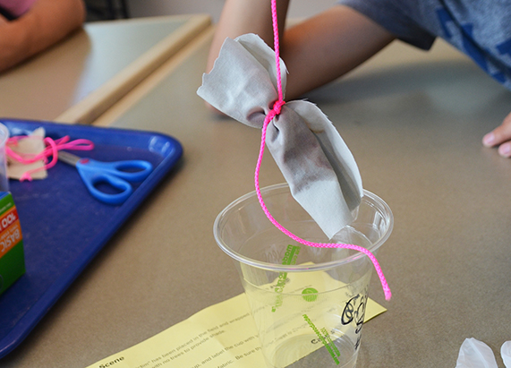
Crime Scene Case #1008
Description: Victim found in a field, wrapped tightly in a blanket to hide the body.
The area is sunny, with no trees to provide shade.
Recreate the crime scene:
  - — Wrap the meat with a small piece of fabric. Be sure that the meat is completely covered.
  - —Place the wrapped meat in a cup.
  - — Place your cup in a sunny area.
- 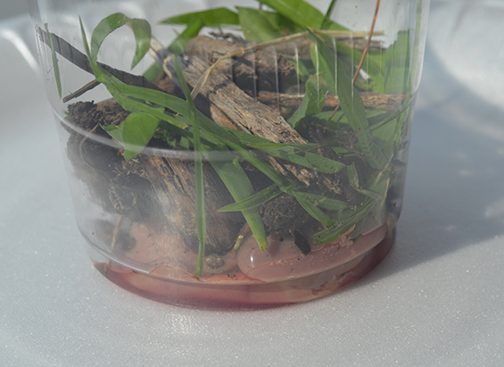
Crime Scene Case #1009
Description: Victim found in the woods, covered with plant scraps to hide the body.
The area is shady, and the body is not exposed to the sun.
Recreate the crime scene:
  - — Place a piece of meat in a cup.
  - — Cover with a thin layer (less than 1 cm) of grass clippings and several (fewer than five) small sticks.
  - — Place your cup in a shady area.
- 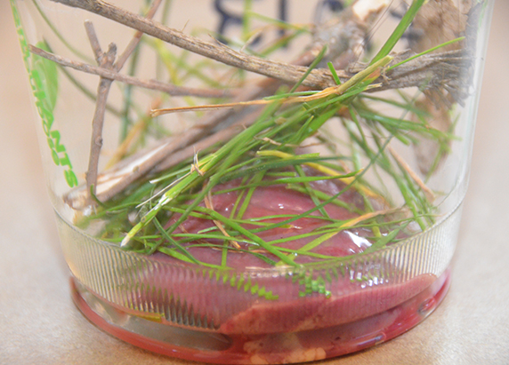
Crime Scene Case #1010
Description: Victim found in a field, covered with plant scraps to hide the body.
The area is sunny, with no trees to provide shade.
Recreate the crime scene:
  - — Place a piece of meat in a cup.
  - — Cover with a thin layer (less than 1 cm) of grass clippings and several (fewer than five) small sticks.
  - — Place your cup in a sunny area.
- 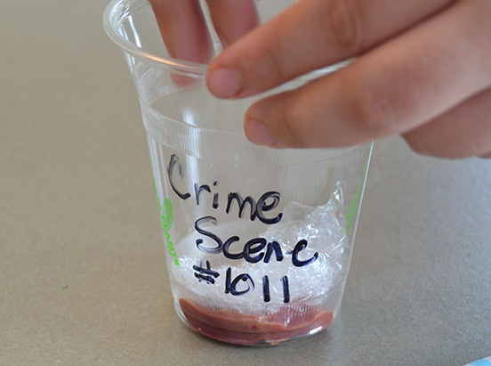
Crime Scene Case #1011
Description: Victim found in the woods, covered with plastic to hide the body.
The area is shady, and the body is not exposed to the sun.
Recreate the crime scene:
  - — Place a piece of meat in a cup.
  - — Cover the meat with a small piece of plastic. Do not wrap the plastic around the meat.
  - — Place your cup in a shady area.
- 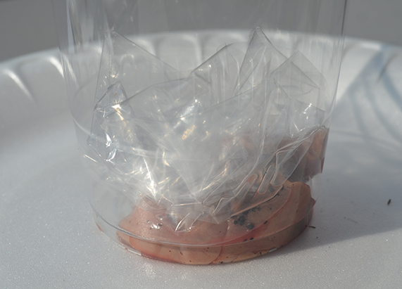
Crime Scene Case #1012
Description: Victim found in a field, covered with plastic to hide the body.
The area is sunny, with no trees to provide shade.
Recreate the crime scene:
  - — Place a piece of meat in a cup.
  - — Cover the meat with a small piece of plastic. Do not wrap the plastic around the meat.
  - — Place your cup in a sunny area.
- 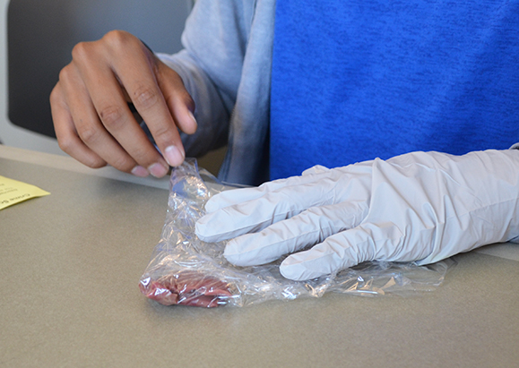
Crime Scene Case #1013
Description: Victim found in the woods, wrapped tightly in plastic to hide the body.
The area is shady, and the body is not exposed to the sun.
Recreate the crime scene:
  - — Wrap the meat with a small piece of plastic wrap. Be sure that the meat is completely covered.
  - —Place the wrapped meat in a cup.
  - — Place your cup in a shady area.
- 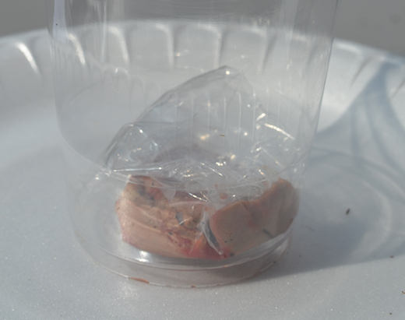
Crime Scene Case #1014
Description: Victim found in a field, wrapped tightly in plastic to hide the body.
The area is sunny, with no trees to provide shade.
Recreate the crime scene:
  - Wrap the meat with a small piece of plastic wrap.
Be sure that the meat is completely covered.
Place the wrapped meat in a cup.
Fly Life Cycles
The green bottle fly is found in most tropical and temperate regions around the world, and it’s often one of the first insects to arrive at a corpse. Scientists have studied the life cycle of green bottle flies and have a good understanding of how environmental variables like temperature affect its rate of development.
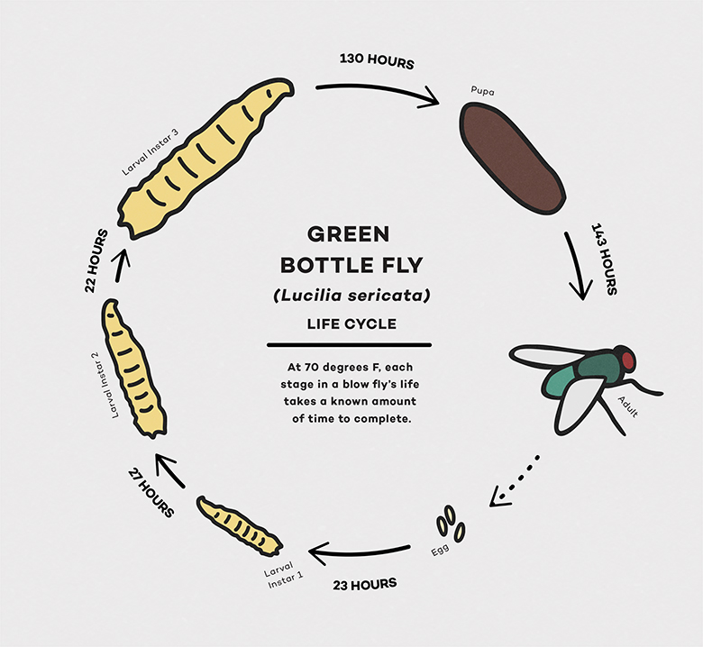 do
Fly development: egg stage followed by larval stage, then pupa, then adult emerges.
the chart below shows how long it takes a maggot to develop into an adult in cool, warm, and hot conditions.
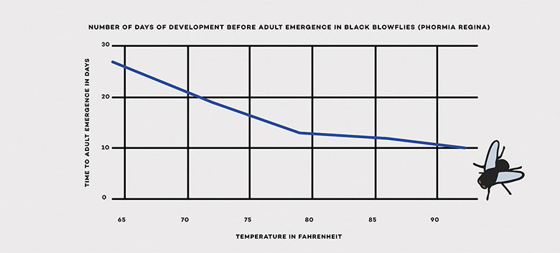

Day 1:
Check out the status of your body farm specimens.
Carefully move any plant material or soil using forceps or plastic utensils to check the surface of the meat, and then return the covering. If you wrapped the meat in plastic or fabric, leave the meat wrapped and only observe insects outside the wrapping.
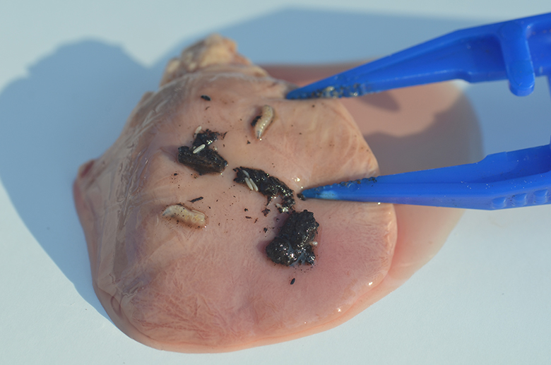
Return to the body farm each day for up to a week to record observations. Day 1 is one day after you placed the cups outside. Day 2 is two days after, and so on. You might have to briefly lift up the laundry baskets in order to see better. On the final day of observation, use forceps or plastic utensils to unwrap any meat wrapped in fabric or cloth. Check to see if the unwrapped meat has insects on it. Be sure to wear latex or nitrile gloves. Dispose of cups, meat, and all wrappings in an outdoor trash receptacle.

Analyzing Your Body Farm
Once all of the control and crime scene conditions have been examined, look for patterns.
**Compare your observations of the crime scene(s) and control cup(s). Look at the number and types of insects you found each day.
**Compare your observations of different crime scene cups. Look at the number and types of insects you found each day.
**Make a bar graph of the number of insects you found on the meat in your control and crime scene cups on the last day. You can graph one crime scene cup and its control, or multiple.
**Answer these questions:
1. How did the number and type of insects found in the control and crime scene cups vary over time?
2. Was your prediction supported by the data you collected? Explain.
3. After comparing all the crime scene and control cups, which conditions attracted more insects? Which conditions attracted fewer?
4. Did the maggots in some cups appear to grow faster than maggots in other cups? If so, why do you think that is?
5. What patterns do you notice about the different crime scene conditions studied?
6. How could the patterns you observed be useful in a real crime scene analysis?
**Calculate the Time of Death
Maggots found at a crime scene can help forensic entomologists determine how long a corpse was there. To understand how, let’s take another look at the Green Bottle Fly Life Cycle to see how long it takes a larva to develop at 70°F into an adult.
Now let’s revisit the black blow fly graph. The graph shows that it takes longer for a black blow fly to develop into an adult when temperatures are cooler than when they’re warmer.
Why does temperature matter? First, insects can only develop if the temperature is above a certain threshold, which varies from species to species. And then to grow from one stage in its life cycle to the next, an insect requires a certain amount of thermal energy, or heat.
Calculating the thermal energy for a given stage of growth entails multiplying the temperature by the time the insect was exposed to that temperature. Because the temperature outside is always changing during the day, scientists use the average daily temperature for this calculation.
The total amount of thermal energy that an insect requires to reach a given stage of its life cycle is referred to as the accumulated degree hour (ADH). Scientists have determined ADH values for many species of fly that can be found on corpses.
If forensic entomologists can determine the life stage of maggots on a corpse at a crime scene, they can estimate how long the body was there. But it’s sometimes hard to figure out life stage just by looking at maggots. Instead, scientists collect the larvae and transfer them to temperature-controlled incubators in the lab. There, they let the maggots develop into adults.
Based on the time it takes the maggots to mature in the lab at a controlled temperature, the scientists can determine how much thermal energy the insects used in the lab. By subtracting that value from the total ADH required for the species’ entire life cycle, the scientists can determine the thermal energy the maggots must have accumulated at the crime scene. Armed with that information, along with data on the average daily temperatures at the crime scene, the scientists can calculate how long it took for the maggots to develop on the corpse, and hence determine the approximate time of death of the body.
Using your local weather conditions, estimate the age of fly larvae found in your body farm.
How to calculate ADH:
Practice by starting with ADH calculations for the green bottle,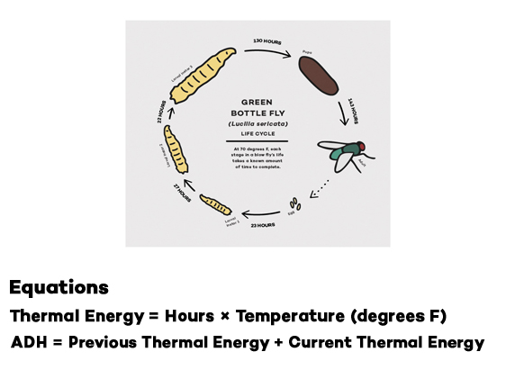
It takes 23 hours for an egg to hatch into a first instar if the temperature is 70ºF.
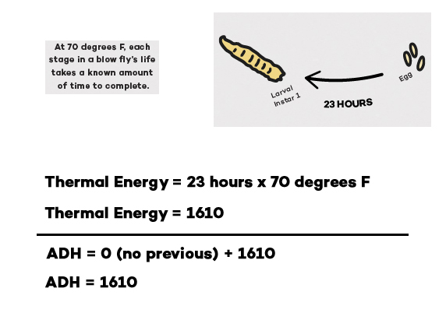
The thermal energy during this stage is 1610. Since this is the initial stage,
the ADH = 1610. (If the temperature were cooler than 70ºF, then the fly would
develop slower, because an ADH of 1610 MUST be reached in order for the fly
to get to the next stage. The ADH is a constant for each stage.)
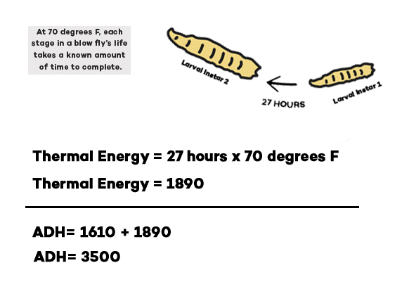
The thermal energy during the next stage is 1890. Adding 1890 to the
previous 1610 gives an ADH of 3500.
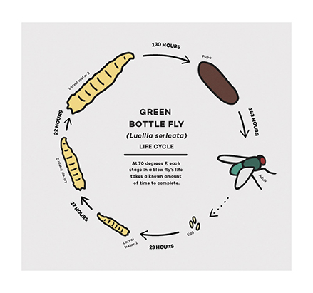
Before beginning, look up the average daily temperatures at your
location during the week of your investigation.
Pick one control cup in which you saw eggs and maggots, and record the
date and average temperature.
**Calculate the Thermal Energy and ADH for each day the eggs or maggots
were present.
**Compare the ADH you calculated to the values of ADH for the green
bottle fly and determine what stage of development your maggots
should have been in on the last day of the experiment.
**Based on your calculations, in what stage of development should the
maggots have been in on the last day of the experiment?
**How precise do you think your calculations are? Why?
**Does your calculation of the total ADH match the physical appearance
of your maggots on the last day? For example, if your calculation corresponds to the ADH required
to reach the 2nd instar, did you observe medium-size maggots?
**What factors could have influenced when the eggs were laid in the cup?

