REGULAR MEETING
APRIL 18, 2019

A Regular Meeting of the Town Board of the Town of Hampton, County of Washington and the State of New York was held at the Town Hall, 2629 State Route 22A, Hampton, New York on the 18th day of April 2019.

PRESENT: David K. O’Brien------------Supervisor
Tamme Taran----------------Councilwoman
Donald Sady-----------------Councilman – came at 8:13pm
Andrea Sweeney------------Councilwoman
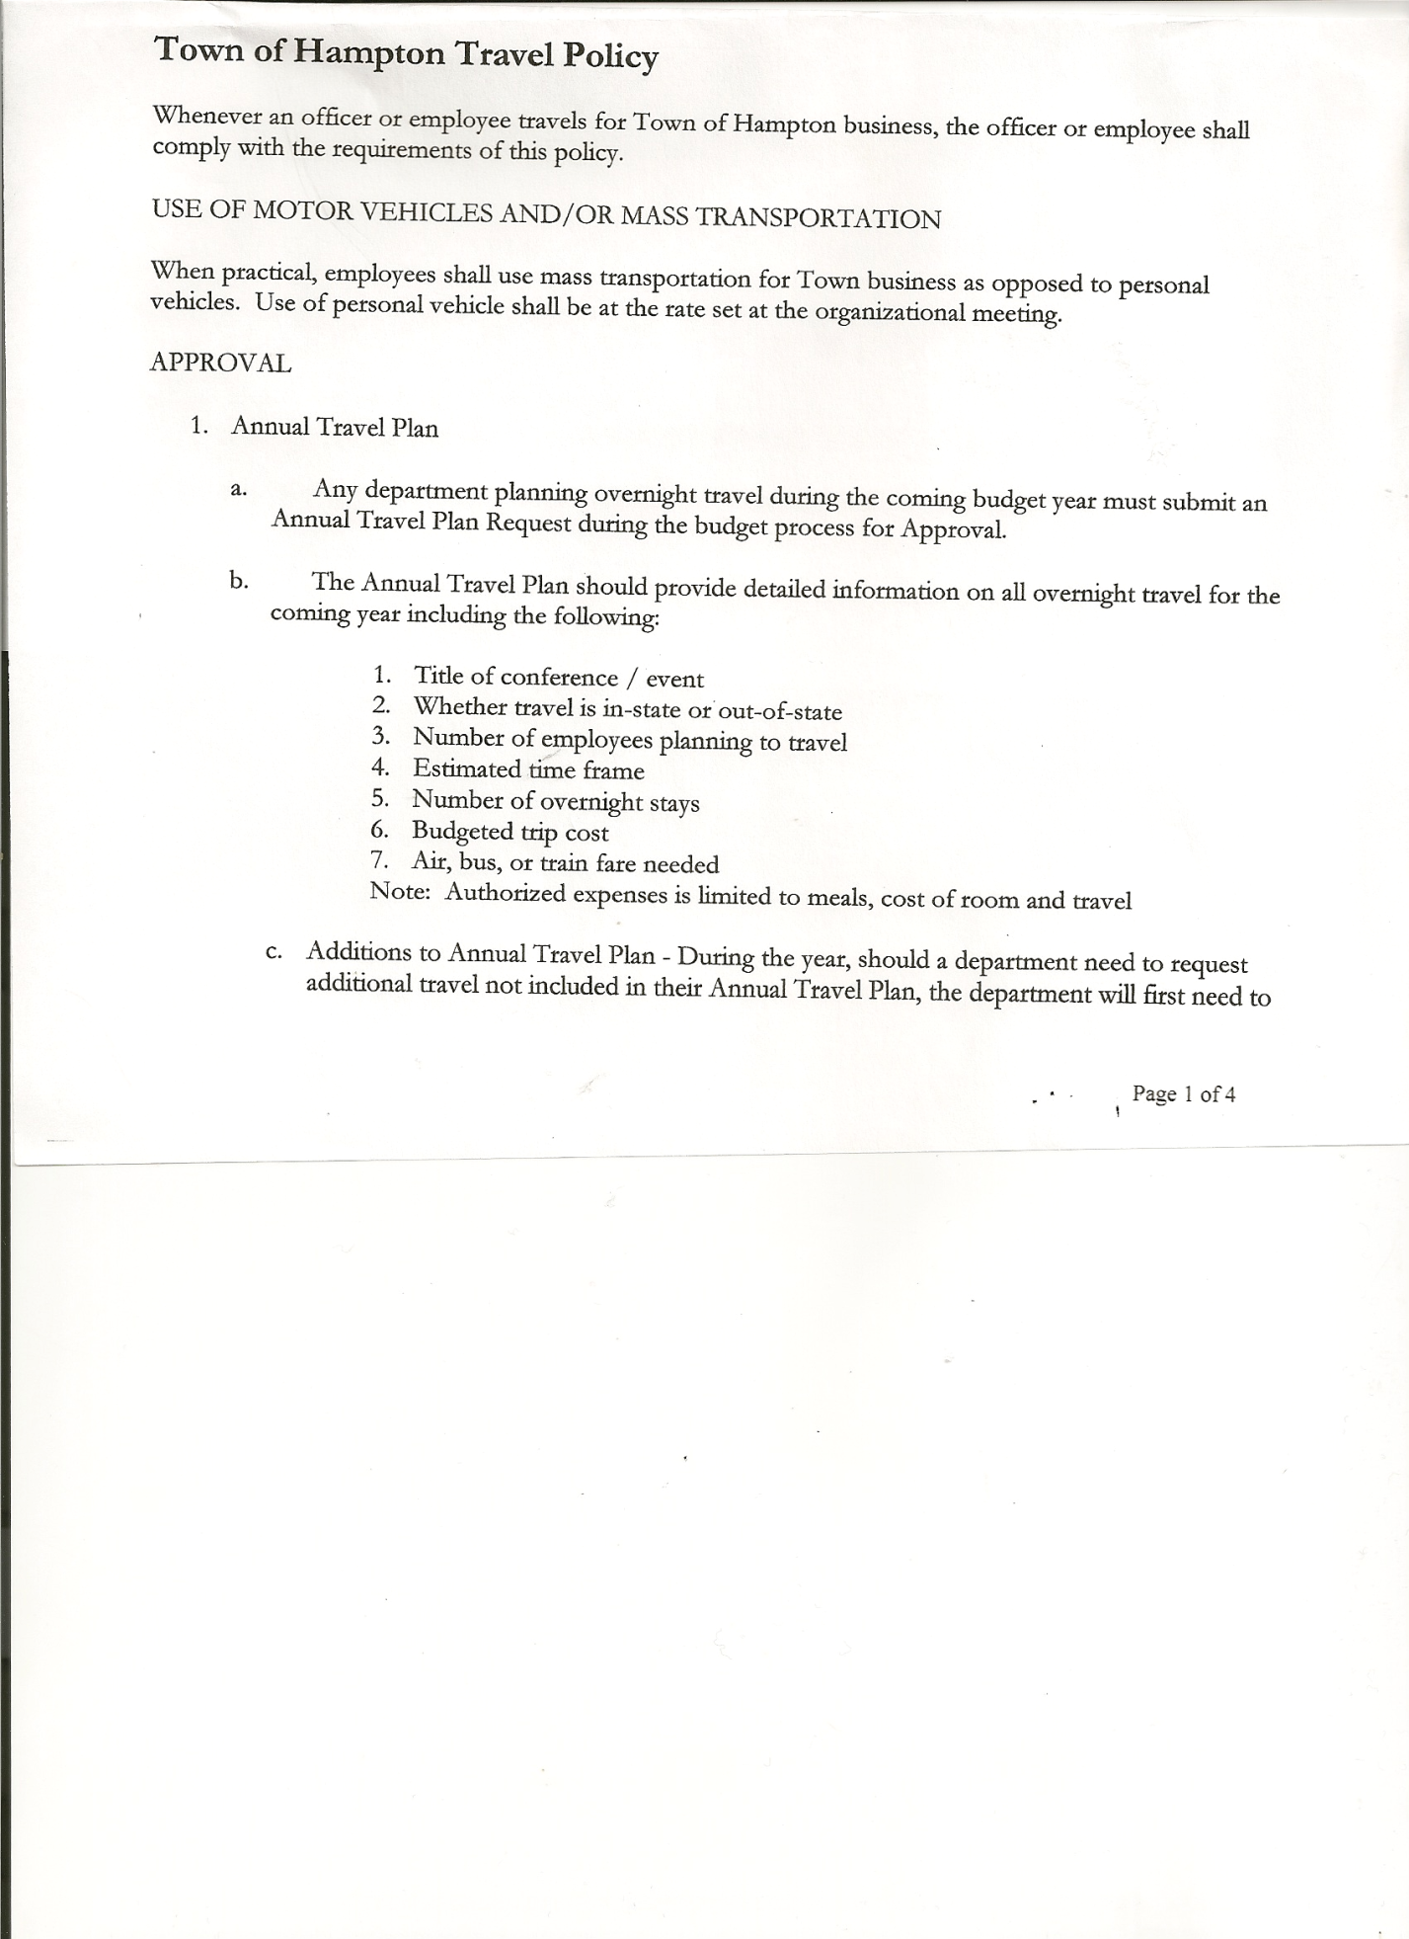
Roger Weeden---------------Councilman
Rebecca Jones---------------Town Clerk
Camilla Shaw----------------Tax Collector/Deputy Town Clerk
Herbert Sady, Jr.-------------Highway Superintendent - absent
Larry Carman----------------Dog Control Officer

Planning Board Member(s): Bonnie Hawley, Chair

Also present: see attached list

The Regular Meeting was called to order by Supervisor O’Brien at 7:30pm, followed by the Pledge of Allegiance. Location of Fire Exits were given. Quorum of board members present.

RESOLUTION NO. 46-2019
APPROVAL OF THE MINUTES
On a motion of Councilwoman Taran, seconded by Councilman Weeden, the following resolution was ADOPTED: Ayes 5 O’Brien, Taran, Sady, Sweeney, Weeden
Nays 0
RESOLVED, that the Regular Town Board Minutes for March 21st, 2019 are approved.

Camilla Shaw, Tax Collector- Submitted March/April 2019 report to the Board and also submitted a Bank Statement to the Board for review and signatures.

Larry Carman, Dog Control Officer…was present and read his report, copy attached.
(report period: March 26, 2019 – April 14, 2019).

Planning Board Report…
- Training in Fort Edward was attended by Steve Fernett and Ginny Kinsey
- Continuing work on Ag Plan
- Next meeting will be May 8th, 2019 @ 7:00pm at the Town Hall

Herbert Sady, Jr., Highway Superintendent submitted his report, copy of which, is attached.
Supervisor O’Brien read the report in Herb’s absence.
Grant process and Highway Truck were discussed.
Grader is still being repaired.
Paving…need a 5 year plan for the roads, asking Highway Superintendent for a plan and Councilman Weeden is willing to work with Herb on a plan.
Discussed weight limits on the dirt roads. Will continue discussion with Highway Superintendent.
Still waiting to hear back from the State on Speed Limits.

TOWN BOARD MEETING
APRIL 18, 2019 PAGE 2

RESOLUTION NO. 47-2019
APPROVAL OF SUPERVISOR’S MONTHLY REPORT
On a motion of Councilwoman Taran, seconded by Councilman Sady, the following resolution was ADOPTED: Ayes 5 O’Brien, Taran, Sady, Sweeney, Weeden
Nays 0
RESOLVED that, the Supervisor’s Monthly report be accepted as submitted for MARCH.
2/28/19 03/31/19
ACCOUNT BALANCE RECEIPTS DISBURSEMENTS BALANCE
General Fund $ 81,548.79 $ 1,452.10 $ 14,353.94 $ 68,646.95
Highway Fund $214,805.97 $ 8.84 $ 45,536.60 $169,278.21
Equipment Reserve $ 94,155.99 $ 29,511.25 $ 0.00 $123,667.24
Fire #1 $ 41,616.00 $ 0.00 $ 0.00 $ 41,616.00
Fire #2 $ 7,756.00 $ 0.00 $ 0.00 $ 7,756.00
Cemetery $ 1,711.43 $ 2.17 $ 0.00 $ 1,713.60
Totals $441,594.18 $ 30,974.36 $ 59,890.54 $412,678.00
All Board Members present signed Supervisor’s Report.

OLD BUSINESS
Goodspeed Services has been contacted and will provide two (2) 95 gallon cans for free to the Town for garbage removal.

Sexual Harassment Training/Workplace Violence….any employee or elected or appointed official needs to complete this training. Supervisor O’Brien will send link to everyone to do a self-session.

NEW BUSINESS
Following a discussion regarding amending Town of Hampton Electronic Banking Policy, the following resolution was introduced.

RESOLUTION NO. 48-2019

MOTION BY: Councilwoman Tamme Taran
SECONDED BY: Councilman Donald Sady
RESOLUTION ADOPTING THE TOWN OF HAMPTON ELECTRONIC BANKING POLICY
WHEREAS, the Town of Hampton has determined that it is desirable to utilize Electronic Banking to streamline Banking and bill paying.
WHEREAS, prior to utilizing Electronic Banking, the TOWN OF HAMPTON desires to adopt a written policy, hereafter known as the “TOWN OF HAMPTON Electronic Banking Policy” which, among other things, establishes what can be performed utilizing Electronic Banking and who can perform various functions.
NOW THEREFORE, BE IT RESOLVED:
That the TOWN OF HAMPTON hereby adopts the TOWN OF HAMPTON Electronic Banking Policy attached hereto; and
TOWN BOARD MEETING
APRIL 18, 2019 PAGE 3

BE IT FURTHER RESOLVED that the Town Supervisor is hereby authorized to setup and monitor Electronic Banking functions according to the attached policy; and
BE IT FURTHER RESOLVED that the Town Clerk is hereby directed to add the following policy to the policy manual/employee handbook for the TOWN OF HAMPTON
TOWN OF HAMPTON Electronic Banking Policy
PURPOSE:
The Town recognizes the use of various electronic banking transactions as a faster, easier, and more efficient substitute for paper transactions. Electronic banking uses computer and electronic technology to streamline the processing and recording of receipts and disbursements, while reducing the cost of processing these transactions. Receipts, disbursements, bill paying and transfers in proper circumstances can be processed via electronic funds transfer (EFT) and online payment services provided by banks, whether transferring funds from one account to another account at the same bank, or making a payment to a vendor's bank across the country. Internal controls, such as written policies and procedures, authorizations, segregation of duties and monitoring, however, are still important in the new technological world.
By adopting this policy, the Town Board of Hampton authorizes the Town Supervisor or their designee to engage in electronic banking in accordance with all applicable laws and regulations including General Municipal Law Section 5-a.
The Agency also recognizes that most banking institutions no longer provide cancelled paper checks to their customers, but instead offer an electronic image obtained online. As such, the Agency authorizes the acceptance of these electronic images in lieu of cancelled checks as required by statute.
SCOPE:
Electronic banking activities will be used for, but not limited, to the following:
- Online banking services (reviewing account balances, retrieving bank statements, downloading
copies of cancelled checks, making stop payment orders, etc.)
- Pre-authorized debit payments
- ACH vendor payments
- EFT or wire transfers
- Electronic Federal Tax Payment System (EFTPS)
- Electronic State Tax Payment System and Withholding
- Electronic Payments from Federal, State, or County

TOWN BOARD MEETING
APRIL 18, 2019 PAGE 4

Online Banking Services are recognized as standard practice and procedure for maintaining an effective cash management program. Online Banking Access to any of the Town's online bank accounts will be managed by the Town Supervisor or their designee to allow other users restricted access as necessary to their specific accounts (Town Clerk, Tax Collector, and Town Justice) for banking functions as needed. (Examples of various online banking functions include monitoring account balances, issuing stop payment orders, retrieving copies of cancelled checks, statements, etc.) payment of bills, deposits where practical and transfers between accounts.
Electronic Funds Transfers (EFT's) and wire payments can only be initiated by the Executive Director or their designee. The recording of such transactions will be captured manually by the Budget Officer through the use of journal entries. Dual approvals are required for any transaction with an end recipient not a TOWN OF HAMPTON account or in a different financial institution. A record of these transactions will be provided to the Town Supervisor within three days who will review and retain these records for a period of three years.
ACH Vendor Payments are authorized by the Town Supervisor or their designee after standard processing and recording through the accounts payable transaction cycle and claims auditing process. Recording of ACH vendor payments will be the responsibility of the Budget Officer through the standard posting of the monthly cash disbursements journal. All payments made through this process are subject to the same claims audit process as exists currently with paper drawn checks.
Pre-authorized Debit Payments are authorized by the Town Supervisor or their designee. The Budget Officer is responsible for making said payments and will provide the Town Supervisor a record of such transactions for his records. Recording of such transactions will be captured through Quick Books or the accounting system currently in use or manually by the Town Supervisor or their designee through the use of journal entries.
Monitoring
The Town Supervisor or their designee is responsible for implementing adequate internal controls for each of the electronic banking methods utilized. An effective internal control system includes, but is not limited to, segregation of duties, proper authorization, and adequate documentation for all electronic transactions. All records will be provided with the bank records to be reviewed at each Town Board Meeting.
DATED: April 18, 2019 Supervisor O’Brien AYE
Councilwoman Taran AYE
Councilman Sady AYE
Councilwoman Sweeney AYE
Councilman Weeden AYE

Received report from NYS Agriculture and Markets our Municipal Shelter Inspection Report our dog shelter services were rated “Satisfactory”.

Due to the cost for a FAX line…we will be switching to E-Fax thru the computer.

Quarterly Audits will be scheduled for May 16th, 2019, next regular town board meeting.

TOWN BOARD MEETING
APRIL 18, 2019 PAGE 5

Hampton Roundtable has submitted a Town Hall Use Form.
RESOLUTION NO. 49-2019
TOWN HALL USE
On a motion of Councilman Sady, seconded by Councilman Weeden, the following resolution was ADOPTED: Ayes 5 O’Brien, Taran, Sady, Sweeney, Weeden
Nays 0
RESOLVED, to approve the request from Bonnie Hawley to use the Town Hall on Friday, April 19th, 2019 for a workshop to create an Easter Centerpiece.

The Town Clerk’s report for March 2019 was submitted to the Board. The Town Clerk had Board Members review and sign bank reconciliation statements for the Town Clerk Account and Special Town Clerk Account dated March 31st, 2019.

PUBLIC COMMENTS/COUNCIL COMMENTS
Bonnie Hawley would like to see a signboard of some kind over by the new Fire House on County Route 11 so as to advertise events/etc going on in town. Matt Pratt will check with the Fire Company on this request.
Bonnie also mentioned that the Miller Chapel Historians are planning on having a 170th Anniversary celebration for the Miller Chapel on October 18th & 19th, 2019.
Suggestion for the next newsletter from the Planning Board…would like some info in there in regards to Mobile Homes coming into Town.

RESOLUTION NO. 50-2019

AUDIT OF CLAIMS
On a motion of Councilwoman Taran, seconded by Councilman Sady, the following resolution was ADOPTED: Ayes 5 O’Brien, Taran, Sady, Sweeney, Weeden
Nays 0
RESOLVED that the bills have been reviewed by the Town Board and are authorized for payment in the following amounts.
General Fund No. 57 through No. 71 $ 2,775.23
Highway Fund No. 27 through No. 40 $10,849.36
Total both funds $13,624.59

On a motion of Councilman Sady, seconded by Councilwoman Taran, the meeting adjourned at 8:52pm. All in favor Aye.

Respectfully submitted,

Rebecca S. Jones, RMC
Town Clerk

