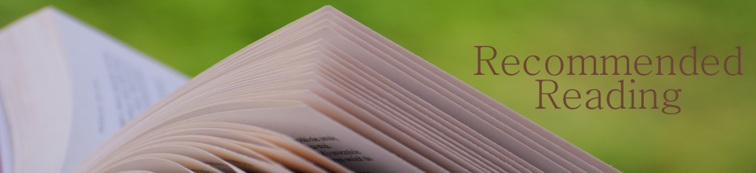

Suggested Reading: Lady Bird Johnson
Compiled by Leslie Goddard

Lady Bird Johnson: Hiding in Plain Sight by Julia Sweig (2021)

Lady Bird and Lyndon: The Hidden Story of a Marriage That Made a President by Betty Boyd Caroli (2015)

A White House Diary by Lady Bird Johnson (originally published 1970)

Wildflowers Across America by Lady Bird Johnson and Carlton B. Lees (2000)

Lady Bird Johnson: An Oral History by Michael L. Gillette (2013)

Lady Bird: A Biography of Mrs. Johnson by Jan Jarboe Russell (2016)

FOR CHILDREN:
Lady Bird Johnson, That’s Who!: The Story of a Cleaner and Greener America by Tracy Nelson Maurer (2021)

Miss Lady Bird’s Wildflowers: How a First Lady Changed America by Kathi Appelt (2021)

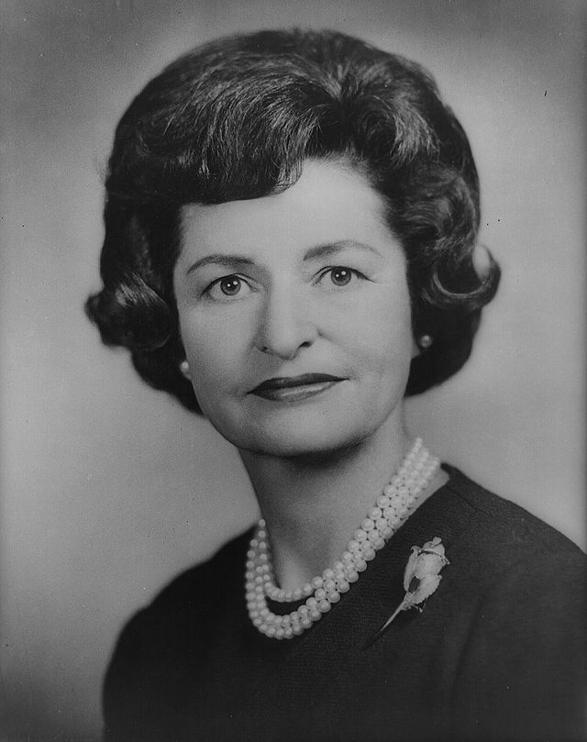

TIMELINE

1912 – Claudia Alta “Lady Bird” Taylor born Dec. 22 in Karnak, TX.
1934 – Lady Bird marries Lyndon B. Johnson
1963 – Lady Bird becomes First Lady of the United States
2007 – Lady Bird Johnson dies of natural causes at age 94

