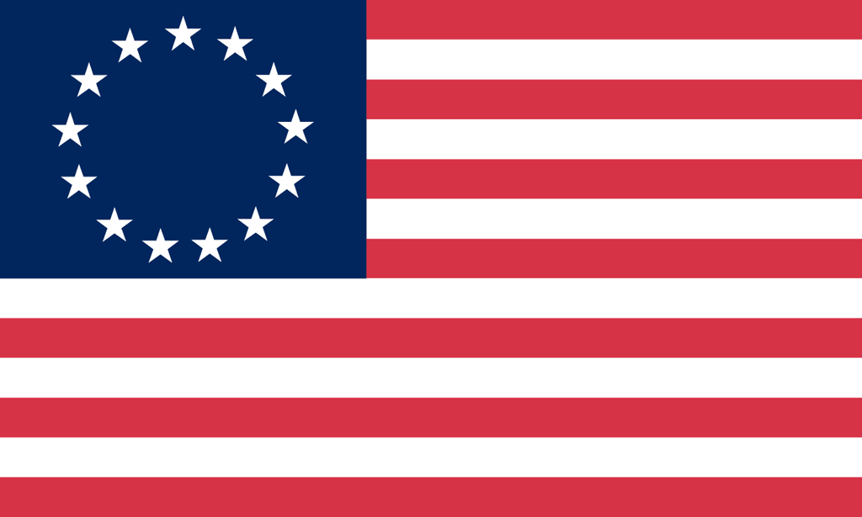U.S. History with Mr. Brown Name _______________________________ Period _____
European Exploration Learning Goals 2.0
All of the facts in your notes are important and are STAAR testable materials. Learning goals are the specific facts that WILL be on the C-Scope unit tests.

Learning Goal | Test Q#
Groups like the Pilgrims, Puritans, and Quakers went to the New World seeking Religious Freedom. | 12
The French were more interested in the Mississippi River and access to the Great Lakes they were mainly fur trappers and traders so they wanted access to the wilderness and water transportation routes | 20
The major era we are studying is Exploration and Colonization | 26
Columbus was trying to find a western sailing route to Asia
The Three G’s; God, Gold, and Glory were the motivators for European countries to explore and settle in the new world. European countries like Spain wanted to spread Christianity to the New World. Other European settlers were seeking religious freedom. Countries wanted to gain wealth in the new world in the form of food, furs, and other resources as well as gold and silver. Countries wanted to gain power by spreading their territory and control. Explorers wanted fame and importance because of their finds.  Three G motivators for European Colonization included specifically: Adventure, Political Freedom, Land, Religious Freedom, trade, economic opportunities, escaping debt and prison | 12

