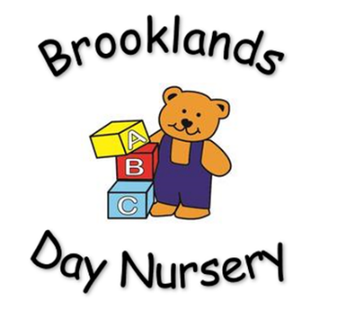
Brooklands Private Day Nursery
Uncollected child Policy

Aim: To ensure the safe collection of all children.
Rationale:
To enable us to ensure the safety and emotional well-being of the children in our care, we have in place guidelines for staff to follow in the event of a child not being collected from nursery.
Procedure:
Whilst your child is in our care, we are primarily responsible for their health, safety and well-being. It is for this reason that we must insist you collect your child on time. Children who are collected late begin to feel frightened and abandoned, which in turn affects their overall well-being. It is your responsibility as parent/carer to ensure that your child is collected on time, by yourself or another responsible adult.
If another person is collecting your child, you MUST inform the nursery, giving a name, a description and a password. Anyone under 16 years of age will not be permitted to leave the nursery with your child.
Should a child not be collected from nursery on time, the senior member of staff will endeavour to contact the parent/carer or another authorised person, as listed in the child’s contact file.
In the instance that we are unable to contact a suitable person to collect the child, arrangements will be made by the senior member of staff to ensure that suitably qualified members of staff stay on the premises until the person collecting the child arrives. For which, there will be an overcharge payable. For this time a charge of £1 per minute will be payable.
In the unlikely event that we have had no contact with the parent/carer, after 30 minutes, the senior person has a duty to inform social services (MASH team) or the police and ask for further advice.

Emergency contact numbers
Social services (MASH): 0161 770 7777 - 8.40am - 5.00pm, Monday to Friday.
Police: 999

This policy will be reviewed every 12 months by management.

