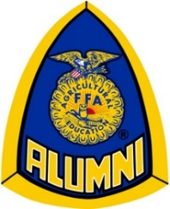
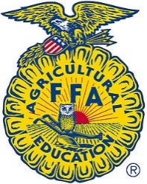
New Richmond FFA Family, Friends and Alumni

Scholarship Application

DUE MARCH 1st, 2017 – Submitted by the end of the school day to Mrs. Sauvola.
Late or incomplete applications will not be accepted.

The New Richmond FFA Family, Friends and Alumni affiliate is proud to offer up to $1000 in scholarships to students who are pursuing studies in agricultural fields at a short-course, technical school, or college. Our local FFA alumni affiliate recognizes the important role agriculture has in our local economy. We’re confident our scholarship program will help deserving students open the doors of opportunity in continuing their education.
To be eligible for this scholarship, there must be proof that you have made a reasonable contribution to the New Richmond FFA Family, Friends and Alumni group throughout your year(s) of participation.

General Information-

Member Name: _________________________________________________________

Parent/Guardian Name(s): ________________________________________________

Address: ______________________________________________________________

Phone: _______________________________________________________________

Email Address: _________________________________________________________

School Attending: _______________________________________________________

Degree/Program: _______________________________________________________

Applicants must be graduating seniors in good standing with the National FFA Organization and New Richmond FFA Chapter.

Rules and award selection for the scholarship will be approved by members of the New Richmond FFA Family, Friends and Alumni affiliate. Parents of applicants will not be permitted to serve on the selection committee. All rules are subject to change without notice.

Scholarship recipients will be announced at the annual FFA awards banquet in April. Money will be dispersed after successful completion of the first semester; details will be provided to the winner(s).

Please attach the following, in typed material format, with this cover sheet-

Provide a resume (see attached sample) listing the following categories:

- Years of involvement in FFA (including middle school locally or elsewhere). Note: Please list School/State if this pertains to you.

- Local FFA Activities

- FFA Activities Beyond the Chapter Level

- Activities with Local FFA Alumni

- Community Involvement

Answer the following essay questions (on separate page(s)). Each question should not exceed one page.

Question 1: How has FFA made an impact on you?

Question 2: How are you going to take what you’ve learned in FFA and use it in the future?

I have read and understood the above scholarship criteria.

Student Signature: ______________________________________________________ Date: _________________________

Parent/Guardian Signature: _______________________________________________ Date: _________________________

 | Excellent 10-8 | Above Average 7-4 | Average 3-1 | Weight | Total
Local FFA Chapter Activity | Involved in 10+ FFA activities at the local level | Involved in 5-10 FFA activities at the local level | Involved in 0-5 FFA activities at the local level | ____ x 2
FFA Activity Beyond the Chapter Level | Involved in 10+ FFA activities beyond the chapter level | Involved in 5-10 FFA activities beyond the chapter level | Involved in 0-5 FFA activities beyond the chapter level | ____ x 3
Activity with Local FFA Alumni | Involved in 10+ activities with local alumni | Involved in 5-10 activities with local alumni | Involved in 0-5 activities with local alumni | ____ x 2
Community Involvement | Involved in 10+ community activities | Involved in 5-10 community activities | Involved in 0-5 community activities | ____ x 1
Answer to question #1 | Candidate provided a powerful, meaningful statement on how FFA has impacted them and how FFA has made a difference in their life | Candidate gave examples of what they have done with FFA and why they are interested in FFA | Candidate only briefly talked about how FFA has impacted them and why they have interest in FFA | ____ x 3
Answer to question #2 | Candidate provided a powerful, meaningful statement on what FFA has taught them and how they will use these skills in the future | Candidate gave examples of how FFA has taught them and how they will use these skills in the future | Candidate only briefly talked about how FFA has taught them and how they will use these skills in the future | ____ x 3
Are they an FFA officer? |  | YES ______ | NO______ | 10 pts
 |  |  | Maximum Possible  150 points | TOTAL

Essay question 1: How has FFA made an impact on you?

Essay question 2: How are you going to take what you’ve learned in FFA and use it in the future?

(Sample FFA Resume)

John E. Johnson

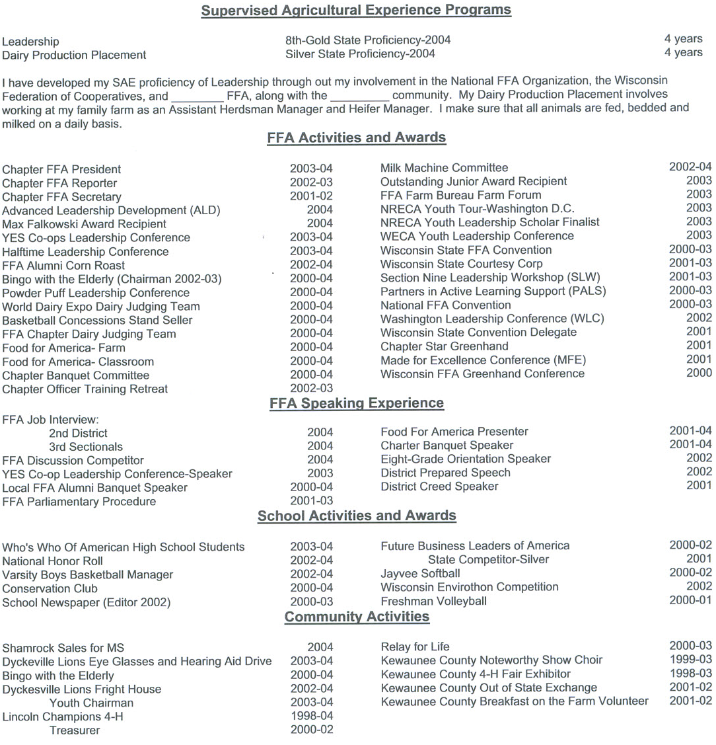

Advisor Evaluation Form
New Richmond FFA Family, Friends and Alumni Scholarship

Rank the student’s demonstrated ability in the following areas: (5 = most ability)

FFA Participation | 5 | 4 | 3 | 2 | 1
Citizenship | 5 | 4 | 3 | 2 | 1
Leadership | 5 | 4 | 3 | 2 | 1
Cooperation | 5 | 4 | 3 | 2 | 1
Community Service | 5 | 4 | 3 | 2 | 1
Public Speaking Skills | 5 | 4 | 3 | 2 | 1
Written Communication Skills | 5 | 4 | 3 | 2 | 1
Ability to Relate to Peers | 5 | 4 | 3 | 2 | 1
Ability to Relate to Authority Figures | 5 | 4 | 3 | 2 | 1

Additional Advisor Comments:

______________________________________________________________________________________________________________________________________________________________________________________________________________________________________________________________________________________________________________________________________________________________________________________________________________________________________________________________________________________________________________________________________________________________________________________________________________________________________________________________________________________________________________

Advisor Signature: ___________________________________________________ Date: _________________________

