Rock City Church Unoffendables
Curriculum

Contents

Introduction………………………………………………………………………..........Page 4

Table of Contents

Lesson 1: “A Clean Heart”……………………………………..………………….....Page
Lesson 2: “It’s Not Fair”...........…………………………………………………….. Page
Lesson 3: “Mad at Dad: When Fathers upset us.…………………………..Page
Lesson 4: “Because I say so”………...……………………………………….........Page
Lesson 5: “Stronger than the Giants”…………………………………………..Page
Lesson 6: “A Precious Stone”…………..…………….………………………........Page
Lesson 7: “Building others up”..………………………………..…………..........Page
Lesson 8: “Forgiving others” ………………………...........................................Page
Lesson 9: “He is My Defender”………….………………………………………...Page
Lesson 10: “Don’t Judge Others”……………………………………………........Page
Lesson 11: “Getting It Right”.........………………………………………………..Page
Lesson 12: “Will you Forgive Me?”……………………….................................Page
Lesson 13: “Walking in Forgiveness”…………………………………………...Page

Forgiving Others Mark 11:24-26

KINGDOM KADETS: FALL LESSON 8
AGE: NURSERY (INFANTS & TODDDLERS 0-2)
Adopted From Bait of Satan by John Bevere

Lesson Topic: Forgiving Others

LESSON | WHAT CHILDREN DO | SUPPLIES | PREPARATION
1  Getting Started | Introduction/Ice Breaker:  Hokey-Pokey | No Supplies Needed | No Preparation Needed
2  Bible Exploration.  Key Verse Activity | Key Verse:  Ephesians 4:32  Bible Story:  MARK 11:24-26 | No Supplies Needed  Kids Bible | No Preparation Needed
 | Bible Activity For Infants:  Forgiveness Makes us Clean | -Mirror  -Erasable Marker  -Paper towel or rag.  -Spray bottle with water. | No Preparation Needed
 | Bible Activity for Toddlers:  Forgiveness Makes us Clean | -Colander  -Two clear plastic cups  -Water  -Small rocks | No Preparation Needed
LESSON | WHAT CHILDREN DO | SUPPLIES | PREPARATION
3  Weaving Faith  Into Life | Craft/Make and Take For Toddlers:  Forgiveness Soap | -Bar Soap  -Colored Pencils or Markers  -Scissors  -Glue | - You can get inexpensive soap bars from the Dollar Store.  -Design the soap cover and make copies before class. (You can draw a design or you can make it on your computer).
Prayer Points:
Asking God to enable you to truly forgive the people who have offended you so that you will be able to receive God’s forgiveness.

4  Lasting Impressions | Faith at Home:  Talk about how to share what they learned with their families. | What parents can do at home:  Teach the kids about forgiveness using the Parable of the Lost Son (Luke 15:11-32) and have fun making this cute craft with your kids.  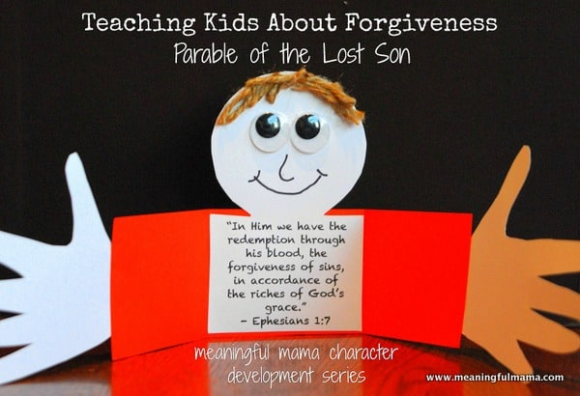  https://meaningfulmama.com/teaching-kids-forgiveness-parable-lost-son-craft.html

Lesson Topic: Forgiving Others

Lesson Background/Foundation for Teachers:
Are you forgiving others so that you might receive forgiveness? We live in a culture where we don’t always mean what we say. Consequently we do not believe others mean what they say to us. A person’s word is not taken seriously. But when Jesus says something, He means it. He walks at a level of integrity that transcends our culture or society. Are you taking Jesus seriously?

Introduction Activity: Hokey-Pokey
This game is super fun to play and helps the kids follow instructions and learn the names for their body parts. The song “Hokey-Pokey” is a simple one with instructional lyrics. Playing is easy (you just do as the song says) and there are no losers!
You can find the song in YouTube : Jesus Hokie Pokie Song (Little Praise Party)`

Praise & Worship:
- Song 1: You Forgive Me (Lifetree Kids)
- Song 2: Love One Another (Little Praise Party)
- Song 3: Brand New Day (Little Praise Party)

Key Verse: Ephesians 4:32 New International Version (NIV)
³² Be kind and compassionate to one another, forgiving each other, just as in Christ God forgave you.

Bible Story: Forgiving Others

- Scripture Reference: MARK 11:24-26
Narrative of Story: Therefore I say to you, whatever things you ask when you pray, believe that you receive them, and you will have them. And whenever you stand praying, if you have anything against anyone, forgive him, that your Father in heaven may also forgive you your trespasses. But if you do not forgive, neither will your father in heaven forgive your trespasses.- MARK 11:24-26

Bible Activity for Infants: Forgiveness Makes us Clean

- Supplies Needed:
-Mirror
-Erasable Marker
- Paper towel or rag.
- Spray bottle with water.

- Directions:
- Begin by holding the mirror for each baby to see their own reflection.
- Color the mirror with the erasable marker and tell the kids that staying ,mad at others (unforgiveness) makes us look dirty in God’s sight.
- Hold the mirror for the children to each see their distorted reflections.
- Spray the mirror with a couple squirts from the water bottle, and then begin wiping the mirror with the rag or paper towel, let the older babies help you as you tell them that forgiveness is just like the spray bottle and the paper towel- it makes us clean again.

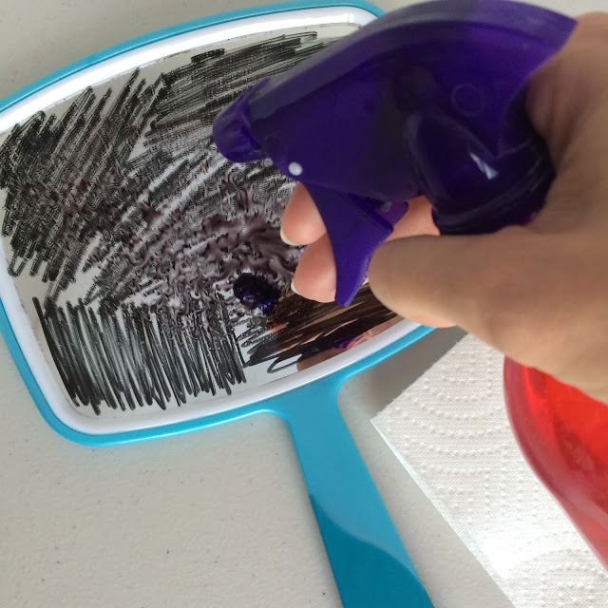
Activity from faithsprouts.blogspot.com

Bible Activity for Toddlers:

- Supplies Needed:
-Colander
-Two clear plastic cups
-Water
-Small rocks

- Directions:
-Fill one cup with water, tell the kids that this cup represents you and me.
- Let the toddlers take turns adding a couple of rocks to the water. Tell the kids that the rocks represent bad feeling like anger against other people (unforgiveness).
-Take the colander and tell the kids that it represents “Forgiveness” and explain that forgiveness makes us clean from the bad feelings like anger. Use the colander to drain the water in the second cup and show the kids how the water (you and me) is clean again.

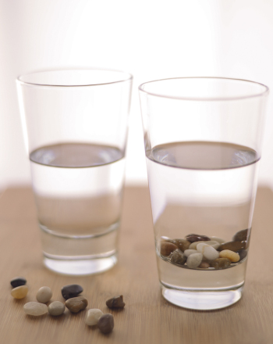

Craft/Make & Take for toddlers:

- Title: Forgiveness Soap
- Supplies Needed:
-Bar Soap
-Colored Pencils or Markers
-Scissors
-Glue

Directions:
-Design one soap cover and make copies (you can draw a design or you can make it on your computer).
- In class have your children color the patterns, cut them out, and glue them around the soap bars.

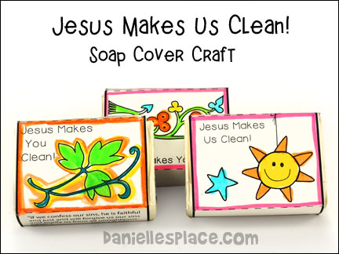

Activity from www.daniellesplace.com

Closing Prayer: Asking God to enable you to truly forgive the people who have offended you so that you will be able to receive God’s forgiveness.
Faith At Home:
- Description: Teach the kids about forgiveness using the Parable of the Lost Son (Luke 15:11-32) and have fun making this cute craft with your kids.

Activity from www.meaningfulmama.com

https://meaningfulmama.com/teaching-kids-forgiveness-parable-lost-son-craft.html

