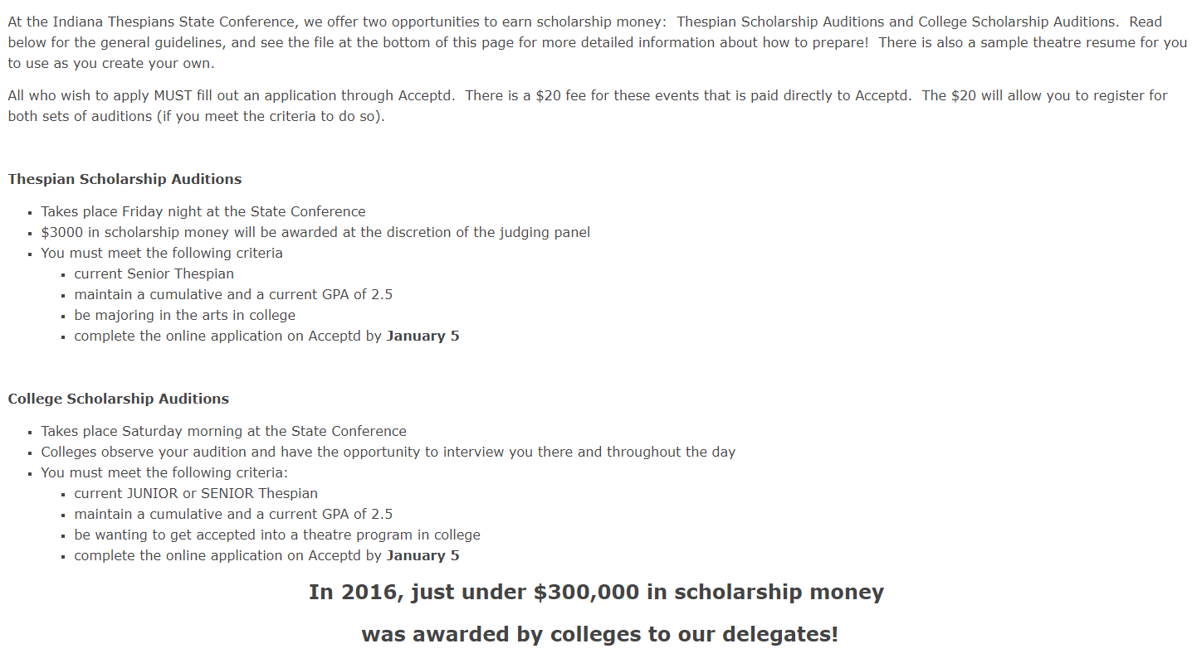

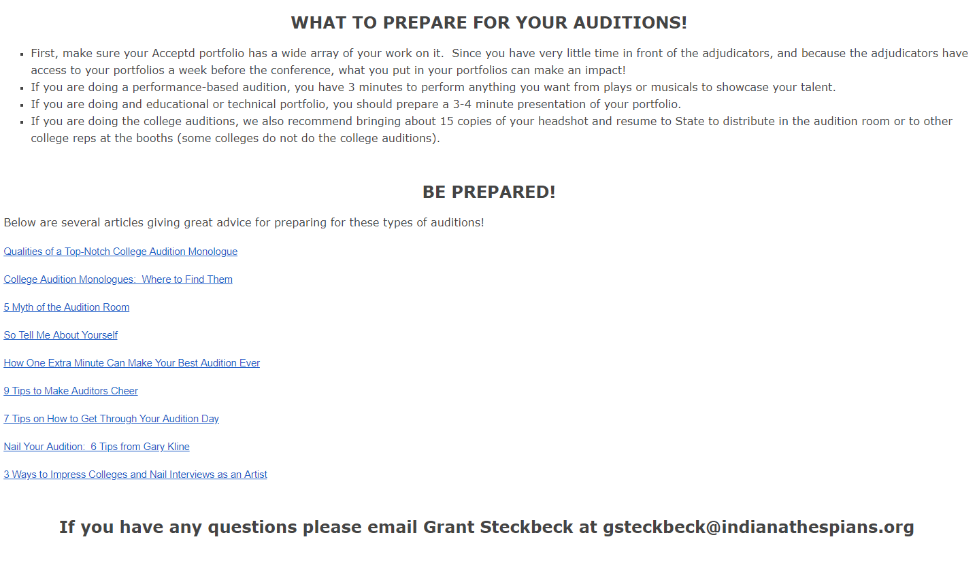

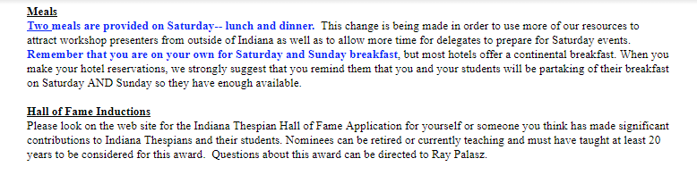

Other information needed:

Must turn in health form, code of conduct, general information sheet, and $25 deposit for state by December 1. Turn everything into Mrs. Neth. Be sure to give this to her, NOT just put on her desk!
All other fees must be paid by December 14 or you may lose your spot to someone who has paid everything!
IE’s are a first come, first serve! Please check requirements for songs, monologues, etc. to be sure they can be done. If you need to get permission, be sure to do so!
Senior scholarships must be done online! Go to Indiana Thespians page at https://sites.google.com/site/indianathespians/state-conference for information and link to apply.
Any other questions, check ITS page or go to https://sites.google.com/site/indianathespians/state-conference .
Email me at bgustas@lcscmail.com if you have questions that you can not find elsewhere!

