Texas History with Mr. Brown Name ____________________ Period _____
Chapter 6.2 Review France Looses the Race for Texas

Directions: Use your Study guide to answer the following questions
1) The “Chicken War” demonstrated Spain’s ___________________________ in East Texas.
2) Why did the Spaniards want to prove they controlled East Texas?
3) At each mission, Aguayo left priests, supplies, and enough __________________ to impress the Native Texans in the area.
4) One hundred soldiers and six brass cannons were stationed in the presidio as a show of _____________________________.
5) For its new colonies to grow and survive, Spain needed:
6) In 1719 Aguayo asked the viceroy to send ___________________________ to Texas from Spanish colonies in the Canary Islands.
7) With Spain so firmly established in East Texas, relations with the French began to take on:
8) What did Spain focus on after they established their dominance in East Texas?

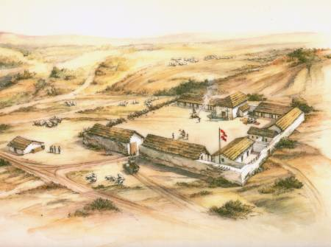
Spanish Presidio

