**A Sick Family Christmas Shoot** by Mike Moran

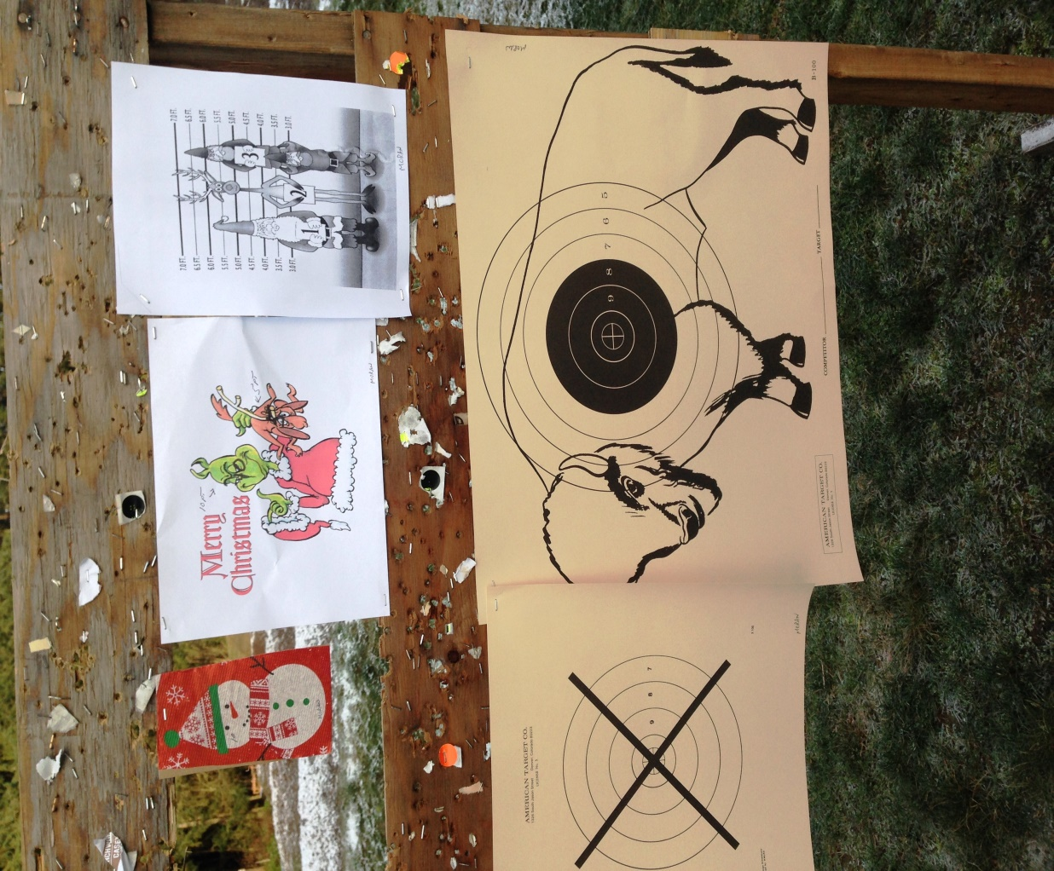

Targets for the Paul Bunyan Christmas Shoot

On a frosty cold morning, with the temperature hovering at 24 degrees, we gathered in the temporary clubhouse at Paul Bunyan to find out what the course of fire would be. Helen Sick had been picked to host the match, and she enlisted the help of her husband Bill to come up with ideas. As you will see, some of them were naughty and some were nice.

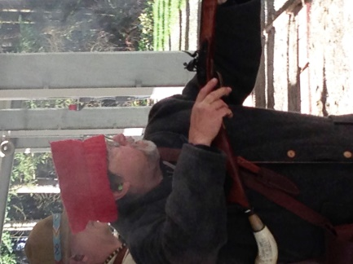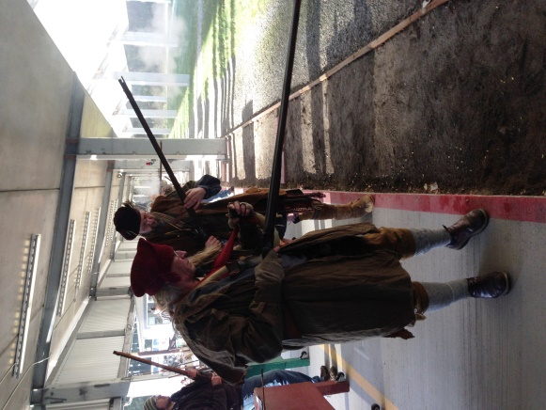 Our capotes were tested as we braved the cold once again to set our target frames. The first two targets were to be fairly standard, a California X and a Buffalo, with five shots at each at a came the Christmas themed targets; a snowman which had been the border of the Christmas party tablecloth, a picture of the Grinch and his dog Max, and a police line-up of Santa, Rudolph, and a couple of elves one standing on the other. Most people realized they could barely see these at 25 yards and were relieved when Bill told us they were to be shot at 15 yards. Unfortunately, the change in distance didn’t make them much easier to see. These targets each receive one shot for a variety of points. Then to round things out, there was a target board with a row of marshmallows and candy canes to hit, one shot each.

A cold Bob DeLisle sizes up his target

Critter & Tom Litts ready their long rifles

The Paul Bunyan Christmas Shoot is a “luck shoot” where the prizes are picked in order of score, but each prize is wrapped like a Christmas present so each is a surprise. And unlike most of the matches, the shooter’s fee is waived and participants are asked to donate to raise money for the **Thurston County Toys for Tots.** David Ball, a retired Marine and a volunteer for the Toys for Tots program, was on hand to tell us about the great things that Toys for Tots does, and how very much they appreciate our donations. David has been coming to collect our donations for several years, but this year he participated in the shoot, where he had a number of firsts; first shots with an in-line, first shots with a flint lock, and his first dry ball.

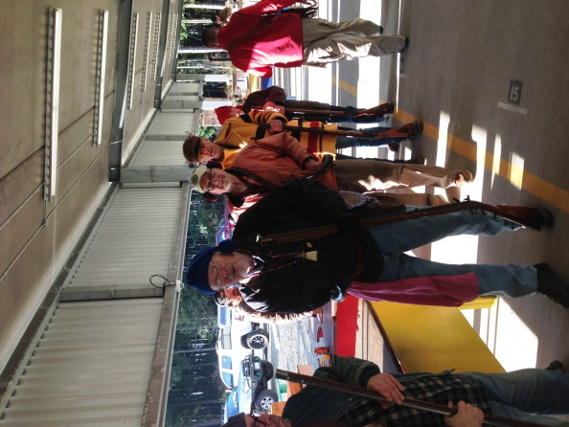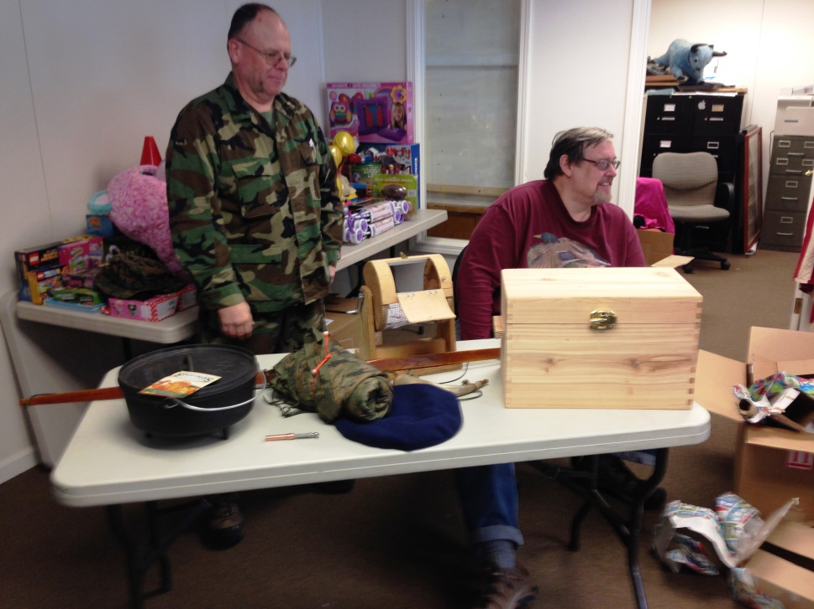 Several of our local craftsmen donated items for the raffle to help increase the donation. Dave Rase had one of his brass & steel adjustable powder measures, Steve Skillman provided a horn, Chip Kormas a bow he had tillered and finished, and Frank Ponceroff made a box with a cedar tray. Also on the table were some other donated items, including a military poncho liner donated by David Ball.

Santa's elves queueing up for the candy cane shoot

**After the raffle was complete there was over $2,600 raised by the muzzleloaders, and donate over $4,000 in cash with the contributions of IPSC, pistol steels and the Ladies League, Paul Bunyan was able to plus a pile of new toys.** It’s not easy to get a Marine to cry, but David left with a tear in his eye. Merry Christmas to all, and to all a good night.

David Ball and Chip Kormas with the raffle prizes

1. Wayne Miller 150 11. Jerry Mayo 123 21. Critter Fields 98

2. Boyd Phillips 148-4x 12. Mike Holeman 120-3x 22. Jim Hillberg 98

3. Wally McKendry 147-1x 13. Mike Nesbitt 120-1x 23. Karla Hillberg 94

4. Rick Hopkins 142 14. Dave Rase 120 24. Terry Gadberry 84

5. Jim Haeckel 139-3x 15. Darrell Behounek 109 25. Chris Statz 81

6. Bob DeLisle 132-3x 16. Mike Moran 108-3x 26. Tom Litts 74

7. Chris Ellis 130 17. Chris Lyman 105 27. Mike Godat 50

8. Dakota Nash 128-1x 18. Ted Hogland 103-2x 28. David Ball 46

9. Don Kerr 125 19. Frank Ponceroff 100 29. Bobby Malkmus 24

10.Mark Curtis 124-2x 20. Lori Caswell 99-2x 30. Chip Kormas 20-1x

31. Rod Mehrer NS