

SUMMER – 2021 SEASON
WEEK 1 – 7th April 2021
SINGLES LEAGUE

Well, I hope everyone enjoyed getting back into action this week with some big league fixtures and some improvements to the playing surface. Thanks for all the positive comments.

Well, if anyone wanted a banker for a draw, its Callum Stewart who shared the spoils with Matt Buesnel. This was Callum’s 100th League draw! A draw also for Winter Champion Geoffroy Buffetrille who came back from losing the first game to Brian Harris.

Laurent Pellaton was the only one to take all three points in his match against Alice Ibitson with outstanding matches.

Joey Le Clech v Toby Northern

Andrew Bellamy-Burt v Neil Selby

In Division 1 Andrew Limbrick, one of the favourites for the title started off well with a win over Natasha Romeril. David Ibitson took all three points against Brigitte Ibitson for a great start to the season.

Despite winning comfortably in the first game 13 – 1, Tim Jackson could not make it count in the second game losing 13 – 10 to Matt Hutchings for a draw.

Well, it was always going to be a tough task for Gavin Scott making the step up to Division one and so it proved, in the closest of matches against Keith Pinel with a 13-12, 12-13 draw and therefore losing his 100% winning streak.

Jean Stewart and Paul Bell, both former Premier League players also shared the spoils in what is going to be a very close league.

Wow big debut for James Mold as he handed out the first certificate of the season to Kim Gallichan on the way to taking all three points.

Mo De Gruchy’s great form continues with a big win over Lorna Limbrick for a great start to the season. James Villalard also took three points over Daniel Villalard, but only just with the first game going to 13 – 12.

New singles player Wendy Ritzema could only draw with new member Kevin Daley who took the second game 13 – 12 as both players gained their first ever league point at the club.

NEXT WEEK - - DOUBLES LEAGUE

Club email address - liberationpc@gmail.com

Club Website - www.liberationpetanque.co.uk

Kind Regards

Toby Northern

Chairman

Liberation Petanque Club

SUMMER – 2021 SEASON
WEEK 2 – 14th April 2021
DOUBLES LEAGUE

A beautiful evening for petanque saw the opening round of fixtures being played with defending champions Laurent Pellaton & Matt Pinel hitting the ground running with a big win over Brian Harris & Paul Le Moine to top the table early on.

A marathon match saw newly promoted Gavin Scott & James Rondel take all three points having come back from 12 – 9 down in the second game to hand Gary Cowburn & Wendy Ritzema their first loss in six matches.

Last summers runners up Andrew Bellamy-Burt & Callum Stewart could only share the spoils with Alice & Brigitte Ibitson and Neil Selby & Ross Payne also drew with Alan Oliveira & Joey Le Clech.

Back in action after last summers absence saw Colin Myers & Steve Simpkin get their usual result, a draw with Graeme Follain & Keith Pinel who have themselves draw 7 out of their last 8 league matches.

Division 1 saw a huge result for Alan Mitchell & Mike Robinson who handed out the second certificate of the season to Daniel & James Villalard winning 13 – 2, 13 – 0 to top the league early on.

A much closer match between Alex & Jean Stewart and Andrew & Lorna Limbrick with the latter just taking the first game 13 – 12 before a win for Alex & Jean in the second 13 – 10. A draw also for John McGaw & Nick Pallot against Brandon De La Haye & Tim Jackson.

SUMMER – 2021 SEASON
WEEK 3 – 21st April 2021
SINGLES LEAGUE

In Division 2 Kevin Daly got his first ever league win at the club, congratulations Kevin. This was a very narrow win over Kim with the first game going 13 – 12.

Cassie made it back to back draws, this time against James Mold who tops the league early on.

Mo and James shared the spoils with James missing out on back to back wins after losing the second game 13 – 11 so both players on four league points. Also, on four league points is Branden who beat Daniel. Daniel has lost both of his first two matches but in both matches has lost one game 13 – 12. Could have been a very different story.

Gary and Lorna both got their first points of the season with a draw.

Division 1 saw three 13 – 12 results and two of them went Keith Pinel way as he handed Andrew Limbrick a defeat in a big result. Jean Stewart lost one 13 – 12 as Gavin got his first win of the season.

Paul Bell made it four points as he defeated David Ibitson to move into the top three. Brigitte got her first point of the season against Matt Hutchings who has drawn both matches so far.

Tim Jackson also got his second draw in a row with a good result against Alex Stewart.

In the Premier League defending Champion Joey got off to a good start with a Win over Matt Buesnel before a good comeback in game one saw him also get a draw against Toby.

Toby played exceptionally well in the second game against Andrew Bellamy-Burt to get his second draw with both players trading carreaux’s on one end had three in a row.

Brian made it four points from two matches as he beat Alice, her second successive defeat.

Geoffroy & Neil shared the spoils also in another close match as they both have two draws each.

Ross just narrowly lost out on a win over Laurent losing three points on the last end with the game finishing 13 – 12 in Laurent favour for a draw.
SUMMER – 2021 SEASON
WEEK 4 – 28th April 2021
DOUBLES LEAGUE

The good weather continued this week and with everyone enjoying the sunshine wo could take early advantage in the league.

Well in the Premier League it turns out that no one could as every singles match ended in a draw!!!

Defending champions Laurent & Matt lost the first game 13 – 6 to Colin & Steve before recovering well winning 13 – 5 so Colin & Steve remaining unbeaten in the early stages of their return to the top league.

Brian & Paul recovered well to get their first league point of the season winning the second game against Alice & Brigitte 13 – 3 for a draw. Alice & Brigitte still unbeaten.

Gavin & James took a very close first game against 13 – 11 against Graeme & Keith, but Graeme & Keith had a great second game running out 13 – 1 winners.

This was a similar story as a poor second game from Andrew allowed the current form player Joey and Alan to win 13 – 2 against Andrew & Callum for both teams second successive draw.

Neil & Ross also got their second successive draw against Geoffroy & Matt sharing 13 – 9 wins each.

This season is definitely going to be close.

Just one match played in Division 1 as Kat & Paul got off the mark with a draw (yes another one) against Matt & Mo.

SUMMER – 2021 SEASON
WEEK 5 – 5th May 2021
SINGLES LEAGUE

With Premier League leader Joey on a bye this week Laurent had a chance to move top with a win over Callum. He achieved this surprisingly comfortably 13 – 6, 13 -2 to sit top with 7 points from 9 so far.

Brian gained a good comeback draw against Ross to move second on 5 points from three matches with Joey sitting in third place.

Toby handed newly crowned Liberation Singles Open champion Matt Buesnel a 13 – 1 defeat in game one but a 9 ½ m spot carreaux by Matt in game two when the match was tied at 9 – 9 gave him three points and an advantage he took closing out for a draw 13 – 11. Matt though sits in the relegation zone but early days.

Alice had lost her first two matches but made up for it this week with a big win over Neil to move up the table. Neil still without a win this season.

Andrew won comfortably in game one against Geoffroy but then blew a big lead in game two as Geoffroy got a valuable draw. Both players with three draws from three matches.

Division 1 saw Matt Hutchings beat league leader Paul to move above him into the top three.

Andrew Limbrick lost back to back matches, this week to rising star Gavin Scott who tops the table with 7 points from 9. Alex moves up the table with a very close win over Brigitte just taking the first game 13 – 12 and David shared the spoils with Jean.

Several players on 4 league points and sights on a top three finish.

Division 2

Cassie won Division 1 in the winter but is struggling in Division 2 this summer with a draw against Daniel making it three draws from three.

Brandon leads early on just like he did last season before fading away, will he keep it consistent this season? He beat Mo this week.

Kevin Daly is enjoying a great start to his Liberation League season with another win over James Mold in a really close match 13 – 10, 13 – 11. James lost his first match against tough opponent Gary who moves up the table with his first win.

Wendy and Lorna shared the spoils with a 13 – 7 win each.

SUMMER – 2021 SEASON
WEEK 6 – 12th May 2021
DOUBLES LEAGUE

Well Week 4 was all about the draws, how would it turn out this week? Would the first proper rain of the season affect performances.

The big match of the week was probably Andrew & Callum against Geoffroy & Matt Buesnel. Matt Buesnel rich vain of form continued in the doubles with a great team performance handing Andrew & Callum a massive defeat 13 – 4, 13 – 0.

Gavin & James have had a good start to the season but played one of the toughest teams to beat in Colin & Steve. Gavin & James though had an even bigger win than Geoffroy & Matt winning 13 – 3, 13 – 0.

In the Premier League defending champions Matt Pinel & Laurent took on Alice & Brigitte who were continuing their struggles from the winter season. Well Laurent & Matt remain top of the league with another win, but only on points difference over Gavin & James.

Could Brian & Paul turnaround their early season struggles against Alan & Joey, the answer was yes as they won their first match of the season moving up to fourth place as a result. Would Gary & Wendy take points off one of the pre-season favourites in Neil & Ross. Well yes they did but only just after losing the first game Gary & Wendy took the second one 13 – 12 for their first point of the season with Neil & Ross, now having drawn all three matches.

In Division 1 Alex & Jean lead the way on 4 points, but could they make it 7 points with a win over John & Nick? Not this time as draw specialist John & Nick shared the spoils winning the second game 13 – 11.

Brandon & Tim and Matt & Mo both with just a draw to their name could one get their first win and catapult them up the table. Another draw here with big game scores either way 13 – 2 to Brandon & Tim and then 13 – 5 to Matt & Mo.

Kat & Paul were expected to get the three points against Daniel & James, but a very close match ended with a Daniel and James second game win 13 – 9 for a valuable draw.

Alex & Jean still top the table with Alan & Mike in second having only played one match so far.
SUMMER – 2021 SEASON
WEEK 7 – 19th May 2021
SINGLES LEAGUE

This week saw top of the league Laurent play champion Joey, would the pair remain unbeaten and share the spoils. That they did which keeps Laurent at the top of the table with 8 points from 4 matches.

Neil lost 13 – 12 to doubles partner Ross in the Island Singles championship, would Neil get his own back and pick up some valuable league points. Well, another draw with big point swings as Neil won the first game 13 – 5, before Ross took the second 13 – 8.

A big match also with Matt Buesnel and Andrew who played together in the World Championships a few years ago. Both players without a win so far could one buck the trend? Well, no they could not, another draw with match scores, with Andrew now having drawn all 4 matches and Matt drawing 3 and losing 1.

Brian was sitting in the top three unbeaten going into this week’s fixtures but played Callum who defeated him in the Island Singles at the weekend, Callum needing points after a poor start. It was Callum who won again though but by the narrowest of margins 13 – 12, 13 – 12 to hand Brian his first defeat of the season, despite this he remains in the top three.

Well despite recent cup form Andrew had lost his last two league matches and this week played Jean who had an impressive Singles Championship but without a league win so far. Andrew recovered his league form to get his second win of the season.

Matt Hutchings has had a decent start to the season, and he played David. Another great result for Matt as he gained a valuable draw and continues to improve.

Alex played Paul also played out a draw, but Natasha lost to Brigitte.

Division 2

New member Kevin played out a good draw against Cassie. Mo beat Daniel to move up the table in this division, no other results in.

SUMMER – 2021 SEASON
WEEK 8 – 26th May 2021
DOUBLES LEAGUE

With only points difference separating champions Matt Pinel & Laurent and Gavin & James, it was going to be an exciting match especially as Gavin and James are two of the form players at the moment, could they take the advantage in the title race? Well game 1 was close going 13 – 10 in favour of the champions and they pushed on in the second game for the win 13 – 6 and hand Gavin & James their first ever league defeat.

Winter champions Geoffroy & Matt Buesnel have a match in hand over the top two having already had their bye. Could they close the gap this week with a win over Brian & Paul who were hoping to break into the top three themselves with a win. They could indeed as a close 13 – 11 win went their way followed by a 13 – 6 so although 3 points off the leaders have a match in hand.

Alice & Brigitte and Alan & Joey was a similar story as both teams were without a win but that changed in the favour of Alan & Joey, leaving Alice & Brigitte in the relegation zone.

Well, although its early in the season, you wouldn’t be expecting to see Andrew & Callum playing in a relegation double header against Gary & Wendy having got just 2 draws from their first three matches and with a minus points difference of 26. A big result needed here and that’s what they got to move up the table.

In Division 1, second in the league Cassie & Chris faced Kat & Paul hoping that a win could move them top of the league, however it was a win for Kat & Paul instead moving them up to 2nd in the league.

Matt & Mo were undefeated as were Andrew & Lorna but only three matches played between them, who would come out on top. The experience of Andrew & Lorna shone through in a big win moving them to the top three.

Brandon & Tim had the chance to move up the table with a win over Daniel & James who were occupying bottom spot. But a first win since the Summer 2019 season and the first one in 18 matches for Daniel & James, well done and let’s hope its not so long a wait for the next one.

SUMMER – 2021 SEASON
2nd June 2021
Liberation Club Doubles Cup

After 2 last minute withdrawals 14 teams took part this year. Round 1 saw 2019 champions Andrew & Callum overcome tough first round opponents in Gary & Wendy in one of two matches not to go the distance winning 12 – 7. Current Island Doubles champions Geoffroy & Matt started off well with a 13 – 2 win over Daniel & James.

Laurent & Toby started off the best possible way against Jess & Tom taking 6 points on the first end before going on to win 13 – 4 and Branden & Tim won by the same margin against Matt & Mo.

Graeme & Keith just made it over the line 10 – 7 against Kat & Paul.

Round 2 saw Geoffroy & Matt win 13 – 2 again, this time against David & Ross. Branden & Tim made it two from two with a big 13 – 5 win over Graeme & Keith.

Daniel & James also had a big win 13 – 2 over Tom & Jess and Gary & Wendy got their first win 13 -5 over Matt & Mo. Andrew & Callum won again over Cassie & Chris and Alex & Jean lost 5 – 9 to Andrew & Lorna.

The closest match was a 12 – 11 win for Kat & Paul over Laurent & Toby with Paul getting four points for his team on one end with a wayward fire somehow cannoning the right boules out of the way and on the last end Laurent & Toby needed three points to tie with Toby getting two Laurent unfortunately on a difficult terrain get any of his three in for a loss.

In a big shock Daniel & James beat Andrew & Callum 13 – 12 for their second win of the campaign.

Kat & Paul made it back to back wins beating Cassie & Chris 13 – 10 and Geoffroy & Matt won big again 13 – 1 over Branden & Tim. Tom & Jess came from 10 – 2 down against Graeme & Keith to win 13 – 12.

Matt & Mo got their first win 11 – 8 against Alex & Jean and there were two 13 – 3 wins, first David & Ross against Laurent & Toby and Gary & Wendy over Andrew & Lorna.

In the final round Geoffroy & Matt had a much closer match winning 9 – 6 against Gary & Wendy to make in four from 4 to top the rankings with Gary & Wendy missing out finishing fifth.

Daniel & James won their third straight match and a big win 13 – 3 against Kat & Paul to finish second in the rankings with the highest BHN, a great achievement.

Andrew & Callum bounced back in style against David & Ross winning 13 – 2 to finish third and Branden & Tim won 13 – 3 against Alex & Jean to take fourth place.

Jess & Tom won 9 – 4 against Andrew & Lorna and Matt & Mo won back to back matches 13 – 5 over Cassie & Chris. Laurent & Toby luck just wasn’t their as they lost on the end again 10 – 9.

FINAL RANKINGS



So, the Semi-Finals were as follows:

Ranked 1st Ranked 4th

Geoffroy Buffetrille & Matthew Buesnel v Branden De La Haye & Tim Jackson

Ranked 2nd Ranked 3rd

Daniel & James Villalard Andrew Bellamy-B & Callum Stewart

Well I am sure a few people were hoping for a Daniel & James v Branden & Tim final, but it wasn’t to be as despite both teams playing well Geoffroy & Matt ran out 13 – 0 winners and Andrew & Callum 13 – 2 winners.

Well there has not been a close final for a long time (at least when you look at the score line) and this was the case here as a big 5 point end early in the game gave the advantage to Andrew & Callum and despite some incredible shooting from Geoffroy considering the light, Callum matched it when needed and so many tight ends just went Andrew & Callum’s way as they ran out 13 – 3 winners for their third title.

The third-place play-off went backwards and forwards as Daniel & James shot out of the starting blocks to lead 6 – 0 before Branden & Tim pulled it all the way back to lead 8 – 6. Daniel & James then took a 2 and 3 point ends to lead 11 – 8 before the next end made it 11 -11. But with the match tied at 12 – 12 a great place at distance gave Daniel & James a 13 – 12 win and a fantastic third place finish and not only that they were the only team to beat champions Andrew & Callum

Champions Callum Stewart & Andrew Bellamy-Burt



SUMMER – 2021 SEASON
WEEK 10 – 9th June 2021
SINGLES LEAGUE

Brian handed Joey his first defeat this season dealing a blow in his bid to retain his title.

Its close at the top though as Laurent couldn’t beat Toby as their shared the spoils. Andrew got his first win of the season over Alice but only just taking one game 13 – 12. This means Alice remains in the bottom three but has a match in hand against Geoffroy.

Geoffroy is still without a win after drawing his fourth straight match, this time against Ross who also has drawn all 4 matches.

Callum and Neil also shared the points with a draw, but Neil gaining good points difference and Callum although currently sitting in 6th place has the worst points difference in the league of -25.

Division 1 saw the lead change hands against as Gavin beat Tim whilst Keith could only draw against Brigitte meaning they swap places at the top of the league.

Andrew Limbrick remains in third place despite not playing as Alex and David drew with each other and Paul drew with Natasha as all these players are on 6 points.

Also, on 6 points in Matt Hutchings who lost his first match of the season to Jean after losing the second game 13 – 12. Jean moving just above the relegation zone as a result.

Division 2 saw Cassie get her first win of the season against Mo who remains in second place despite this result. Branden drew with Wendy to remain top with Wendy remaining in third place.

Daniel is starting to show real signs of improvement and shared the points with Gary who currently has the best points difference in the league.

SUMMER – 2021 SEASON
WEEK 11 – 16th June 2021
DOUBLES LEAGUE

Only a handful of matches played this week, in fact half of them included Neil & Ross who also played a catch-up match against Graeme & Keith. This was an incredibly close match going 13-12, 13-11 so to win it and get the full three points must have been a great feeling for one team and gutting for the team that went away with nothing. Well done to Neil & Ross for taking the win.

Neil & Ross like living life on the edge as they went to the wire again in game one against Colin & Steve just winning 13-12 before a more comfortable score line 13 – 4 in the second game for back to back wins this season moving them into title contention.

The other two matches played in the top division ended in draws with both matches having a 13 – 12 result in them that cost both teams a win and three league points.

Geoffroy & Matt lost game one 13 – 12 to Alice & Brigitte before winning comfortably 13 – 5 in the next game but dropping 2 valuable league points in their quest for the title.

With Graeme & Keith having lost so narrowly against Neil & Ross they would have been hoping for the luck to go their way against Andrew & Callum. They did take the first game 13 – 6 but then lost another game to 13 – 12 to narrowly miss out on their first win of the season.

No matches played / scores received in Division 1.

Two singles matches were played in Division 2, with Kevin Daly moving back into the top three with a win over James Villalard but again another 13-12 score line in the match.

Well there was no 13 – 12 in the next one as Gary handed out a certificate to the league leader Branden in game one before the tables were almost completely turned as Branden won the second game 13 – 1! Branden remaining top of the league repeating his early 2020 form before dropping off the pace. Can he keep it up this season?

SUMMER – 2021 SEASON
WEEK 12 – 23rd June 2021
SINGLES LEAGUE

A huge win for Laurent over Matt Buesnel see’s him extend his lead at the top to four points and leaves Matt rooted to the bottom of the league for yet another week.

Geoffroy had a terrible week as he failed to get his first win with a draw against Callum and then lost his first match in fourteen to Alice. Geoffroy only on five points from six matches. Alice on the other hand recorded her second win moving to 6th in the league and despite being one of only three players to get more than one win has lost four so far.

One of those losses was to Ross this week who remains unbeaten and now on 7 points joint third but only +5 to Toby’s +24 and Andrew’s +18.

In Division 1 it’s starting to look like Gavin will be playing in the Premier League next Summer with another win, this time over Brigitte, who did give him a good game though.

David’s win over Natasha moves him up to second but he has played two more matches than Keith and Andrew.

In Division two a narrow win for Brandon over Kim with one match going to 12 keeps him top and on track for the title. Wendy moved second with her second win of the season over Daniel.

SUMMER – 2021 SEASON
WEEK 13 – 30th June 2021
DOUBLES LEAGUE

Very few matches played this week. In the Premier League Andrew & Callum took advantage gaining three valuable points to move into the top three with a win over Colin & Steve who lost yet another match by one point losing the second game 13 -12.

Gary & Wendy also took advantage with their first win of the season 13 – 9, 13-11 over Alice & Brigitte to move out of the relegation zone with Alice & Brigitte joining Colin & Steve in the relegation zone.

In Division 1 the sole match played saw the ever improving Daniel & James gain a good draw against John & Nick but missed out on all three points losing the second game 13 – 11 after winning comfortably 13 – 3 in the first game.

Alan & Mike handed Kat & Paul their first defeat of the season the leap above them and straight to the top of the table.

Alex & Jean also moved into the top three playing a match in advance against Cassie & Chris, this was a big win including a 13 – 0!

SUMMER – 2021 SEASON
WEEK 14 – 7th July 2021
SINGLES LEAGUE

Please remember the clubs Covid policy.

In the Premier League Ross was just one point away from handing Andrew his first defeat of the season, losing the first game 13-12. This was the same for Brian who lost the second one 13-12 to Matt for another draw.

Joey took points off Geoffroy but his title defence took another hit by dropping two points. Neil Selby quest for his first title took a boost as he beat Toby.

Callum took a big three points with a win over Alice moving him up the table.

Big win in Division 1 for Gavin who took all three points of title rival Paul and now looks certain for promotion to the Premier League and another title.

Jean beat Alex easily for a big three points and there were wins also for Natasha and Andrew over Matt and Brigitte respectively.

Keith missed out on a valuable three points losing the first game 13 – 12 to David which hits his hopes of the title.

In Division 2 yet another 13 -12 result, this time though gave Kevin a win over James as he pushes for the title.

Wendy Ritzema got all three points with a double 13 – 6 win over Mo and Daniel and Kim drew as did Cassie and Gary.

SUMMER – 2021 SEASON
14th July 2021
Liberation Club Handy Cap Cup

21 players turned up for the first competition of this type in the Island with lower ranked players starting with positive points giving them more of a chance of a win and putting more pressure on those players at the top when starting a match already behind.

All matches played in Round 1 were close with a winning margin of 13 – 9 being the biggest win. Two shocks in this round as Daniel beat Geoffroy 13 – 11 with Daniel’s plus 5 helping him on the way. James also won against Premier League opposition with a 13 – 10 win over Brian.

Paul beat Ross to 9 and a good win for Tim over Kevin.

In Round 2 Alex took advantage of his plus 2 to beat Laurent 13 – 12 and Kim was unfortunate giving points away at the end to lose just 12-11 to Andrew Limbrick.

Daniel made it two in a row beating Tim as did Paul over Brandon and Callum over James.

Jean beat Brian 13 – 6 for a big win and two 13 – 4 wins as Toby beat Neil and Andrew Bellamy-Burt beat Ross.

Round 3 saw Alex make it three in a row beating Toby and Andrew Limbrick just beating Daniel 13-12. Tim also won 13-12 over Kim who lost her second match in a row by just 1 point.

Geoffroy won a big match against Laurent 13 – 10 two make it two in a row as did Jean who just beat Mo 13 – 11. Brian just got his first win 11 – 10 over Matt Hutchings.

Round 4 saw Andrew Limbrick come back from 11-2 down to win 13 – 11 against Toby to make it 4 straight wins and Callum also made it four from four beating Alex.

Paul Bell beat Andrew Bellamy-Burt to move both players to three wins as did Geoffroy over Tim.

Daniel took his second Premier League scalp beating Neil to 5 and Branden beat Laurent 13 – 11. Brian won another match by just one point over Kevin.

Lorna got a good win over Mo and Kim beat Matt Hutchings.

In the final round Andrew just beat Callum 12 – 11 to make it 5 wins from 5 but only +9. With Callum qualifying in third place.

Daniel had a big win over Paul which meant he finished second in the rankings with 4 wins.

Geoffroy beat Jean to make it four straight wins which saw him qualify in fourth place by 1 BHN over Andrew Bellamy-Burt who was the only player on four wins not to go through.

Another shock though as Kim beat Neil 13 – 9 for one of the results of the day. Lorna also taking a Premier League player out beating Brian.

FINAL RANKINGS

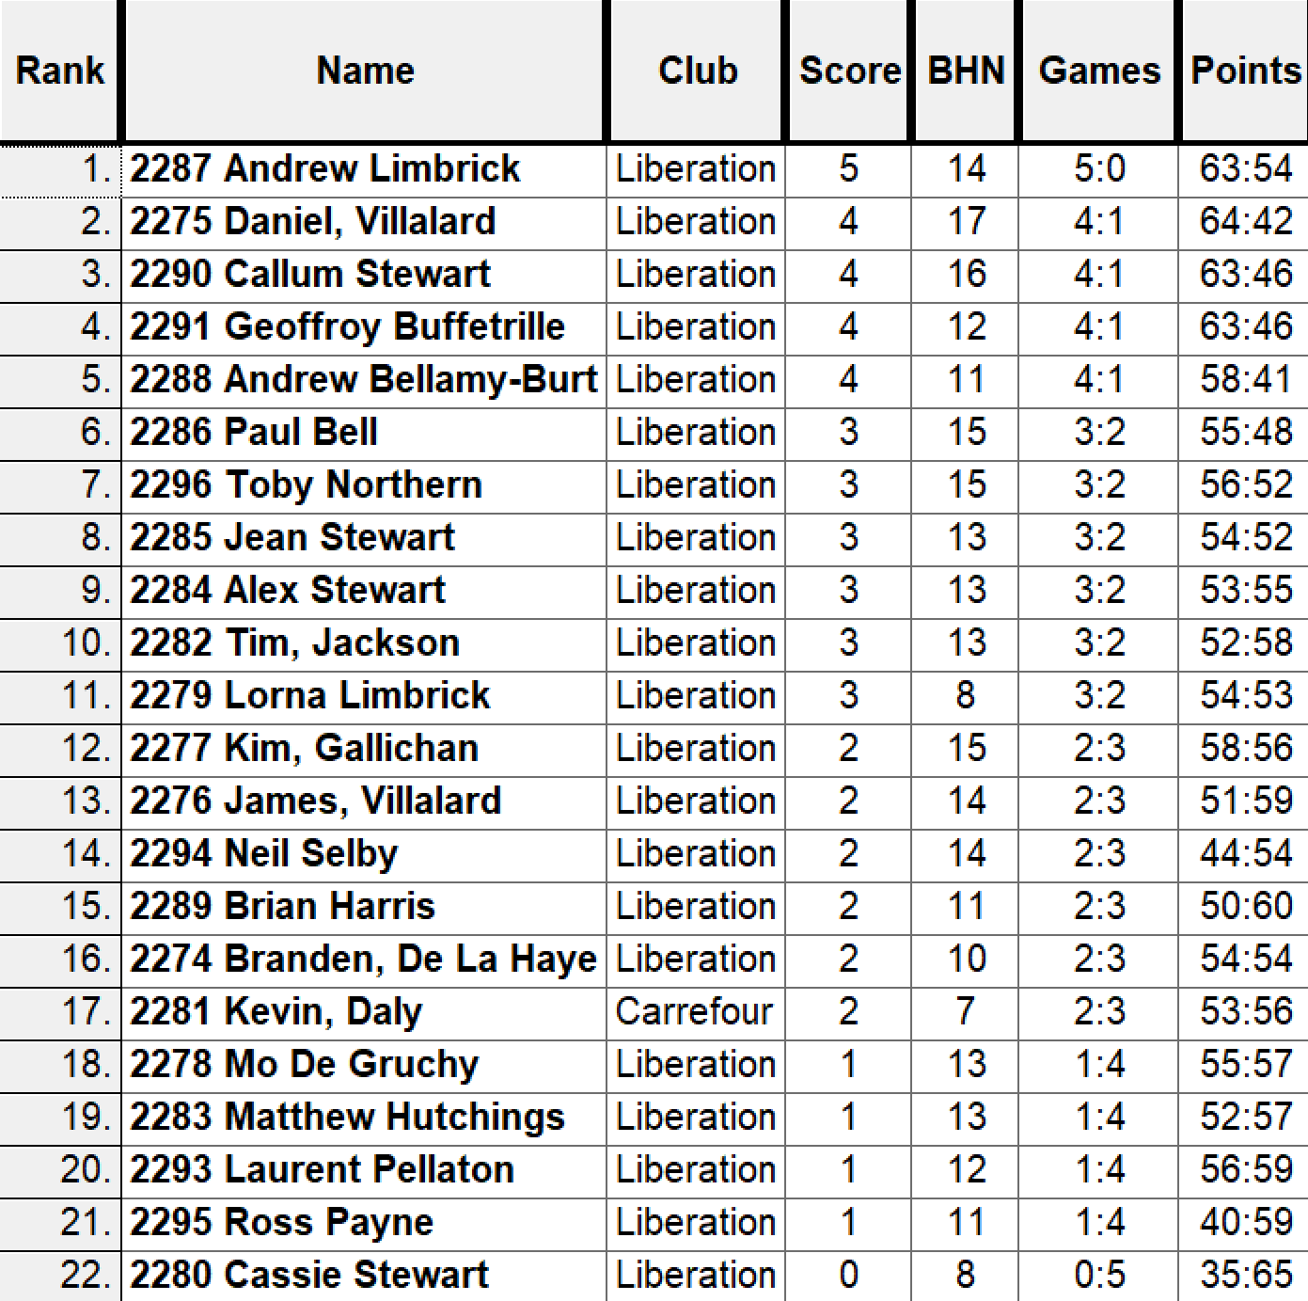

So the Semi Finals were played as follows:

Ranked 1st Andrew Limbrick v Geoffroy Buffetrille Ranked 4th

Ranked 2nd Daniel Villalard v Callum Stewart Ranked 3rd

Well the top ranked curse struck again as Andrew just couldn’t get going against Geoffroy with a few ends giving points away from holding positions to give Geoffroy the advantage who won 13 – 5.

Well Daniel was on great form after winning four out of five in the swiss rankings and only losing 13 – 12 to Andrew Limbrick in Round 3 so was going to be tough for the more experience player Callum. Daniel played exceptionally well and boosted by +5 points went on to take the win 13 – 4 and book a final spot against Geoffroy whom he beat in Round 1.

Third Place went to Andrew Limbrick winning 13 – 8 over Callum for yet another top finish in competitions.

Well despite starting the final 5 – 0 down Geoffroy hit the ground running moving to 8 – 5 up before Daniel got his first points on the next two ends to get to 7 – 8, but that was to be all as Geoffroy skill showed through as he went on to win 13 – 7.

Champion

Geoffroy Buffetrille



Runner Up

Daniel Villalard



SUMMER – 2021 SEASON
WEEK 16 – 21st July 2021
DOUBLES LEAGUE

No matches played in the Premier League this week, but catch up matches saw Neil & Ross top the league pending the result of the outstanding match between Matt Pinel & Laurent v Geoffroy & Matt Buesnel but it’s looking like its going to be a close finish.

Only one match played in Division 1 with a catch up match for Andrew & Lorna v Daniel & James ending in a draw which see’s Daniel & James move into third place.

In a catch up match Tim Jackson won his first singles match of the season to move him off the bottom of the league and into safety, his opponent Andrew Limbrick has now lost three of his six matches and drops into fourth place on points scored, with Paul Bell moving up to third.

SUMMER – 2021 SEASON
WEEK 17 – 28th July 2021
SINGLES LEAGUE

In the Premier League Geoffroy finally got his first win of the season which for now moves him three points clear of relegation. His opponent Toby though now just one point above relegation.

Matt Buesnel loss to Neil means he remains bottom of the league but still only two points from safety whereas Neil now tops the league by one point over Laurent who has two matches in hand.

Andrew played two matches in advance, one against Callum with a good win and then a draw with Brian.

Callum also drew with Ross who is one of three players undefeated.

In Division 1 although he’s not yet mathematically certain of even promotion Gavin win over David means its now very likely he will win the title.

Gavin closest rival Keith won against Matt Hutchings to move second in the league and Tim draw with Jean moves him out of relegation.

Only one result in Division 2 saw Mo beat Kim and although Mo is just one point off the top three has played at least two matches more than those above her.

SUMMER – 2021 SEASON
4th August 2021
Liberation Club Singles Cup

22 players took part in the 10th Anniversary of the competition.

2020 champion Brian Harris started off with a win over Lorna Limbrick, with the match being timed out at 11 – 7. Three-time champion Andrew Bellamy-Burt also with a win 11 – 8 over Gary Cowburn.

James Rondel beat one of the favourites Andrew Limbrick 13 – 7 and Tom Le Sueur handed Premier League player Joey a big defeat 13 – 4.

Wins also for Toby over Alex, Geoffroy over James and Ross over Cassie as well as Branden with a big result over Jean.

Round 2 saw a repeat of last years final between Brian and Andrew BB with Brian again coming out on top but only just 10 – 9.

Tom Le Sueur kept up his impressive results, this time 12 – 8 over James Rondel. James Villalard beat Tim Jackson 9 – 8 in another really close match.

Lorna had a good win over Kevin Daly and Andrew L won his match comfortably over Wendy 13 – 3. Toby, Ross and Geoffroy all winning their second matches.

Round three saw Jean move onto two wins from three with a close 13 – 11 match against Gary. Andrew L beat Ross to also move onto two wins.

Paul Bell just overcame Lorna 13 – 12 to get his second win as did Andrew B over Joey 13 – 2.

Tim Jackson had an impressive win over James Rondel 11 – 9 and Callum beat Branden as both players moved to two wins.

Round 4 saw Toby recover from his loss to beat Jean 13 – 8 and Tim Jackson beat Andrew L 10 – 9 to move into contention for the Quarter finals

Paul Bell beat Callum, Alex beat Tom and Andrew B beat Ross as all three moved to three wins.

Geoffroy handed Brian just his second loss in the tournament in 11 matches. Wendy beat Lorna 12 – 8and James V beat Kevin.

In the final qualifying round Geoffroy just overcame Paul 11 – 10 to finish top of the rankings with 5 wins from 5.

Andrew B beat Toby 13 – 11 to finished third with Toby finishing fifth. Tim Jackson beat Alex Stewart but again both qualified with Tim in fourth and Alex in eight.

James Rondel 13 – 4 win over James Villalard wasn’t enough as he missed out by 1 BHN point against Alex to finish in 9th. Tom Le Sueur had another great result beating Ross Payne 11 – 8 to go through in seventh place with Ross finishing 14th as a result.

Callum loss to Brian 13 – 11 ended his tournament finishing 13th with 2020 champion Brian finishing second.

So James rondel, Paul Bell and Wendy Ritzema all with three wins not going through on BHN.

FINAL RANKINGS

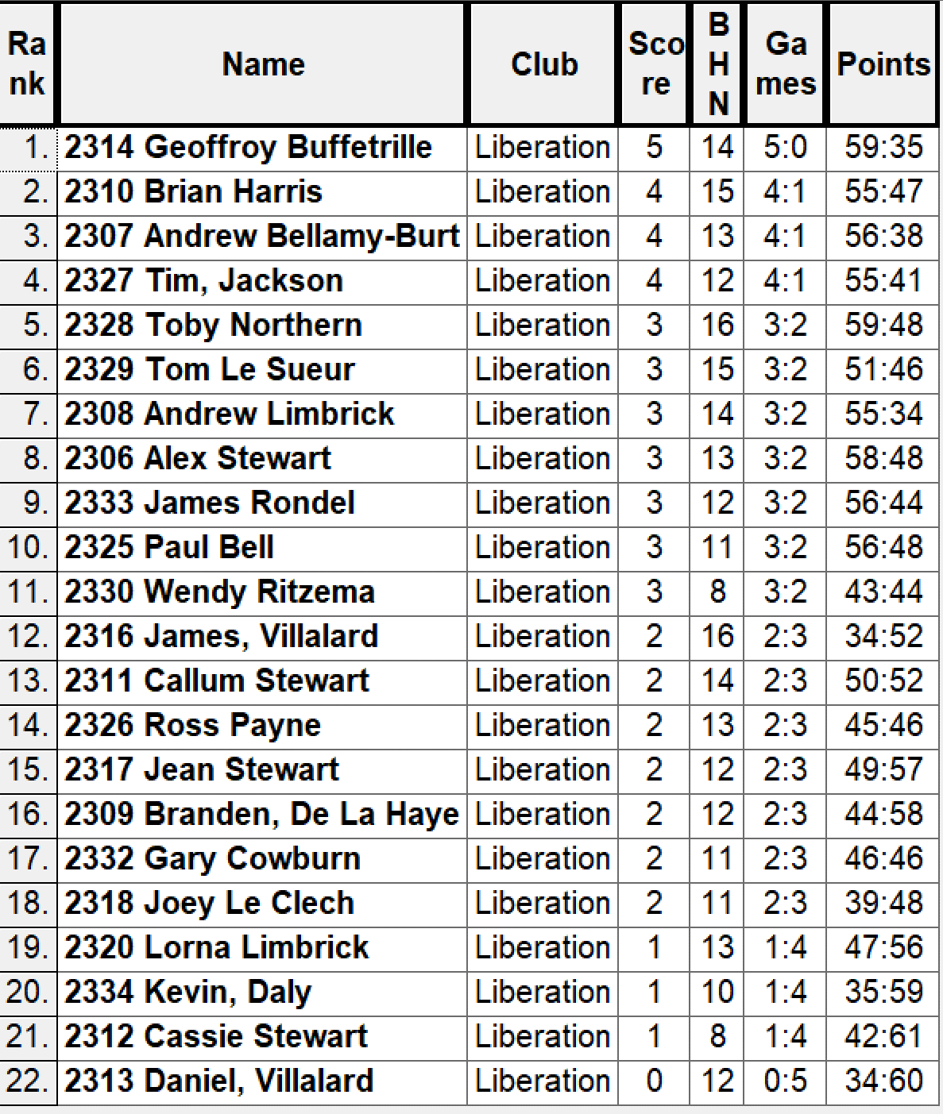

Quarter Finals

Ranked 1st Geoffroy Buffetrille v Alex Stewart Ranked 8th

Ranked 2nd Brian Harris v Andrew Limbrick Ranked 7th

Ranked 3rd Andrew Bellamy-B v Tom Le Sueur Ranked 6th

Ranked 4th Tim Jackson v Toby Northern Ranked 5th

Well Geoffroy made lite work in his match against Alex winning 13 – 1. Tim Jackson had the game of his life with some impressive shooting and placing to beat Toby 13 – 3 and Andrew Limbrick knocked out the champion Brian Harris 13 – 9. Really clos match as Tom just missed out on another big scalp losing 13 – 11 to Andrew Bellamy-B.

So the Semi Finals were played as follows:

Ranked 1st Geoffroy Buffetrille v Tim Jackson Ranked 4th

Ranked 3rd Andrew Bellamy-B v Andrew Limbrick Ranked 7th

Well Tim performance dipped against an impressive Geoffroy who made yet another final winning 13 – 6.

The other Semi-final though was as close as it could get. With 1 minute 30 seconds left Andrew was 8 – 6 up and holding one on the ground with two boules to play with Andrew having played all his. Andrew didn’t get either of his last two in to go into the final end 9 – 6 up but he could have taken the full time to through his boules and won 9 – 6.

So all Andrew L needed to do was ensure Andrew B didn’t get three points and he would make the final. Andrew first boule was a very good, but Andrew just out pointed it. Instead of firing Andrew boule out which would have meant he couldn’t get the three he needed just to tie the match and chose to point his next two but these didn’t beat Andrew Bellamy-B boule and to his credit placed in his last two perfectly to get three points and take it to another end at 9 – 9.

Unfortunately a bad end for Andrew on the next one gave Andrew a 10 – 9 win to make his fourth successive final.

Andrew Limbrick recovered to beat Tim Jackson 13 – 8 for third place, with Tim having another great tournament.

Well the relief for Andrew Bellamy-B must have given him the drive he needed in the final as his placing consistently out did Geoffroy shooting to win comfortably 13 – 4 for his fourth title in ten years, very impressive indeed.

Thanks to James Rondel, Gary Cowburn, Lorna Limbrick, Paul Bell and anyone else who helped on the day.

Champion

Andrew Bellamy-Burt
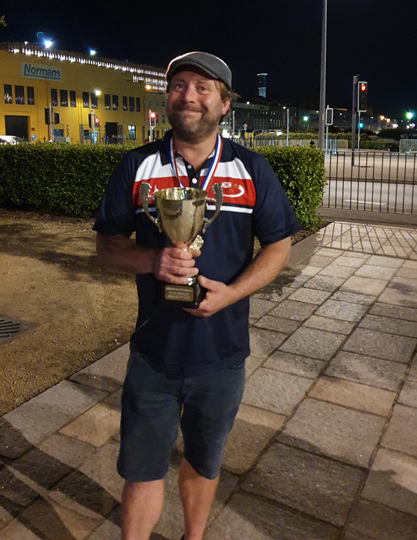

Runner Up Third Place

Geoffroy Buffetrille Andrew Limbrick
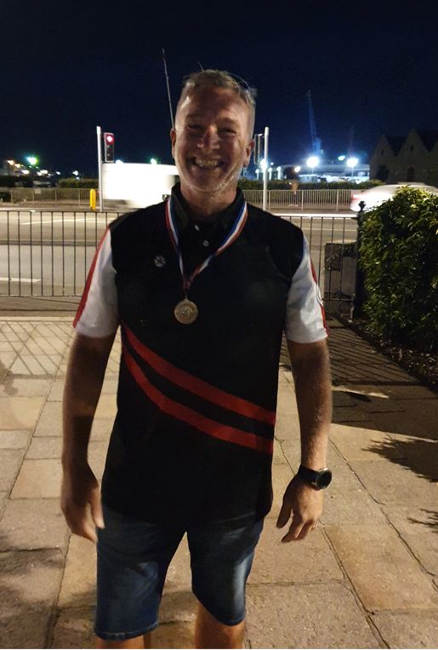


SUMMER – 2021 SEASON
WEEK 19 – 11th August 2021
DOUBLES LEAGUE

As we are now in the second half of the season more than ever, everyone point can make a big difference towards a title, medal or in avoiding relegation.

A huge match in the Premier League this week saw table toppers Neil & Ross take on second in the league and current champions Matt Pinel & Laurent who were only one point behind with a match in hand. We’ll have to wait for this one though.

This match was in contrast to Alice & Brigitte against Colin & Steve who were the bottom two going into this week’s fixtures. A win for either team would have been huge towards survival chances, but the inevitable draw was the result which doesn’t help either team’s chances of staying up.

Another team without a win was Graeme & Keith who played Alan & Joey who are chasing a medal position. Again another draw which leaves Graeme & Keith just above the relegation zone and Alan & Joey drop further off the top three.

Alan & Joey also played a catch up match with another draw against Gary & Wendy who move up the table one place to 8th.

In Division 1 no matches were played

Outstanding matches (Doubles Leagues)

Premier League

Brian & Paul v Gary & Wendy

v Graeme & Keith

v Colin & Steve

Laurent & Matt v Matt & Geoffroy (Expires 18th August)

Gavin & James v Andrew & Callum (Expires 18th August)

Alice & Brigitte v Graeme & Keith (Expires 18th August)

Neil & Ross v Laurent & Matt (Expires 8th Sept)

Gary & Wendy v Matt & Geoffroy (Expires 8th Sept)

Brian & Paul v Gavin & James (Expires 8th Sept)

Division 1

Cassie & Chris v Andrew & Lorna

Cassie & Chris v John & Nick (Expires 18th August)

Alan & Mike v Branden & Tim (Expires 18th August)

Kat & Paul v Alex & Jean (Expires 8th Sept)

Daniel & James v Matt & Mo (Expires 8th Sept)

Andrew & Lorna v Alan & Mike (Expires 8th Sept)
SUMMER – 2021 SEASON
WEEK 2 – 18th August 2021
SINGLES LEAGUE

Crunch time in the Premier League as leader Laurent took all three points against Brian and he followed this up with a draw against Andrew in a catch-up match to move two points clear of Neil in second place and with a match in hand.

So it will be a huge match next time out as Laurent takes on Neil in a match Neil must win for a chance of his first title.

Ross maintained his unbeaten record in the league with his seventh draw in eight matches against Joey who then lost in a catch-up match to Alice meaning he sits in the relegation zone, a stark contrast for the current champion.

Toby got back to winning ways after two defeats as he picked up all three points against Alice to move back up to fifth place with a healthy points difference.

Geoffroy won back to back matches as he confined his doubles teammate, Matt to the bottom of the league and five points from safety with just two matches to go.

In Division 1 two of the top Island ladies players Jean and Natasha shared the spoils. Tim got his second win of the season to move out of the relegation zone despite Matt Hutchings gaining an excellent draw against Gavin. This draw prevented Gavin from claiming the title but has already been promoted.

Gavin was helped by Keith loss to Alex who moves second as a result.

In Division 2 Cassie handed Wendy her first defeat of the season to move into contention for promotion and at the same time handing a big blow to Wendy chance of the title.

Gary moved top with a win over Kim and a draw with Wendy in a catch-up match, but Brandon and Kevin still have to play each other, and Kevin has only played five matches so has the chance to move top.

Outstanding matches (Singles Leagues)

Premier League

N/A

Division 1

Paul Bell v Andrew Limbrick (Expires 25th August)

David Ibitson v Andrew Limbrick (Expires 15th September)

Division 2

Branden De La Haye v Kevin Daly (Expires 25th August)

Lorna Limbrick v Cassie Stewart (Expires 25th August)

Lorna Limbrick v James Villalard (Expires 15th September)

Daniel Villalard v Kevin Daly (Expires 15th September)

SUMMER – 2021 SEASON
WEEK 21 – 25th August 2021
DOUBLES LEAGUE

Crunch time in the Premier League as champions Laurent & Matt moved a giant step to retaining their title with a big win over Geoffroy & Matt. This result puts them top with matches in hand.

Neil & Ross chances of the title took a big hit with a loss to Andrew & Callum, this was their first loss in 13 matches and leaves them 2 points off top spot having played a match more than the leaders.

Andrew & Callum have the same points as Laurent & Matt but have played 3 more matches and have a minus points difference so will more likely be trying to hold on to a top three spot.

James and Gavin took on Alice & Brigitte who have been struggling again this season and needed a win to get out of the relegation zone, with James & Gavin looking to challenge for a top three spot. Alice & Brigitte won comfortably in game one 13- 4 but a good comeback saw Gavin & James win 13 -6 for a draw.

Kat & Paul lost their catch up match against Alex & Jean this week so needed a big three points against Brandon & Tim who had yet to win a match before this week but no result received.

Alan & Mike were looking to keep pushing for the title and took on John & Nick who lost a catch up match to Cassie & Chris this week but no result received.

With Cassie & Chris getting the three points against John & Nick, they needed another win over Matt & Mo to capitalise on an opportunity for promotion and they did so in emphatic style winning 13 – 8, 13 – 0.

Outstanding matches (Doubles Leagues)

Premier League

Brian & Paul v Gary & Wendy

v Graeme & Keith

v Colin & Steve

Brian & Paul v Gavin & James (Expires 8th Sept)

Neil & Ross v Laurent & Matt (Expires 8th Sept)

Gary & Wendy v Matt & Geoffroy (Expires 8th Sept)

Gary & Wendy v Laurent & Matt (Expires 22nd Sept)

Alan & Joey v Colin & Steve (Expires 22nd Sept)

Division 1

Daniel & James v Matt & Mo (Expires 8th Sept)

Andrew & Lorna v Alan & Mike (Expires 8th Sept)

SUMMER – 2021 SEASON
WEEK 22 – 1st September 2021
SINGLES LEAGUE

The Premier League Champion is Laurent Pellaton after he won the title decider against Neil Selby taking one of the matches 13 – 12 in a very close match as expected. Huge congratulations to Laurent on his first title.

Andrew Bellamy-Burt couldn’t beat Brian Harris to end his slim chances of the title also and Ross Payne keeps his unbeaten record with a draw against Toby Northern.

In Division 1 Jean Stewart promotion hopes took a hit with a draw against bottom placed Brigitte Ibitson. Paul Bell also drew against Tim Jackson as his promotion hopes took a hit.

Keith Pinel looks set for promotion again with a win over Natasha who is sitting just above the relegation zone and alex Stewarts valuable draw against Gavin Scott keeps his promotion hopes very much alive.

In the most bizarre matches Matt Hutchings beat Andrew Limbrick 13 – 1 in the first game and chose to remain on the same terrain only to lose the second game 13 – 0! Figure that one out.

In division 2 Cassie Stewart kept he slim hops of promotion alive with another win over James Villalard but Wendy Ritzema 13 – 12 win in game two against Kim Gallichan looks to have sealed the third promotion spot.

Kevin Daly took a big step towards the title with a win over Mo De Gruchy.

SUMMER – 2021 SEASON
WEEK 23 – 8th September 2021
DOUBLES LEAGUE

Neil & Ross won a cracking game against Brian & Paul with the first game going to 13 – 12 with Ross hitting two great fires leaving Neil to place in for the win and they took then second game 13 – 10 to move into second place.

Geoffroy & Matt have had an inconsistent season as another draw against bottom of the league Colin & Steve leaves them in mid table and some way off a medal position.

Andrew & Lorna gained a valuable point against Kat & Paul who are both challenging for a promotion place. Alan & Mike recorded a win over Matt & Mo in a match played in advance as they look odds on to gain promotion and in with a chance of the title.

In a catch-up match Alan & Joey came back from 9 – 0 down in the first game against Colin & Steve to win 13 – 9 and then took the second game 13 – 0 for 26 straight points!

Outstanding matches (Doubles Leagues)

Premier League

Gary & Wendy v Laurent & Matt (Expires 22nd Sept)

Geoffroy & Matt v Graeme & Keith (Expires 22nd Sept)

Gary & Wendy v Graeme & Keith (Expires 6th October)

Andrew & Callum v Laurent & Matt (Expires 6th October)

Division 1

Andrew & Lorna v Alan & Mike (Expired 8th Sept)

Alex & Jean v Daniel & James (Expires 22nd Sept)

Alan & Mike v John & Nick (Expires 22nd Sept)

Cassie & Chris v Daniel & James (Expires 6th October)

Alex & Jean v Brandon & Tim (Expires 6th October)

SUMMER – 2021 SEASON
WEEK 24 – 15th September 2021
SINGLES LEAGUE

Premier League Champion Laurent Pellaton finished the season off in style with a big win over Geoffroy Buffterille 13 – 6, 13 – 4 for an unbeaten title winning season. Geoffroy on the other hand finishes out of the top three with minus points difference.

Neil Selby ends the season 6 points off top spot after beating Brian in his last match but looks to have sealed second place, pending a big win by Andrew over Joey who needs to win to stay up.

Matt Buesnel goes down after throwing an 11 – 5 lead in the first game against Alice losing it 13 – 12 and despite getting a draw, Matt finishes bottom of the league.

Outstanding Premier League matches

Andrew Bellamy-Burt v Joey Le Clech

Callum Stewart v Joey Le Clech

Callum Stewart v Toby Northern

Ross Payne v Matt Buesnel

In Division 1 Gavin Scott had already sealed the title but still has Natasha Romeril to play. Second place went to Keith Pinel who just beat Jean Stewart with the first game going to 12 and Alex Stewart took third with a draw against Andrew Limbrick, who need to beat Alex to go up.

Paul Bell win over Brigitte Ibitson was not enough for him to regain his spot in the Premier League as he finished fifth with Brigitte unfortunately suffering back to back relegations finishing bottom of the league. Matt Hutchings will also go down pending a big loss for Natasha over Gavin.

David Ibitson finished sixth, one place above his opponent Tim Jackson after the pair drew with each other.

Outstanding matches

Natasha Romeril v Gavin Scott

In Division 2, new member Kevin Daly took the Division 2 title over Gary Cowburn despite Gary being the one player to beat Kevin this season. Wendy Ritzema should also go up in third place.

Daniel Villalard has had quite a good season in competitions and ends the season with his first win, over Lorna Limbrick which moved him above son James who drew with Branden.

Kim Gallichan unfortunately finishes bottom but improving all time.

Outstanding Matches

Cassie Stewart v Kim Gallichan

Lorna Limbrick v Branden De La Haye

SUMMER – 2021 SEASON
WEEK 25 – 22nd September 2021
DOUBLES LEAGUE

Please remember the clubs Covid policy.

Laurent & Matt capped their defence of the title which was sealed earlier with another big win over Graeme & Keith who despite this loss just managed to stay up on points difference after Alice & Brigitte could only draw against Neil & Ross.

The draw for Neil & Ross was enough for second place as Geoffroy & Matt could only draw against Gavin & James which meant they finished third with Gavin and James fourth.

Previous champions Andrew & Callum also drew with Brian & Paul to finish fifth but with a shocking points difference by their standards of minus 29!

Colin & Steve dramatic 13 – 12 lost in the second game to Gary & Wendy meant that they finished bottom. One more point and they would have been safe!

In Division 1 Cassie & Chris ended the season in the worst possible fashion as not only did they lose but also lost one game 13 – 0 to Alex & Jean who leap frogged them to take the title from their grasp!

Alan & Mike beat Matt & Mo to take the final promotion place in third. This also prevented Andrew & Lorna from taking that final promotion spot despite beating Branden & Tim.

John & Nick drew their fifth match of the season against Kat & Paul as both remained in the safety of midtable.



Summer 2021
End of Season
Report
What another great season it has been again this season with more new faces creating waves amongst the experienced members, we hope you all enjoyed it.
Premier League Double Champions
Laurent Pellaton & Matthew Pinel
Well, their average points scored and average points against were not as good as last year but they still won comfortably again and undefeated in two consecutive championship seasons. Neil Selby & Ross Payne again finished in the top three, this time taking second place with Geoffroy Buffetrille & Matthew Buesnel taking third place.
Commiserations to Colin Myers & Steve Simpkin who returned to Division 1 along with Alice & Brigitte Ibtison.
Division 1 Double Champions
Alex & Jean Stewart
An unbeaten season for another set of champions as Alex & Jean gain promotion to the Premier League winning the Division 1 league title and are now 18 matches unbeaten.
Also promoted Cassie Stewart & Chris Le Gallais in second and Alan Mitchell & Mike Robinson who took third place.
Commiserations to James Mold & Stephanie O’Driscoll who were relegated due to withdrawal.

Premier League Singles Champion
Laurent Pellaton
Winning his first Premier League title and doing so unbeaten adding his Doubles title to it for a remarkable Summer season for Laurent.
Neil Selby repeated his Summer 2020 season in finishing runners up with Ross Payne pipping Andrew Bellamy-Burt and Toby Northern on points difference taking third place.
Commiserations to Matthew Buesnel who suffers his first ever relegation from the Premier League. Matt is joined by Callum Stewart.

Singles Division 1 Champion
Gavin Scott
Gavin made it back to back promotions following his Division 2 title in Summer 2020 season, this time winning the Summer Division 1 title unbeaten with an impressive points difference of plus 81.
Keith Pinel joins him in the Premier League next summer as runner up, with Alex Stewart taking third place.
Commiserations to Brigitte Ibitson who finished bottom with Matt Hutchings also going down.
Singles Division 2 Champion
Kevin Daly
New member Kevin Daly won the title in his first season at the club but wasn’t unbeaten as runner up Gary Cowburn beat him on the last day of the season but wasn’t enough to catch him. Wendy Ritzema took third place.
Commiserations to Kim Gallichan who finished bottom of the leagues.

Club Singles Cup Winner
Andrew Bellamy-Burt
Andrew won a record fourth Singles Cup title in 10 years with a win over Geoffroy Buffetrille in the final, with Andrew Limbrick taking third place.

Club Doubles Cup Winners
Andrew Bellamy-Burt & Callum Stewart
Andrew & Callum beat Geoffroy Buffterille & Matthew Buesnel in the final with Daniel & James Villalard taking a great third place for a great performance.

Club Super 7’s Cup Winner
Matt Pinel
Matt won back to back Super 7’s Cups with a win over Doubles league partner Laurent Pellaton in the final with Geoffroy Buffetrille taking third.

Club HandyCap Cup Winner
Geoffroy Buffetrille
In the maiden competition Geoffroy beat Daniel Villalard in the final with Andrew Limbrick taking third place.

Club Precision Shooting Cup Winner
Geoffroy Buffetrille
Geoffroy won his third straight cup with a win over Brian Harris who beat Matt Pinel to make the final. Matt Pinel did take third place though.

Liberation Singles Open Winner
Matt Buesnel
Matt beat fellow club member Andrew Limbrick in the final.
Liberation Doubles Open Winner
Geoffroy Buffetrille & Matt Buesnel
Geoffroy & Matt beat club members Callum Stewart & Andrew Bellamy-Burt in the final.

Player of the Season

To be confirmed at the end of season meal.



None club tournaments won by members
Island Singles Championship
Geoffroy Buffetrille

Island Doubles Championship
Matt Pinel & Matt Ryan
Matt & Matt beat club members Laurent Pellaton & Toby Northern in the final.
Island Open Triples Championship
Matt Buesnel, Geoffroy Buffetrille and Laurent Pellaton
They beat club members Toby Northern, Matt Pinel & Mark Nicol in the final.
Island Mens Triples Championship
Andrew Limbrick
Andrew and his team beat Matt Buesnel, Laurent Pellaton & Toby Northern in the final
Carrefour Singles Open
Toby Northern

Special Thanks

Club Committee – Toby Northern, Matt Ryan, Matt Pinel, Matt Buesnel and James Rondel for their hard work making this club a success.

Other Helpers – Geoffroy Buffterille and Laurent Pellaton for their hard work on the terrains and support throughout the season. Anyone else who has helped out setting up the terrains for competitions/leagues etc and running competitions, very much appreciated.

Well, I hope you have all enjoyed the season and are looking forward to playing again in the Winter 2021 / 22 season.

Kind Regards

Toby Northern

Chairman

Liberation Petanque Club

