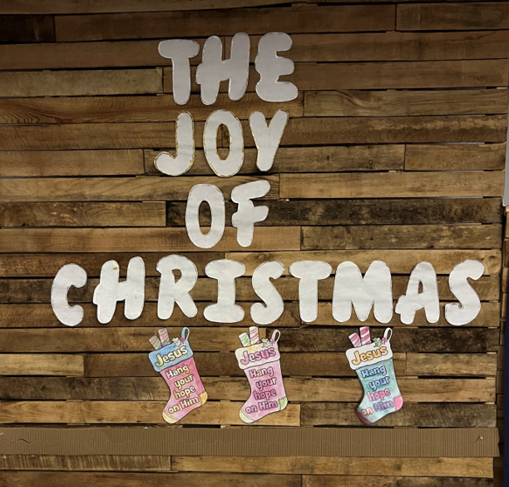

Children’s Christmas
Worship Service
December 18, 2022

December 18, 2022
4th Sunday in Advent

Greeting/Announcements

Call to Worship

L: We Praise You Lord that in the coming of your Son Jesus Christ.
P: Your promises given by the prophets were fulfilled and the day of our deliverance has dawned.
L: We praise you Lord because you sent Jesus Christ, your only Son,
to be born for us of Mary.

P: So, that we might be delivered from sin, and receive power to become your children.
L: We praise you Lord, for in Jesus Christ, the mystery of the Word made flesh.

P: You sent your light to shine upon the world, so that we might be brought out of darkness and into your marvelous light.
*Hymn: “Joyful, Joyful We Adore Thee”
Lighting the Advent Candles
Chris & Jenna Benjamin Family
Opening Prayer:
Grant Wilson & Brenton Butler

Heavenly Father grant us the fullness of your promises. Where we have been weak, grant us your strength; where we have been confused, your guidance; where we have been distraught, grant us your comfort; when we are being led astray, bring us back to your fold, where we have been dead, grant us your life. Apart from you, O Lord, we are nothing, in and with you we can do all things. AMEN.

*Indicates everyone stands to sing

Joy Proclamation
Embersen Wesenberg, Scarlett Monroe, Eleanor Hustin
“Joy, Joy, Joy Down in My Heart”
Adventure Kids

Old Testament Prophecy Isaiah 9:6-7
Aiden Benjamin & Blake Wilson

“Joy to the World”
All Children

Gospel Reading Luke 2:4-15
Colton Butler & Ashton Butler

“Silent Night” piano solo
Ethan Benjamin

“Away in the Manger”
Adventure Kids

Offering
Reagan Benjamin, Kyler Ehlert, Ashlynn Lewis, Abby Krantz
Doxology
Offertory Prayer
Bristol Wilson

*Hymn: “Go Tell it on the Mountain”

Hallelujah Shadow Play
FBI

Closing Thoughts
Pastor Ian McDonald

Benediction
Ben Wilson

Invitation
Dominic Lewis

Have a Joyful Christmas!

Adventure Kids

Ethan Benjamin
Reagan Benjamin
Ashton Butler
Brooklyn Butler
Colton Butler
Kyler Ehlert
Sylvia Hanson
Eleanor Hustin

Izzy King
Abby Krantz
Ashlynn Lewis
Scarlett Monroe
Betty Severson
Millie Severson
Embersen Wesenberg
Bristol Wilson

F.B.I.

Aiden Benjamin
Collin Benjamin
Brenton Butler
Benson Eckelbarger
Brynn Eckelbarger
Brantley Ehlert
Lilly Hagerman
Saige Hanson
Tempi King
Dominic Lewis
Ashton Lott
Reese Skinner
Ren Skinner
Blake Strouse
Savannah Wesenberg
Blake Wilson
Grant Wilson
Jackson Wilson
Wyndsor Wilson

89 Joyful, Joyful, We Adore Thee
Verse 1
Joyful, joyful, we adore thee, God of glory, Lord of love. hearts unfold like flowers before thee, opening to the sun above. Melt the clouds of sin and sadness; drive the dark of doubt away. Giver of immortal gladness, fill us with the light of day!

Verse 2
All thy works with joy surround thee, earth and heaven reflect thy rays, stars and angels sing around thee, center of unbroken praise. Field and forest, vale and mountain, flowery meadow, flashing sea, chanting bird, and flowing fountain, call us to rejoice in thee.

Verse 3
Thou art giving, and forgiving, ever blessing, ever blest, well spring of the joy of living, ocean depth of happy rest! Thou our Father, Christ our brother, all who live in love are thine, teach us how to love each other, lift us to the joy divine.

Verse 4
Mortals join the mighty chorus which the morning stars began, love divine is reigning o’er us, binding all within its span. Ever singing, march we onward, victors in the midst of strife, joyful music leads us sunward, in the triumph song of life.
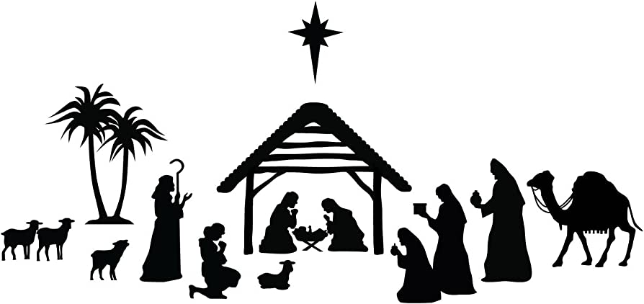

DOXOLOGY

Praise God, from whom all blessings flow; praise him, all creatures here be - low; praise him above, ye heavenly host; praise Father, Son, and Holy, Ghost. Amen.

251 Go, Tell It on the Mountain
Verse 1
While shepherds kept their watching o’er silent flocks by night, behold through-out the heavens there shown a holy light.

Chorus
Go tell it on the mountain, over the hills and everywhere; go, tell it on the mountain, that Jesus Christ is born.

Verse 2
The shepherds feared and trembled, when lo! above the earth,
rang out the angel chorus that hailed the Savior’s birth.

Chorus

Verse 3
Down in a lowly manger the humble Christ was born,
and God sent us salvation that blessed Christmas morn.
Chorus

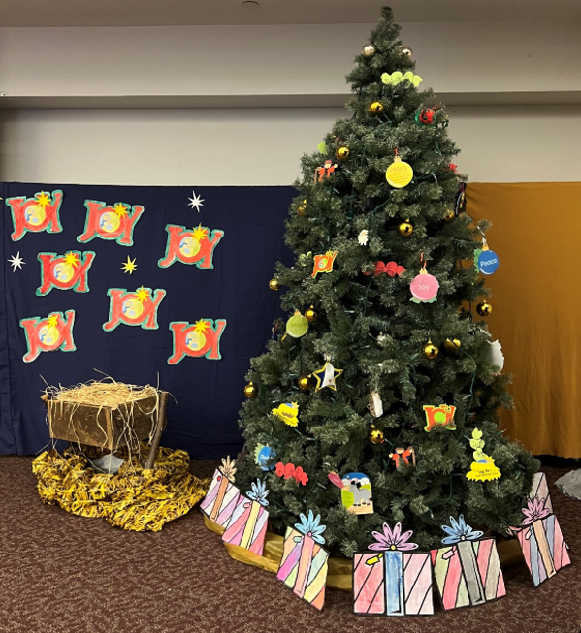

Please join Carson City United Methodist Church for our Annual Christmas Eve Candlelight Service to be held on Sat,
Dec 24th at 7:00 pm

Church closed on Sunday, December 25th

