November 2017
At a glance

Full descriptions of activities in bulletin.

Sun | Mon | Tues | Wed | Thurs | Fri | Sat
5  Worship  11:15  Communion | 6  Meditation 7 pm  AA 8 pm | 7  Cards  9:30  TOPS  6:30 | 8  Coffee Shop Office Hours  U of R | 9  Craft/Study  1:30  Munch Café Fundraiser  6 pm | 10 | 11  Women’s Breakfast  8 am  St. P Fowl Supper
12  Worship  11:15  Open Hearts  Gong Bath 3 pm | 13  Meditation 7 pm  AA 8 pm | 14  Cards  9:30  TOPS  6:30  LSC Council 7 pm | 15  Coffee Shop Office Hours  U of R  Taste of Skylight Planning 7 pm | 16  Craft/Study  1:30 | 17 | 18  LBC Musical  St. James  UC  7pm
19  Worship  @ 10 am St. James  United  For LBC Musical | 20  Meditation 7 pm  AA 8 pm | 21  Cards  9:30  TOPS  6:30  Faith Formation 7 pm | 22  Coffee Shop Office Hours  U of R | 23  Craft/Study  1:30 | 24  Film & Faith | 25  IMCF Breakfast  9 am
26  Worship  11:15  Potluck | 27  Meditation 7 pm  AA 8 pm  Russell Away – United-Anglican Dialogue | 28  Cards  9:30  TOPS  6:30 | 29 | 30  Craft/Study  1:30 | 1 | 2
3  Worship  11:15  Communion | 4  Meditation 7 pm  AA 8 pm | 5  Cards  9:30  TOPS  6:30 | 6  Leadership Team 7 pm | 7  Cong Care 10 am  Craft/Study  1:30  Family Dinner  6 pm  Carol Singing & Nativity Nt  7 pm | 8 | 9  Women’s Breakfast  8 am

TOPS = Take Off Pounds Sensibly
AA = Alcoholics Anonymous
ANNOUNCEMENTS
November 5, 2017

306-761-0556 eastsideunited@sasktel.net
Like us on facebook (Eastside United Church)
Follow us on Twitter @Eastside_united
www.eastsideunited.ca

W
elcome to Eastside United. May our opportunities of ministry offer you rest, challenge and peace on your Christian journey.

Ministers:
Minister: Russell Mitchell-Walker
Greeting: Brenda Adamko and Wanda Barr
Congregational Care Greeter:
Prayers: Bonnie Yake
PowerPoint: Janet Bjorndahl
Music: Michelle Dickie
Last week’s attendance: 49

Russell’s e-mail address: russell.eastside@sasktel.net

Office Hours:
Tuesday, Wednesday and Thursday from 8:30 am to 3:30 pm

Russell’s Office Hours:
Russell is in the office Tuesday through Thursday, working from home Friday.

Coffee Shop Office Hours Wednesdays from 2 to 4:30. Month of November at the Campion College Brewed Awakening!

Scripture Reading: 1 Kings 19: 1-18

Songs –
Who is My Mother? MV #178 vs. 1, 2
Come and Find the Quiet Centre VU #374
I Can Feel You Near Me God MV #48
Over My Head MV #88
What Can I Do? MV #191
For the Faithful Who Have Answered VU #707
May God’s Sheltering Wings MV #214

St. Philip Senior Ministry Outreach card playing program, Tuesday mornings at 9:30 am in the East Sanctuary at the Living Spirit Centre. Whist and lessons to those that would like to learn. Come out and enjoy fellowship, coffee and card playing. If you need a ride call Rod 306-789-1388. Everyone is welcome.

Eastside’s Craft/Study Group Thursdays at 1:30 pm in the Multipurpose Room and East Sanctuary! We are reading Flipped by Doug Pagitt. Join us as we share in discussion, handiwork and coffee time following. We have an extra copy of the book - let the office know if you are interested.

LSC Meditation Group: Join us on Monday, November 6 at 7 pm in the East Sanctuary. We’d love to have you join us whether you’re new to meditation or an experienced practitioner. All are welcome, remember to wear comfortable clothing. For more info, please get in touch with Sheri Nupdal at sherinupdal7@gmail.com.

THE NEW PARISH – Connecting with the neighbourhood
As part of Russell's study and exploration of The New Parish, he will be spending more time out and about in our neighbourhood. To enjoy this experience even more and engage more fully with area residents, he is offering a free Dog Walking Service. If you live in the vicinity of 3018 Doan Drive (University Park, Arcola East, Wascana, etc.) and have a pooch that would appreciate some exercise, please let Russell know. FYI, dog owners are welcome to go on these walks, too!

Also part of Russell’s New Parish coursework, he is looking for two or three individuals interested in exploring a vision of our neighbourhood. Where do people tend to bump into each other? What are the assets in the area? Let Russell know if you would like to join him for group mapping of our Arcola East Parish - a one evening commitment.

Do you have a group in the neighbourhood that you have coffee with regularly? Russell would love to join you and have a visit with your group as part of his New Parish and sabbatical work. You can extend an invitation to Russell to join you between now and April.
Disaster relief: Mission and Service is assisting with flood and hurricane relief in South Asia and the US. Please visit www.united-church.ca/news/emergencies-home-and-around-globe to see how you can help. Our support makes a difference as millions confront the impact of global climate change.

“War destroys all of us: we desperately appeal for peace on the Korean peninsula.” Connected to Catherine Christie’s visit with us on October 15, the National Council of Churches in Korea (NCCK) has released this collective call and urgent appeal to the international community for peace in Korea: http://bit.ly/2yOgsfs.

Our Moderator Jordan Cantwell has written to all MP’s as they head back to their fall session after the summer break. She addresses our concerns regarding Reconciliation, Israel-Palestine, and refugees. See it here: http://bit.ly/2i8oLJp.

The Regina MultiFaith Forum sponsored a refugee family that arrived in Regina almost a year ago and is getting settled very nicely. Refugee committee members have very generously given of their time in seeing that the family’s needs around language, transportation, and job seeking have been met but have determined that an extension of financial assistance to the family would be beneficial. The RMFF is therefore looking to raise an additional $15K to extend support to their family. Please make cheques payable to The Archdiocese of Regina noted for RMFF Refugee Fund and send c/o Dwaine Dornan at 207-4451 Nicurity Dr. Regina, SK S4X 0E5.Tax receipts will be issued by the Archdiocese.

Football season is almost over! Did you know you can support both the Riders and Indian Metis Christian Fellowship by parking in the ministry’s parking lot? A $10 contribution provides you with great parking within a few blocks of the game. Park at 3131 Dewdney Avenue and walk to the game in less than five minutes. Directions: from Dewdney Avenue turn south from Garnet Street and turn left into the alley and you have arrived!

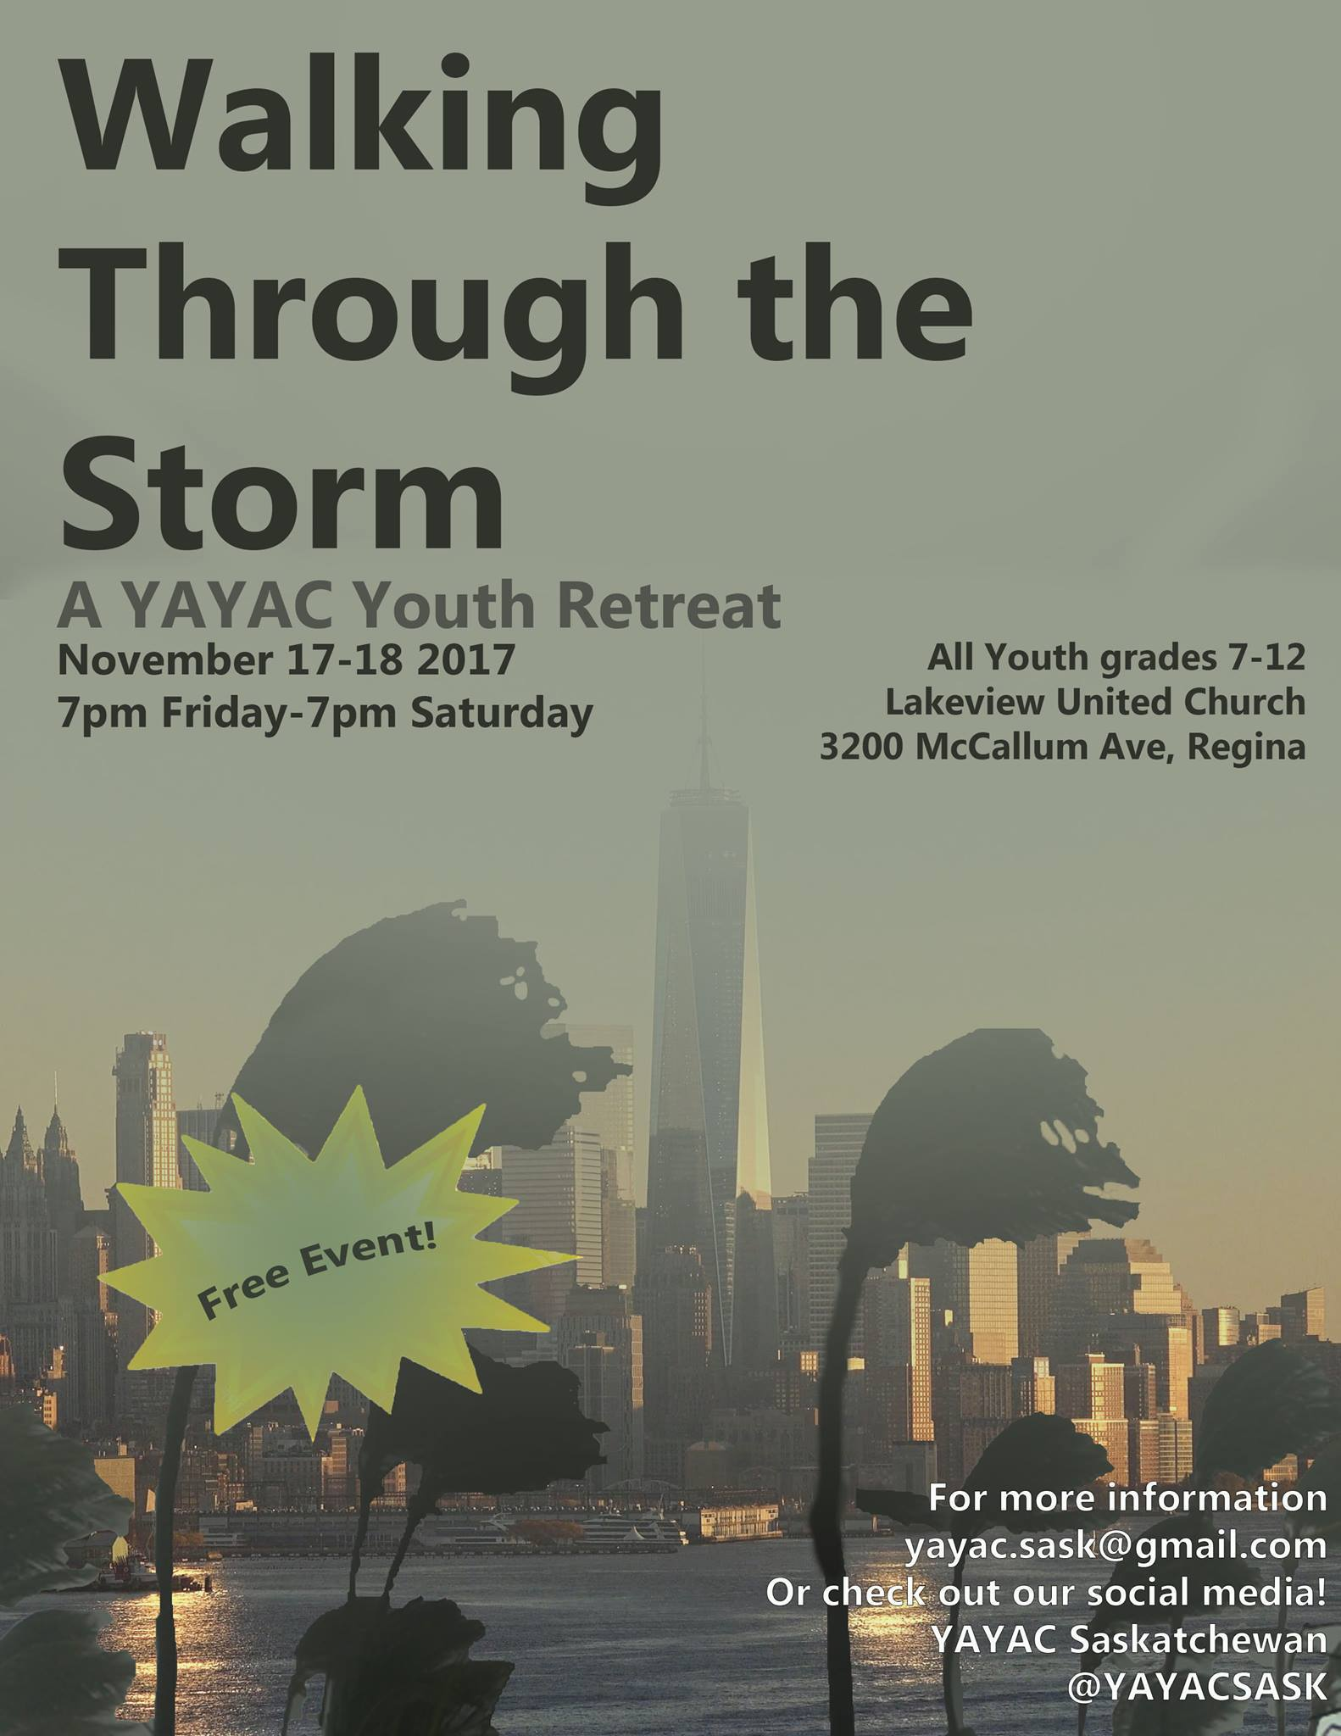
Registration forms on Eastside bulletin board.

LBC MUSICAL: Mark your calendar for the performances in Milestone: November 4 at 7 pm; St. James November 18 7 pm and Sunday Worship November 19 at 10 am. Tickets for November 18 performance are available after church or from the office. Heads up: Eastside worship will be at St. James November 19 at 10 am.

Munch Café and Catering 2nd Annual Fundraising Dinner: Thursday, November 9, doors open at 5:30, supper at 6, program at 7. Sausage and perogie supper; cash bar; amazing silent auction and raffle prizes; entertainment by Colby Nargang. Entry by donation. At Holy Child Parish hall, 2636 7th Avenue. RSVP by emailing catering@munchinregina.ca.

LSC Women's Spirituality Breakfast, Saturday, November 11 from 8 to 10 am. This months’ speaker is Judith Hindle, volunteer Co-founder and Facilitator for 15 years with the Regina and area “As Good as it Gets” Self Help Group for Individuals and Families with Obsessive Compulsive Disorder. Judith is a retired Registered Nurse, adult educator, and provincial government Health Policy Analyst with Portfolios for Women’s and Seniors Health and International Human Rights, among others. Her professional career and volunteer involvement have been grounded in the health and continuing education spheres for over thirty years. Judith is a long-time member of the Canadian Mental Health Association Saskatchewan Division; she has continued to be involved with the OCD Self Help Group in responses to telephone and e-mail inquiries and referrals to OCD resources since retiring as facilitator in 2013.
Judith will be speaking about OCD (Obsession Complusive Disorder):
major features, causes, treatment approaches, and Regina area and other self-help resources for individuals and families affected by it. Questions and open discussion will be welcome. All women are invited for breakfast. Bring two toonies to cover the cost.
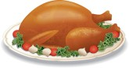
Everyone is invited to attend St. Philip's Annual Fowl Supper on Saturday, November 11. Serving starts at 5:30 pm. Tickets are $18 for adults ($10 for children under 10) and must be purchased in advance. Call Don Metz for tickets 306-789-5241.

A Taste of Skylight: Skylight Festival of Arts, Spirituality, Faith and Justice is a national event started three years ago in Paris, Ontario. Russell is the program chair for the event. We are hosting a tri-parish, ecumenical event in the flavour of Skylight Festival (www.skylightfestival.ca) in early spring 2018, to enable local folk to experience the Festival. Watch for details.

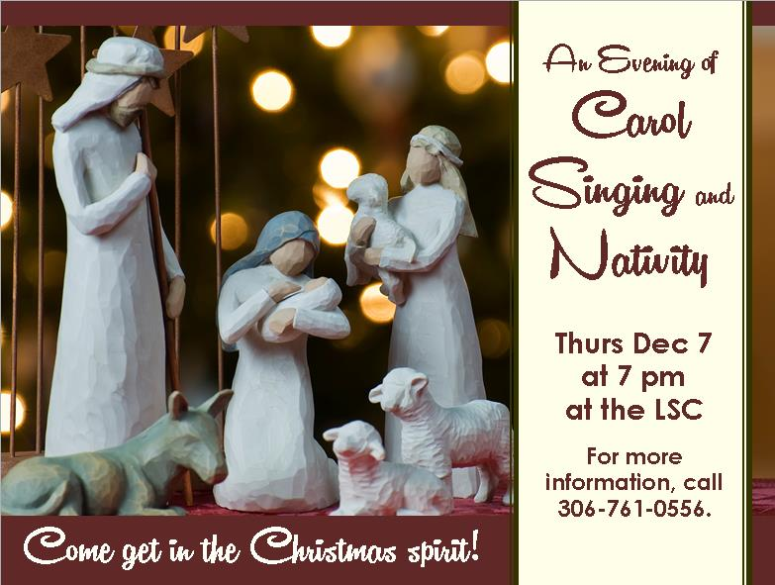
Do you have a special nativity scene with a story you’d like to share?
Please write the story of your nativity on an index card and plan to bring it by the LSC any time the week of December 5.

Jingle Bell Bazaar, Tea & Bake Sale: at Whitmore Park United Church on Saturday, November 18 from 2-4pm. Baking, Turkey Pies, Preserves, Christmas Crafts, White Elephant: Admission is $3 and includes teas, coffee or juice and dessert.

Christmas Tea Broadway United Church, 105 Broadway Avenue.
Saturday, November 18, 2017 1 to 4pm. Bake Sale, White Elephant Table, Craft Tables, Tea, Coffee and Dessert $3 at the door.

Wesley’s Annual Christmas Market with Children’s Shopping Spree
November 25, 10 am - 2 pm at Wesley United Church, 3913 Hillsdale St.
Tickets $3. children under 10 free, available in advance from church office or at the door (Includes beverage and muffin).

WESTMINSTER WORLD MARKET: Saturday, November 25 from 10 am to 2 pm, Westminster will host approximately 30 tables where Newcomers to our city will sell their products of food and crafts. Our last market had 16 countries represented! Entry by donation goes to our Refugee Fund. Come and enjoy the flavours of the world! Pop up Ten Thousand Villages Sale next door at Holy Rosary Cathedral too!

Christmas Turkeys!
Order your Christmas turkey through LBC this year and everyone wins. For $100 you will receive an 8 kg (approx) turkey and charitable tax receipt for $50. Turkeys can be picked up on Sunday, December 17 from 3 to 5 pm at Eastside United. Or for $10 more an LBC volunteer will deliver your turkey to your doorstep. To place your order, email info@lumsdenbeachcamp.com.
