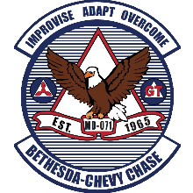
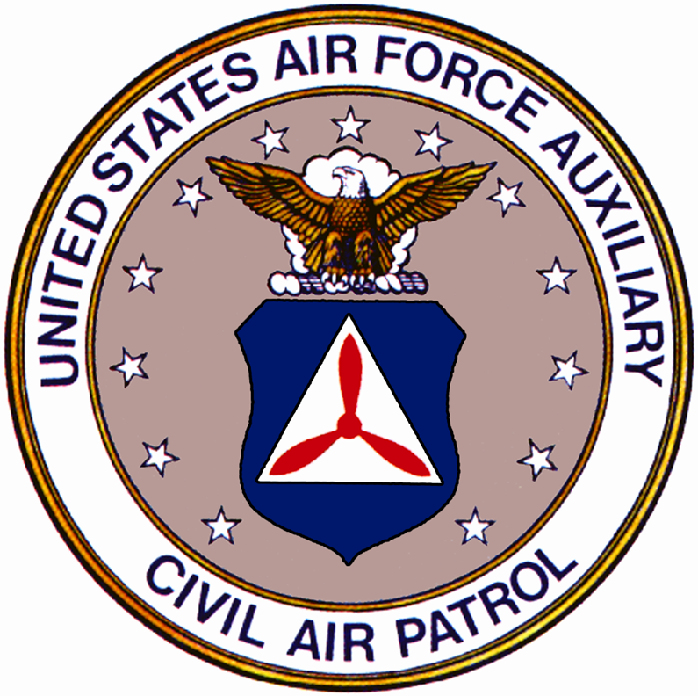
BETHESDA-CHEVY CHASE COMPOSITE SQUADRON
CIVIL AIR PATROL

UNITED STATES AIR FORCE AUXILIARY
4732 Brightwood Road
Olney, MD 20832-1847

[DD Month YYYY]

[Insert your rank and name]
[Insert your address]
[Insert your city, state, zip code]

Dear [Name],

This year my Civil Air Patrol Squadron, the Bethesda-Chevy Chase Composite Squadron, is supporting the Wreaths Across America Program. This program focuses on three goals:

- REMEMBER our fallen U.S. veterans
- HONOR those who serve
- TEACH our children the value of freedom

Wreaths Across America is a nationwide program through which individuals can sponsor holiday wreaths to be laid on Veterans’ graves at participating locations across the nation and abroad on National Wreaths Across America Day, observed annually on the third Saturday in December (this year on December 17th). These wreaths serve as a small tribute to these men and women for their sacrifices made in defense of our freedom. Civil Air Patrol is a national partner of Wreaths Across America and assists in selling wreath sponsorships and placing them on veteran graves.
Wreath sponsorships sold by my squadron specifically support this effort at the Cheltenham Veterans Cemetery in Cheltenham, MD where 24,000 local veterans are laid to rest. With every wreath sponsorship sold, another wreath will be laid at Cheltenham. Additionally, $5 of each $15 wreath sponsorship will be returned to my Squadron as a donation to support our Cadet Program. This year, we have set a goal of sponsoring 500 wreaths! On National Wreaths Across America Day, December 17th, our Squadron will then assist in laying the wreaths at Cheltenham.
On behalf of the volunteers and military families looking to honor all the veterans laid to rest at Cheltenham Veterans Cemetery, and the Wreaths Across America extended family, I thank you for your consideration of this meaningful cause. Please let me know if you would be interested in supporting the mission to Remember, Honor, Teach.
Respectfully,

[Insert rank and name here]
[Insert title/position here if applicable]
Bethesda-Chevy Chase Composite Squadron

