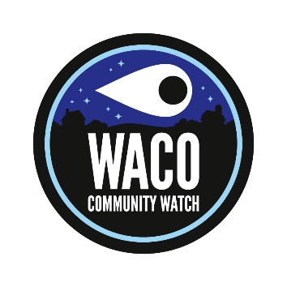 Waco Community Watch Meeting
Thursday April 7, 2022
6:30 pm
Minutes:
- J. Barrett introduced the new Waco Community Watch logo design that was created by our local business, Graphic Designs by Jimmy Carpenter.

- J. Barrett reported that the Shelby Star had ran a front page news story about the Community Watch program development. He said that the article had been promoted and shared on the Town of Waco Facebook page. Barrett also reported that he had been contacted by the Kings Mountain Herald requesting information on the program for an article for their paper. That article was in their last issue. He stated that he would contact the Cherryville Eagle and the Shelby Shopper to get articles in both to help spread information on the program.

- J. Barrett reported that a private Waco Community Watch Facebook Group page had been developed and was open to members of the community to join. The page is a way to share information on issues in the community and as a communications link for local citizens. The page currently has 15 members.

- J. Barrett reported that he had asked for pricing on getting 4” window stickers made of the new logo. The idea is to hand out these to homes and businesses in the community to be displayed in windows showing they are a part of the Community Watch program.

- J. Barrett reported that he would like to have a tri-fold brochure developed that could be handed out in the community to introduce the program and share information on how to join. He hopes to gather donations from businesses to pay for the cost of developing and printing both the window stickers and the brochure.

- Members also discussed purchasing and posting Community Watch signs in town and in the community. Information on pricing for the signs will be presented at the next meeting.

- J. Barrett reported that he had drafted a letter to all the businesses in the Waco Community explaining that the Town had started a Community Watch program and that the plan was to expand the program into the entire Waco Community. The letter defined the community watch program concept and explained what the expectations were for moving forward and expanding into the community. The letter also encouraged the businesses leaders to assist with helping purchase signs, window stickers and brochures to make available to the residents to promote interest in the program.

- Members present discussed how to engage more interest and participation in the group and how to get members to turn out for meetings. Everyone agreed that the program was still very new and that the time change probably affected attendance. Members felt sure that attendance would pick up. Everyone present were challenged to spread information in their neighborhoods before the next meeting.

- Members discussed sharing information to the local churches about the group and Barrett said he would draft a letter to local pastors asking them to share information with their congregation.

- The group discussed ways to communicate with the non-Facebook members. Barrett reported that there is an email group from the earlier meetings that he has used to contact members about this meeting. The group agreed that information could be shared through an active email chain and that we will continue to build on this idea.

- Members discussed holding a community event this summer sponsored by the Community Watch program as another way to promote the program. This idea will be discussed more at the next meeting.

- The group discussed developing a monthly meeting schedule and felt that Thursday nights were the best night to hold these. The next meeting of the Waco Community Watch program will be on Thursday May 5th at 6:30 pm.

- J. Barrett advised he would share information on what was discussed at the meeting with members of the Facebook page and through the email chain.

- Meeting adjourned at 7:10 pm

