14th April 2024

Hi All,

PROPOSED CHANGES TO RUSHYFORD ROUNDABOUT

I just wanted to convey my thanks to you all for attending the Meeting with Paul Howell MP on Thursday 11th April and/or for taking the time to compile a letter detailing your individual concerns regarding Durham County Council's (DCC) proposals to upgrade the road infrastructure around Rushyford Roundabout.

Just to give you a bit of an update, I have now received an email from Durham County Council Officers in response to residents’ letters of concern, and following a meeting, that myself and local Councillors attended with Officers from the Local Authority about the plans, and which I have attached for your information below. As you will see the letter indicates that at the current time DCC's position remains unchanged, and the Local Authority obviously intend to proceed with the plans as they stand, without any changes.

That said, I have passed the Local Authority's response to Paul Howell MP, who is currently trying to organise an urgent meeting with Transport Officers at DCC, to put forward our case for incorporating speed calming measures and safe pedestrian crossings into the plans (i.e. traffic lights with pelican crossings). Having visited the roundabout in person twice last week, Paul is fully aware of the issues faced and will do his best to support residents in this matter.

Works on the roundabout are scheduled to commence at the end of April and complete by the Autumn, as such Paul will be trying to negotiate with DCC Officers as a matter of urgency. Paul is back in Parliament on Monday, so any meeting may have to be held remotely via Teams, but he will remain in touch with myself, and as soon as he gets back to me with an update, I will of course be back in touch with yourselves to keep everyone informed.

I have sent this email to everyone who I have an email address for and have uploaded a copy onto the News section of the Parish Council website for residents’ information. If I can be of any further assistance, please do not hesitate to get back in touch with myself.

Many thanks and kind regards
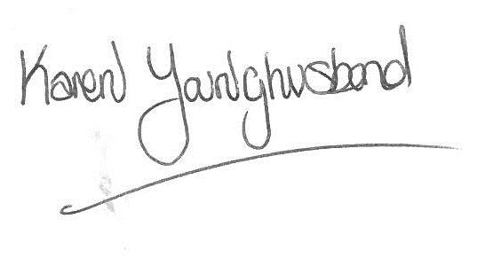
Karen Younghusband
Clerk Windlestone Parish Council
Mobile: 07808062525

(SEE EMAIL BELOW FROM DURHAM COUNTY COUNCIL)

EMAIL FROM CRAIG MACLENNAN, DCC

Hi Karen,

Thank you for your time recently at the meeting to discuss the proposals.

As discussed the funding for the roundabout has been secured, considering it alleviates current significant congestion issues as well as facilitating house growth at Low Copelaw.

As explained as a five arm roundabout, with a relatively small footprint, it is not possible to signalise with associated pedestrian crossing facilities. This would require queueing space within the gyratory, which is not available. It would also negatively impact upon traffic flow and capacity, not resolving congestion issues and meaning development could not come forward.

However it should be noted that walking and cycling measures have been considered as part of the design, to reflect a balanced design.

- Increased 3 metre width footpaths provided around the gyratory
- Tactiles replaced
- New and improved signage
- The width of the total carriageway, at point which pedestrians cross, have been contained as far as possible
- Whilst an extra island has been incorporated in the design (for the eastern, southern and western arms), meaning an extra pedestrian ‘hop’, the distances for the respective ‘hops’ have decreased. This considers narrower traffic lanes
- The use of narrower traffic lanes in the non-peak traffic periods, should also reduce traffic speeds approaching and moving around the gyratory.

The works will be monitored post completion in the form of a further Road Safety Audit.

Regards,

Craig

