**PEDIATRIC PATIENT INTAKE – AGE 6-18**

**CHILD’S NAME: ________________________________________________________________________**

**Last First Middle**

**MOTHER’S NAME: ____________________________________FATHER’S NAME: ___________________________________**

**HOME PHONE: _________________ MOTHER’S PHONE: _________________ FATHER’S PHONE: ______________**

**ADDRESS: ___________________________CITY/TOWN:___________________STATE:_________ ZIP: __________**

**BIRTH DATE: __________ AGE: ____ GENDER: _ MALE _ FEMALE _ NON BINARY _ PREFER NOT TO ANSWER**

**PRIMARY COMPLAINT(S)__________________________________________________________________________**

**________________________________________________________________________________________________**

**________________________________________________________________________________________________**

**________________________________________________________________________________________________**

**PAIN DIAGRAM – Where does it hurt? Circle the areas on the diagram:**

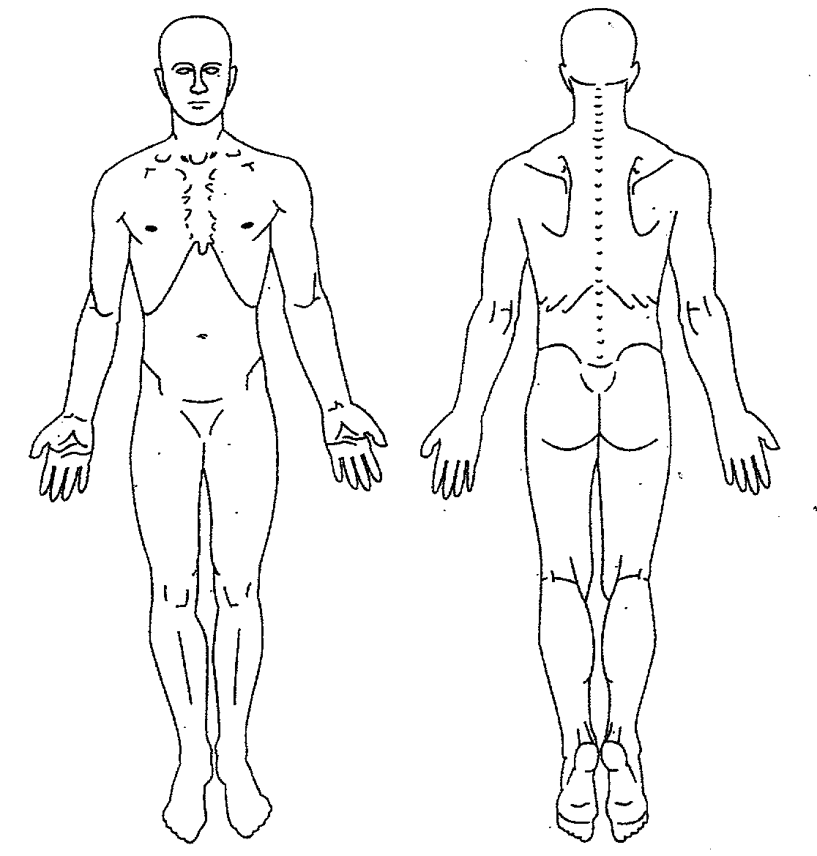

**PEDIATRIC CASE HISTORY**

**HAS THIS CHILD EVER SUFFERED FROM:**

* **Arthritis**
* **Neck Problems**
* **Joint Problems**
* **Backaches**
* **Walking Problems**
* **Arm Problems**
* **Orthopedic Issues**
* **Paralysis**
* **Broken Bones**
* **Leg Problems**
* **Muscle Jerking**
* **“Growing Pains”**
* **Digestive Disorders**
* **Sugar Concentration**
* **Stomach Aches**
* **Constipation**
* **Diarrhea**
* **Diabetes**
* **Poor Appetite**
* **Dizziness**
* **Fainting**
* **Convulsions**
* **Hyperactivity**
* **Behavioral Problems**
* **Anemia**
* **Blood Disorders**
* **Heart Trouble**
* **Hypertension**
* **Asthma**
* **Sinus Trouble**
* **Chronic Earaches**
* **Colds/Flu**
* **Allergies**
* **Bed Wetting**
* **Rheumatic Fever**
* **Tuberculosis**
* **Ruptures/Hernias**
* **Neuritis**
* **Other**

**LIST ANY SURGERIES: _____________________________________________________________________________**

**_________________________________________________________________________________________________**

**MEDICATIONS: ____________________________________________________________________________________**

**_________________________________________________________________________________________________**

**ACCIDENTS: ______________________________________________________________________________________**

**_________________________________________________________________________________________________**

**RELEVANT FAMILY HISTORY: _______________________________________________________________________**

**_________________________________________________________________________________________________**

**_________________________________________________________________________________________________**

**IS THERE ANYTHING ELSE YOU WANT US TO KNOW? __________________________________________________**

**_________________________________________________________________________________________________**

**AUTHORIZATION FOR CARE OF MINOR**

**I HEREBY AUTHORIZE THIS CLINIC AND ITS DOCTOR(S) TO ADMINISTER CARE AS THEY DEEM NECESSARY TO MY SON/ DAUGHTER/ WARD (UPON APPROVAL OF PARENT OR GUARDIAN).**

**SIGNED: __________________________________ WITNESSED: __________________________ DATE: _____________**

**I REALIZE THAT I AM RESPONSIBLE FOR ALL FEES CHARGED BY THIS CLINIC AND THAT I WILL PAY FOR ALL SERVICES AS THEY ARE PERFORMED.**

**DATE: __________________________ SIGNATURE: ___________________________________________________**

**Form Developed by Peter Pan Potential**