Volume 1 | Issue 1

24SEP2016

**Bulgogi Soy Curls**

# Soy Curls

Heat up water in a pot and place one cube of No-Chick seasoning in water. When water comes to a boil, place ½ bag of Butler Soy Curls in for 10 minutes. Remove Soy Curls and drain out as much water as you can. Put rehydrated Soy Curls in a big Ziploc bag.

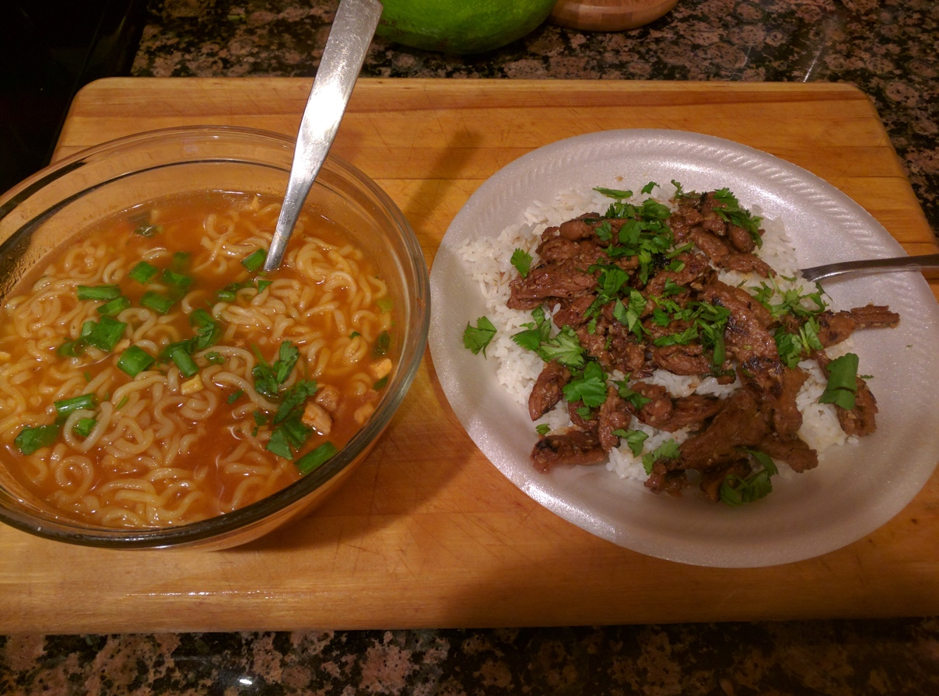

# Bulgogi Sauce

* 1/3 cup of Low Sodium Soy Sauce od Bragg’s Liquid Aminos
* 1/3 cup water
* 2 TBSP of Agave
* 2 TBSP of Sesame Oil
* 3 cloves garlic, minced
* ½ medium yellow onion chopped
* 4 green onions, sliced
* 2 TBSP of Sesame Seeds
* ¼ tsp of black pepper

**Cooking Instructions**

Now that you have your soy curls and have made your Bulgogi sauce;

* Pour sauce into your Ziploc bag with soy curls
* Let it marinate for about 1 hour
* After an hour, remove soy curls (without sauce) and fry in a pan
* I allow it to get slightly burnt, so that it is crispy
* Once the soy curls are crispy, pour remaining sauce over the soy curls.
* Add your soy curls over Jasmin or basmati rice
* As an added touch, I like to sprinkle fresh cilantro over the top.

**ENJOY!!!**