1ST ANNUAL

ROSWELL RANCHERS SELECT SALE

**Presented by Roswell Livestock Auction**

**APRIL 9, 2016**

**FEATURING:**

21 - HORSES

33 - CHAROLAIS BULLS

300 – 2 YEAR OLD ANGUS & ANGUS PLUS PAIRS &

BRED HEIFERS

30 – FRESH CORRIENTE ROPING STEERS

70 – FRESH ROPING CALVES

3 – STOCK DOGS

**SCHEDULE OF EVENTS:**

9:00 A.M. – 1:00 P.M – All cattle will be available for preview at

Roswell Livestock Auction

9:00 A.M. – Horse and Stock dog preview to be announced

1:00 P.M. – Sale starts at Roswell Livestock Auction

**ORDER OF SALE:**

2 year old Angus & Angus Plus pairs & bred heifers

Charolais Bulls

Horse Sale

Stock Dog Sale

Corriente Roping steers

Roping Calves

**INDEX**

|  |  |  |
| --- | --- | --- |
| Lot # | Owner’s Name | Animal |
|  | CAZA RANCHES – ARTESIA, NM | 300 ANGUS BRED HEIFERS & PAIRS |
| 1-25 | BILL KING RANCH, MORIARTY, NM | 20 CHAROLAIS BULLS |
| 26-35 | GRAU RANCH – GRADY, NM | 6 CHAROLAIS BULLS |
| 36-45 | BILL SIMS – EUNICE, NM | 6 CHAROLAIS BULLS |
| 1 | KIM CHESSER | HADIEE GUN |
| 2 | CHANCE GAINER | CEE BEES BALLIO |
| 3 | CASEY HATLEY | DRIFTER |
| 4 | CORY ROWLAND | TROY DUN |
| 5 | DICKIE MCINTOSH | LARNED SHOWSOFF GIN |
| 6 | SHANNON MOORE | GO ROUND |
| 7 | ADAM SCHULTE | BABYDOLL |
| 8 | BOBBY VAUGHN | LISTONIC |
| 9 | COLE BURSON | SATIN LIL SUGAR |
| 10 | C W MORRIS | DOCS NOEL |
| 11 | KOLYN DUTTON | SMOKE |
| 12 | DAVE MCINTOSH | SOCKS |
| 13 | WESLEY GRAU | TEXAS SILVER COYOTE |
| 14 | WAYNE METCALF | SIXES WIMPY |
| 15 | DENNIS KLINGHAGEN | DOCS QUICK PEP UP |
| 16 | SAM COBERLY | CATTS KIKN A LIL ACE |
| 17 | CADE HOOTEN | LUCKY CHOICE HAND |
| 18 | JERRIVON THOMAS | RBS PEPPY SAN VILLA |
| 19 | JARROD HARRAL | JACKS DARLIN GEMINI |
| 20 | KELLY HATLEY | CHILDRESS DOC PEPPY |
| 21 | ROSENDO APODACA | MARIACHI |
| 22 | E C CATTLE | HAIDEE GUN |
|  | NATE CATER – CALLIE | STOCK DOG |
|  | KORKY HARE – TAZ | STOCK DOG |
|  | BRAD ODER - ROCK | STOCK DOG |
|  |  | CORRIENTE STEERS |
|  | D K BOYD RANCHES | ROPING CALVES |

**HORSE SALE**

|  |  |  |
| --- | --- | --- |
| 1 | HAIDEE GUN | 5159751 |
|  | **2008 BAY GELDING** | **KIM CHESSER** |
|  |  |  |
|  |  | Peppy San Badger |
|  | Haidas Little Pep |  |
|  |  | Doc’s Haida |
| HAIDAS SAN SMOKE |  |  |
| 4245484 |  |  |
|  |  | Mr Gun Smoke |
|  | Jo Ell Smoke |  |
|  |  | Jo Ell San |
|  |  |  |
|  |  | Freckles Playboy |
|  | Young Gun |  |
|  |  | Lenaette |
| SQUEEKY GUN |  |  |
| 3435676 |  |  |
|  |  | Tivio Tramp |
|  | Mr Tivio Squeeker |  |
|  |  | Squeekin Jane |
|  |  |  |

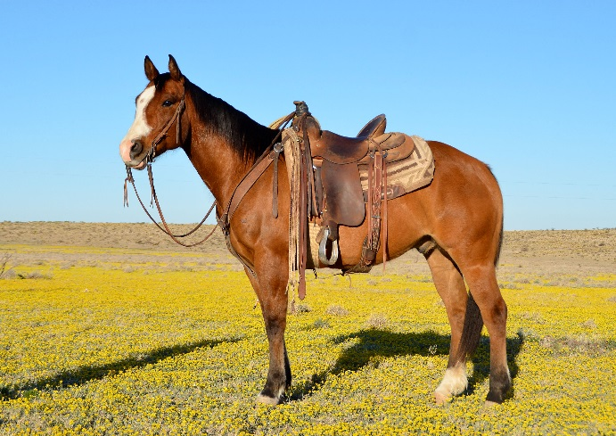

I’ve owned “Kid” for the last 6 years. He is gentle, has great conformation and is 100% sound. He is easy to shoe, rides around nicely and has a big stop. Easy to look at, with neat coloring, looks like a bay with the dorsal stripe of a Dun. We’ve used him in all aspects of ranch work and he has been Tye’s go-to ranch using/ day working horse for the past four years. Handles himself well in rough and rocky country. Tye has started heeling on him and he has the potential to be a top end heel, breakaway, or calf roping horse. Great prospect with the potential for anything from a ranch horse to a timed event or performance horse. “Kid” is a fun horse with lots of personality.

|  |  |  |
| --- | --- | --- |
| 2 | CEE BEES BALLIO | 4896645 |
|  | **2006 BUCK GELD** | **CHANCE GAINER** |
|  |  |  |
|  |  | Fritz Command |
|  | Cee Bee Command |  |
|  |  | Jay Bee’s Best |
| CEE BEES PEPPY |  |  |
| 3424693 |  |  |
|  |  | Peppys Humo |
|  | Peppys Apree |  |
|  |  | Saucy Bar Flit |
|  |  |  |
|  |  | Classy Doc Bar |
|  | Cola Cowboy |  |
|  |  | Ben’s Velveteen |
| CALM COMMOTION |  |  |
| 2992298 |  |  |
|  |  | Harmac Bull |
|  | Miss Harmac |  |
|  |  | Okie Stormy |
|  |  |  |

“Fritz” is a 10 year old Buckskin gelding. He stands 14.2 hands and weighs 1200 pounds. He has a good mane, tail, and lots of foot and bone. He has done everything you can do on the ranch. Drug calves to the fire, roped cattle outside, and sorted in the pens. “Fritz” is started in the arena on both ends but is making a better head horse. He will be hauled to a few jackpots before the sale. 100% sound and gentle.

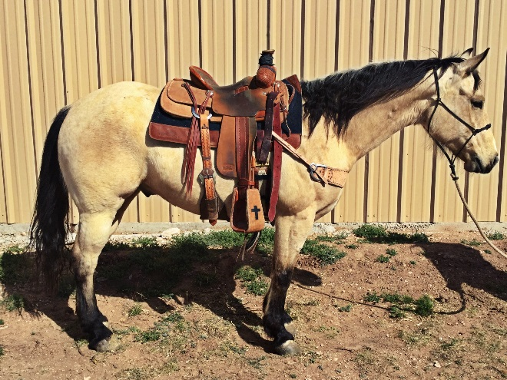

|  |  |  |  |  |
| --- | --- | --- | --- | --- |
| 3 | | DRIFTER | | GRADE |
|  | **8 YEAR OLD PALOMINO GELD** | | | **CASEY HATLEY** |
|  | | |  |  |

Drifter has been in the family for the past four years. If you are looking for one can do it all, here he is. He has been hauled to jackpots on both ends. He scores well, plenty of run, rate, and a strong finish then take him home Monday morning go do your daily ranch work from doctoring calves to dragging them to the fire. Not many like him, 100% sound.

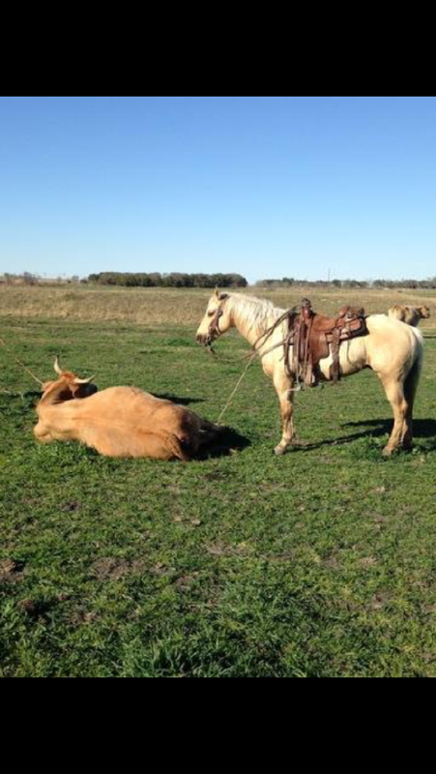

|  |  |  |  |
| --- | --- | --- | --- |
| 4 | TROY DUN | | X0631670 |
|  | **2004 DUN GELD** | | **CORY ROWLAND** |
|  |  | |  |
|  |  | | Nero’s Bracket |
|  | Nero’s Roan | |  |
|  |  | | Watterson Fish |
| NEROS FIDDLING DUDE | |  |  |
| 3834817 |  | | Sporty Jay |
|  | Sporty Miss Dude | |  |
|  |  | | Miss Karen Kay |
|  |  | |  |
|  |  | | Mr San Peppy |
|  | Mr Gold Peppy | |  |
|  |  | | Bill’s Vanette |
| QUEEN CURLEY SUE |  | |  |
| X0534844 |  | |  |
|  |  | | King of Kings |
|  | Queen Hellaina | |  |
|  |  | | Hellaina Marie |
|  |  | |  |
|  |  | |  |

If you are looking for a big horse that will cover country, this is him. He has been used in all phases of ranch work. He has had a lot of cattle roped on him outside. Started on the head side. Willing to please, smooth to ride, gentle and sound. Ready to go ranch, ride or rope.

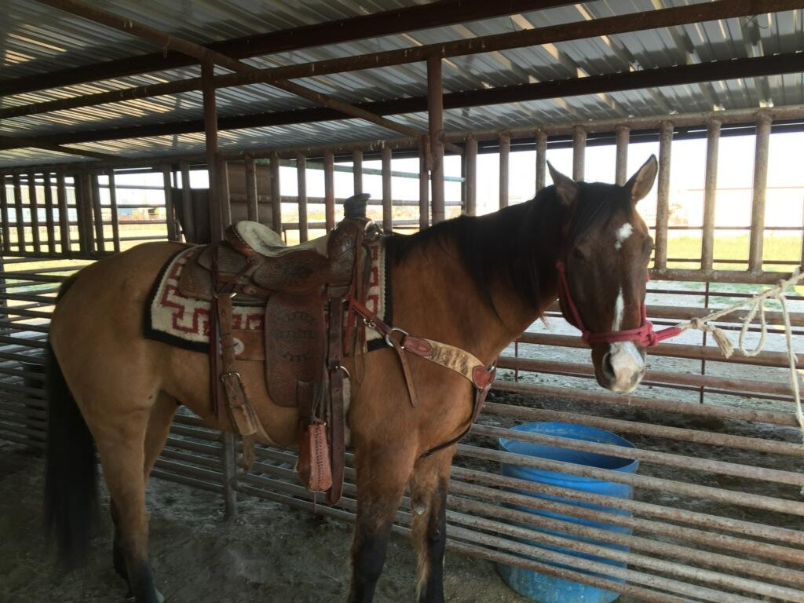

|  |  |  |
| --- | --- | --- |
| 5 | LARNED SHOWSOFF GIN | 5018397 |
|  | **2007 SORREL MARE** | **DICKIE MCINTOSH** |
|  |  |  |
|  |  | Preferred Pay |
|  | Preferred Gin |  |
|  |  | Model Gin |
| BECACO DIAMOND GIN |  |  |
| 3458274 |  | Some Six |
|  | Becaco Ss Fo |  |
|  |  | Becaco Bar Fose |
|  |  |  |
|  |  | Stats Jimmy |
|  | Showtime Stats |  |
|  |  | Roguish Bars Miss |
|  |  |  |
| LARNEDS EASY MOVER |  |  |
| 3816152 |  | Strictly Easy |
|  | Easy Caliente Larned |  |
|  |  | Caliente Tequilla |
|  |  |  |
|  |  |  |

Really nice mare with a lot of ability and a willing attitude. Has been used a lot outside and roped on in the arena.

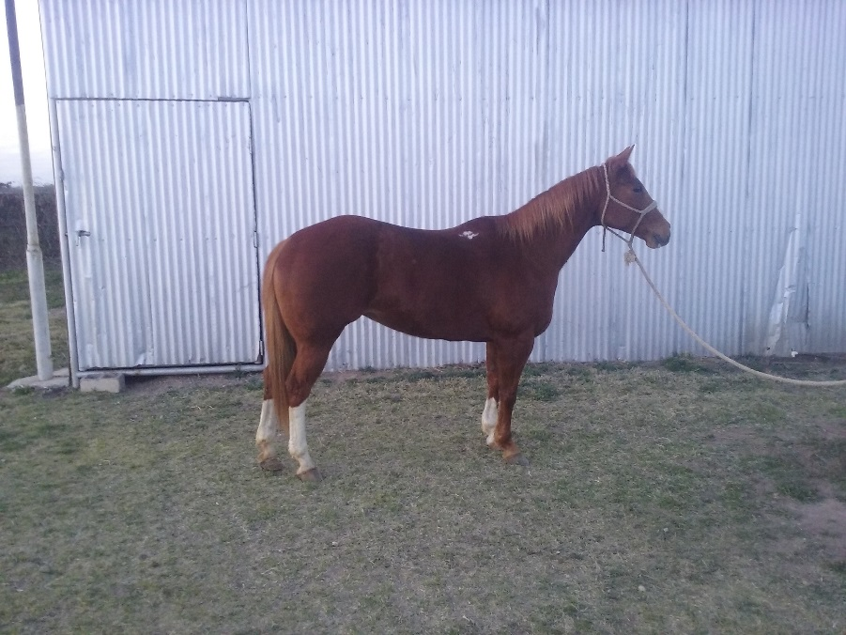

|  |  |  |
| --- | --- | --- |
| 6 | GO ROUND | GRADE |
|  | **5 YEAR OLD SORL GELD** | **SHANNON MOORE** |
|  |  |  |
|  |  |  |

Real nice young horse with a big future ahead of him. We looked after wheat cattle on him all winter and day worked on him. He is started in the arena and would be a nice horse to take to the ranch or to the arena.

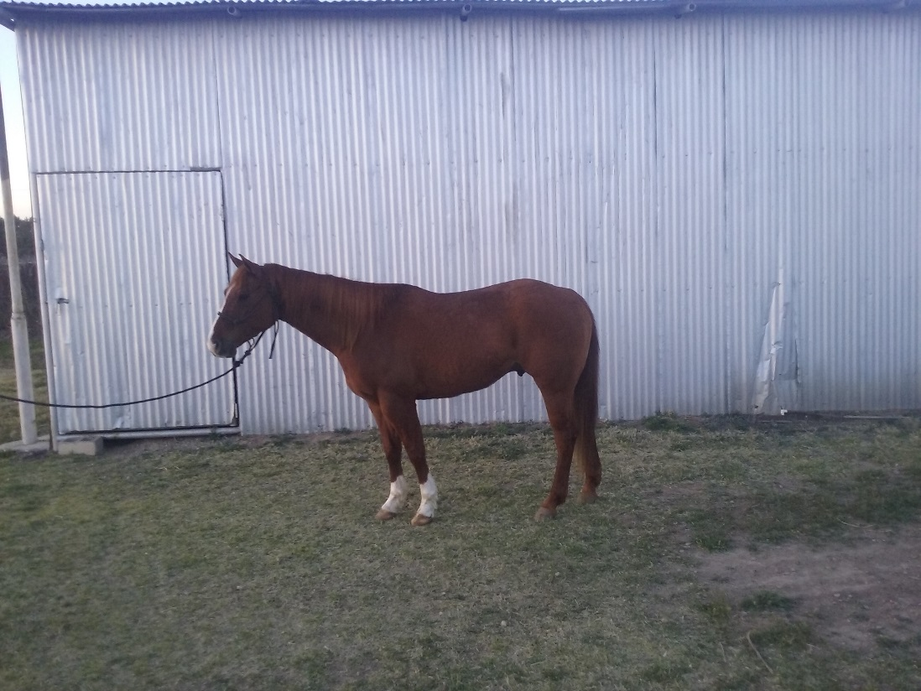

|  |  |  |
| --- | --- | --- |
| 7 | BABY DOLL | GRADE |
|  | **8 YEAR OLD BAY MARE** | **ADAM SCHULTE** |
|  |  |  |
|  |  |  |

“Baby Doll” is an 8 year old mare out of Playgun bred stock but will be sold as grade. She is a good gentle horse that is an easy keeper. “Baby Doll” has been ridden in a feed yard for six years. She is good with gates and mud. She has a good eye and is very cowy. She has had a lot of wheat pasture calves roped on her and she has also started heading and heeling in the arena. She is sound, super gentle and ready to go to work.

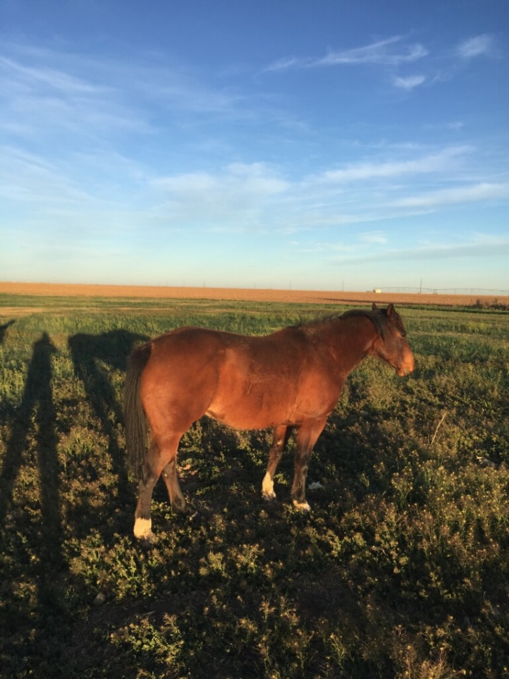

|  |  |  |
| --- | --- | --- |
| 8 | LISTONIC | 4667219 |
|  | **2005 SORL GELD** | **BOBBY VAUGHN** |
|  |  |  |
|  |  | Smart Little Lena |
|  | Smart Chic Olena |  |
|  |  | Gay Sugar Chic |
| LISTO POLLITO LENA |  |  |
| 3086836 |  |  |
|  |  | Doc’s Remedy |
|  | I’m Dee Remedy |  |
|  |  | Miss Yucca Dee Bar |
|  |  |  |
|  |  | Doc’s Remedy |
|  | Reminic |  |
|  |  | Fillinic |
| PEPPYNIC KIST |  |  |
| 3598035 |  |  |
|  |  | Peppy San Badger |
|  | Peppys Sunkist |  |
|  |  | Naranja Sequnda |
|  |  |  |

Very versatile horse with a great disposition and fun to ride. You can do just about anything on him. Carries his head low and moves smooth and easy. He has been used mainly as a heel horse and calf horse. He has also been used outside and in the branding pen. He is gentle, easy to catch and shoe. He will be the same every time you put your saddle on him.

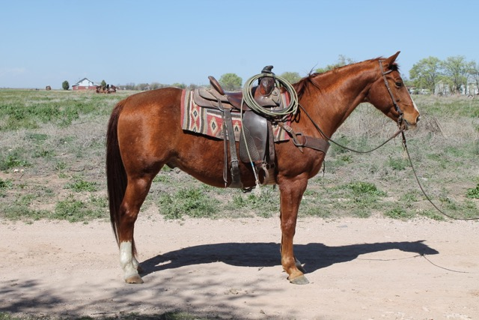

|  |  |  |
| --- | --- | --- |
| 9 | SATIN LIL SUGAR | 4000447 |
|  | **2000 CHESTNUT GELD** | **COLE BURSON** |
|  |  |  |
|  |  | Sugar Bars |
|  | Satin ‘N’ Sugar |  |
|  |  | Angel Note |
| SATIN SUGARITO |  |  |
| 3528452 |  |  |
|  |  | Peppy Chex Doc |
|  | Peppys Sweet Rose |  |
|  |  | Ima Sugar Chick |
|  |  |  |
|  |  | Sugar Bars |
|  | Satin ‘N’ Sugar |  |
|  |  | Angel Note |
| LIL SUGAR BONITA |  |  |
| 3201705 |  |  |
|  |  | Milford One |
|  | Gentle Impression |  |
|  |  | All I Do |
|  |  |  |

Good with his feet and loads easily. Quiet in cattle. Has been ridden in ranch rodeos and outside a lot. Gentle.

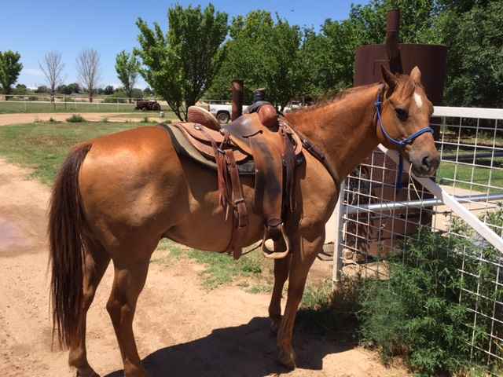

|  |  |  |
| --- | --- | --- |
| 10 | DOCS NOEL | 4748306 |
|  | **2005 BUCKSKIN GELD** | **C W MORRIS** |
|  |  |  |
|  |  | Gay Bar King |
|  | Somekinda Magic |  |
|  |  | Poco Miss Solis |
| DOCS RAZMATAZ |  |  |
| 3827028 |  |  |
|  |  | Pajarito Doc |
|  | Graygo Sunshine |  |
|  |  | Razmataz Jet |
|  |  |  |
|  |  | Winning Hit |
|  | Quarter Hit |  |
|  |  | Star Lady Kay |
| TEDS CHEQUITA |  |  |
| 2579182 |  | Spanish Mac |
|  | Spanish Lita |  |
|  |  | Bellita Sue |
|  |  |  |
|  |  |  |

“Shiner” is an easy keeper that everyone wants to ride when they show up at the house. Go rope both ends or gather cattle in the rocks and rough country. You can leave him sitting for as long as you want, then cinch him up and lope off. Kids have ridden him at play days and we have used him at a few ranch rodeos. Hauls and shoes easily. (Four black hooves) You can ride off like Marshal Dillion on this guy.

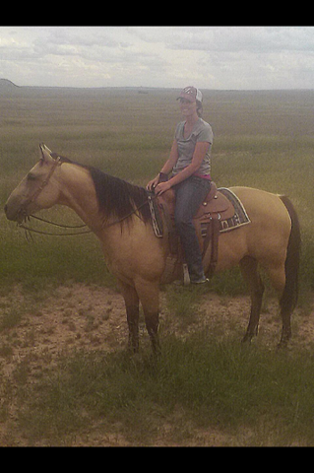

|  |  |  |  |
| --- | --- | --- | --- |
| 11 | | SMOKE | GRADE |
|  | **12 YR OLD GRULLA GELD** | | **KOLYN DUTTON** |
|  | |  |  |

“Smoke” is an all-around horse. You can head, heel, and breakaway rope on him. You can run barrels, poles and tie goats on him. He has had a lot of cattle doctored on him outside. Travels good and is handy to have around.

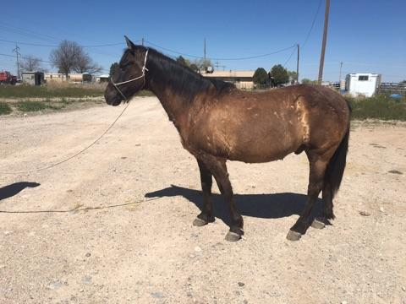

|  |  |  |  |
| --- | --- | --- | --- |
| 12 | | SOCKS | GRADE |
|  | **7 YEAR OLD BROWN GELD** | | **DAVE MCINTOSH** |
|  | |  |  |

Nice gentle ranch horse. Has had a little bit of everything done on him. He has been used at Roswell Livestock Auction. Has been used to drag calves and has been roped off some in the arena.

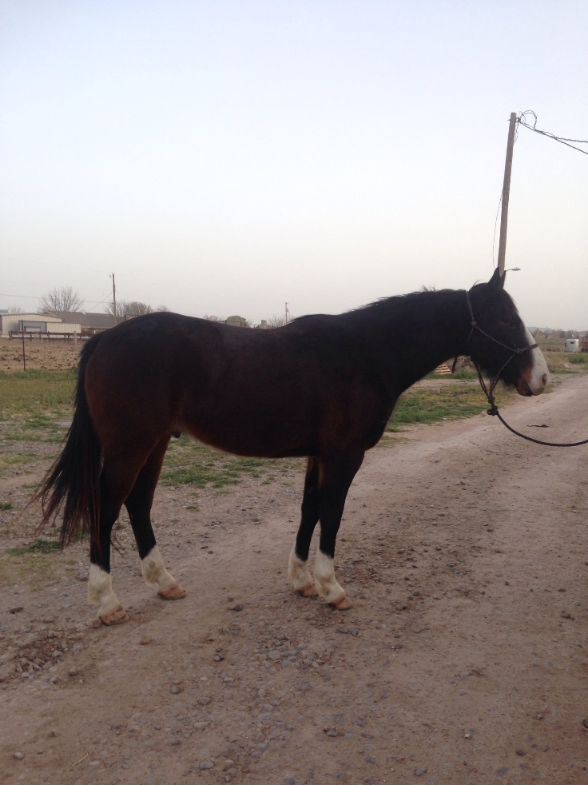

|  |  |  |
| --- | --- | --- |
| 13 | TEXAS SILVER COYOTE | 4452039 |
|  | **2003 GRAY GELD** | **WESLEY GRAU** |
|  |  |  |
|  |  | Deck Trouble Bar |
|  | Deck Trouble Skipbar |  |
|  |  | Princess Yen |
| MR GRAY COYOTE |  |  |
| 3592674 |  | Coyote Colonel |
|  | Miss Hickory Coyote |  |
|  |  | Hickory Dickory Miss |
|  |  |  |
|  |  | Strait Silver |
|  | Turnin Silver |  |
|  |  | Turnin Around |
|  |  |  |
| MISS TEXAS SILVER |  |  |
| 3513936 |  |  |
|  |  | Gamblin Ticket |
|  | Texas Ticket |  |
|  |  | Texas Holly Bee |
|  |  |  |

“Tejas” has done everything on a ranch. He has a laid back personality, but responds well to leg pressure. Has been shod a lot and can get the job done. Can strip calves, pen bulls, and drag calves. We have owned him since he was weaned. Good horse, handles really well, and he is sound in every way.

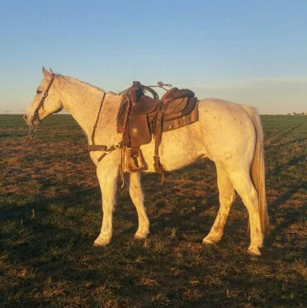

|  |  |  |
| --- | --- | --- |
| 14 | SIXES WIMPY | 4590649 |
|  | **2004 SORREL GELD** | **WAYNE METCALF** |
|  |  | DANNY CAMP, AGENT |
|  |  | Nu Cash |
|  | Nu Chex To Cash |  |
|  |  | Amarillo Chex |
| WIMPYS LITTLE STEP |  |  |
| 3863115 |  |  |
|  |  | Fourty Seven |
|  | Leolita Step |  |
|  |  | Step Lite |
|  |  |  |
|  |  | Doc O’Lena |
|  | Tanquery Gin |  |
|  |  | Gin Echols |
| NATURAL SENSE |  |  |
| 3554482 |  |  |
|  |  | Coe Badger Two |
|  | Natural |  |
|  |  | Miss Cee Bar 99 |
|  |  |  |

Very Nice gelding 14.2 hands tall. He will spin a hole in the ground. Have been roping calves on him at the numbered calf ropings. He has a great stop and will get back on that rope. Super horse, anyone would love to own him. Sound, gentle, and the kind.

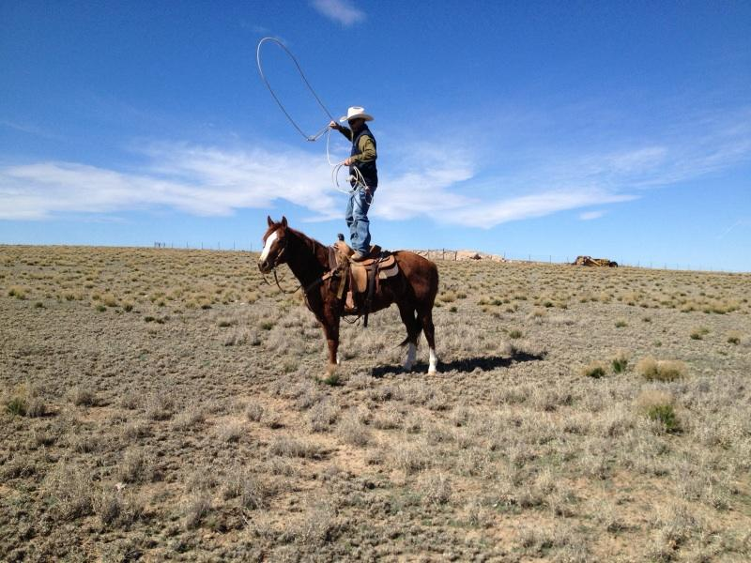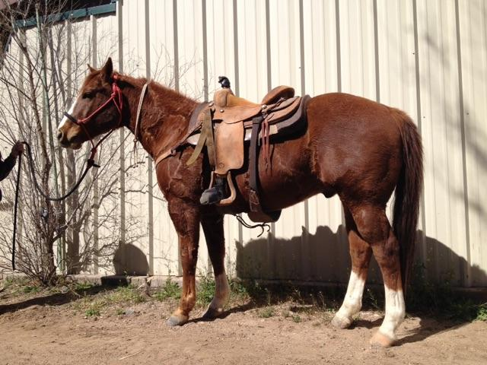

|  |  |  |
| --- | --- | --- |
| 15 | DOCS QUICK PEP UP | 5412050 |
|  | **2011 GRAY GELD** | **DENNIS KLINGHAGEN** |
|  |  |  |
|  |  | Tee J Badger Boy |
|  | Dels cutter Jay bar |  |
|  |  | Jay Missy |
| DOCS QUICK PEP UP |  |  |
| 3409925 |  | Brays Badger Bar |
|  | Pretty Bonnie Zero |  |
|  |  | Pretty Bonnie Bray |
|  |  |  |
|  |  | Doc’s Hickory |
|  | Pep Up Hickory |  |
|  |  | Escondida Peppy |
|  |  |  |
| DOCS PEPPY HICKORY |  |  |
| 3966885 |  | Salty Doc One |
|  | Quick Gray Girl |  |
|  |  | Quick Charlotte |
|  |  |  |
|  |  |  |

“Cutter” is a really built gray quarter horse gelding. Only a 5 year old, he rides low headed and quiet. He needs a little more outside riding but is coming along really well. I’ve roped a few calves in the lane & have followed the Hot Heels on him. He has never offered to buck and want to please. Sells 100% sound. We’ve enjoyed having him around.

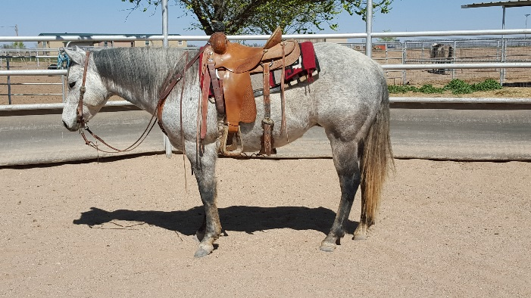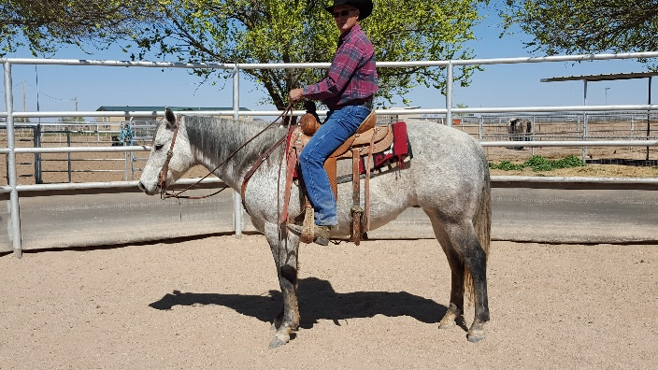

|  |  |  |
| --- | --- | --- |
| 16 | CATT KIKN A LIL ACE | 5418323 |
|  | **2010 SORREL GELD** | **SAM COBERLY** |
|  |  |  |
|  |  | High Brow Hickory |
|  | High Brow Cat |  |
|  |  | Smart Little Kitty |
| SOPHISTICATED CATT |  |  |
| 4342421 |  |  |
|  |  | Peppys Boy 895 |
|  | Shania Cee |  |
|  |  | Lynx Melody |
|  |  |  |
|  |  | Doc’s Hickory |
|  | SR Hallmarked |  |
|  |  | Doc’s Serendipity |
| LIL HOLY HALLMARK |  |  |
| 3030431 |  |  |
|  |  | Doc O Lena Twist |
|  | Little Girls Gremlin |  |
|  |  | Biggirlsdontcray |
|  |  |  |

Bred up, fancy horse. Do it all on this one. Sort, cut, rope or ride, this horse will do it all. Really cowy and will ride around. Doctor cattle, drag calves, then haul him to the ranch sorting or cutting and win. Started very well on the heel side. Very willing to please and ready to be finished and go any direction. Sound and Gentle.

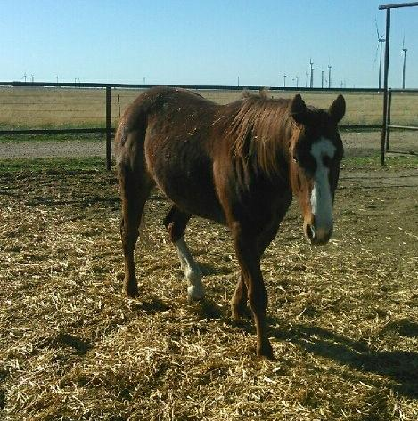

|  |  |  |
| --- | --- | --- |
| 17 | LUCKY CHOICE HAND | 4355168 |
|  | **2003 CHESTNUT GELD** | **CADE HOOTEN** |
|  |  |  |
|  |  | Hired Hand’s Rey |
|  | Hired Hand’s Dee |  |
|  |  | HH Dee |
| HIRED HAND LUCKY |  |  |
| 2522595 |  |  |
|  |  | Lucky Roan King |
|  | Lucky Roan Miss |  |
|  |  | Explosive Snoopy |
|  |  |  |
|  |  | El Rey Rojo |
|  | Bolsa Rojo |  |
|  |  | La Bolseria |
| BOLSA CHOICE |  |  |
| 3885810 |  |  |
|  |  | Lord Peppy |
|  | Peppy Choice |  |
|  |  | Mickie Choice |
|  |  |  |

“Ed” is a using horse deluxe. He has been used in all aspects of ranch work, from riding pens, to roping bulls, He can go all day and make the outside swing. “Ed” is sound and sane. He has been used extensively on a yearling operation and tied down a bunch of calves. He has the good looks to go with his ability.

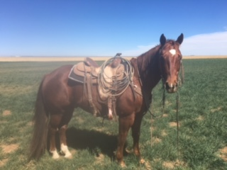

|  |  |  |
| --- | --- | --- |
| 18 | RBS PEPPY SAN VILLA | 4963906 |
|  | **2007 PALOMINO GELD** | **JERRIVON THOMAS** |
|  |  |  |
|  |  | Peppy San |
|  | Imapeppysandoc |  |
|  |  | Doc’s Madonna |
| REBS PEPPY SAN |  |  |
| 3490207 |  |  |
|  |  | Doc’s Tom Thumb |
|  | Mame Baby |  |
|  |  | Cutter’s Mame |
|  |  |  |
|  |  | Mr San Peppy |
|  | Peppy San Badger |  |
|  |  | Sugar Badger |
| PEPPY SAN VILLA |  |  |
| 3057982 |  |  |
|  |  | Doc Holliday |
|  | Holliday Villa |  |
|  |  | Marvilla Alejos |
|  |  |  |

This is a super broke gelding. He has been used in the feed yard, wheat fields and has had lots of cattle roped on him outside. He has lots of cow and is an easy keeper. Sound and Gentle.

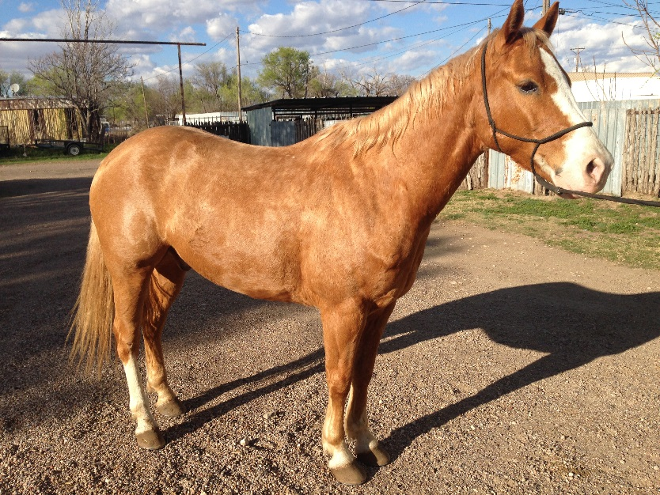

|  |  |  |
| --- | --- | --- |
| 19 | JACKS DARLIN GEMINI | 5336764 |
|  | **2010 SORREL GELD** | **JERROD HARRAL** |
|  |  |  |
|  |  | Two Eyed Jack |
|  | Jack Two Star |  |
|  |  | Starabar |
| JACKS BLUE BONITA |  |  |
| 3807631 |  | Mr Gray Bonita |
|  | Bonita Blue Barby |  |
|  |  | Higgins Gal Two |
|  |  |  |
|  |  | Joe Country |
|  | Masterful Hancock |  |
|  |  | Masterful Leona |
|  |  |  |
| MASTERFUL DARLING |  |  |
| 4111669 |  |  |
|  |  | Smoky Sundance |
|  | Darling Sundance |  |
|  |  | Eds Darling Deck |
|  |  |  |

Has been used for general ranch work. He has been used to doctor wheat and grass cattle. Sound and Gentle.

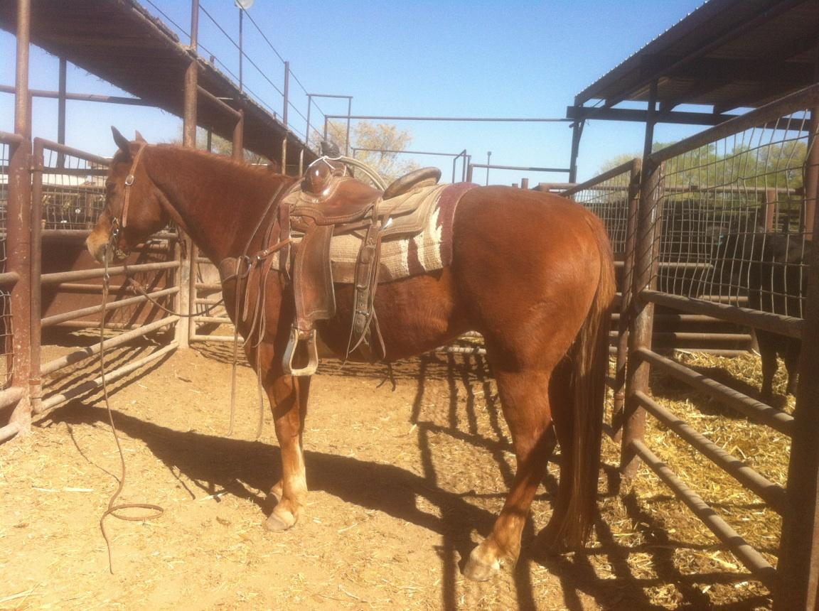

|  |  |  |
| --- | --- | --- |
| 20 | CHILDRESS DOC PEPPY | APHA 1024827 |
|  | **2012 BLK TOBIANO GELD** | **KELLY HATLEY** |
|  |  | Peppy San Cuss |
|  | KG Hockley Peppy San |  |
|  |  | Frecklescolord ReyJay |
|  |  |  |
| CHILDRESS BLACK PEPPY |  |  |
| APHA971864 |  | Cutters Judge |
|  | Nan Badger Two |  |
|  |  | Rocking Badge |
|  |  |  |
|  |  | Poco Judge Texas |
|  | Cutters Judge |  |
|  |  | Miss Black Chance AQHA |
|  |  |  |
| LENA CUTTER DOC |  |  |
| APHA691223 |  | Doc’s Stinger AQHA |
|  | Doc Olena Sting |  |
|  |  | Naomis Cat AQHA |
|  |  |  |
|  |  |  |

“Pepper” has had a lot of cattle doctored on him. He has been used on big drives. We have been heading on him for the last six months and he is ready to be hauled to ropings. 100% sound and gentle, Very nice prospect.

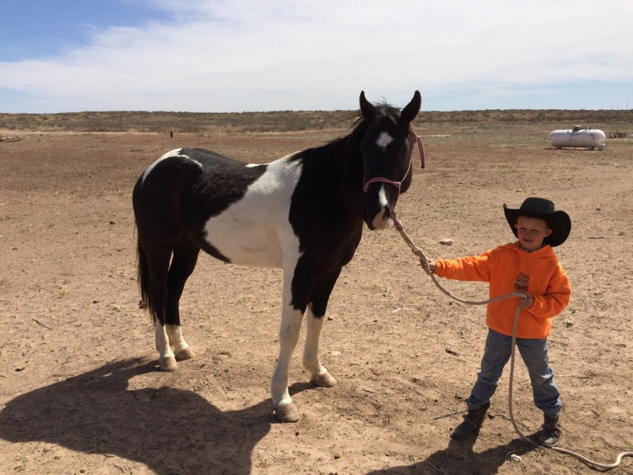

|  |  |  |
| --- | --- | --- |
| 21 | MARIACHI | GRADE |
|  | **6 YR OLD RED ROAN GELDING** | **ROSENDO APODACA** |
|  |  |  |
|  |  |  |

14 ½ hands. Been used in feedlot and outside. Knows all the cowboy work. Real Gentle. 100% sound.

|  |  |  |
| --- | --- | --- |
| 22 | CLASSY POCO OJOS | 4797406 |
|  | **2004 PALOMINO GELD** | **E C CATTLE** |
|  |  |  |
|  |  | Poco Bueno |
|  | Poco Ojos Grande |  |
|  |  | Wimpy’s Ojos |
| POCO OJOS DIEGO |  |  |
| 3844470 |  |  |
|  |  | Poco Diego |
|  | Poco Chulura |  |
|  |  | Chula Duquesa |
|  |  |  |
|  |  | Sassy Doc |
|  | Poco Gay Doc |  |
|  |  | Miss Gay Space |
| SHEZA CLASSY SASSY |  |  |
| 2645439 |  |  |
|  |  | String’s of Gold |
|  | Strings of Amber |  |
|  |  | Amber Mine |
|  |  |  |

“Bandido” very gentle Palomino gelding with all the chrome you could ask for. Been used outside extensively, drug calves, and caught cattle outside. Stands 14.1 weighs 1075. He’s been headed and heeled on in the arena. Loads and hauls well, stands good to shoe, and very easy to catch. Sells 100% sound.

