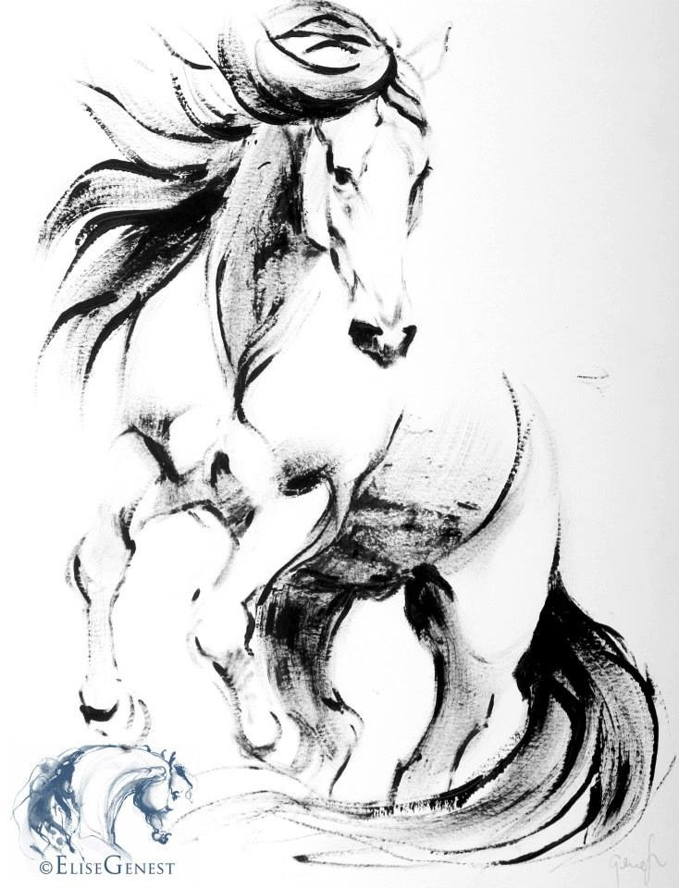

Camps and Clinic Information

Show Prep Clinic
Show season is here and can be over whelming for everyone especially for beginners. This clinic is designed for the parents and students to work together while learning the ins and outs of proper show preparation and turnout. Clinic will cover basic horse handling and safety, lunging, horse and rider turnout, braiding, last minute “bedazzling pit crew” etc.

Natural Horsemanship Clinic
Learn the ability to communicate and play with your horse on a whole new level.
Clinic is based on the Parelli training system and classical equine techniques and will cover ground and riding skills, equine behavior, psychology/ body language, round pen, trailer loading, Parelli seven games, personal assistance with your horse’s vices and much more! This clinic will give you the confidence and skill for only yourself but, for your horse to handle and try any situation with savvy and trust.

Parelli Play Day
Communicate and play with your horse while hanging with friends and club members.
Play day is based on the Parelli training system and will cover team challenges on ground and riding skills, round pen work, trailer loading, Parelli seven games etc. Play day will be a ton of fun to participate in watch!!

Dressage Naturally Clinic
Ground Training and Riding
Make riding and horsemanship understandable, accessible and enjoyable for you and your horse. Melissa will demonstrate exercises used to teach these to your horse and show you how to use them to create movements and qualities that is best for riding style. This clinic will change the way you look at your relationship with your horse. Melissa’s instruction and schooling methods are combination of natural horsemanship and classical riding. Clinic offered for beginner through advanced levels of training also for young or “problem” horses.

Parent and Child Play Day (Mommy and Me/ Daddy and I)
Parents have the opportunity to spend the day with your little ones while doing what they enjoy the most! Spend time doing crafts and horse activities which will also give your child the chance to teach the parents the skills and knowledge they have learned during their lessons.

Camps will cover:
Advanced Pre - Fair Camp
Walk, Trot, Canter, Jumping, Advanced Horsemanship, Cart, Advanced Horse Care, Show Grooming and Preparation, Practice Patterns and Specialized Displine prep
Beginner Camp
Walk, Trot, Beginning Canter, Beginner Horsemanship, Cart, Basic Horse Care, Crafts
Intermediate Camp
Walk, Trot, Beginner Canter and Horsemanship, Cart, Basic Horse Care, Crafts
Pony ½ Day Camp
Walk, Trot, Beginner Horsemanship, Cart, Basic Horse Care, Crafts All Children will have an older student as a helper while handling horses.

Summer Horse Camps
It is HIGHLY recommended that your child take at least 2 lessons at our stable prior to attending our Horse Camp. This allows the student to feel comfortable, familiar, and more confident. We will offer several different Camps this year. I am actively working on this; therefore, when you email me please provide age weeks you are interested in attending, and riding experience. This information will assist us in planning our schedule. Pricing will also be different for each Camp, which is based on skill and level of instruction received. We will offer half and full day camps with various horse related activities according to rider’s skill and experience.

Besides learning basic care of a horse, children will learn other responsibilities such as cleaning stalls, feeding etc. All camps will offer plenty of crafts, games and “horsey” activities. Week long camps will have a “Mini Show” for parents and families each Friday.

PROGRAMS OFFERED
The Pony Program is dedicated to children ages 4-7. The focus of this program is building a solid foundation with basic riding skills and safety while keeping fun in mind. In addition to developing proper riding skills, these children build confidence and self-esteem. All lessons begin in a 50 foot round pen with ponies led by the instructor. As the child learns the necessary skills and develops their confidence, the lead rope is removed and the instructor moves further away from the pony and student, always ready to step in to reassure or assist as necessary. As the children progress through the building blocks of the Preschool Pony Program, they will develop the skills and confidence to control their ponies independently.

The Beginner Riding Program is for children 7 years of age or older
who have had little to no exposure to horses and horseback riding. The student, horse and instructor work together to build a strong, relaxed and confident foundation for riding success. Students learn how to use a positive attitude improving self confidence,
self esteem, and self respect along the way.

We help the student focus on “what I can do” and “what I will do” rather than “what I can’t do” and “what my horse won’t do”. The beginner student will learn how to handle a horse on the ground and natural horsemanship in addition to learning balance and control in the saddle.
Walk, trot, transitions, and patterns are the riding skills we focus on at this level.

Intermediate Riding Program This program continues to hone the basic riding skills and adds cantering and more complex transition and pattern work to the lesson plan.
In addition, the students will learn Natural Horsemanship seven games, how to read a horses body language and understand how to work with horses of many different levels and abilities.

Once the student is comfortable in the saddle introductions to jumping, dressage, competitive trail riding, western, contesting and other areas of interest can be added to the program.

Pre Fair Boot Camp – Shine your boots and tack, its show time!! This camp is dedicated to our students with a competitive side. Students will be practicing their moves and patterns to build confidence for the ring for every displine from showmanship, halter, Western/English pleasure/equitation, jumping, dressage, driving, saddleseat, reining and more! We will also be covering what the judge is looking for, tips to place higher in the ring, arena etiquette, ring attire/ presence for the horse and rider etc.

In addition to Private instruction and semi-private lessons, the camps are strongly encouraged because it gives children the opportunity to build friendships and memories, by play games on and off the horse, water fights, crafts, the additional skills needed to ride with others and much more!!!
ALL students at Transitions Equestrian Center are offered instruction on
equine behavior/instincts, horse care /grooming, basic stable management/nutrition, safety around horses, anatomy/physiology/bio mechanics, tack cleaning/maintenance, saddling/bridling, safe and quite riding and putting on a halter/tying.


__________________________________________________________________________________

Camp Schedule

Transitions will be offering several different camps this summer for children and adults.
For full days campers will arrive at farm at 10:00 am and be picked up at 4:00 pm.

If you, or someone you know, are interested in receiving more information about these camps,
contact Melissa Ashcraft, Please Leave A Message.

This is an average schedule during full day camp:
10:00 – Drop off children
10:15 - 11:30 Tack & Riding lesson (students will be broken up into groups based on their skill level)
11:30 – 12:15 Untack and groom horses
12:15 – 1:00 Lunch (pack your own)
1:00 – 2:00 Learning project of the day (Farrier, vet, horse information) or craft
2:00 – 3:30 Second riding lesson
Untack and turn out horses

Students will review the following:
• Cleaning stalls (the campers’ favorite part!!)
• Cleaning tack
• Conformation
• Grooming
• Feeding

~ Students must ride in a helmet, a closed shoe with a low heel and jeans or breeches,
~ All students should bring a lunch, a snack and a lot to drink. We do have a refrigerator and microwave. ~ We may be washing horses Please have camper prepared with extra clothes and a towel.
~ Week Camps and 4 Day Camps Only students families and friends are invited on the last day to watch an exhibition starting or “mini show” at 1:30

Camp is a great experience for both the novice and experienced horse rider, giving them an opportunity not only to have fun with friends, improve their riding skills, but also learn how to care for a horse. Please call Transitions if you have any questions regarding camp. We look forward to seeing everyone there!!

Please return all enclosed forms at least one week before the camp.

_________________________________________________________________________

Rider’s Name ________________________________ Birth date _______ Height ________ Weight ______

Indicate your choice of camp and dates student will be attending: __________________________________

If unable to attend full week days child will be able to attend:
______________________________________________________________________________________

Parent/Guardian_____________________________ Phone __________________ Cell ________________
Address _________________________________________ City___________________ Zip____________
Email ________________________________________________________
Emergency Contact person, other than parent:
Name__________________________________ Phone _____________ Relation to student _____________
Physician’s Name________________________ Phone ________________
Preferred Medical Facility _________________________ Date of last tetanus shot ____________________

Describe ANY medical condition (including allergies) requiring special precautions or treatment and any medications and dosage: None Otherwise, Please

Describe:_______________________________________________________________________________

In case of medical emergency, the undersigned authorizes an agent of Transitions Equestrian Center to provide or arrange for medical assistance as they determine necessary, at your cost. The undersigned authorizes any licensed physician and/or hospitalization for the rider, including anesthetic, which they determine necessary or advisable. No person can be accepted for riding instruction until this form has been completed by the parent or guardian. If the person is of legal age (18), he/she may complete the form. Riding instruction will be under strict supervision, and although every effort will be made to avoid any accident, NO LIABILITY can be accepted by Transitions Equestrian Center. There will be no refunds made for deposits or for a camper leaving during the session for which he or she has registered, except with the written verification of a physician of injury or physical illness. A camper who exhibits emotional, psychological, or behavioral conditions which are harmful to themselves or others will be dismissed with no refund of fee.

I HAVE READ THIS ENTIRE RELEASE AND AGREE TO IT.

PARENT/GUARDIAN SIGNATURE _____________________________________________ DATE _______________

Head Instructor: Melissa Ashcraft
Transitions Equestrian Center
2525 E. 850 N.
(219) 778 - 9592
transitionshorses.com
HORSEBACK RIDING EXPERIENCE FORM

Has the rider:
Walked on a horse? Yes No
Trotted on a horse? Yes No
Cantered on a horse? Yes No
Been on a trail ride? Yes No
Natural Horsemanship Experience? Yes or No
Taken lessons? Yes No
If so, for how long? ______________________________________________
Jumped? Yes No
If so, to what height? ______________________________________________
Owned their own horse? Yes No
If so, for how long? _______________________________________________

Are there any specific skills that the rider needs to work on, or would like to work on? _______________________________________________________________________________________

_______________________________________________________________________________________

What if anything is student not comfortable with doing?________________________________________________________________________________________________

Additional Notes and Comments: _______________________________________________________________________________________________________

PHOTO RELEASE FORM
For valuable consideration given and which is hereby acknowledged, the undersigned hereby grant to Transitions Equestrian Center permission to take or have taken, still and moving photographs and films including television pictures of _______________________ and consents and authorizes Transitions Equestrian Center its advertising agencies, news media, and any other persons interested in , and its work, to the use and reproduction of the photographs, films, and pictures to circulate and publicize the same by all means including without limit, the generality of the foregoing newspapers, television media, brochures, pamphlets, instructional materials, books and clinical material. With regard to the foregoing material, no inducements or promises have been made to us/me to secure our/my signature(s) to this release other than the intention of to use or be used such photographs, films and pictures for the primary
purpose of promoting and aiding its program and its work.

PARENT/GUARDIAN SIGNATURE _____________________________________________ DATE _______________

RELEASE FROM LIABILITY AGREEMENT
THIS RELEASE FROM LIABILITY AGREEMENT is entered into between ______________________ hereinafter referred to as Riding Student and TRANSITIONS EQUESTRIAN CENTER and its Riding Instructors. If said Riding Student is a minor, I _________________________________ parent and/or guardian (circle one) of aforementioned minor child and Riding Student agree to the following release from liability terms:
- Riding Student (parent and/or guardian if Riding Student is a minor), understands the hazards, dangers, and inherent risks involved with horse handling. These risks include dangers and conditions that are innate part of equine activities and a horse’s unpredictable nature and temperament that may cause injury, harm, or death. Such activities include, but are not limited to the following:
  - Biting, kicking, falling, being stepped on, bucking, rearing, shying, fleeing, spooking
  - Unpredictable and/or erratic reactions to injuries, ailments, medications, unfamiliar objects, situations, noises, people, animals, movements, hazards, obstacles, terrain, or tack
  - Collision with objects or other horses
  - Problems resulting from another rider not maintaining control over his/her horse
- Riding Student (parent and/or guardian if Riding Student is a minor), assumes responsibility for all risks entailed in/or arising from Riding Student’s use of or presence on the Riding Instructor’s property or facility. Such risks include, but are not limited to the following:
  - Bodily injury and/or death
  - Property damage, sustained by Riding Student in relation to the riding facility and it’s operation
  - Falls, kicks, bites, collision with objects or other horses
  - Fire
  - Unavailability of emergency medical care
  - Negligence and/or deliberate act of another person
- Riding Student (parent and/or guardian if Riding Student is a minor), agrees to hold stable, it’s owner/s, Riding Instructor, and all staff affiliates completely free and harmless from claims, loss, litigation, demands, actions and causes of actions, injuries, damages, liability and cost or expense arising out of Riding Student’s use of or presence on the Riding Instructor’s or stable’s property and facilities, including without limitation those based on the following:
  - Bodily injury or death
  - Property damages sustained in relation to premises and operations of this stable including damages sustained while riding, handling, or being in proximity a horse owned by or in the care, custody and control of this stable; unless damages are caused by the direct, willful and wanton gross negligence of the Riding Instructor.
- Riding Student, (parent and/or guardian if Riding Student is a minor) agrees to waive the protection of any state or jurisdiction statue that provides a general release from claims that the Riding Instructor and/or Riding Student does not know about or does not suspect exists at the time this release is signed.
- Riding Student, (parent and/or guardian if Riding Student is a minor) assumes responsibility for all risks entailed in/or arising from Riding Student’s use of or presence on the Riding Instructor’s property or facility and holds Riding Instructor free and harmless from any and all claims, damages, judgments, expenses and/or attorney fees, which arise from use or presence on said property or facility.
- Riding Student, (parent and/or guardian if Riding Student is a minor) agrees to abide by all Riding Instructor’s rules and regulations.
- Riding Student, (parent and/or guardian if Riding Student is a minor) is responsible for use of proper equipment including helmets, gloves and boots.
- Riding Student (parent and/or guardian if Riding Student is a minor), if using his/her own horse, declares that said horse is free from any infections and contagious or transmissible diseases.
- Riding Instructor reserves the right to refuse a horse not in proper health, undesirable or is dangerous.
- Riding Student, (parent and/or guardian if Riding Student is a minor) is responsible for complete insurance coverage for his/her horse, personal property, and self.
- This agreement shall be subject to and under the laws of the statute of the State of Indiana.
______________________________________________ ___________________
Riding Instructor, TRANSITIONS EQUESTRIAN CENTER Date

___________________________________ __________ ___________________
Riding Student Age Date

___________________________________ __________________ ___________________
Parent or Guardian Relation Date
Riding Student (if over the age of 18) understands that horses and riding can be very dangerous. It is strongly recommended to wear a riding helmet while riding or handling and accepts all responsibility for medical and legal expenses and injuries if said Student refuses to wear proper safety gear. By signing this document I waive the right to wear a riding helmet for myself or my child. All riders must wear a helmet while jumping, doing gymkhana, on a young or unruly horse or trail riding.
___________________________________ __________ ___________________
Riding Student Age

Date___________________________________ __________________ ___________________
Parent or Guardian Relation Date

Photo Release Waiver / Authorization and Release

I hereby grant permission to Transitions Equestrian Center, their employees, agents, students, representatives to photograph my image, likeness, or depiction and/or that of my minor children (if applicable). I also grant permission to Transitions to edit, crop, or retouch such photographs, and waive any right to inspect the final photographs. I hereby consent to and permit photographs of me and/or those of my minor children to be used by Transitions for any purpose, including educational and advertisement purposes, and in any medium, including print and electronic. I understand that Transitions Equestrian Center may use such photographs with or without associating names thereto. I further waive any claim for compensation of any kind for Transitions use or publication of photographs of me and/or those of my minor children (if applicable).

I hereby fully and forever discharge and release Transitions Equestrian Center from any claim for damages of any kind (including, but not limited to, invasion of privacy; defamation; false light or misappropriation of name, likeness or image) arising out of the use or publication of photographs of me and/or those of my minor children (if applicable) by Transitions , and covenant and agree not to sue or otherwise initiate legal proceedings against Transitions Equestrian Center for such use or publication on my own behalf or on behalf of my minor children. All grants of permission and consent, and all covenants, agreements and understandings contained herein are irrevocable.

I acknowledge and represent that I am over the age of 18, have read this entire document, that I understand its terms and provisions, and that I have signed it knowingly and voluntarily on behalf of myself and/or my minor children (if applicable).
Participant’s Name, printed: ______________________________________________________________________

Participant’s Signature: _____________________________________________________ Date_________________

Parent’s Signature:_________________________________________________________ Date_________________
(If participant under18 years of age)

