CHEMICAL, OIL and SOLVENT RESISTANCE
OF POLYURETHANE
Samples of both polyether and polyester
were immersed for seven days at 75
°F.
The rating was
based on volume change according
to
the following *key:
1
=
Excellent
(
0
-
3%)
2
=
Good
(
4
-
15%)
3
=
Fair
(16 - 35%)
4
=
Poor
( 36% Up )
Chemical
Ether
Ester
Acetaldehyde
4
4
Acetic Acid
4-3
Acetic Anhydride
4
4
Acetone
4
4
Acetyl Bromide
3-4
4
Acetyl Chloride
3-4
4
Acetylene
2-3
3
Adipic Acid
1
2
Aluminum Chloride
2
2
Aluminum Sulphate
2
2
Aluminum Sulfide
2
2
Ammonia
2
2-3
Ammonium Acetate
3-4
3-4
Ammonium Carbonate
2
2
Ammonium Hydroxide
1-2
2
Ammonium Nitrate
2
2-3
Ammonium Persulfate
2
9
Ammonium Sulfate
2
2
Ammonium Sulfide
2
Ammonium Thiocyanide
2
2
Amyl Acetate
4
Amyl Alcohol
3
3-4
Amyl
Chloride
3
3
Aniline
4

Chemical
Ether
Ester
Animal Fats & Oils
2-3
2-3
Antimony Salts
2
•
2
Aqua Regia
4
4
Arsenic Salts
2-1
2
ASTM Oil #1
1-2
1
ASTM Oil #2
2
1
ASTM Oil #3
2
1
ASTM Reference Fuel A
1
1-2
ASTM Reference Fuel B
2
2
Atlantic Oil
1
1-2
Barium Carbonate
2
2
Barium Hydroxide
1
2
Benzaldehyde
3-2
4
Benzene
4
4
Benzene (Gasoline)
(Aromatic)
2-3.
3
Benzoic Acid
2-3
3-4
Boric Acid
1
2
Bromine
2-3
2-3
Bunker Oil
1-2
2
Butane
1
2-3
Butyl Acetate
4
4
Butyl Alcohol
2
3
Calcium Carbonate
2
2
Calcium Chloride
1
2
Calcium Hydroxide
1
2
Calcium Nitrate
2
2
Calcium Sulfate
2
2
Carbon Dioxide
1
1
Carbon Disulfide
2-3
2-3
Carbon Monoxide
1
1
Carbon Tetrachloride
3
4
Castor Oil
1-2
2
Chlorine
2-3
2-3
Chloroacetic Acid
3-4
4
Chloroform
4
4
Chromic Acid
3-4
4
Chromium Potassium Sulfate
2
2
Citric Acid
,
2
2
Cottonseed Oil
_
1
2
Cresol (meta)
4
4
Cupric Chloride
1
2
Cupric Nitrate
2
2
Cupric Sulphate
2
2
Cyclohexanone
4
4
Cyclohexane
2 2

Chemical
Ether
Ester
Dibutyl Phthalate
3-4
4
Dibutyl Ether
2
2
Dichlorobenzene (Ortho)
3
3
Dodecyl Mercaptan
2-3
2
Diester Oil
2
2
Dimetnyl Acetamide
4 .
4
Dimetnyl Formamide
4
4
DTE Oil (neavy,medium)
2
2-3
Etner
2-3
2-3
Etnyl Acetate
4
4
Etnyl Alcohol (Etnanol)
3
2-3
Ethyl Bromide
3
3-4
Etnyl Chloride
3
3-4
Ethylene Glycol
2
2-3
Esso #90 Lub.Oil
1 .
2
Ferric Chloride
2
2
Ferric Nitrate
2
2
Ferrous Cnloride
2
2
Ferrous Sulfate
2
2
Formaldenyde
3
2
Formic Acid
3-4
4
Freon, 12 or 113
1
2
Fuel Oil
2
2
Gasoline
2
2-3
Glycerine (Glycerol)
1
2
Glycolic Acid
2
2-3
Greases
1-2
2
Heptane
1
2
Hexane
1
2
Hydrazine
4
4
Hydrobromic Acid
2
2
Hydrocarbon Oil
1
2
Hydrochloric Acid, 20%
2
2-3
Hydrofluoric Acid
2-3
3
Hydrogen
1-2
2
Hydrogen Peroxide
,
2
2
Hydrogen Sulfide
3-4
4
,
Hydrolodic Acid
2
2
Iodine Solution
1
2
Isooctane
2
2
Isopropyl Alconol
(Isopropanol)
2-3
3
Isopropyl Ether
2
2-3

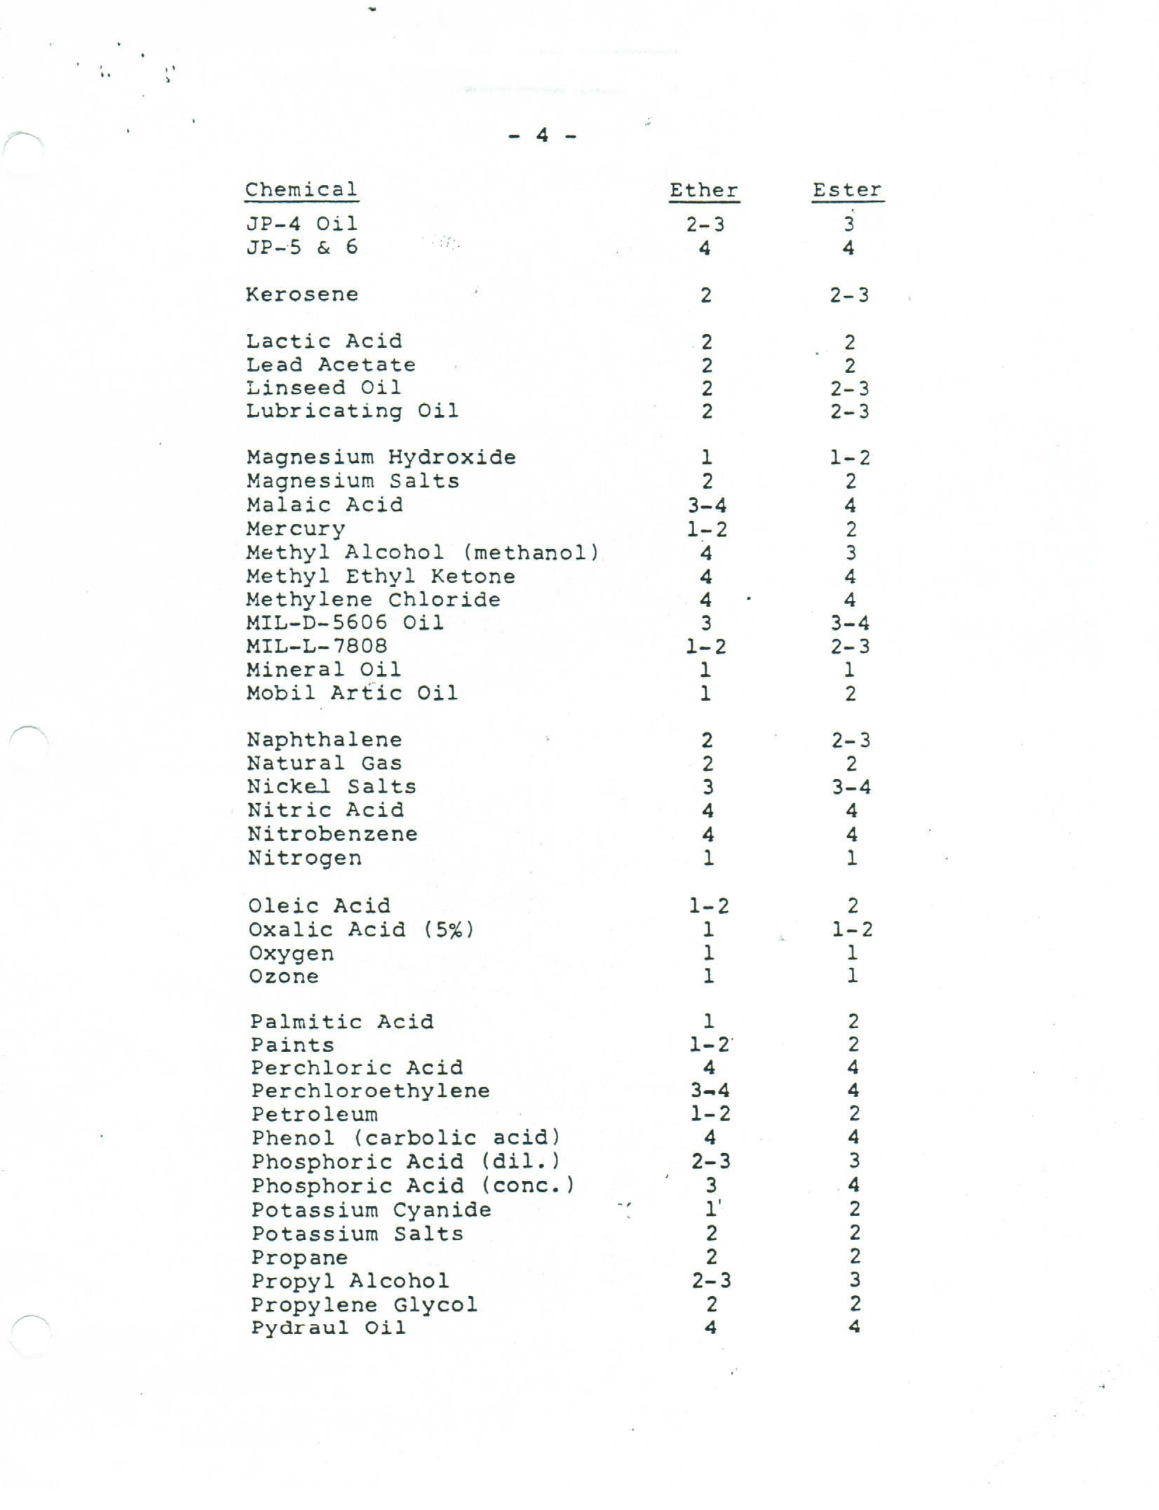

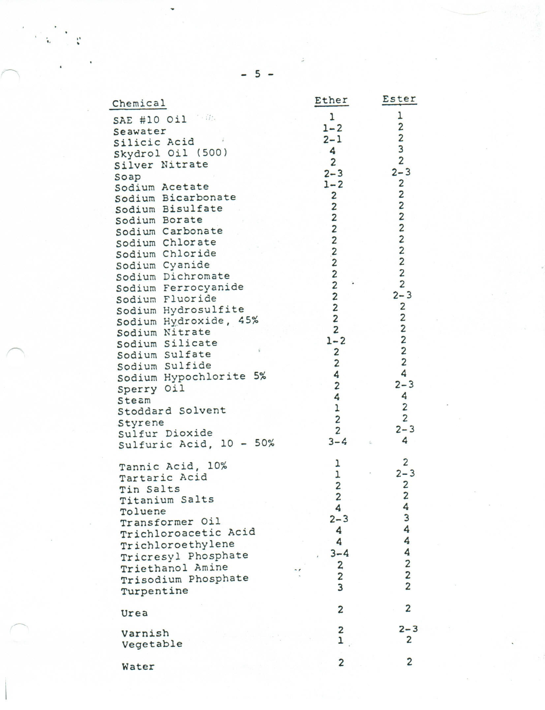

CHEMICAL

Ether Ester
Xylene 3 3-4

Xylol 3-4 4

Zinc Chloride 2 2

Zinc sulfate 2 2

