

S K u t t l e b u t t

# Newsletter for the

# Macomb County Detachment

**Marine Corps League and Auxiliary**

**Department of Michigan**

**Marine Corps League and Auxiliary**

**Mike Hall, Detachment Commandant – (586) 604-4834 – email:** [10659mh@gmail.com](mailto:10659mh@gmail.com)

**Loretta Balderson, Auxiliary President – (**[**810-392-2590**](mailto:810-392-2590)**) – email:** [balde1010@yahoo.com](mailto:balde1010@yahoo.com)

**september 2022**

**Elaine Arnold, Newsletter Editor – (248) 606-2600 email: elaine48178@gmail.com**

**Detachment WEB Site: www.macombmarines.com**

## september meeting notice

The next in person General Membership Meeting will be held on Thursday **September 1st at our usual time 7:30 pm (1930.)** Join us at the American Legion, Post 351, 46146 Cass Avenue located in Utica, always on the first Thursday of the month. The telephone number to the Post is (586) 731-9833.

**Officer Elections**

The second round of nominations for elected officers will take place at the September meeting. Following nominations, the election will be held. Installation of officers will take place at the October 6th meeting, which will start at 1900 hours (7:00 pm).

Elected Officers are:

Commandant

Sr. Vice Commandant

Jr.Vice Commandant

Adjutant/Paymaster

Judge Advocate

Chaplain

Sergeant at Arms

## detachment and auxiliary

## birthdays for september



|  |  |
| --- | --- |
| **Clement Buck** | **Paul Rangel** |
| **Carl Chupa** | **Terry Rigney** |
| **Michael Dahm** | **Gordon Schick** |
| **Jackie Dennis** | **Howard Schulte** |
| **Dawn Griffith** | **Mark Spooner** |
| **James Grime** | **Bradford Steensen** |
| **Ed Mader** | **Steve Whitfield** |
| **Gene Meredith** | **Will Wiggins** |

**If your birthday doesn’t get listed it means we don’t have it on record. Notify the Adjutant**

**New Member Reporting In**



**At the August General Membership Meeting, the following Marine was accepted as a member in our Detachment:**

**Marine Vic Racosky**.

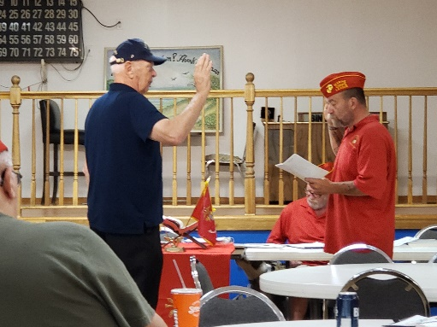

Welcome aboard Marine!

***We hope your association with the Detachment will be***

***a memorable one***

**commandant’s message**

Semper Fi

*Mike Hall, Commandant*

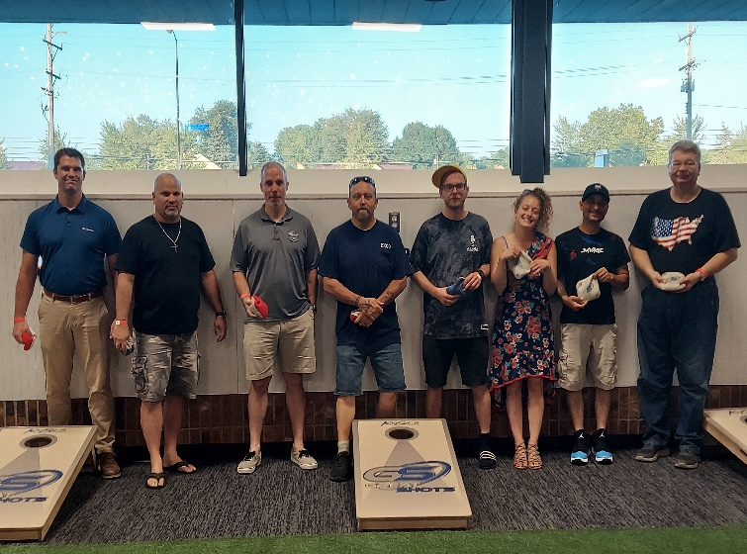

*Great Shots Backyard games in Clinton Township, July 30*

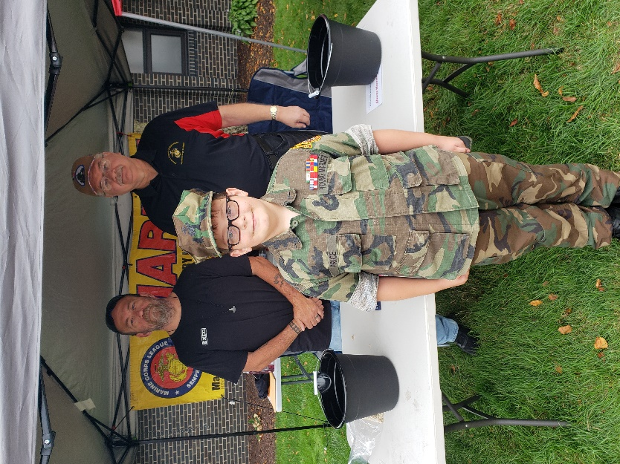

*Gasoline Alley -* ***Utica, August 13 classic car show, gas show, and swap meet,***

MCL DET 154 had an information/ recruiting booth in conjunction with Macomb County Young Marines at this year's Gasoline Alley.  John Myroniuk held down double duty with The American Legion and the MCL, John Sterniki supported us as well as Commandant Mike Hall. Young Marine Thomas Price represented the Young Marines program.



**auxiliary news**

It’s hard to believe, but the last full month of summer is just about over. As of August 30th, it’s time to collect annual Auxiliary dues. Annual dues for our Unit are $30. If you are interested in becoming a life member, age-based dues are as follows:

Up to age 35: $500.00

36 to 40: $400.00

41 to 50: $350.00

51 to 60: $300.00

61 & over: $150.00

We’ll be nominating and voting for officers at the September meeting. I strongly urge all members to attend this meeting. If we don’t have enough members stepping up to the plate as officers, we can no longer function as a lawful Auxiliary and we will fold. Our Auxiliary has done a darn good job of supporting the Detachment and supporting a variety of charitable causes. So, for those of you in the Detachment and the Auxiliary reading this, if you know of someone who would like to support the good work we do for the Detachment itself and for active military and veterans, bring your wife, daughter, daughter-in-law, niece, etc. to our meeting. We enthusiastically welcome all potential new members. We need new ideas and suggestions. Think about it. We need you!

For those of you who attended the Annual Picnic, you know how much fun we all had. Despite the heat, it was a great way to spend a summer afternoon. The American Legion Hall was open for those of us who needed to cool down a bit. Once again American House supplied and prepared the food. What a treat. The hamburgers were the biggest and best. The hot dogs, chicken and sausage were delicious. Salad, cookies and drinks rounded out the menu. The staff from American House couldn’t have been nicer. Great music was provided by Oscar, the music man. He did a superb job picking out tunes that made you want to sing along. There was a bouncy house for the kids. The Utica Fire Department paid a visit and splashed the kids. There was a “6 x” truck for picture taking and checking out. Good times with good friends. What could be better?

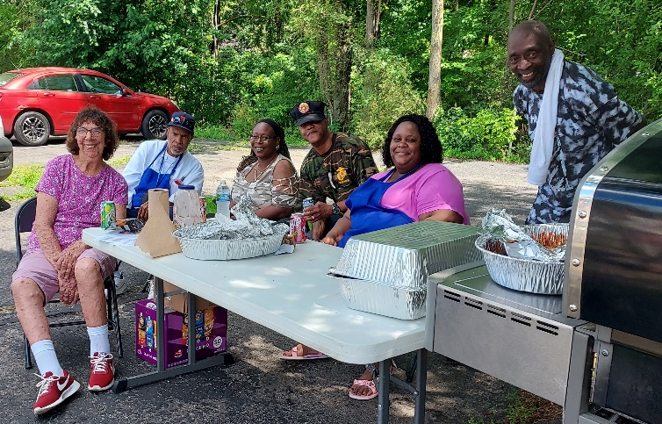

*American House staff*



*Dig in, Let’s Eat! Burgers, chicken, hot dogs*

*were a big hit*



*Is all that food for you Commandant Mike Hall?*

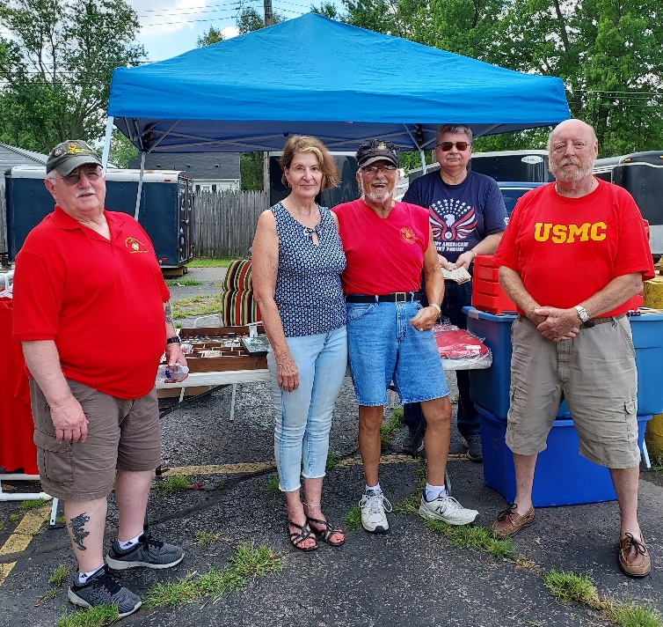

*Angelo Lema, Marie Leonetti, Dave Trevino, Mark Spooner checking the new items at the Merchandise table run by John Sternicki (standing in the back)*

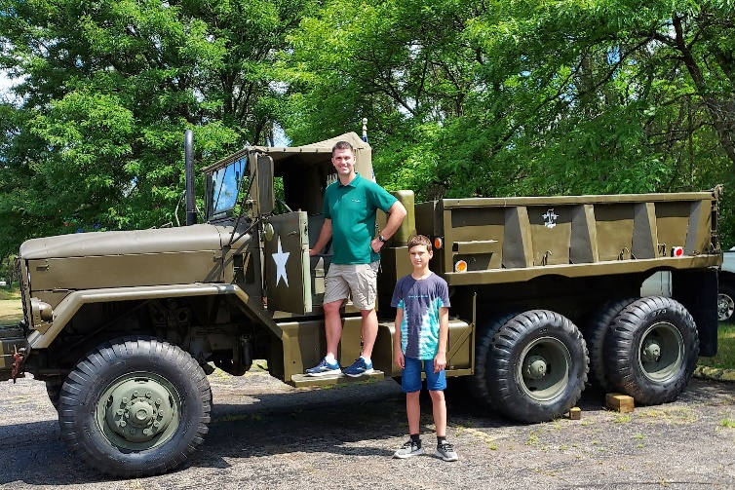

*Detachment member Justin Kane and son Titus*

*at the “6 by”*

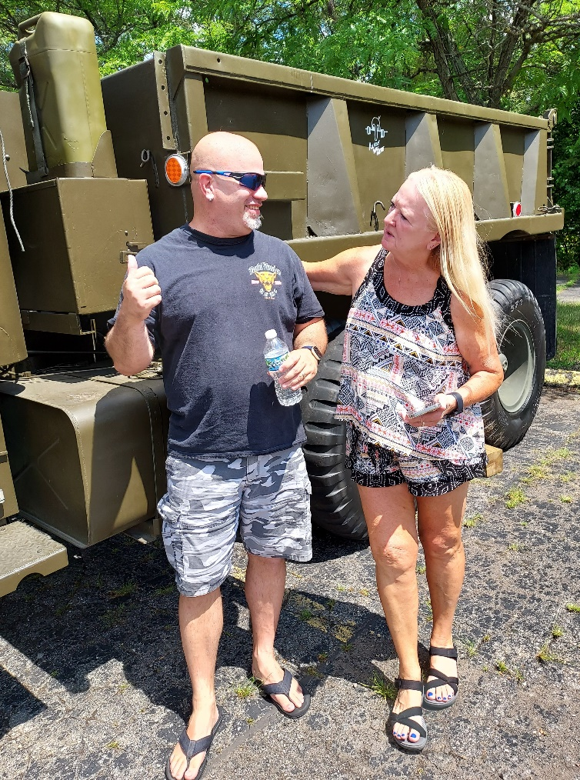

*Senior Vice Steve August providing some info about*

*the “6 by” to newsletter editor, Elaine Arnold*

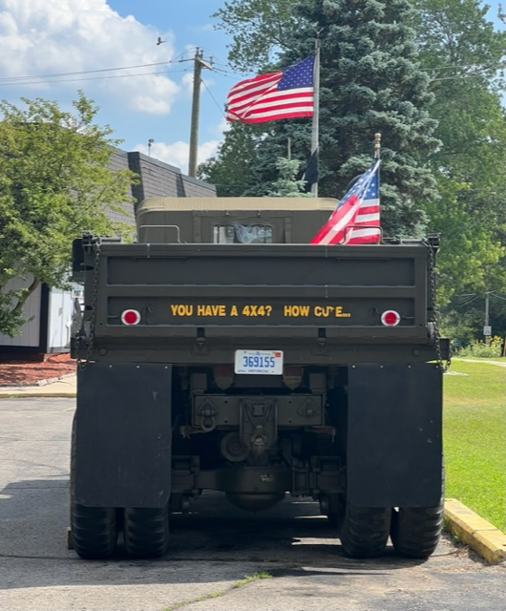

*You have a 4x4? How Cute*



*Let’s see the back of that shirt Devil Dog Steve August!*

The Auxiliary Picnic raffle was well received. The baskets were enticing. Thank you to all the donors for the basket items. They were a hit. Thank you to all the ticket buyers, Auxiliary, Detachment and American Legionnaires. As we always state, the funds received from our raffles go to veteran and military charities, many of them local.



*Elaine Arnold, Irene Spooner and Alice Lyon hawking tickets*

*for the Auxiliary raffle*

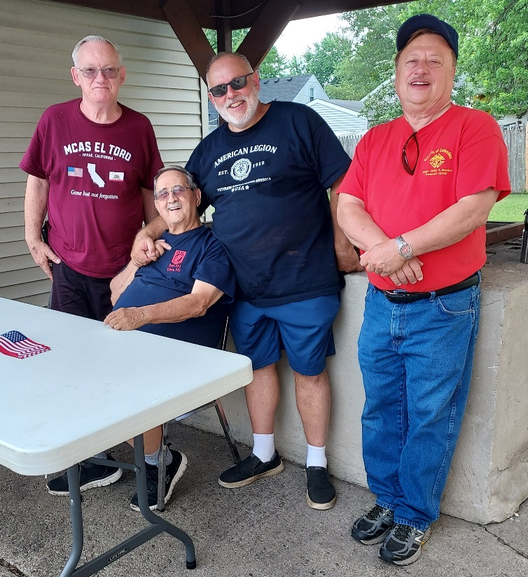

*Ticket table manned by Detachment & Legion member John Myroniuk, and Legion members Eddie, Mayor of Utica Gus Calandrino and Tom Presler*

The next Auxiliary fundraiser will be a Marine Rose table on September 17, 2022 at the Tractor Supply store in Richmond, Mi. Tractor Supply is located at 67500 Main Street. (M-19) We’ll set up at 10 am and wind it up around 2 pm. We need volunteers. This will be discussed at September’s meeting. There was an explanation of the Marine Rose in the August Skuttlebutt and why this is the flower of the Marine Corps that parallels the Army’s Poppy. If you didn’t have time to read that article, I suggest you go back to the August Skuttlebutt and do so. It’s an interesting piece of Marine Corps history.

I mentioned earlier that elections take place at the September meeting. Jumping ahead to October’s meeting, I want you remind you to mark your calendars for the Installation of Officers for Thursday, October 6, 2022. Typically, we begin our October meeting a half hour earlier, starting at 7:00 pm. We need to plan at our September meeting for the food arrangements and what the Auxiliary members will bring. Saying that, we’ll get together with the Detachment to see what their plans are. It’s a nice social event after the installation ceremony, so planning ahead will enhance the evening for all in attendance.

We plan to donate to the annual Baby Shower at the Detroit VA as we have done for the past few years. This typically takes place at the end of September. More on this and other items at the September meeting which takes place on Thursday, September 1, 2022 at 7:30 pm.

See you there and Semper Fidelis,

*Irene Spooner*

*Treasurer, Macomb County MCLA*

*\*\*\*\*\*\*\*\*\*\*\*\*\*\*\*\*\*\*\*\*\*\*\*\*\*\*\*\*\*\*\*\*\*\*\*\*\*\*\*\*\*\*\*\*\*\*\*\*\*\*\*\*\*\*\*\*\*\*\*\*\*\*\**

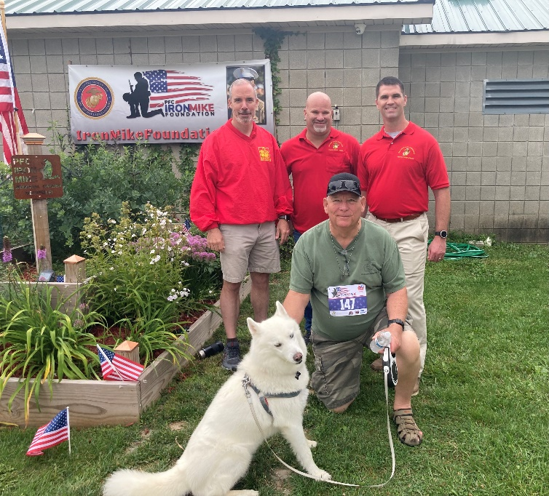

*Jim Dewey, Steve August, Justin Kane,*

*in foreground Rick Kincaid and his dog Maya (who walked the 5K route and made friends along the way)*

MCL Detachment 154 members pictured above participated in the 4th annual IronMike 5K Run and Walk in Armada on August 13. It’s an event to raise funds for the IronMike Foundation in memory of the founder’s son, Mike Giannattasio. PFC Michael Giannattasio, at the age of twenty-two, suddenly died during basic Reconnaissance training on August 30, 2017. He had passed his swim tests at the top of his class, where many Marines drop, and on the third day, with one more land navigation point to accomplish, he suddenly collapsed.

The funds collected for this foundation are for helping people with special needs. Michael had a great tenderness in his heart for his younger brother, Louis, who is severely cognitively impaired. 100% of the proceeds go into a scholarship fund that supports educational and special needs programs/therapies.

The Macomb County Detachment donated $100 to the foundation and another member matched that donation privately. We also had one participant in the race and three volunteers who helped set up, pass out water, and guide the runners along the pathway toward the finish line. Other Marines were also present to honor Mike's memory including two recruiters from the recruiting station where Mike had joined the Corps.

The Detachment plans to continue volunteering annually as this is very much a Marine Corps themed event which gives us a chance to connect with fellow Marines while honoring the memory of one from Macomb County

*Submitted by Detachment Member Justin Kane.*

## Calendar of Events

September 2 General Membership Meeting 1930

September 17 Auxiliary Marine Rose Table Fundraiser Tractor Supply 67500 Main St. Richmond MI 10:00 – 2:00

September 24 Golf Outing, Fern Hill Golf Club

Fundraiser benefitting Detachment 154 Charities

October 6 Installation of Officers 1900 (7:00)

November 3 General Membership Meeting 1930

November 10 Marine Corps Birthday Party

December 1 General membership meeting and Christmas party 1900

**2023**

January 5 General Membership Meeting 1930

February 2 General Membership Meeting 1930

March 2 General Membership Meeting 1930

April 6 General Membership Meeting 1930

May 4 General Membership Meeting 1930

June 1 General Membership Meeting 1930

www.thelittleworldofliz.com

## Macomb County Detachment

Department of Michigan

Marine Corps League

# Incorporated by act of Congress

Mailing Address:

14656 Eastport Drive

Sterling Heights, MI 48313-5325

Published monthly for members of the Macomb County Detachment and Auxiliary. SKUTTLEBUTT Newsletter is a non-profit monthly publication for the use of the Macomb County Detachment/Auxiliary, Department of Michigan, Marine Corps League. Article deadline is the 15th of each month

***Change of Address:*** Send to the Detachment Adjutant/Paymaster at:

14656 Eastport Drive

Sterling Heights, MI 48313

Or email to Macomb.marines@gmail.com

*New Address (please print):*

Name___________________________________________________________________________________________________

Street __________________________________________________________________________________________________

City/Zip_________________________________________________________________________________________________

Phone__________________________________________________________________________________________________

Email address____________________________________________________________________________________________

|  |  |  |  |  |  |  |
| --- | --- | --- | --- | --- | --- | --- |
| Commandant | Mike Hall | (586) 604-4834 |  | Auxiliary President | Loretta Balderson | ([810) 392-2590](https://hangouts.google.com/?action=chat&pn=%2B18103106081&hl=en&authuser=2) |
| Senior Vice Commandant | Steve August | (586) 823-4454 |  | Senior Vice President | Maureen Ailor | ([810) 310-6081](https://hangouts.google.com/?action=chat&pn=%2B18103922590&hl=en&authuser=2) |
| Junior Vice Commandant | Norm Pfaff | (586) 263-3448 |  | Junior Vice President | Alice Lyon | ([586)](https://hangouts.google.com/?action=chat&pn=%2B15862928132&hl=en&authuser=2) 216-0523 |
| Judge Advocate | Christine Tonegatto-Salo | (586) 801-0081 |  | Judge Advocate | Christine  Tonegatto-Salo | ([586) 801-0081](https://hangouts.google.com/?action=chat&pn=%2B15862633448&hl=en&authuser=2) |
| Adjutant/Paymaster | Don Lyon | (586) 532-8225 |  |  |  |  |
| Chaplain | James Dewey | (910) 333-2224 |  | Chaplain | Joan Pfaff | ([586) 263-3448](https://hangouts.google.com/?action=chat&pn=%2B15862633448&hl=en&authuser=2) |
| Sergeant at Arms | Clement Buck | (586) 383-3940 |  | Secretary | Maureen Ailor | (810) 310-6081 |
| Editor, Newsletter | Elaine Arnold | (248) 606-2600 |  | Treasurer | Irene Spooner | (586) 466-5708 |
| Honor Guard Commander | Frank Petricevich | (586) 531-5726 |  |  |  |  |
| Quartermaster | Dean Miles | (586) 457-7008 |  |  |  |  |
| Deputy Quartermaster | John Sternicki | (586) 468-1014 |  |  |  |  |
| Historian | Greg Pawlik | (586) 979-2986 |  |  |  |  |
| Web Sergeant | Don Lyon | (586) 532-8225 |  |  |  |  |
|  |  |  |  |  |  |  |
|  |  |  |  |  |  |  |
|  |  |  |  |  |  |  |

Auxiliary Officers 2012 - 2013

Detachment Officers 2012 - 2013