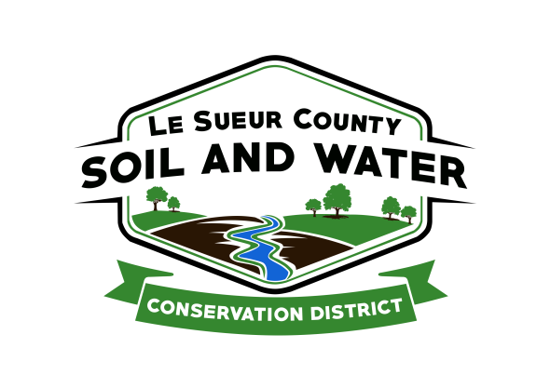

Le Sueur County Soil & Water Conservation District

Le Sueur County SWCD Tel. (507) 357-4879 Ext. 3
181 W Minnesota St Website: www.lesueurswcd.org
Le Center, MN 56057

2019 Tree Order

500 American Arborvitae TR2-3 12-18”
300 Eastern Red Cedar TR2-2 15-18”
250 Red Pine TR2-2 7-15”
500 White Pine TR2-2 7-15”
350 Balsam Fir TR2-3 12-18”
500 Black Hills Spruce TR2-2 7-15”
500 Norway Spruce TR2-2 7-15”

100 Quaking Aspen 2-3’
50 Autumn Blaze Maple 3-4’

1000 Redosier Dogwood 2-3’
150 Red Splendor Crabapple 2-3’
100 Paper Birch 3-4’
250 Sugar Maple 2-3’
50 Autumn Blaze Maple 3-4’
250 Red Oak 2-3’

500 Common Purple Lilac 18-24”
300 American Plum 2-3’
100 Cranberrybush 18-24”
250 Amur Maple 18-24”

20 Techny Arborvitae 2C 18-24”
20 Meyer Spruce 2C 18-24”

